Platform – HackerRank
Question – Conditional Statements in C
Problem Statement Link - https://www.hackerrank.com/challenges/conditional-statements-in-c/problem
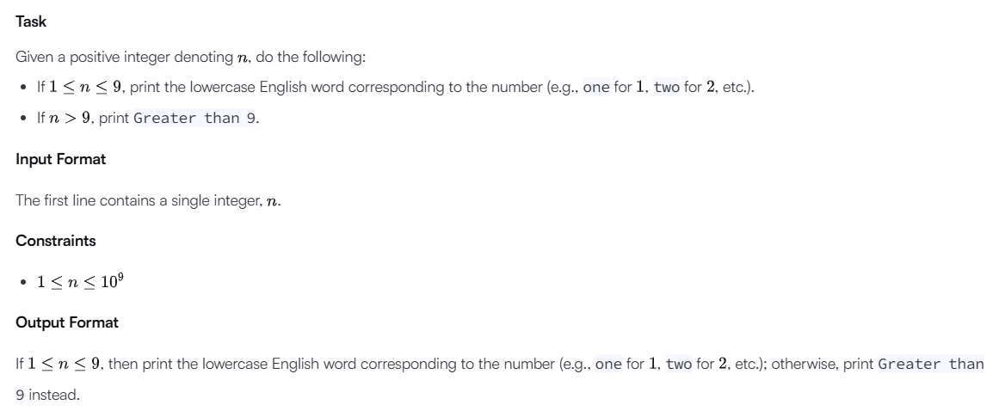C Source Code – 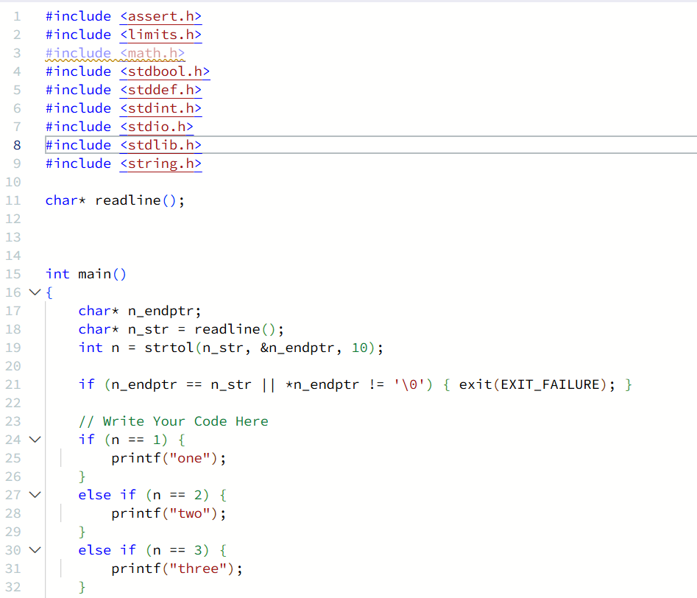
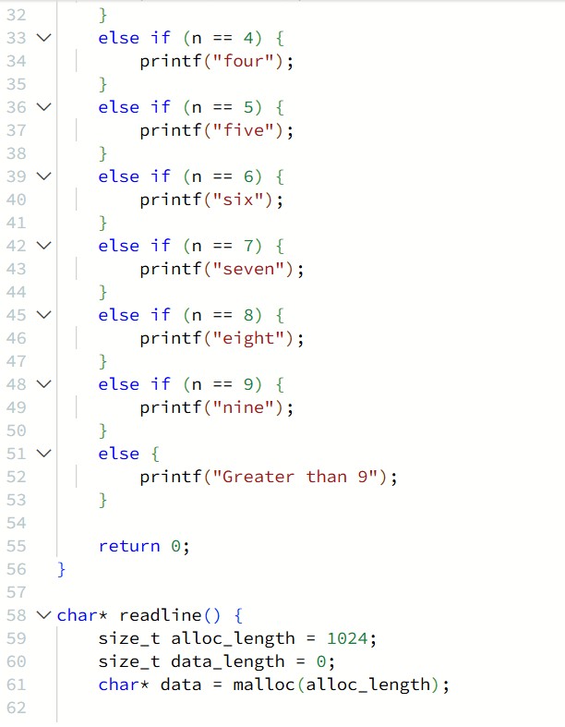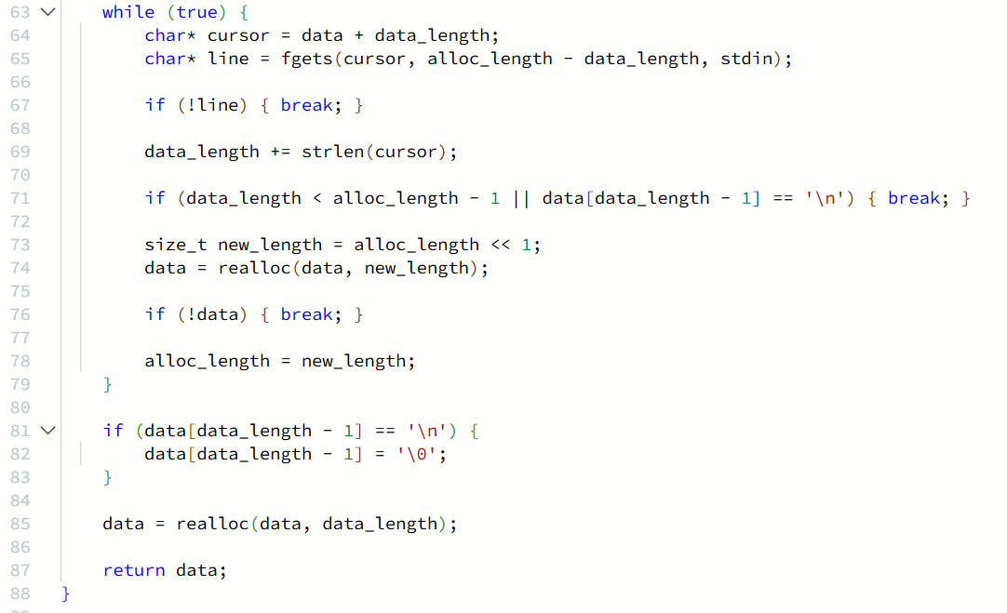

Submission –


