Platform – HackerRank
Question – FizzBuzz
Problem Statement Link - https://www.hackerrank.com/challenges/fizzbuzz/problem
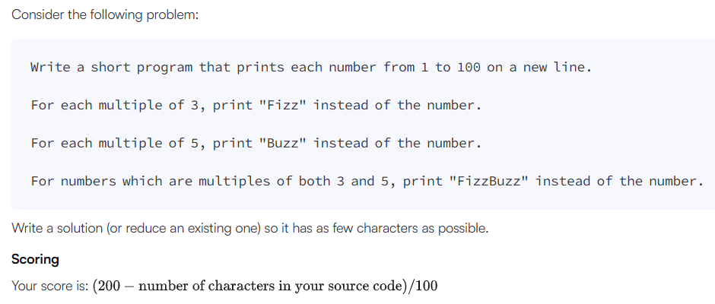
C Source Code –
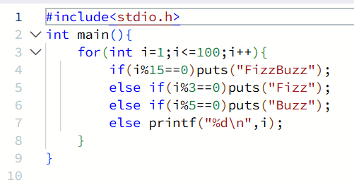
Submission –


