Platform – HackerRank
Question – For Loop in C
Problem Statement Link - https://www.hackerrank.com/challenges/for-loop-in-c/problem
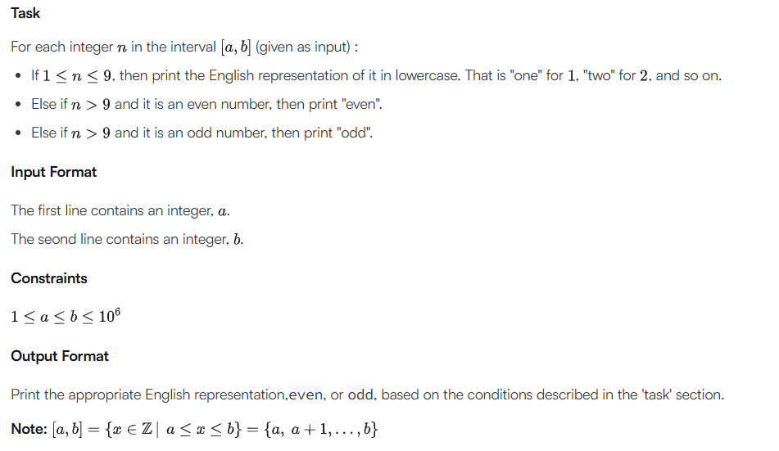
C Source Code –
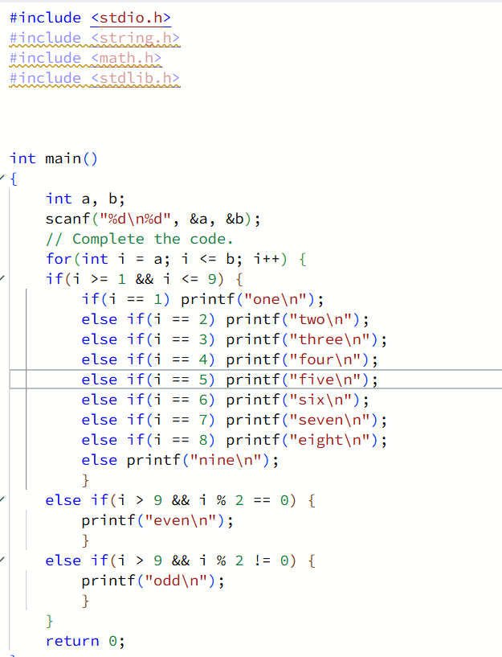
Submission –


