Platform – LeetCode
Question – 1342. Number of Steps to Reduce a Number to Zero
Problem Statement Link - https://leetcode.com/problems/number-of-steps-to-reduce-a-number-to-zero/description/
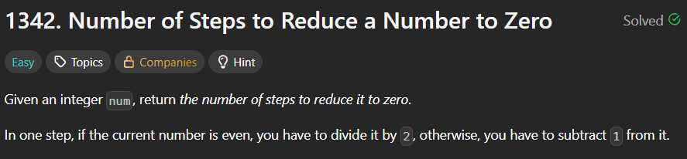
C Source Code –
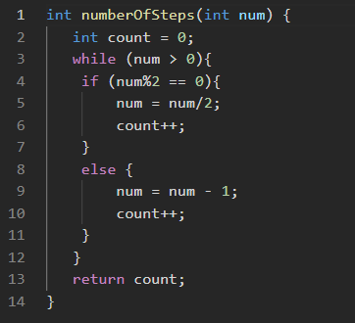
Submission –


