Platform – LeetCode
Question – 2169. Count Operations to Obtain Zero
Problem Statement Link - https://leetcode.com/problems/count-operations-to-obtain-zero/description/
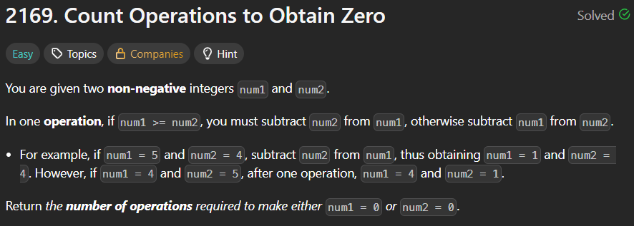
C Source Code –
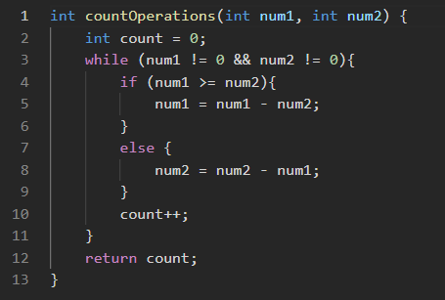
Submission –


