Platform – LeetCode
Question – 2235. Add Two Integers
Problem Statement Link - https://leetcode.com/problems/add-two-integers/description/
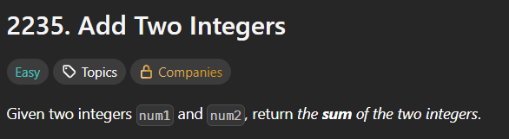
C Source Code –
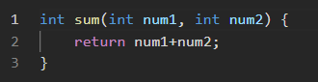
Submission –


