Platform – LeetCode
Question – 2413. Smallest Even Multiple
Problem Statement Link - https://leetcode.com/problems/smallest-even-multiple/description/
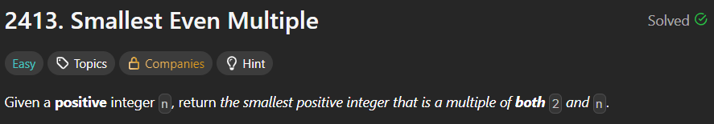
C Source Code –
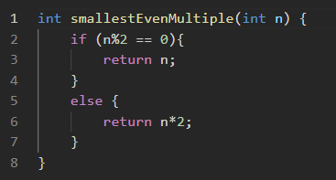

Submission –


