Platform – LeetCode
Question – 2651. Calculate Delayed Arrival Time
Problem Statement Link - https://leetcode.com/problems/calculate-delayed-arrival-time/description/
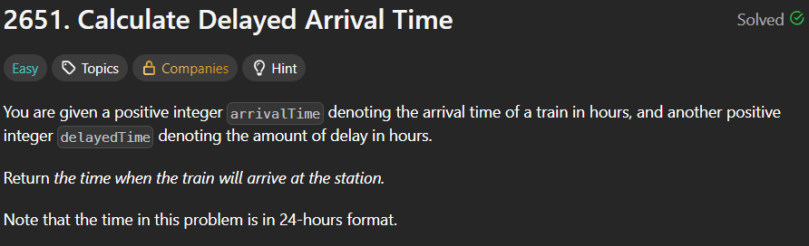
C Source Code –
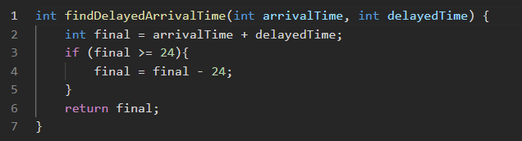
Submission –


