Platform – LeetCode
Question – 2739. Total Distance Traveled
Problem Statement Link - https://leetcode.com/problems/total-distance-traveled/description/
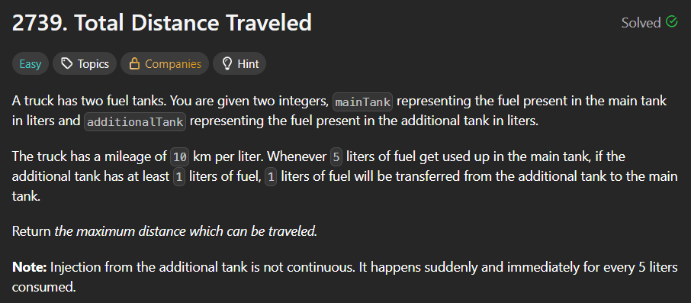
C Source Code –
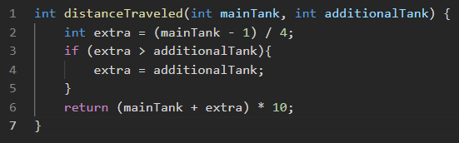
Submission –


