1. **Adding chair field into the course table.**

alter table course

add chair varchar(50);

**Inserts:**

insert into course (departmentName, courseName, courseNumber, description, units)

values ('Computer Engineering Computer Science', 'The Digital Information Age',

202, 'The introduction and use of common-place digital and

electronic devices and how this technology affects our society.

Topics include advances in 3D imaging, 3D printing,

Processors, Memory, Security and Privacy.', 3),

('Computer Engineering Computer Science', 'Database Fundamentals',

323, 'Fundamental topics on database management. Topics include

entity-relationship models, database design, data definition

language, the relational model, data manipulation language,

database application programming and normalization.', 3),

('English', 'Introduction to Creative Writing: Fiction',

205, 'Practice in the basic elements of fiction writing: character

sketch, plot development, description, and dialog.', 3);

**Course before update trigger:**

update course  
set chair = "David Brown"  
where departmentName = "Computer Engineering Computer Science"

The query was passed but the table was not updated.

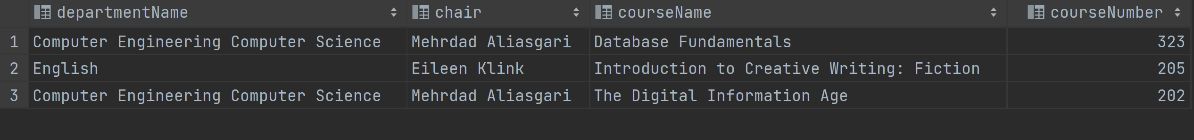

**After Trigger update:**

update department  
set chair = "David Brown"  
where deptname = "Computer Engineering Computer Science"

Trigger made sure the changes were updated. The chair in the computer Engineering and Computer Science was updated to ‘David Brown’.

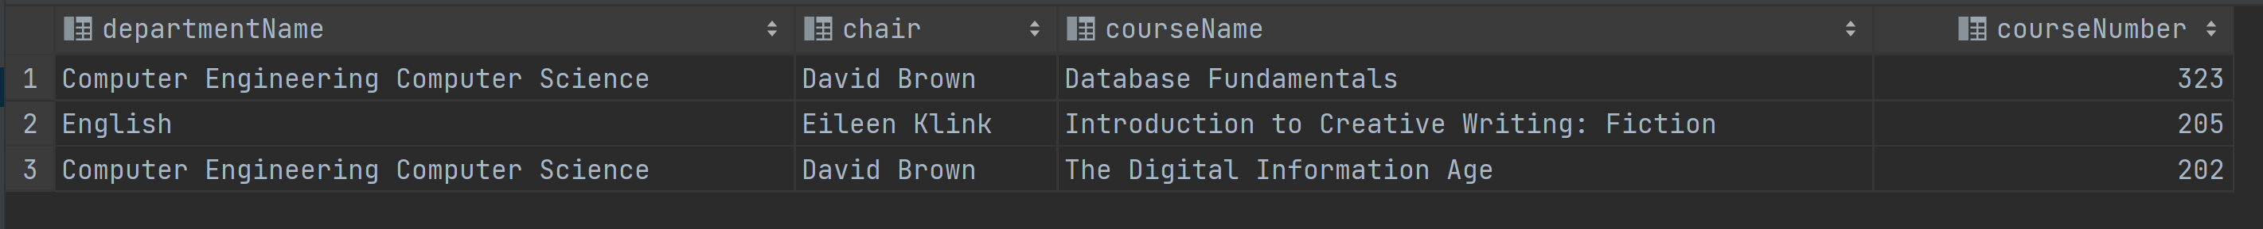

1. **Table For deptCourse:**

create table deptCourse(  
 college varchar(50) not null,  
 deptname varchar(50) not null,  
 chair varchar(50) not null,  
 officeBldg varchar(10) not null,  
 officeNo integer not null,  
 courseName varchar(50) not null,  
 courseNumber integer not null,  
 description varchar(2000) not null,  
 units int not null,  
 constraint deptCourse_pk primary key(deptname, courseNumber),  
 constraint deptCourse_ck unique(deptname,courseName));

**Inserts:**

The trigger stops the query and informs the user that the information they're inputting does not match the department information.

insert into deptCourse (college, deptname, chair, officeBldg, officeNo, courseName, courseNumber, description, units)  
values ('Engineering', 'Computer Engineering and Computer Science', 'David Brown', 'ECS', '303', 'Database Management', '323','SQL and databases', '3');



**Before trigger update:**

Checks to make sure that the department info can’t be changed since it will cause misalignment between the course info and the department info.

