Stock Market Analysis – Tata Consultancy Services (TCS)

Introduction
Stock market analysis plays a vital role in evaluating the financial performance of a company, identifying long-term trends, and supporting informed decision-making for various stakeholders. By examining historical financial data, analysts can assess key aspects such as growth patterns, profitability, liquidity, operational efficiency, and potential risk factors associated with a business. This type of analysis is widely used by investors, financial analysts, and corporate decision-makers to understand a company’s position in the market and its future potential.
In today’s data-driven environment, financial analysis has become increasingly important as companies operate in highly competitive and dynamic markets. Organizations are required not only to maintain profitability but also to ensure financial stability and sustainable growth. Through the use of financial ratios, statistical techniques, and visualization tools, large volumes of financial data can be transformed into meaningful insights that support strategic planning and decision-making.
This project focuses on the financial analysis of Tata Consultancy Services (TCS), a leading global IT services and consulting company, over a five-year period from 2021 to 2025. TCS is widely recognized for its strong market presence, consistent financial performance, and operational excellence. Analysing such a company provides valuable insights into how well-established organizations manage growth, profitability, and financial stability over time.
The primary objective of this analysis is to evaluate the financial health of TCS using key financial metrics such as revenue growth, profit margin, return on equity (ROE), liquidity ratios, and solvency indicators. In addition to ratio analysis, statistical techniques such as correlation and trend analysis are applied to understand relationships between variables and identify patterns in the data. Data visualization tools are also used to present the findings in a clear and intuitive manner.
Furthermore, this project aims to derive meaningful insights from the analysis and provide strategic recommendations tailored to different stakeholders. For investors, the analysis helps in assessing the company’s potential as an investment option. For managers, it provides insights into operational performance and areas of improvement. For executives and decision-makers, it supports long-term strategic planning and risk management.
Overall, this study provides a comprehensive view of TCS’s financial performance and highlights the importance of data-driven analysis in understanding and evaluating business performance.
Data Collection
The data used for this analysis was collected from Moneycontrol, a widely recognized and reliable financial data platform that provides comprehensive information on publicly listed companies. It is commonly used by investors, analysts, and researchers due to its accuracy, accessibility, and regularly updated financial records.
The dataset consists of financial information for Tata Consultancy Services (TCS) over a five-year period from 2021 to 2025. This time frame was selected to provide a balanced view of the company’s recent performance, allowing for meaningful trend analysis and comparison across multiple years. A multi-year dataset helps in identifying patterns, growth consistency, and potential fluctuations in financial performance.
The key parameters collected for the analysis include:
- Revenue – Represents the total income generated from business operations and is a primary indicator of growth.
- Net Profit – Reflects the company’s earnings after all expenses, taxes, and costs, indicating overall profitability.
- EBITDA – Measures operating performance by excluding non-operating expenses such as interest, taxes, depreciation, and amortization.
- Total Assets – Indicates the total resources owned by the company, used to assess financial strength and scale.
- Equity – Represents shareholders’ ownership in the company and is essential for calculating returns such as ROE.
- Current Assets and Current Liabilities – Used to evaluate short-term liquidity and the company’s ability to meet its immediate obligations.
These variables were selected because they collectively provide a comprehensive view of the company’s financial position, covering aspects of growth, profitability, liquidity, and solvency.
The collected data serves as the foundation for the entire analysis. It is used to compute financial ratios, perform year-on-year comparisons, and conduct statistical analysis such as correlation and trend evaluation. Accurate and relevant data is critical, as all subsequent insights and conclusions depend on the quality of this dataset.
However, the raw data obtained from the source was not in a directly usable format. It contained formatting inconsistencies such as commas in numerical values, variations in year representation, and structural issues that needed to be addressed. Therefore, a data cleaning and preparation phase was necessary before performing any analysis.
Overall, the data collection process ensured that all relevant financial variables were gathered systematically, providing a strong and reliable base for further analysis and interpretation.
Data Cleaning and Preparation
Data cleaning is a critical step in any data analysis process, as the accuracy and reliability of the final results depend heavily on the quality of the input data. Raw data obtained from external sources is often unstructured, inconsistent, or contains formatting issues, which can lead to incorrect calculations and misleading insights if not handled properly. Therefore, a systematic data cleaning and preparation process was carried out to ensure the dataset was accurate, consistent, and suitable for analysis.
The dataset collected required multiple preprocessing steps before it could be used effectively. The following steps were performed:
Removal of commas and formatting inconsistencies:
The numerical values in the raw dataset contained commas (e.g., 1,67,311), which prevented Excel from recognizing them as numeric values. These commas were removed to ensure that all figures could be used in calculations and formulas without errors.
Standardization of year format:
The year values were initially represented in formats such as “Mar 2021,” which were inconsistent and not ideal for analysis. These were standardized to a uniform format (e.g., 2021, 2022, etc.) to ensure consistency across the dataset and enable easier sorting, filtering, and visualization.
Conversion to numeric data types:
Some values were treated as text due to formatting issues. All financial figures were converted into proper numeric data types so that mathematical operations such as ratio calculations and statistical analysis could be performed accurately.
Removal of unnecessary or empty rows:
The dataset contained extra rows and irrelevant entries that did not contribute to the analysis. These were removed to improve clarity and ensure that only relevant data points were retained.
Structuring the dataset into tabular format:
The cleaned data was organized into a well-structured table with clearly defined columns such as Year, Revenue, Net Profit, EBITDA, Assets, Equity, Current Assets, and Current Liabilities. This tabular format made it easier to apply formulas, perform analysis, and create visualizations.
Ensuring consistency across all columns:
All columns were checked to ensure that values were aligned correctly with their respective years and categories. This step helped prevent errors in calculations and ensured data integrity throughout the analysis.
After completing these steps, the dataset became clean, structured, and analysis ready. This preparation ensured that all subsequent calculations, visualizations, and interpretations were based on accurate and reliable data. A well-cleaned dataset not only improves the quality of insights but also enhances the overall credibility of the analysis.
Financial Ratio Analysis & Financial Health
Financial ratio analysis is a fundamental tool used to evaluate a company’s financial performance and overall health. It helps in interpreting raw financial data by converting it into meaningful indicators that highlight strengths, weaknesses, and trends. In this project, ratio analysis was conducted to assess Tata Consultancy Services (TCS) across key dimensions, including liquidity, profitability, solvency, and efficiency.
By analysing these ratios over a five-year period, a comprehensive understanding of the company’s financial stability, operational effectiveness, and growth trajectory can be achieved.
4.1 Liquidity Ratios
Liquidity ratios measure a company’s ability to meet its short-term obligations using its current assets. These ratios are crucial for assessing the financial stability of a company in the short term and its ability to manage working capital efficiently.
The current ratio was calculated by dividing current assets by current liabilities for each year. The analysis shows that the current ratio for TCS remained consistently above 2 throughout the five-year period. This indicates that the company possesses more than twice the current assets required to cover its short-term liabilities.
Such a strong liquidity position reflects that TCS has sufficient resources to meet its immediate financial obligations without difficulty. It also suggests effective working capital management and a low risk of liquidity-related issues. A consistently high current ratio is generally considered a positive sign, as it enhances the company’s ability to withstand short-term financial stress and maintain smooth business operations.
4.2 Profitability Ratios
Profitability ratios evaluate a company’s ability to generate earnings relative to its revenue, assets, and equity. These ratios provide insights into operational efficiency and the company’s overall financial performance.
The profit margin, calculated as net profit divided by revenue, remained stable at approximately 18–19% over the five-year period. This consistency indicates that TCS has strong control over its costs and expenses, allowing it to maintain steady profitability despite changes in revenue. A stable profit margin also reflects the company’s ability to sustain its pricing strategies and manage operational efficiency effectively.
The Return on Equity (ROE) was another key metric analysed. ROE values were consistently high, exceeding 50% in recent years. This indicates that the company is highly efficient in utilizing shareholders’ equity to generate profits. A high ROE is often considered a strong indicator of effective management and efficient allocation of resources.
Overall, the profitability analysis suggests that TCS maintains a strong earnings position and demonstrates consistent financial performance over time.
4.3 Solvency Ratios
Solvency ratios assess a company’s ability to meet its long-term financial obligations and evaluate its overall financial risk.
The debt-to-equity ratio for TCS was found to be zero across all years, indicating that the company operates without any debt financing. This is a significant indicator of financial strength, as it eliminates risks associated with interest payments, debt servicing, and financial leverage. A zero-debt structure provides the company with greater financial flexibility and stability, especially during periods of economic uncertainty. It also reflects a conservative financial strategy, where the company relies primarily on internal funds and equity rather than external borrowing. This strong solvency position significantly reduces financial risk and enhances the company’s long-term sustainability.
4.4 Efficiency Ratios
Efficiency ratios measure how effectively a company utilizes its assets and resources to generate revenue and profit. Although detailed efficiency ratios such as asset turnover were not explicitly calculated in this analysis, indirect indicators such as high ROE and consistent profitability suggest that TCS operates efficiently. The company’s ability to generate strong returns on equity indicates optimal utilization of its financial resources. Additionally, the steady growth in revenue and net profit further supports the conclusion that the company is effectively managing its operations and resources. Efficient operations contribute to sustained profitability and long-term growth.
4.5 Year-on-Year Performance Analysis
A year-on-year (YoY) analysis was conducted to evaluate the company’s growth trends over the five-year period.
The analysis shows that revenue has consistently increased each year, indicating steady business expansion and strong demand for the company’s services. However, it was observed that the rate of revenue growth has gradually declined in recent years, suggesting a possible slowdown in growth momentum. Similarly, net profit has shown a consistent upward trend, reflecting sustained profitability and effective cost management. The alignment between revenue growth and profit growth further reinforces the company’s operational efficiency.
This YoY analysis highlights that while TCS continues to grow, it may be transitioning from a high-growth phase to a more stable and mature phase. Such a trend is common for large, well-established companies.
Overall Financial Health
Based on the ratio analysis and performance trends, TCS demonstrates strong financial health across all key dimensions. The company maintains high liquidity, consistent profitability, zero financial leverage, and efficient resource utilization. These factors collectively indicate that TCS is a financially stable organization with a low-risk profile and strong operational performance. Its ability to sustain growth while maintaining stability makes it a robust and reliable entity in the market.
Statistical & Predictive Analysis
Statistical and predictive analysis plays an important role in transforming raw financial data into meaningful insights. While financial ratios provide a snapshot of performance, statistical techniques help in identifying relationships between variables, understanding underlying patterns, and forecasting future trends.
In this project, statistical analysis was performed to examine the relationship between key financial variables and to assess the future growth potential of the company. Techniques such as correlation and regression analysis were used to derive insights from the data and support data-driven conclusions.
To enhance the analysis, conditional formatting (heat maps) was applied to key financial ratios such as revenue growth, profit margin, and return on equity. This color-coded representation helps in quickly identifying trends, highlighting strong performance areas, and detecting any potential weaknesses across the five-year period.
5.1 Correlation Analysis
Correlation analysis was conducted to measure the strength and direction of the relationship between revenue and net profit. This analysis helps in understanding how closely these two variables are related and whether changes in one variable are associated with changes in the other.
The results indicate a strong positive correlation between revenue and net profit. This means that as the company’s revenue increases, its net profit also increases in a similar direction. The strength of this relationship suggests that revenue growth is a key driver of profitability for the company.
This finding is significant because it highlights the efficiency of the company’s operations. A strong positive correlation implies that increases in revenue are not being offset by disproportionate increases in costs. Instead, the company is able to convert additional revenue into profit effectively, indicating strong cost control and operational efficiency.
Furthermore, this relationship also reflects the scalability of the business model. As TCS expands its operations and generates higher revenue, it is able to maintain or improve profitability, which is a desirable characteristic for long-term growth.
5.2 Regression Analysis
Regression analysis was used to examine trends in revenue over time and to make predictions about future performance. This technique helps in identifying the overall direction of growth and estimating future values based on historical data.
The regression results indicate a positive upward trend in revenue over the five-year period. This confirms that the company has experienced consistent growth, with revenue increasing year after year. The upward trend line suggests that TCS has a strong and stable growth trajectory.
Regression-based forecasting was performed using historical data to estimate future performance. Using linear regression techniques, the revenue and net profit for the next year (2026) were predicted.
The forecast indicates that both revenue and net profit are expected to continue their upward trend, reflecting sustained business growth. However, the growth rate is expected to remain moderate, consistent with the observed trend of gradual slowdown.
EPS forecasting was not conducted due to the unavailability of data related to the number of outstanding shares. Despite this, revenue and profit forecasts provide a reliable indication of the company’s future performance.
Based on this trend, it can be inferred that the company is likely to continue growing in the coming years. However, the analysis also reveals that the rate of growth has gradually slowed down in recent periods. While revenue is still increasing, the percentage growth year-on-year has decreased.
This observation suggests that TCS may be entering a mature phase of its business lifecycle. In this phase, companies typically experience stable but slower growth as they reach a larger market size and face increased competition. Growth becomes more incremental rather than exponential.
From a predictive standpoint, this indicates that while the company is expected to remain profitable and stable, it may need to explore new strategies—such as innovation, diversification, or expansion into new markets—to sustain higher growth rates in the future.
Overall Interpretation of Statistical Analysis
The statistical analysis reinforces the findings from the financial ratio analysis. The strong correlation between revenue and net profit confirms operational efficiency, while the regression analysis highlights a stable but gradually moderating growth trend.
Together, these insights provide a deeper understanding of the company’s performance and future outlook. They indicate that TCS is a well-managed organization with strong fundamentals but also highlight the importance of strategic planning to maintain growth momentum in the long term.

Visualization – Charts
Data visualization is an essential component of financial analysis, as it enables complex numerical data to be represented in a clear and visually appealing manner. Charts help in identifying patterns, trends, and relationships that may not be immediately evident from raw data alone. In this project, various charts were created using Power BI to analyse the financial performance of TCS over a five-year period.
These charts provide a graphical representation of key financial metrics and allow for easier interpretation of the company’s growth, profitability, and financial stability.
6.1 Revenue Trend Analysis
A line chart was used to visualize the revenue of the company from 2021 to 2025. The chart clearly shows a consistent upward trend in revenue over the years, indicating steady business growth and expansion.
However, a closer observation of the chart reveals that while revenue continues to increase, the rate of growth has gradually slowed in recent years. This suggests that the company may be transitioning from a rapid growth phase to a more stable and mature stage of development.
The revenue trend chart provides a clear understanding of the company’s growth trajectory and highlights both its strengths and emerging patterns.
6.2 Net Profit Trend Analysis
A line chart was also created to analyse the trend in net profit over the same period. The visualization shows a steady increase in net profit, reflecting the company’s ability to maintain profitability alongside revenue growth.
The alignment between revenue and net profit trends indicates that the company is effectively managing its costs and converting revenue into profit efficiently. This consistency is a positive indicator of strong financial performance.
6.3 Profitability Comparison Chart
A clustered column chart was used to compare profitability metrics such as net profit and EBITDA across different years. This visualization allows for a side-by-side comparison of key performance indicators.
The chart highlights that both net profit and EBITDA have shown consistent growth over time. It also reflects the company’s operational efficiency and its ability to sustain earnings before accounting for non-operational expenses.
Such comparative visualizations help in understanding how different financial components contribute to overall performance.
6.4 Ratio Analysis Charts
Charts were created to visualize key financial ratios, including profit margin, return on equity (ROE), and current ratio.

- The profit margin chart shows stability over time, indicating consistent cost management.
- The ROE chart highlights high and increasing returns, reflecting efficient utilization of equity.
- The current ratio chart demonstrates strong liquidity, with values consistently above 2.
These ratio-based charts simplify the interpretation of financial metrics and provide a quick overview of the company’s financial health.
6.5 Importance of Chart-Based Analysis
The use of charts significantly enhances the analytical process by:
- Making trends and patterns more visible
- Simplifying complex numerical data
- Enabling quick comparisons across years
- Improving clarity and understanding
Charts also improve the overall presentation of the report, making it more engaging and easier to interpret for readers.
6.6 Key Insights from Charts
The visual analysis of charts reveals the following key insights:
- Revenue and net profit have shown consistent growth over the years
- Profitability remains stable, indicating strong operational efficiency
- Financial ratios reflect strong liquidity and low financial risk
- Growth rate shows slight moderation, indicating a mature business phase.

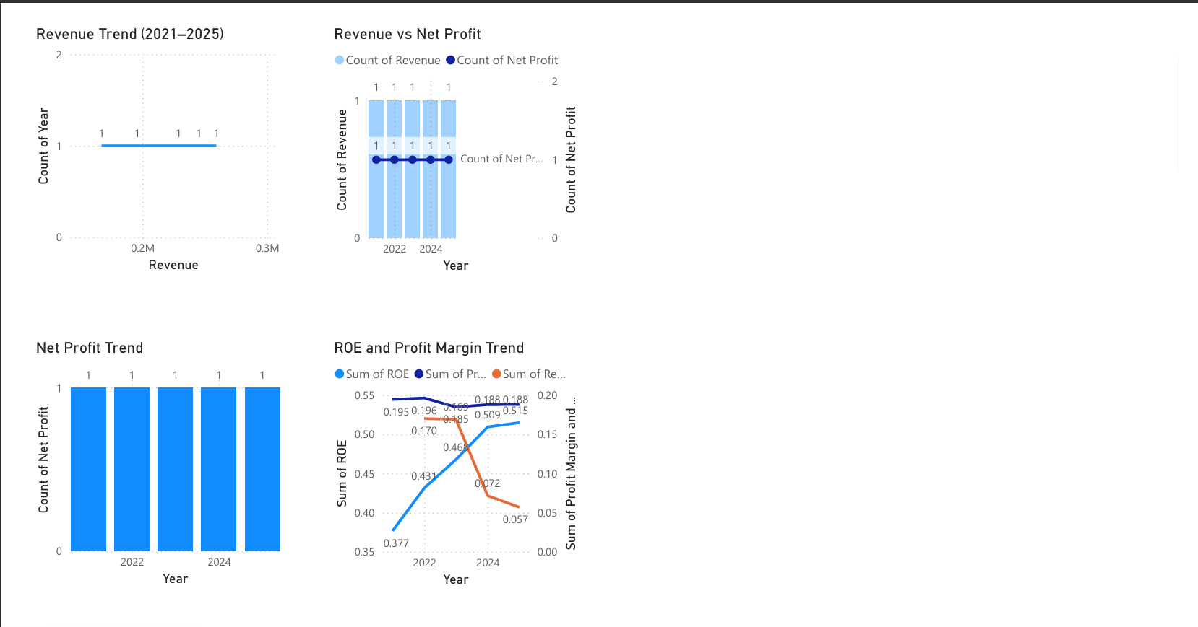

Visualization – Dashboard
In addition to individual charts, a comprehensive dashboard was developed using Power BI to provide a consolidated and interactive view of the company’s financial performance. While charts focus on specific aspects of the data, the dashboard integrates multiple key metrics into a single interface, enabling quick and efficient analysis.
The primary objective of the dashboard is to present key performance indicators (KPIs) in a clear and structured manner, allowing users to assess the company’s financial health at a glance. It serves as a decision-support tool for stakeholders by summarizing important insights in a visually appealing format.
7.1 Key Performance Indicators (KPIs)
The dashboard includes several important KPIs that represent the core financial performance of the company:
- Total Revenue:
Displays the overall revenue generated, reflecting the company’s scale and growth.
- Net Profit:
Indicates the company’s earnings after all expenses, providing insight into profitability.
- Return on Equity (ROE):
Highlights the efficiency with which the company utilizes shareholders’ funds to generate returns.
- Profit Margin:
Represents the percentage of revenue converted into profit, indicating operational efficiency.
These KPIs are presented in card format, making them easy to read and interpret.
7.2 Trend Analysis Using Dashboard
The dashboard incorporates trend indicators that allow users to observe how key metrics have evolved over time. By selecting a specific year (such as 2025), users can view the most recent performance while also understanding the historical trend.
This feature enhances the analytical capability of the dashboard by combining both current and historical perspectives, enabling better evaluation of performance.
7.3 Interactive Features
One of the key advantages of using Power BI is its interactivity. The dashboard allows users to:
- Filter data by year
- Analyse trends dynamically

- Focus on specific metrics of interest
These interactive elements make the dashboard more flexible and user-friendly compared to static charts.
7.4 Importance of Dashboard in Analysis
The dashboard plays a crucial role in summarizing complex data into a single, easy-to-understand view. It is particularly useful for:
- Quick decision-making
- Performance monitoring
- Identifying key trends and insights
- Communicating results effectively to stakeholders
By presenting all key metrics in one place, the dashboard enhances the overall efficiency of analysis.
7.5 Insights from Dashboard
The dashboard highlights several important insights:
- The company demonstrates strong and consistent financial performance
- Profitability and returns remain high across the years
- Liquidity is strong, indicating financial stability
- Overall financial health is robust with minimal risk
These insights align with the findings from ratio and statistical analysis, reinforcing the reliability of the results.
The dashboard is designed from an investor and CXO perspective, focusing on key financial indicators such as growth, profitability, and financial stability to support strategic decision-making.

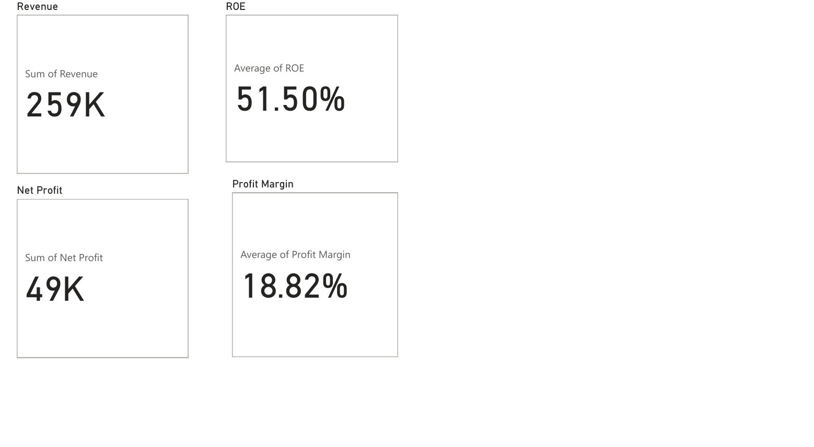

Comparison with Industry
A comparison with industry standards is an important aspect of financial analysis, as it provides context to a company’s performance. Evaluating a company in isolation may not give a complete picture; therefore, comparing its financial metrics with typical industry benchmarks helps in understanding its relative strengths and weaknesses.
In this analysis, Tata Consultancy Services (TCS) demonstrates strong performance when compared to general industry standards, particularly within the IT services sector. The company’s financial metrics indicate a well-balanced combination of growth, profitability, and financial stability.
One of the key areas where TCS stands out is profitability. The company maintains a stable profit margin of around 18–19%, which reflects efficient cost management and a strong operational framework. In comparison to many industry peers, maintaining such consistent margins over multiple years is a sign of a mature and well-managed business model.
Another significant strength is the company’s liquidity position. With a current ratio consistently above 2, TCS demonstrates a strong ability to meet its short-term obligations. This level of liquidity is generally considered healthy and indicates that the company has sufficient short-term assets to manage operational needs without financial stress.
The most notable differentiator, however, is TCS’s zero-debt structure. Unlike many companies in the industry that rely on debt financing for expansion and operations, TCS operates without any financial leverage. This significantly reduces financial risk and eliminates the burden of interest payments. As a result, the company enjoys greater financial flexibility and stability, especially during periods of economic uncertainty.
In terms of efficiency, the company’s high Return on Equity (ROE), exceeding 50%, indicates exceptional performance in generating returns for shareholders. This level of ROE is typically higher than industry averages and highlights the company’s ability to utilize its equity base effectively. It also reflects strong management practices and efficient allocation of resources.
Overall, when compared to industry benchmarks, TCS demonstrates superior performance across key financial dimensions. Its combination of stable profitability, strong liquidity, high efficiency, and low financial risk positions it as one of the more reliable and financially robust companies in its sector. This competitive advantage enhances its attractiveness to investors and strengthens its position in the market.

Red Flags & Risk Indicators
An important part of financial analysis involves identifying potential risks and warning signs that could impact a company’s future performance. These indicators, often referred to as “red flags,” help in assessing the stability and sustainability of a company’s operations. By analysing financial data over a period of time, it is possible to detect patterns that may signal underlying issues or emerging risks.
In the case of Tata Consultancy Services (TCS), the overall analysis indicates a low-risk financial profile, with no major red flags observed in the available data.
8.1 Overleveraging Risk
One of the most common financial risks for companies is overleveraging, which occurs when a company relies heavily on debt financing. High levels of debt can lead to increased financial burden due to interest payments and can reduce financial flexibility.
In this analysis, TCS does not exhibit any signs of overleveraging, as the company operates with zero debt. This completely eliminates risks associated with borrowing, such as interest obligations and repayment pressures. The absence of debt reflects a conservative and stable financial strategy, which enhances the company’s resilience during economic downturns.
8.2 Profitability Stability
Another potential red flag is declining or inconsistent profit margins, which may indicate inefficiencies or rising costs.
The analysis shows that TCS has maintained stable profit margins (around 18–19%) over the five-year period. This consistency suggests strong cost control, efficient operations, and the ability to sustain profitability even as revenue changes. The absence of significant fluctuations in margins indicates that the company is not facing major operational challenges.
8.3 Revenue Growth Trends
While the company demonstrates consistent revenue growth, a notable observation is the gradual slowdown in the growth rate over recent years. Although revenue continues to increase, the percentage growth year-on-year has declined.
This trend can be interpreted as a potential early warning sign. It may indicate factors such as:
- Increasing competition within the IT services industry
- Market saturation in existing segments
- Reduced pace of expansion compared to earlier years
While this does not represent an immediate risk, it highlights the need for the company to focus on innovation, diversification, and exploring new markets to sustain higher growth levels in the future.

8.4 Liquidity and Cash Flow Position
Liquidity issues and poor cash flow management are also considered major risk indicators for companies.
In this case, TCS maintains a strong liquidity position, as indicated by a consistently high current ratio. This suggests that the company has sufficient short-term assets to meet its obligations, reducing the risk of cash flow shortages or operational disruptions.
8.5 Market Dependency and External Factors
Another potential risk factor is dependency on specific markets or external economic conditions. Companies operating in global industries, such as IT services, may be affected by economic fluctuations, currency changes, or shifts in demand.
While this analysis does not include detailed external data, it is important to recognize that TCS, like other IT companies, may face risks related to global economic conditions and technological changes. However, its strong financial position helps mitigate these risks to a significant extent.
8.6 Overall Risk Assessment
Based on the analysis, TCS demonstrates a strong and stable financial position with minimal risk exposure. The absence of debt, stable profitability, and strong liquidity significantly reduce the likelihood of financial distress.
The only minor concern identified is the slowdown in revenue growth, which should be monitored over time. However, this does not currently pose a significant threat to the company’s overall performance.
Conclusion of Risk Analysis
Overall, TCS does not exhibit any major red flags in its financial data. The company’s conservative financial structure, consistent performance, and strong fundamentals make it a low-risk organization. With appropriate strategic actions to address slowing growth, TCS is well-positioned to maintain its stability and continue its performance in the future.

Strategic Insights & Recommendations
Based on the comprehensive analysis of financial ratios, statistical trends, visualizations, and risk indicators, several strategic insights can be derived regarding the performance and future direction of Tata Consultancy Services (TCS). These insights provide a deeper understanding of the company’s strengths, areas of improvement, and long-term potential.
The recommendations are tailored for different stakeholders, including investors, management, and top-level executives (CXOs), to support informed decision-making.
9.1 Strategic Insights
The analysis highlights that TCS is a financially strong and stable organization with consistent performance across key metrics. The company demonstrates steady revenue growth, stable profitability, high returns on equity, and a strong liquidity position. Its zero-debt structure further enhances its financial stability and reduces overall risk.
However, one notable observation is the gradual slowdown in the rate of revenue growth. While the company continues to grow, the declining growth rate suggests that it may be entering a mature phase of its business lifecycle. This indicates the need for strategic initiatives to sustain and accelerate future growth.
Additionally, the strong correlation between revenue and net profit reflects efficient cost management and a scalable business model. This suggests that the company is well-positioned to convert future growth opportunities into increased profitability.
9.2 Recommendations for Investors
From an investment perspective, TCS presents itself as a reliable and low-risk investment option. The company’s consistent financial performance, stable profit margins, and high return on equity make it attractive for long-term investors.
The absence of debt significantly reduces financial risk, making the company resilient during economic downturns. Investors seeking stable returns with relatively lower risk may consider TCS as a suitable addition to their portfolio.
However, investors should also be aware of the slowing growth rate and monitor the company’s future strategies to ensure continued growth and value creation.
9.3 Recommendations for Management
For the management team, the primary focus should be on revitalizing revenue growth. While the company has demonstrated strong performance, sustaining long-term growth will require proactive strategies.
Some key recommendations include:
- Exploring new markets: Expanding into emerging markets or untapped regions can create new revenue streams.
- Investing in innovation: Adopting new technologies such as artificial intelligence, cloud computing, and digital transformation can enhance service offerings and competitiveness.
- Diversifying services: Broadening the range of services can help reduce dependency on specific segments and increase overall revenue potential.
- Enhancing operational efficiency: Continued focus on cost management and process optimization will help maintain profitability.
By implementing these strategies, management can address the slowdown in growth and strengthen the company’s competitive position.
9.4 Recommendations for CXOs (Top Executives)
For CXOs, the focus should be on long-term strategic planning and sustainable growth. While the company’s current financial position is strong, maintaining this performance requires continuous adaptation to changing market conditions.
Key recommendations include:
- Maintaining operational excellence: Continue to optimize processes and ensure efficient resource utilization.
- Driving innovation and transformation: Invest in research and development to stay ahead of industry trends and technological advancements.
- Strategic expansion: Identify new business opportunities, partnerships, and acquisitions that can support long-term growth.
- Risk management: Continuously monitor external factors such as market competition, economic conditions, and technological disruptions.
CXOs play a crucial role in shaping the company’s future direction, and their strategic decisions will determine the company’s ability to sustain growth and maintain its competitive advantage.
9.5 Investment Decision & Risk Mitigation
Based on the overall analysis of financial performance, ratios, and trends, the following recommendations can be made:
Investment Decision:
TCS can be classified as a “Hold / Invest” opportunity. The company demonstrates strong financial stability, consistent profitability, and low risk due to its zero-debt structure. For long-term investors, it represents a reliable investment option. However, due to the slight slowdown in revenue growth, aggressive short-term growth expectations should be moderated.
Operational Improvements:
To sustain and enhance future growth, the company should focus on improving its revenue growth rate. This can be achieved by expanding into new markets, investing in emerging technologies, and diversifying its service offerings. Strengthening innovation capabilities and exploring digital transformation opportunities will be crucial.
Potential Risks and Mitigation:
The primary risk identified is the gradual slowdown in revenue growth, which may result from increased competition or market saturation. To mitigate this risk, the company should focus on innovation, strategic expansion, and continuous improvement in service quality. Additionally, monitoring global market trends and adapting to changing customer demands will help reduce long-term risks.
9.6 Overall Strategic Recommendation
Overall, TCS is in a strong financial position and well-equipped to sustain its performance in the long term. The key challenge lies in maintaining growth momentum in an increasingly competitive and mature market.
By focusing on innovation, expansion, and efficiency, the company can overcome this challenge and continue to deliver strong financial performance. The combination of strong fundamentals and strategic initiatives positions TCS as a stable and promising organization for the future.

Conclusion
The comprehensive financial analysis of Tata Consultancy Services (TCS) over the five-year period from 2021 to 2025 provides valuable insights into the company’s performance, stability, and future outlook. By combining financial ratio analysis, statistical techniques, and data visualization, a holistic understanding of the company’s financial health has been achieved.
The analysis indicates that TCS has demonstrated consistent growth in revenue and net profit, reflecting strong business performance and effective operational management. Despite a slight slowdown in the rate of growth in recent years, the company continues to expand steadily, highlighting its resilience and ability to sustain performance in a competitive market environment.
From a profitability perspective, the company maintains stable profit margins, which indicates strong cost control and operational efficiency. The consistently high Return on Equity (ROE) further demonstrates the company’s ability to generate significant returns for its shareholders, reflecting efficient utilization of resources and effective management practices.
In terms of financial stability, TCS exhibits a strong liquidity position, with current ratios consistently above the acceptable benchmark. This ensures that the company is well-equipped to meet its short-term obligations without financial stress. Additionally, the company’s zero-debt structure significantly reduces financial risk and enhances its long-term solvency, making it a financially secure organization.
The statistical analysis reinforces these findings by highlighting a strong positive relationship between revenue and net profit, indicating that growth in business operations directly contributes to increased profitability. The regression analysis further suggests a stable upward trend, although it also points to a gradual transition towards a more mature phase of growth.
The risk analysis confirms that TCS has a low-risk profile, with no major red flags identified. The only minor concern is the moderation in revenue growth, which may require strategic intervention to sustain long-term expansion. However, the company’s strong fundamentals and stable financial structure mitigate this concern to a large extent.
Overall, the findings of this project suggest that TCS is a financially robust, stable, and well-managed company. Its strong performance across key financial metrics, combined with low risk and high efficiency, makes it a reliable entity in the market.
In conclusion, TCS is well-positioned to maintain its performance in the future. With continued focus on innovation, strategic expansion, and operational efficiency, the company has the potential to sustain growth and strengthen its position in the industry. This analysis highlights the importance of data-driven decision-making in evaluating business performance and supports the view that TCS remains a strong and dependable organization for stakeholders.

