A
PROJECT REPORT
ON
“FOOD ORDERING SYSTEM”
IN PARTIAL FULFILMENT OF
BACHELOR OF COMPUTER APPLICATION
BY
MISS. ______________________________________
(Name of the Student)
BCA-III Sem-V
Roll No : ____________ PRN No : ____________________
(A.Y. 2026-27)
SUBMITTED TO
SAVITRIBAI PHULE PUNE UNIVERSITY, PUNE
THROUGH
Navsahyadri Education Society’s Group of Institutions
Faculty of Management – BCA


 | NAVSAHYADRI GROUP OF INSTITUTIONS  FACULTY OF MANAGEMENT – BCA  Approved by AICTE, New Delhi  Affiliated to Savitribai Phule Pune University  Address : Sr. No. 69, 70, 71 Naigaon, Nasarapur, Pune, Maharashtra – 412 213  Website : https://www.navsahyadri.edu.in | E-mail : director@navsahyadri.edu.in | 

Date: / /2027
CERTIFICATE
This is to certify that Miss. ________________________________________ , student of Navsahyadri Education Society’s Group of Institutions, Faculty of Management – BCA, Pune, of BCA-III Sem-V, Roll No. __________ , PRN No. ____________________ , has satisfactorily completed the project work titled “FOOD ORDERING SYSTEM” in partial fulfilment of the Bachelor of Computer Application course of Savitribai Phule Pune University for the academic year 2026-27.
The project has been carried out by her under my guidance and supervision. The work submitted in this report is her own work and has not been submitted earlier to this university or to any other university for the award of any degree.
______________________  Prof. ___________________  Project Guide | ______________________  Prof. ___________________  HOD - BCA | ______________________  Dr. ____________________  Director

Internal / External Examiners
1. ______________________________ 2. ______________________________

DECLARATION
I, the undersigned, hereby declare that the project report titled “FOOD ORDERING SYSTEM”, submitted to Savitribai Phule Pune University, Pune, in partial fulfilment of the requirement for the award of the degree of Bachelor of Computer Application, is my own work.
The Java desktop application described in this report, the MySQL database used by it and the diagrams, screenshots and test results given in this report are prepared by me during the project work. The information taken from books and websites has been properly listed in the References chapter.
This report has not been submitted earlier to this university or to any other university for the award of any degree, diploma or certificate.
Place : _______________
Date : _______________
______________________________
(Signature of the Student)
Miss. ______________________
BCA-III Sem-V

ACKNOWLEDGEMENT
It gives me great pleasure to present this project report on the “Food Ordering System”. Completing this project has helped me understand how a real desktop application is planned, designed, coded and tested, and I am thankful to everyone who helped me during this work.
First of all, I would like to thank my project guide Prof. ____________________ for the constant guidance and encouragement. Whenever I was stuck in the design of the database or in the Java code, the suggestions given by my guide helped me to solve the problem in a simple way.
I am also thankful to Prof. ____________________ , Head of the BCA Department, and to Dr. ____________________ , Director of Navsahyadri Education Society’s Group of Institutions, for providing the laboratory facilities and the environment needed to complete this project.
I would like to thank all the teaching and non-teaching staff of the BCA department for their help during the project work. I am also thankful to my friends and classmates who tested the application, pointed out mistakes in the screens and gave useful suggestions to improve it.
Finally, I am grateful to my parents for their support and patience throughout the duration of this project.

Miss. ______________________
BCA-III Sem-V

INDEX
Chapter | Content | Page No.
Chapter 1 | Introduction
1.1 | Introduction of the Project
1.2 | Problem Statement
1.3 | Objectives of the Proposed System
1.4 | Scope of the System
1.5 | Need for the System
Chapter 2 | System Analysis and Design
2.1 | Existing System
2.2 | Proposed System
2.3 | System Requirements
2.4 | Functional Requirements
2.5 | Non-Functional Requirements
2.6 | User and Stakeholder Description
2.7 | System Architecture
2.8 | Use Case Diagram
2.9 | Customer Use Case Diagram
2.10 | Admin Use Case Diagram
2.11 | Activity Diagram
2.12 | Sequence Diagram
2.13 | Class Diagram
2.14 | Component Diagram
2.15 | Deployment Diagram
2.16 | Database Design / ER Diagram
2.17 | Table Specifications
Chapter 3 | Implementation
3.1 | Development Environment
3.2 | Technologies Used
3.3 | Frontend Development using Java Swing
3.4 | Backend / Business Logic using Java
3.5 | Database Connectivity using JDBC
3.6 | Login Module
3.7 | Customer Module
3.8 | Category Module
3.9 | Food / Menu Module
3.10 | Cart Module
3.11 | Order Module
3.12 | Billing Module
3.13 | Admin Order Management
3.14 | Database Integration
3.15 | Module Integration
Chapter 4 | Testing
4.1 | Introduction to Testing
4.2 | Test Strategy
4.3 | Test Environment
4.4 | Test Cases
4.5 | Functional Testing
4.6 | Database Testing
4.7 | Validation Testing
4.8 | Test Results
4.9 | Screenshots of Successful Execution
Chapter 5 | Conclusion
5.1 | Conclusion
5.2 | Summary
5.3 | Benefits of the System
5.4 | Limitations of the System
5.5 | Future Enhancements
Chapter 6 | References
Chapter 7 | Appendices
7.1 | Database SQL Script
7.2 | Important Source Code
7.3 | Important Screenshots
Chapter 8 | Annexure – Progress Sheet

CHAPTER 1 : INTRODUCTION
1.1 Introduction of the Project
The Food Ordering System is a desktop application developed in Java that allows a customer to look at the food menu of a restaurant, select the items he or she wants, put them in a cart and place an order. Once the order is placed the application prepares a bill showing the ordered items, their quantity, their rate and the final amount. The restaurant administrator uses the same application to keep the menu up to date and to follow the orders received from the customers.
In many small restaurants and canteens the order is still taken on paper. The waiter writes the items on a slip, the total is calculated by hand and the same slip is used as a bill. This works when the number of customers is small, but it becomes slow and confusing when many orders come together. Slips get lost, a dish that is finished is still offered to the customer, and the total amount is sometimes calculated wrongly.
This project replaces that paper work with a simple computer application. The menu is stored in a MySQL database, so the price of a dish has to be changed only in one place. The customer selects the food from the screen, so there is no confusion about what was ordered. The total is calculated by the program, so a mistake in addition is not possible. Every order is saved in the database along with the items of that order, which means the restaurant can see the complete order history at any time.
The application has been written in Java using the Swing library for the screens and JDBC for talking to the MySQL database. It is a standalone desktop application, so it runs on a single computer in the college laboratory without needing a web server or an internet connection.
There are two types of users in the system. The administrator manages the food categories, the food items and the orders. The customer registers once, logs in with the registered email and password, browses the menu, places orders and sees the previous orders. When a user logs in, the role stored in the database decides which of the two dashboards will open.
1.2 Problem Statement
The problems listed below were noticed while studying how orders are handled in a small restaurant or canteen. The Food Ordering System has been developed to solve these problems.
1. Manual order taking is slow and can go wrong. When the order is written on a paper slip, the handwriting may not be clear and the slip may be lost between the counter and the kitchen. The customer then receives a wrong item or has to repeat the order.
2. The bill amount is calculated by hand. The waiter has to multiply the rate by the quantity for every item and then add all the amounts. When there are many items in one order a small mistake in addition causes a loss to the restaurant or an argument with the customer.
3. There is no proper record of old orders. Once the paper bill is given to the customer, the restaurant has no easy way to check what was ordered last week or which customer placed a particular order.
4. Menu and price changes are difficult to manage. If the price of a dish changes, the printed menu card has to be corrected everywhere. Till that is done the customer may be charged the old price.
5. Customers are not told when an item is not available. A dish that is finished for the day is still printed on the menu card, so the customer orders it and is told only later that it cannot be prepared.
6. The status of an order is not visible. The customer keeps asking whether the food is ready, because there is no place where the current stage of the order is written down.
7. Anybody can see and change the records. In a manual system the same register is used by everybody, so there is no way to separate what a customer may do from what the manager may do.
1.3 Objectives of the Proposed System
The main objective of this project is to build a simple and working desktop application that handles the complete food ordering process, from showing the menu to generating the bill. The detailed objectives are given below.
• To store the food categories, the food items and their prices in a MySQL database so that the menu is maintained at one place.
• To allow the administrator to add, view, update and delete categories and food items through simple forms.
• To allow a new customer to register and then log in with the registered email and password.
• To show only the food items which are marked as available, so that a customer never orders a dish that cannot be prepared.
• To let the customer search a dish by its name or see the dishes of one category only.
• To provide a shopping cart in which the customer can add items, change the quantity and remove an item before confirming the order.
• To calculate the subtotal of every line and the total amount of the order automatically, so that no calculation has to be done by hand.
• To save an order together with all its food items in the database and to give every order a unique order number.
• To generate a readable bill after the order is placed, showing the order number, the customer name, the ordered items and the final amount.
• To let the customer see the list of previous orders with the amount and the current status of each order.
• To let the administrator see all the orders and change the status of an order from Pending to Confirmed, Preparing, Ready or Delivered.
• To keep the admin work and the customer work separate by using a role for every user.
• To check the values entered in the forms and to show a clear message when something is wrong, instead of letting the program stop with an error.
1.4 Scope of the System
The scope of the project explains what the Food Ordering System does and what it does not do. It has been kept limited so that the whole application could be completed, tested and understood properly within the time given for the project.
Work included in the project
• Login and authentication : one login screen for both the admin and the customer, with the role of the user deciding which dashboard opens, and a logout option on every dashboard.
• Customer management : registration of a new customer, login with the registered email and password, and a profile screen where the customer can correct the name, mobile number, address and password.
• Category management : the admin can add a category, see the list of categories, update a category and delete a category which has no food items in it.
• Food and menu management : the admin can add a food item with its name, description, category, price and availability, and can update or delete it later.
• Food browsing : the customer sees the available food items in a table and can filter them by category or search them by name.
• Shopping cart : the customer can add an item with a quantity, change the quantity of a line, remove a line and see the subtotal of every line and the total amount.
• Order management : the order is saved in the orders table and every ordered item in the order_items table, a unique order number is generated and the order starts with the status Pending.
• Billing : a bill is displayed after the order is placed and the same bill can be opened again from the order history. The bill can also be saved as a text file.
• Order history : the customer sees the previous orders with the date, the total amount and the current status.
• Admin order management : the admin sees the orders of all customers, filters them by status, opens the details of an order and changes its status.
Work not included in the project
• Online payment through a payment gateway. The payment is recorded only as Cash on Delivery or Pay at Counter.
• A website or a mobile application. The project is a desktop application only.
• Home delivery tracking, delivery boy allocation or map based tracking.
• Table booking, kitchen display screens or printing on a thermal bill printer.
• Sending an email or an SMS to the customer.
• Detailed sales reports, graphs and business analytics.
1.5 Need for the System
A small restaurant does not need a costly commercial software package, but it does need something better than a paper register. The Food Ordering System fills this gap. It runs on an ordinary computer, needs only Java and MySQL, and can be used after a few minutes of practice.
The first need is accuracy. Because the customer picks the item from the screen and the program multiplies the rate by the quantity, the bill amount is always correct. The rate of an item is copied into the order_items table at the time of ordering, so an old bill continues to show the price that was actually charged even if the menu price is changed afterwards.
The second need is speed. Adding a dish to the cart takes one click and placing an order takes one more. The total is shown immediately, so the customer does not have to wait while somebody adds up the amounts.
The third need is record keeping and control over the menu. Every order is stored permanently together with the customer who placed it and the items in it, so the restaurant can look at the orders of any day. The admin can also mark a dish that is finished as not available, and it disappears from the customer menu at once without deleting the dish and without disturbing the old orders which contain it.
Finally, the system is also needed as a learning exercise. Building it required designing a small relational database, writing Java classes for each part of the work, connecting Java with MySQL through JDBC and testing the finished application. These are exactly the skills expected from a BCA student at the end of the course.

CHAPTER 2 : SYSTEM ANALYSIS AND DESIGN
2.1 Existing System
The existing system in most small restaurants and canteens is a manual system. The customer looks at a printed menu card, tells the order to the waiter and the waiter writes it on a paper slip. One copy of the slip goes to the kitchen and the other copy is used at the counter to prepare the bill. The amount of every item is calculated by multiplying the rate by the quantity, and all the amounts are added by hand.
This method works, but it has several weaknesses. Since everything is written by hand, the writing may not be clear and the kitchen may prepare a wrong dish. The slip is a small piece of paper and it can be lost. If the customer asks for the bill of an order placed a week ago, the restaurant has no way of finding it.
Price changes are another difficulty. When the rate of a dish changes, all the printed menu cards have to be replaced, and till that is done the customer sees the old price. In the same way, when a dish is finished for the day there is no way to remove it from the menu card, so the customer orders it and is disappointed later.
Disadvantages of the existing system
• Orders are written by hand, so mistakes happen.
• The bill amount is calculated manually and can be wrong.
• Paper slips are easily lost and cannot be searched later.
• There is no record of the previous orders of a customer.
• Changing a price means reprinting the menu card, and an item that is finished still appears on it.
• The current stage of an order is not written anywhere, and there is no difference between what a customer may do and what the manager may do.
2.2 Proposed System
The proposed system is the Food Ordering System, a Java desktop application connected to a MySQL database. The complete menu is kept in the database, the customer selects the food from the screen and the program does all the calculation and the record keeping.
There are two kinds of users. The administrator manages the food categories, the food items and the orders, while the customer registers once, logs in and then browses the menu, fills the cart, places orders and sees the old orders. Both use the same login screen, and the role stored in the users table decides which dashboard is opened.
When the customer places an order, the application saves one row in the orders table and one row in the order_items table for every food item in the cart. Both these inserts are done inside a single transaction, so either the whole order is saved or nothing is saved. A unique order number such as ORD20260904181231 is generated from the date and time, and the bill is displayed immediately.
The admin can change the status of an order as the work goes on, from Pending to Confirmed, then Preparing, Ready and finally Delivered, and the customer sees this status in the My Orders screen without asking anybody.
Advantages of the proposed system
• The total amount is calculated by the program, so the bill is always correct.
• Every order and every ordered item is stored permanently in the database, and a customer can see all previous orders with the amount and the status.
• The price of a dish is changed at one place and takes effect immediately.
• An item that is finished is marked as not available and disappears from the customer menu, but the old orders containing it are not disturbed.
• The admin work and the customer work are separated by the role column.
• The values typed in the forms are checked, so wrong data does not reach the database.
• The application runs on a single laboratory computer and needs no internet connection.
2.3 System Requirements
2.3.1 Hardware Requirements
Component | Minimum Requirement | Recommended
Processor | Intel Core i3 or equivalent | Intel Core i5 or higher
RAM | 4 GB | 8 GB
Hard Disk | 20 GB free space | 50 GB free space
Display | 1366 x 768 resolution | 1920 x 1080 resolution
2.3.2 Software Requirements
Software | Version / Details | Purpose
Operating System | Windows 10 / 11 or Linux | To run the application
JDK | Java SE Development Kit 21 | To compile and run the Java code
IDE | Apache NetBeans, IntelliJ IDEA or Eclipse | To write and open the project
Database | MySQL Server 8.0 | To store all the data
JDBC Driver | mysql-connector-j 8.4.0 | To connect Java with MySQL
Database Tool | MySQL Workbench or MySQL Command Line Client | To create the database using the SQL script
Build Tool | Apache Maven 3.9 (optional) | To build the runnable jar file
2.4 Functional Requirements
The functional requirements describe what the Food Ordering System must actually do. Every requirement written below is implemented in the application.
ID | Requirement | Description
FR-1 | User Login | The system shall check the email and password entered on the login screen against the users table and shall open the admin dashboard or the customer dashboard according to the role of the user, or display “Invalid email or password” when no row matches.
FR-3 | Customer Registration | The system shall allow a new customer to register with full name, email, password, mobile number and address, shall not allow two accounts with the same email, and shall let a logged in customer change these details on the My Profile screen.
FR-5 | Category Management | The system shall allow the admin to add a category, view all categories, update a category and delete a category which has no food items linked to it.
FR-6 | Food Item Management | The system shall allow the admin to add, view, update and delete food items with name, description, category, price and availability.
FR-7 | Menu Display | The system shall display to the customer only those food items whose availability is Yes, with the name, description, category and price.
FR-8 | Search and Filter | The system shall allow the customer to see the items of one selected category and to search items by a part of the food name.
FR-9 | Add to Cart | The system shall allow the customer to add a selected food item to the cart with a quantity, and shall increase the quantity if the same item is added again.
FR-10 | Cart Management | The system shall allow the customer to change the quantity of a cart line, to remove a line, and shall show the subtotal of every line.
FR-11 | Total Calculation | The system shall calculate the subtotal of each line as rate multiplied by quantity and the total amount as the sum of all subtotals.
FR-12 | Place Order | The system shall save the order in the orders table and every cart line in the order_items table when the customer confirms the order.
FR-13 | Order Number | The system shall generate a unique order number for every order using the date and the time of ordering.
FR-14 | Bill Generation | The system shall display a bill containing the order number, order date, customer name, payment mode, ordered items with rate and quantity and the total amount, and shall allow the bill to be saved as a text file.
FR-16 | Order History | The system shall show a customer the list of his or her previous orders with the date, total amount and current status, newest order first.
FR-17 | Admin Order List | The system shall show the admin all the orders of all customers along with the name of the customer who placed each order, and shall allow the list to be filtered by status.
FR-18 | Order Status Update | The system shall allow the admin to change the status of an order to Pending, Confirmed, Preparing, Ready or Delivered.
FR-20 | Input Validation | The system shall check the values entered in every form and display a clear message when a value is empty, in the wrong format or out of range.
FR-21 | Logout | The system shall allow both the admin and the customer to log out and shall return to the login screen, clearing the cart of the customer.
2.5 Non-Functional Requirements
Non-functional requirements describe the qualities the system should have rather than the work it should do.
Quality | Description
Usability | Every screen has a title bar, clearly labelled boxes and buttons with meaningful names such as Add, Update, Delete and Place Order. All screens use the same colours and fonts, so a new user can understand a screen without training.
Correctness | The amounts shown on the screen and on the bill are calculated by the program from the rate and the quantity, so they are always correct. The rate is copied into order_items at the time of ordering, so an old bill never changes.
Reliability | An order and its items are written in one transaction. If any insert fails, the whole order is rolled back so that a half saved order is never left in the database.
Data Integrity | Primary keys and foreign keys are defined in the database. A category that still has food items cannot be deleted and a food item that is part of an old order cannot be deleted, so the tables always stay consistent.
Security | A user can use the application only after a successful login, and the role column decides which screens are available. Every query uses a PreparedStatement, so values typed by the user are sent as parameters and cannot change the meaning of the SQL statement.
Performance | The database is small and every query works on indexed primary keys, so a screen loads in about a second on an ordinary laboratory computer.
Maintainability | The code is divided into packages for the screens, the DAO classes, the model classes and the database connection. To change the database user name or password only DBConnection.java has to be edited.
Portability | The application is written in plain Java, so the same jar file runs on Windows and on Linux as long as Java 21 and MySQL are installed. It also works without an internet connection, because the program and the database run on the same computer.
2.6 User and Stakeholder Description
The table below lists the people connected with the system and the work each of them does in it.
User / Stakeholder | Description | Work done in the system
Admin | A single account created directly in the users table by the SQL script. Its role column has the value ADMIN. It represents the restaurant owner or manager. | Manages categories and food items, sets the availability of a dish, views all orders, filters them by status, opens the order details and updates the order status.
Customer | Any number of accounts created through the registration screen. The role column has the value CUSTOMER. | Registers, logs in, browses and searches the menu, adds items to the cart, changes quantities, places orders, views the bill, sees the order history and updates the profile.
Project Guide / Examiner | The college. | Reviews the design, the code and the working of the finished application.
2.7 System Architecture
The Food Ordering System follows a simple three layer architecture. Each layer has its own job and talks only to the layer below it. This keeps the project organised and makes it easy to find where a particular piece of work is done.
The presentation layer contains the Java Swing screens in the package com.foodordering.ui. These classes only display information and collect what the user types. They do not contain any SQL statement.
The business logic layer contains the DAO classes in com.foodordering.dao and the model classes in com.foodordering.model. The DAO classes contain all the SQL statements and the model classes carry the data between the layers. The Validator class in com.foodordering.util checks the values entered by the user.
The data access layer contains the DBConnection class in com.foodordering.db and the MySQL JDBC driver. DBConnection is the only class that knows the database URL, the user name and the password.
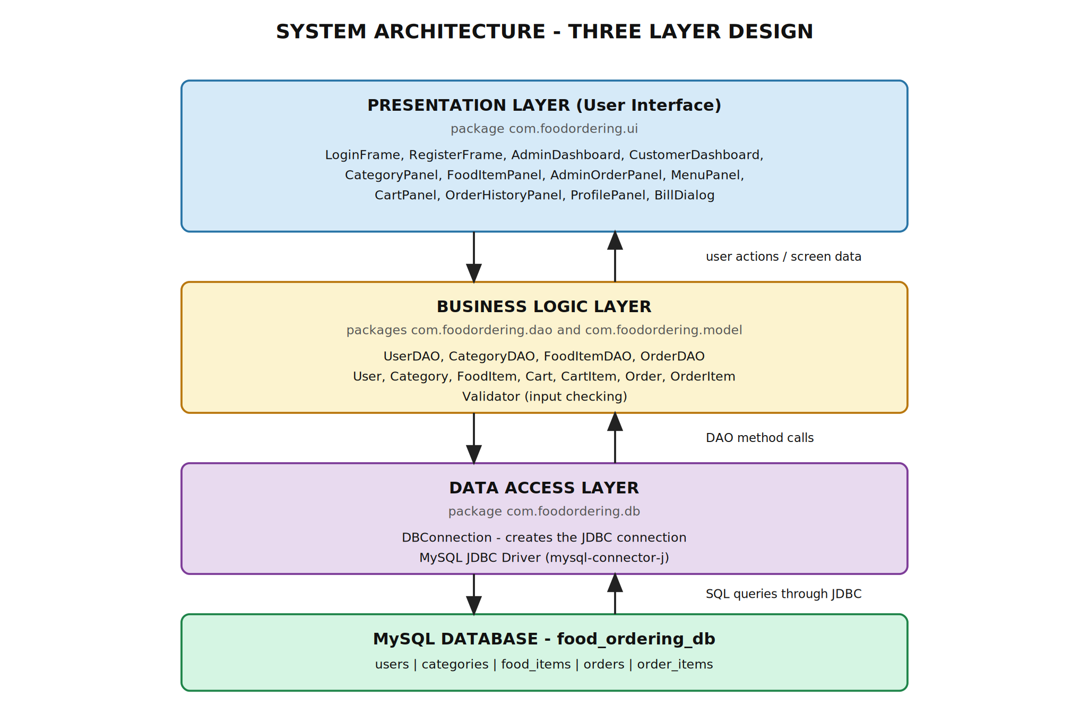
Fig. 2.1 Three Layer System Architecture
2.8 Use Case Diagram
The use case diagram shows the two actors of the system, Customer and Admin, and the work each of them can do. Login and Logout are used by both actors. The «extend» relationship from Login to Invalid Login shows the error message which appears when the credentials are wrong, and the «include» relationship from Place Order to Generate Bill shows that a bill is always produced when an order is placed.
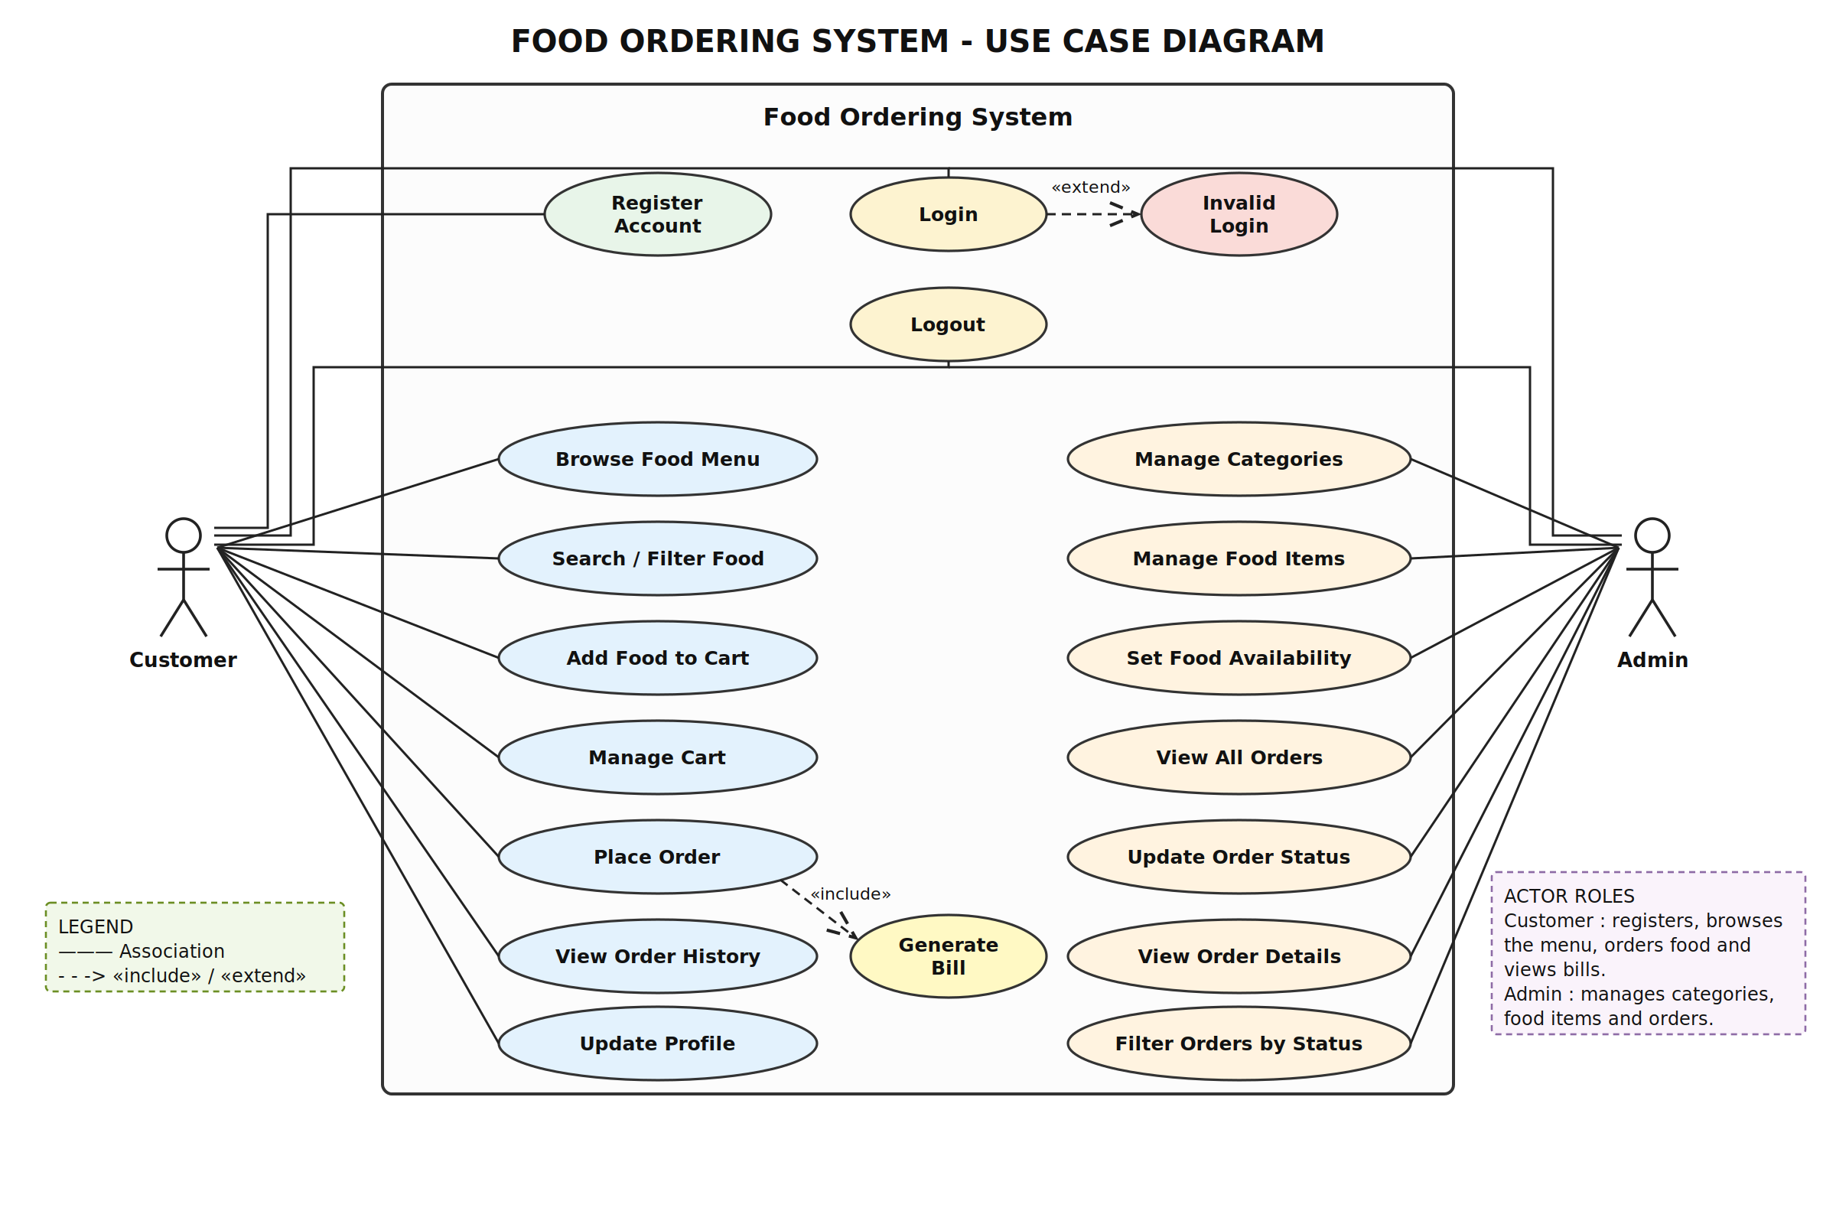
Fig. 2.2 Use Case Diagram of the Food Ordering System
2.9 Customer Use Case Diagram
This diagram shows only the work of a customer. A new customer first registers and then logs in. After logging in the customer can browse the menu, search a dish by name, see the dishes of one category, add items to the cart, change the quantity or remove an item, place the order and finally log out. Placing an order always includes generating the bill.
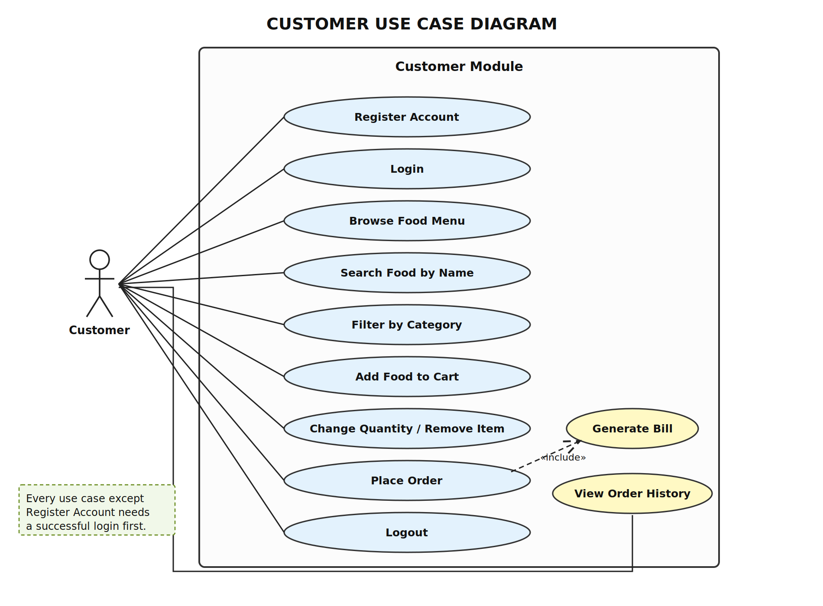
Fig. 2.3 Customer Use Case Diagram
2.10 Admin Use Case Diagram
This diagram shows only the work of the administrator. The admin logs in with the account created by the SQL script, manages the categories and the food items, marks a dish as available or not available, sees the orders of all customers and updates the status of an order.
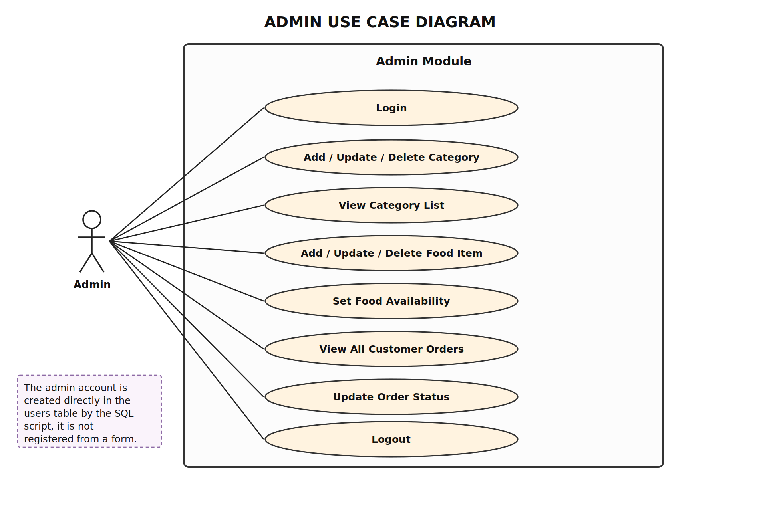
Fig. 2.4 Admin Use Case Diagram
2.11 Activity Diagram
An activity diagram shows the flow of work step by step, including the decisions taken on the way. The diagram below shows the complete flow followed by a customer while placing an order, which is the main activity of the system.
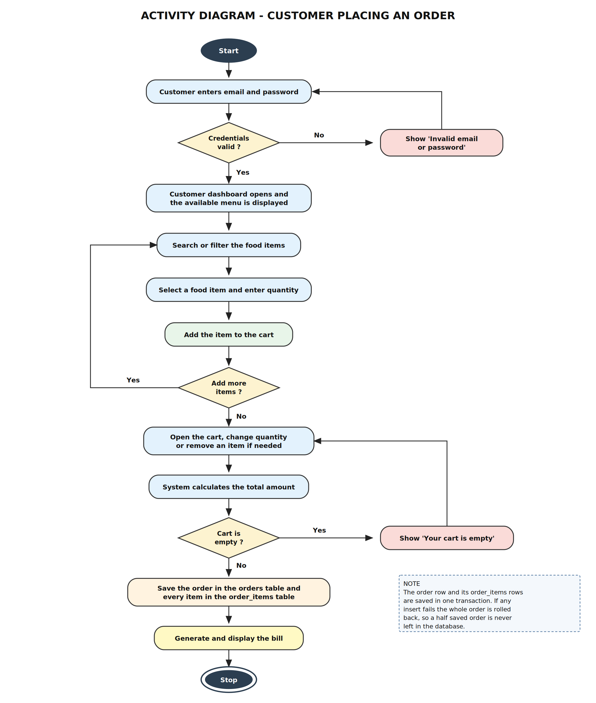
Fig. 2.5 Activity Diagram - Customer Placing an Order
The customer first logs in. If the credentials are wrong the error message is shown and the login screen appears again. After a successful login the available menu is displayed. The customer searches or filters the items, selects one, enters the quantity and adds it to the cart, and repeats this for as many items as required. In the cart the quantity can be changed or a line removed, and the total is recalculated every time. When Place Order is clicked the program checks that the cart is not empty, saves the order and its items in the database and shows the bill.
2.12 Sequence Diagram
A sequence diagram shows the messages passed between the objects of the system in the order in which they happen. The first diagram shows the login process and the second one shows the placing of an order, which is the most important operation of this project.
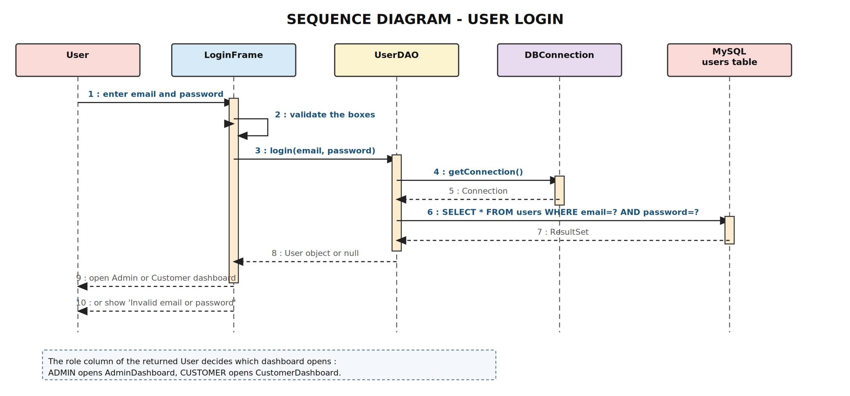
Fig. 2.6 Sequence Diagram - User Login
The user types the email and the password in LoginFrame. LoginFrame first checks that the boxes are not empty and that the email is in the correct format, and then calls the login method of UserDAO. UserDAO takes a connection from DBConnection, runs a SELECT statement on the users table and returns a User object if a matching row is found, or null if no row matches. LoginFrame then opens the admin dashboard or the customer dashboard depending on the role, or shows the error message.
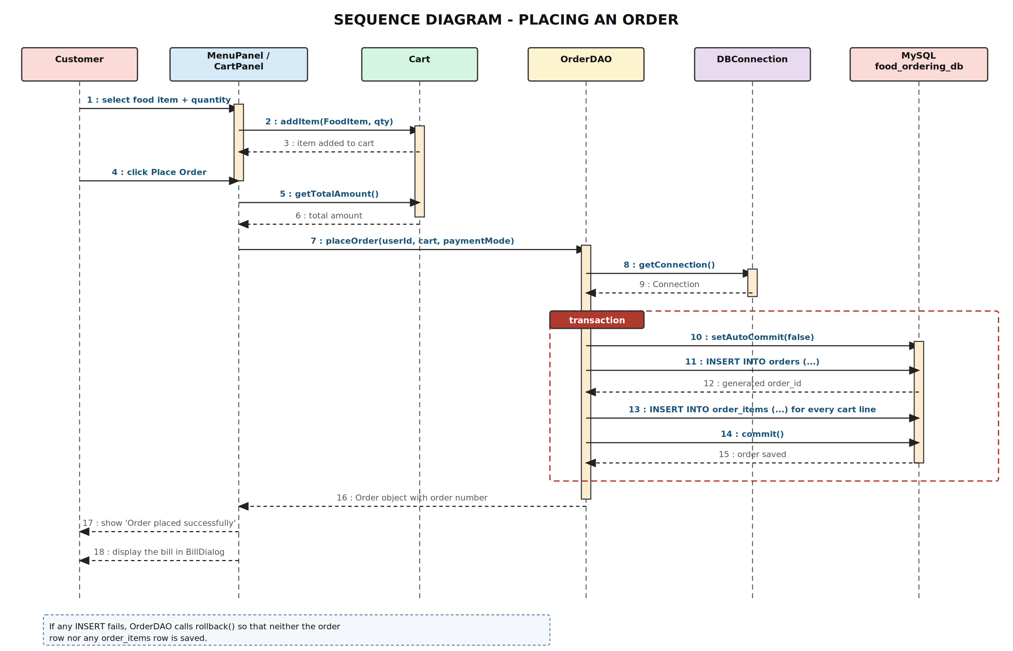
Fig. 2.7 Sequence Diagram - Placing an Order
The customer adds items to the Cart object through MenuPanel. When Place Order is clicked, CartPanel asks the Cart for the total amount and then calls the placeOrder method of OrderDAO. OrderDAO takes a connection, switches off auto commit, inserts one row in the orders table, reads back the generated order_id, inserts one row in order_items for every cart line and finally commits the transaction. The saved Order object is returned to CartPanel, which shows the confirmation message and opens BillDialog.
2.13 Class Diagram
The class diagram shows the main classes of the project with their fields and methods and the relationships between them. The model classes at the top carry the data, the DAO classes at the bottom contain the SQL statements and DBConnection creates the JDBC connection used by all the DAO classes.
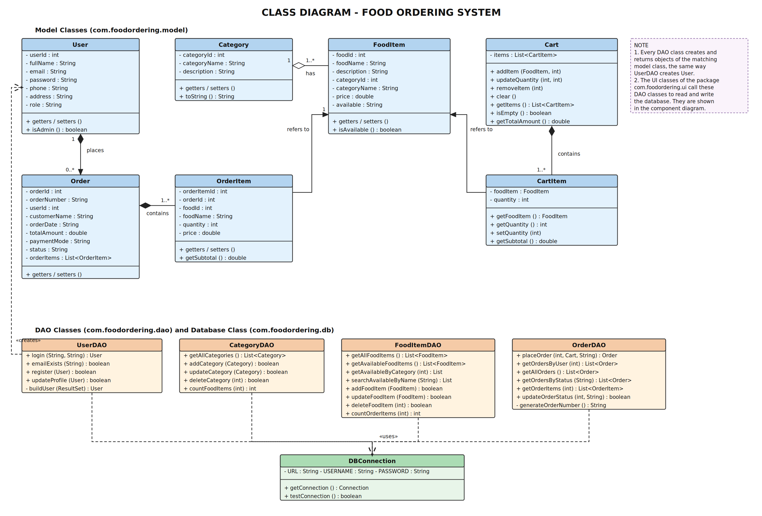
Fig. 2.8 Class Diagram of the Food Ordering System
Relationships shown in the diagram
• One Category has many FoodItems. Every food item belongs to exactly one category.
• One User places many Orders. An order always belongs to the customer who placed it.
• One Order contains many OrderItems. Each OrderItem is one line of the bill.
• A CartItem and an OrderItem refer to one FoodItem. CartItem holds the FoodItem object while the customer is logged in, and OrderItem stores the food_id together with a copy of the rate at the time of ordering.
2.14 Component Diagram
The component diagram shows the actual classes of the project arranged in the three layers and the way they depend on each other. The screens of the presentation layer call the methods of the DAO classes, the DAO classes ask DBConnection for a connection, and DBConnection uses the MySQL JDBC driver to reach the database.
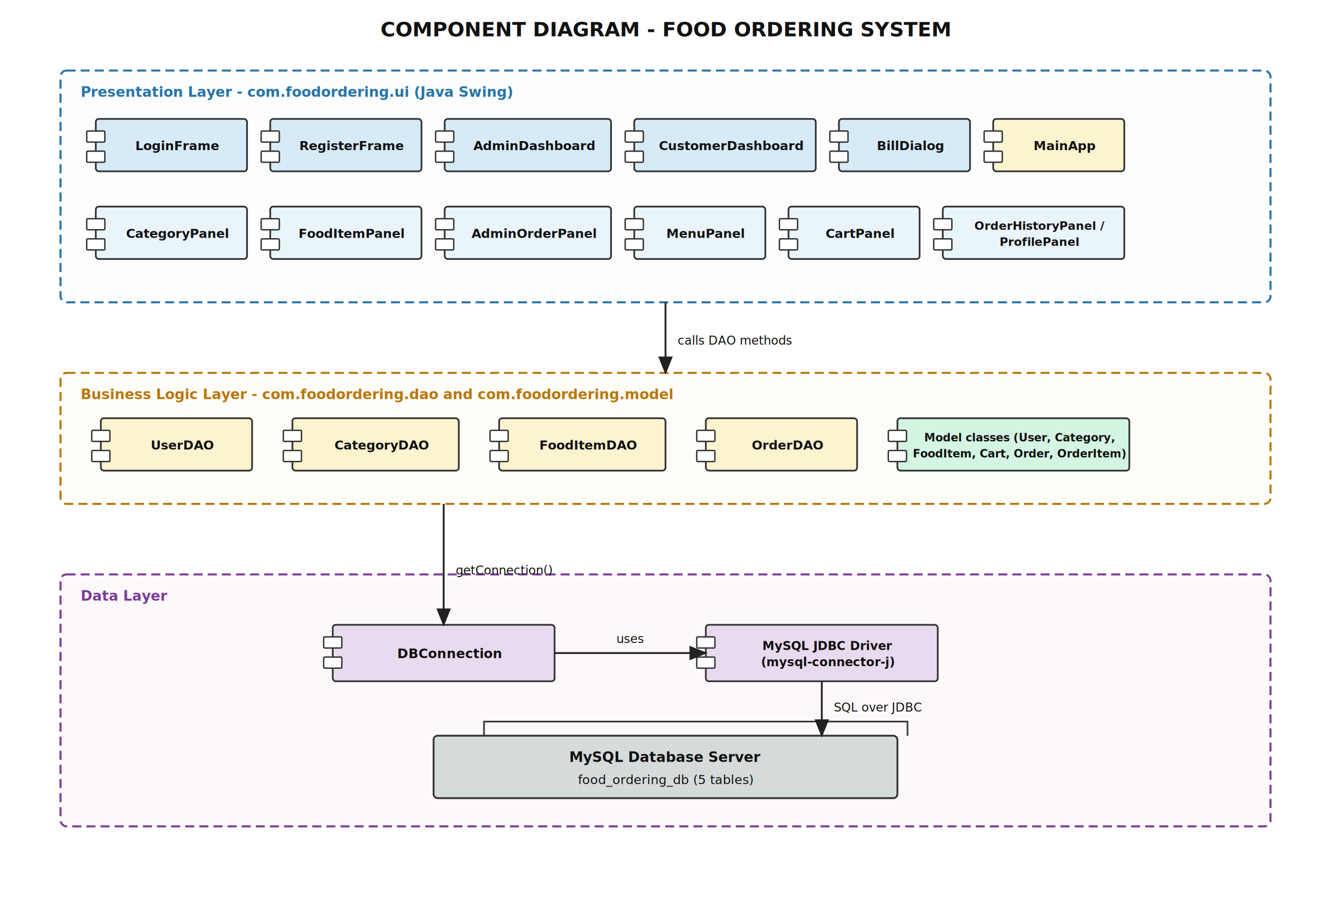
Fig. 2.9 Component Diagram
2.15 Deployment Diagram
The deployment diagram shows where the parts of the system are installed. In the college laboratory the Swing application and the MySQL server run on the same computer, so the JDBC URL used in DBConnection.java points to localhost on port 3306. If the database is kept on a separate machine, only the host name in that URL has to be changed.
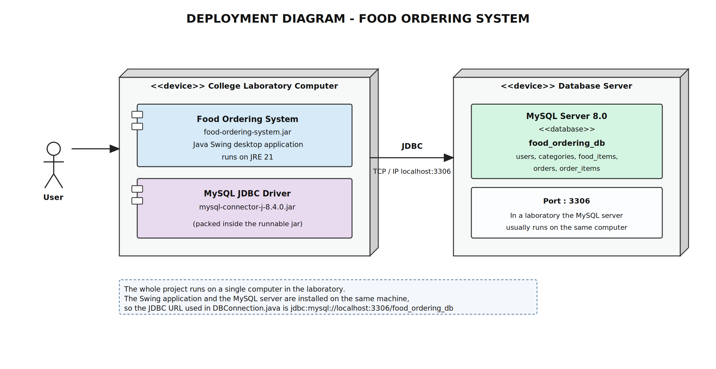
Fig. 2.10 Deployment Diagram
2.16 Database Design / ER Diagram
The database is named food_ordering_db and contains exactly five tables. No extra table has been created, because every piece of information needed by the application fits into these five tables. The ER diagram below shows the tables, their columns and the relationships between them.
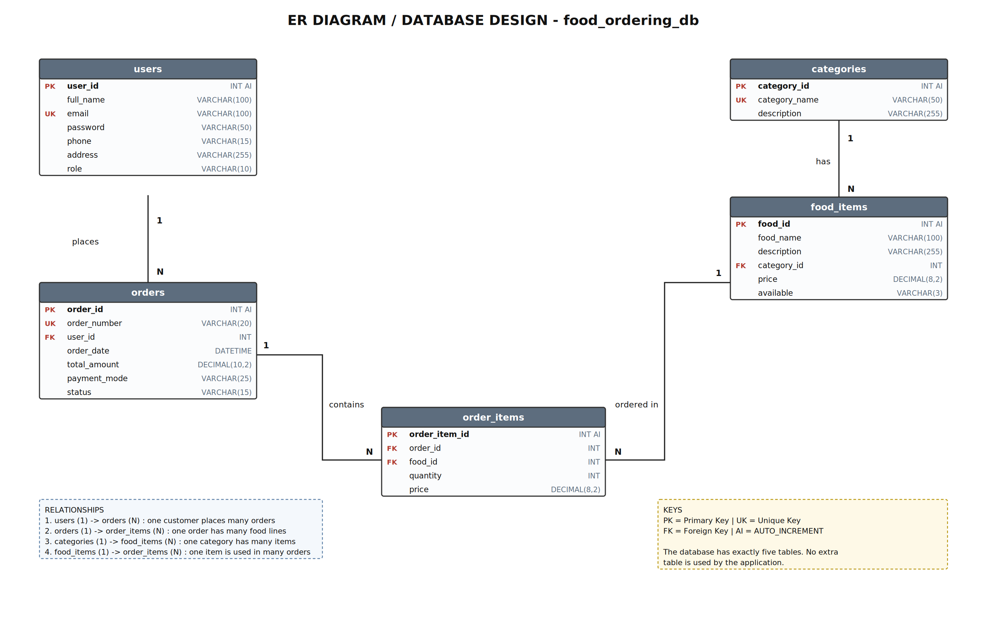
Fig. 2.11 ER Diagram of food_ordering_db
Explanation of the relationships
• users to orders (one to many) : the orders table has a foreign key user_id which points to users(user_id). One customer can place many orders but one order belongs to one customer.
• orders to order_items (one to many) : the order_items table has a foreign key order_id which points to orders(order_id). One order contains as many rows in order_items as there were lines in the cart.
• categories to food_items (one to many) : the food_items table has a foreign key category_id which points to categories(category_id). One category can have many dishes.
• food_items to order_items (one to many) : the order_items table has a foreign key food_id which points to food_items(food_id). The same dish can appear in many different orders.
The users table keeps both the admin and the customers. Keeping them in one table avoids a second table with almost the same columns, and the role column with the value ADMIN or CUSTOMER is enough to tell them apart. The price column in order_items may look like a repetition of the price in food_items, but it is needed because it stores the rate that was actually charged. If the admin changes the menu price later, the old bills still show the correct amount.
2.17 Table Specifications
This section describes each of the five tables of the database food_ordering_db. For every table the purpose, the primary key and the complete list of columns with their data types and constraints are given. These specifications match exactly the SQL script given in Appendix 7.1.
1. Table Name : users
Table Description : Stores the login details of the administrator and of every registered customer.
Primary Key : user_id
Sr No | Field Name | Data Type | Size | Constraint | Description
1 | user_id | INT | 11 | PRIMARY KEY, AUTO_INCREMENT | Unique id of the user
2 | full_name | VARCHAR | 100 | NOT NULL | Full name of the user
3 | email | VARCHAR | 100 | NOT NULL, UNIQUE | Email used to log in, cannot repeat
4 | password | VARCHAR | 50 | NOT NULL | Password used to log in
5 | phone | VARCHAR | 15 | - | Ten digit mobile number
6 | address | VARCHAR | 255 | - | Delivery address
7 | role | VARCHAR | 10 | NOT NULL, DEFAULT 'CUSTOMER' | ADMIN or CUSTOMER, decides the dashboard
Note : the admin row is inserted by the SQL script. The registration screen always inserts the role CUSTOMER, so a customer cannot create an admin account.
2. Table Name : categories
Table Description : Stores the food categories such as Starters, Main Course, Beverages and Desserts.
Primary Key : category_id
Sr No | Field Name | Data Type | Size | Constraint | Description
1 | category_id | INT | 11 | PRIMARY KEY, AUTO_INCREMENT | Unique id of the category
2 | category_name | VARCHAR | 50 | NOT NULL, UNIQUE | Category name, cannot repeat
3 | description | VARCHAR | 255 | - | Short description
3. Table Name : food_items
Table Description : Stores the complete menu. Every food item belongs to one category.
Primary Key : food_id
Sr No | Field Name | Data Type | Size | Constraint | Description
1 | food_id | INT | 11 | PRIMARY KEY, AUTO_INCREMENT | Unique id of the food item
2 | food_name | VARCHAR | 100 | NOT NULL | Name of the dish
3 | description | VARCHAR | 255 | - | Short description
4 | category_id | INT | 11 | NOT NULL, FOREIGN KEY REFERENCES categories(category_id) | Category of the dish
5 | price | DECIMAL | 8,2 | NOT NULL | Rate of one plate (Rs.)
6 | available | VARCHAR | 3 | NOT NULL, DEFAULT 'Yes' | Yes or No, only Yes is shown to customers
Note : the available column is used instead of deleting a dish, so a dish that is finished for the day can be hidden without disturbing the old orders containing it.
4. Table Name : orders
Table Description : Stores one row for every order placed by a customer.
Primary Key : order_id
Sr No | Field Name | Data Type | Size | Constraint | Description
1 | order_id | INT | 11 | PRIMARY KEY, AUTO_INCREMENT | Unique id of the order
2 | order_number | VARCHAR | 20 | NOT NULL, UNIQUE | Shown to the customer, e.g. ORD20260904181231
3 | user_id | INT | 11 | NOT NULL, FOREIGN KEY REFERENCES users(user_id) | Customer who placed it
4 | order_date | DATETIME | - | NOT NULL | Date and time of the order
5 | total_amount | DECIMAL | 10,2 | NOT NULL | Final amount of the order (Rs.)
6 | payment_mode | VARCHAR | 25 | NOT NULL, DEFAULT 'Cash on Delivery' | Cash on Delivery or Pay at Counter
7 | status | VARCHAR | 15 | NOT NULL, DEFAULT 'Pending' | Pending / Confirmed / Preparing / Ready / Delivered
5. Table Name : order_items
Table Description : Stores the individual food items of every order. One order has as many rows here as there were lines in the cart.
Primary Key : order_item_id
Sr No | Field Name | Data Type | Size | Constraint | Description
1 | order_item_id | INT | 11 | PRIMARY KEY, AUTO_INCREMENT | Unique id of the ordered line
2 | order_id | INT | 11 | NOT NULL, FOREIGN KEY REFERENCES orders(order_id) | Order this line belongs to
3 | food_id | INT | 11 | NOT NULL, FOREIGN KEY REFERENCES food_items(food_id) | Food item ordered
4 | quantity | INT | 11 | NOT NULL | Number of plates ordered
5 | price | DECIMAL | 8,2 | NOT NULL | Rate at the time of ordering
Note : the price column stores a copy of the rate at the time of ordering. Because of this, an old bill continues to show the amount that was actually charged even if the admin changes the menu price afterwards.

Summary of the database
Sr No | Table Name | No. of Columns | Primary Key | Foreign Keys
1 | users | 7 | user_id | -
2 | categories | 3 | category_id | -
3 | food_items | 6 | food_id | category_id
4 | orders | 7 | order_id | user_id
5 | order_items | 5 | order_item_id | order_id, food_id

CHAPTER 3 : IMPLEMENTATION
3.1 Development Environment
The project was developed and tested on an ordinary laboratory computer. The tools listed below are all that is needed to open, compile and run the application.
Item | Details
Programming Language | Java (JDK 21)
User Interface Library | Java Swing (javax.swing), part of the standard JDK
Database Connectivity | JDBC (java.sql) with mysql-connector-j 8.4.0
Database | MySQL Server 8.0
IDE | Apache NetBeans (IntelliJ IDEA or Eclipse can also be used)
Build Tool | Apache Maven 3.9 (used to build the runnable jar)
Database Tool | MySQL Workbench / MySQL Command Line Client
Operating System | Windows 10 / 11 or Linux

Project folder structure
Food-Ordering-System-Java
├── pom.xml Maven build file
├── README.md
├── database/food_ordering_db.sql SQL script to create the database
├── docs/diagrams , docs/screenshots diagrams and screenshots
└── src/main/java/com/foodordering
├── MainApp.java starting point of the application
├── db : DBConnection.java
├── model : User, Category, FoodItem, Cart, CartItem, Order, OrderItem
├── dao : UserDAO, CategoryDAO, FoodItemDAO, OrderDAO
├── ui : LoginFrame, RegisterFrame, AdminDashboard, CustomerDashboard,
│ CategoryPanel, FoodItemPanel, AdminOrderPanel, MenuPanel,
│ CartPanel, OrderHistoryPanel, ProfilePanel, BillDialog
└── util : Validator.java , UITheme.java

The project contains 27 Java classes arranged in six packages. Keeping the screens, the DAO classes, the model classes and the database class in separate packages makes it easy to find the file in which a particular piece of work is written.
3.2 Technologies Used
Layer | Technology
Front End | Java Swing
Back End / Business Logic | Core Java (JDK 21)
Database Connectivity | JDBC with MySQL Connector/J
Database | MySQL 8.0
Editor / IDE | Apache NetBeans
Java
Java is an object oriented language which runs on the Java Virtual Machine, so the same program works on Windows and on Linux without any change. In this project Java is used for everything except the database : the model classes, the DAO classes, the screens and the validation. It was chosen because it already provides a library for windows and forms (Swing) and a standard way of talking to a database (JDBC), so no extra framework had to be learned.
Java Swing
Swing is the standard library of Java used to build desktop screens. It provides ready components such as JFrame for a window, JPanel for a group of components, JLabel for text, JTextField and JPasswordField for input boxes, JComboBox for a drop down list, JButton for buttons, JTable for showing rows of data and JOptionPane for message boxes. Swing is part of the JDK, so no extra library has to be downloaded. In this project every screen, from the login window to the bill window, is built with Swing.
JDBC
JDBC (Java Database Connectivity) is the standard API through which a Java program talks to a database. The main interfaces used in this project are Connection, PreparedStatement and ResultSet. A connection is opened to MySQL, a PreparedStatement carries the SQL statement with the values as parameters, and the rows returned by a SELECT statement are read from a ResultSet. The MySQL Connector/J driver is the implementation of JDBC for MySQL.
MySQL
MySQL is a relational database management system which stores the data in tables and supports primary keys, foreign keys and unique keys. Here it stores the users, the categories, the food items, the orders and the ordered items. It was chosen because it is free, easy to install and already used in the college laboratory.
3.3 Frontend Development using Java Swing
All the screens of the application are built with Java Swing. The layout of the screens follows the same pattern everywhere, so that a person who has understood one screen can understand the rest easily.
• Windows : LoginFrame, AdminDashboard and CustomerDashboard are JFrame windows. RegisterFrame and BillDialog are JDialog windows, because they open on top of another window.
• Dashboards : Both dashboards use a BorderLayout. An orange title bar is placed at the top, a dark menu strip on the left and the working area in the centre.
• CardLayout : The working area uses a CardLayout. All the panels are added to it once and the button clicked on the left decides which panel is shown, so only one screen is visible at a time and the window never flickers.
• Forms : The forms use GridBagLayout, which keeps the labels and the boxes in straight columns even when the window is resized.
• Tables : Data is shown in a JTable with a DefaultTableModel. The tables are made read only by overriding isCellEditable to return false, so the user cannot change the data by typing in the table.
• Messages : JOptionPane is used for all the messages. showMessageDialog is used for information and errors and showConfirmDialog is used before deleting a record or placing an order.
To keep all the screens looking the same, a small helper class named UITheme was written. It holds the colours, the fonts and three methods : createButton for a coloured button, createTitleLabel for the orange title bar and styleTable for giving every JTable the same row height, fonts and header colour. Because of this class the look of the whole application can be changed by editing one file.
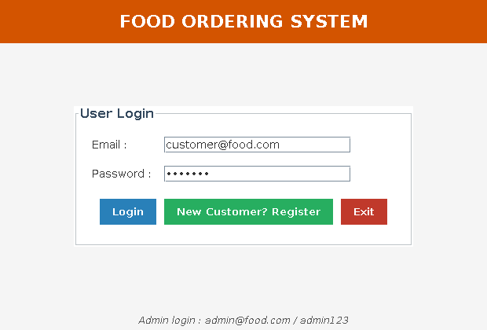
Fig. 3.1 Login screen built with Swing
3.4 Backend / Business Logic using Java
The business logic of the project is written in the DAO classes and the model classes. The screens never contain a SQL statement, they only call a method of a DAO class.
Model classes
A model class is a simple Java class with private fields and public getter and setter methods. It carries the data between the screens and the database. There are seven model classes : User, Category, FoodItem, Cart, CartItem, Order and OrderItem. For example, when UserDAO reads a row from the users table it copies the column values into a User object and returns that object to the login screen.
DAO classes
DAO stands for Data Access Object. There are four DAO classes, one for each part of the database : UserDAO, CategoryDAO, FoodItemDAO and OrderDAO. Each of them contains the SQL statements for its own tables. Keeping the SQL in these four classes means that a change in a query has to be made in one place only.
Validator class
The Validator class in the util package holds the small checks used by the forms : isEmpty, isValidEmail, isValidPhone, isValidPrice and isValidQuantity. Every form calls these methods before sending anything to the database.
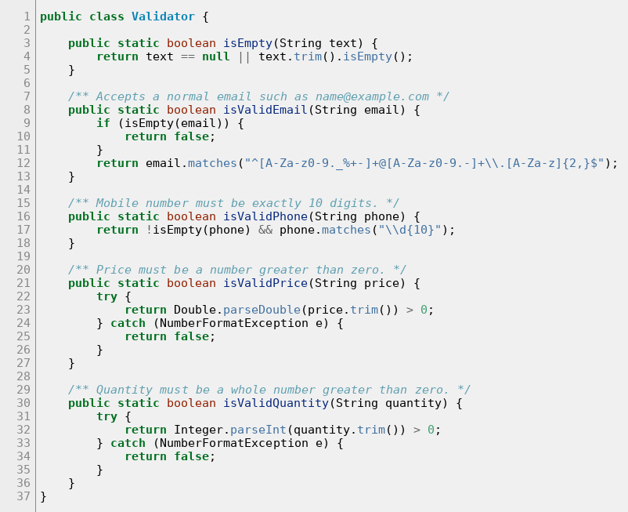
Fig. 3.2 Validator.java - the checks used by all the forms
3.5 Database Connectivity using JDBC
All the database connections of the project are created in one class named DBConnection. It holds the database URL, the user name and the password, loads the MySQL driver and returns a Connection object. Every DAO class calls DBConnection.getConnection(), so if the MySQL password of the laboratory computer is different, only this one file has to be edited.
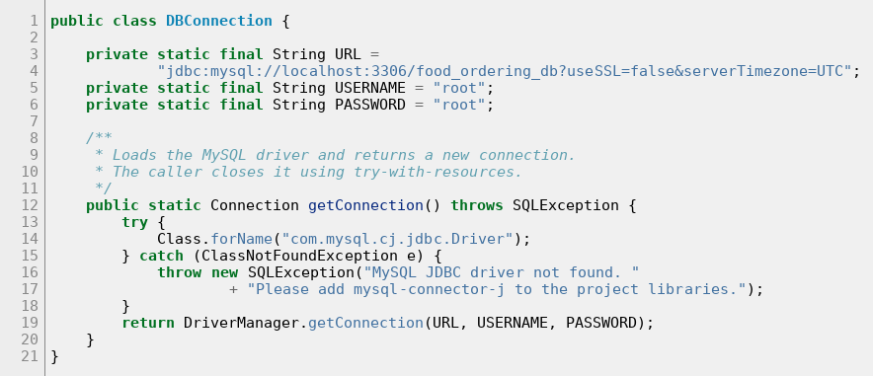
Fig. 3.3 DBConnection.java - the JDBC connection to MySQL
The testConnection method is called by MainApp when the application starts. If MySQL is not running or the password is wrong, a clear message is displayed at once instead of the program failing later on some screen.
Steps followed to connect Java with MySQL
1. Load the driver class com.mysql.cj.jdbc.Driver using Class.forName.
2. Create a Connection using DriverManager.getConnection with the URL, the user name and the password.
3. Create a PreparedStatement from the connection and set the values with setString, setInt or setDouble.
4. Run the statement with executeQuery for a SELECT or executeUpdate for an INSERT, UPDATE or DELETE.
5. Read the rows returned by a SELECT from the ResultSet.
6. Close the ResultSet, the statement and the connection.
In this project step 6 is done automatically by the try-with-resources statement. Any object opened inside the round brackets of try is closed by Java as soon as the block finishes, even if an exception occurs, so a connection is never left open by mistake.
Why PreparedStatement is used
Every query uses a PreparedStatement with question marks instead of joining the values into the SQL text with the + operator. The values typed by the user are then sent to MySQL as parameters, so text such as an apostrophe in a name cannot break the query and a SQL injection attack is not possible. MySQL also compiles such a statement once and can run it again with different values, which is faster.
3.6 Login Module
The login module is made of two classes, LoginFrame for the screen and UserDAO for the database work. LoginFrame first checks that the email and the password boxes are not empty and that the email is in the correct format. It then calls the login method of UserDAO, which runs a SELECT on the users table with the email and the password as parameters. If a row is found the values are copied into a User object, otherwise null is returned. LoginFrame looks at the role of the returned User and opens AdminDashboard when the role is ADMIN or CustomerDashboard when it is CUSTOMER.
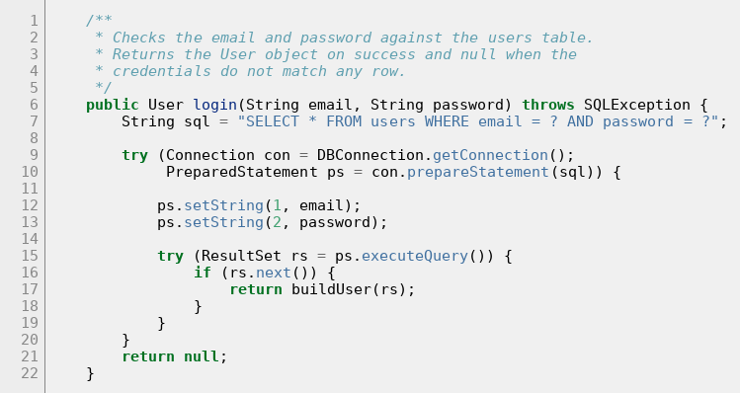
Fig. 3.4 UserDAO.login() - checking the credentials
3.7 Customer Module
The customer module allows a new customer to create an account and allows a logged in customer to correct the personal details. RegisterFrame collects the full name, email, password, confirm password, mobile number and address. Before saving anything it checks that the required boxes are filled, that the email is in a correct format, that the password is at least five characters long, that the two passwords match and that the mobile number has exactly ten digits. It then calls emailExists of UserDAO, and only if the email is free the register method inserts the new row with the role CUSTOMER.
The ProfilePanel screen shows the details of the logged in customer. The customer id and the email are only displayed, because the email is used to log in. The name, the mobile number, the address and the password can be changed and are saved by the updateProfile method of UserDAO.
3.8 Category Module
The category module is used by the admin to maintain the groups under which the dishes are arranged, such as Starters, Main Course, Beverages and Desserts. CategoryPanel shows a small form at the top and the list of existing categories in a table below it. Clicking a row of the table copies its values into the form, so the same form is used for adding, updating and deleting.
Two situations are handled carefully in this module. First, the category_name column has a UNIQUE key, so adding a category that already exists throws an SQLException. The message of the exception is checked for the word duplicate and a readable message is shown instead of the technical error. Second, a category that still has food items cannot be deleted because food_items has a foreign key pointing to it. The screen therefore calls countFoodItems first and, if the count is more than zero, tells the admin how many items belong to that category instead of attempting the delete.
3.9 Food / Menu Module
The food module is used by the admin to maintain the menu. A food item has a name, a description, a category chosen from a drop down list, a price and an availability which is Yes or No. FoodItemPanel works in the same way as CategoryPanel : the table shows all the items and clicking a row fills the form.
The select queries of FoodItemDAO join the categories table so that the screens can show the category name instead of the category number. Four different select methods are provided : getAllFoodItems for the admin screen, getAvailableFoodItems for the customer menu, getAvailableByCategory for the category filter and searchAvailableByName for the search box.
A food item that is already part of an old order cannot be deleted, because order_items has a foreign key pointing to food_items. In that case the screen suggests setting Available to No, which hides the dish from the customer menu while keeping the old orders correct.
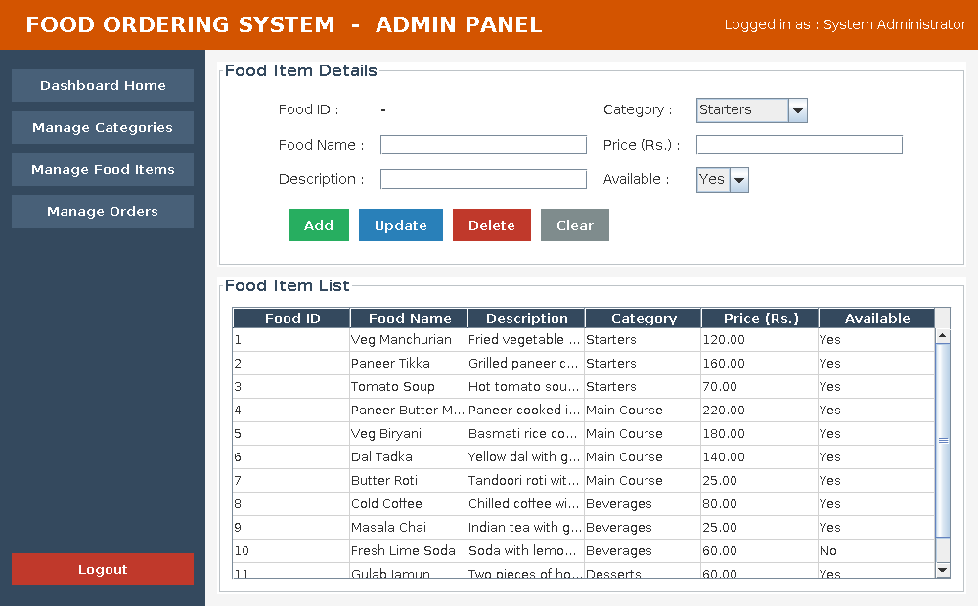
Fig. 3.5 Manage Food Items screen
3.10 Cart Module
The cart is the only part of the project which is not stored in the database. It is a plain Java object which lives in memory as long as the customer is logged in, and it is written to the database only when the order is placed. One Cart object is created in CustomerDashboard and is passed both to MenuPanel and to CartPanel, so an item added on the menu screen appears immediately on the cart screen.
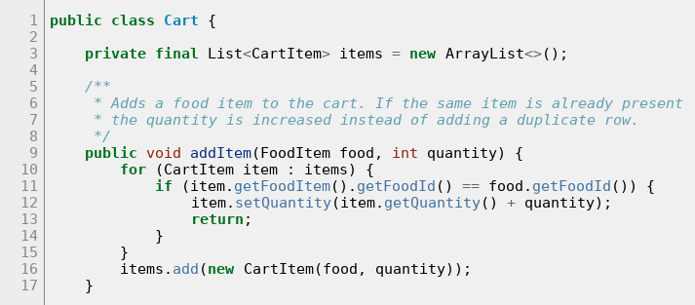
Fig. 3.6 Cart.addItem() - adding an item to the cart
The addItem method first looks through the existing lines. If the same food item is already in the cart it only increases the quantity, otherwise it adds a new CartItem. Because of this the cart never shows the same dish twice.
The subtotal of one line is calculated in CartItem as the price of the food item multiplied by the quantity. The total amount of the cart is the sum of the subtotals of all the lines. Both values are recalculated every time the cart screen is refreshed, so the amount on the screen is always correct.
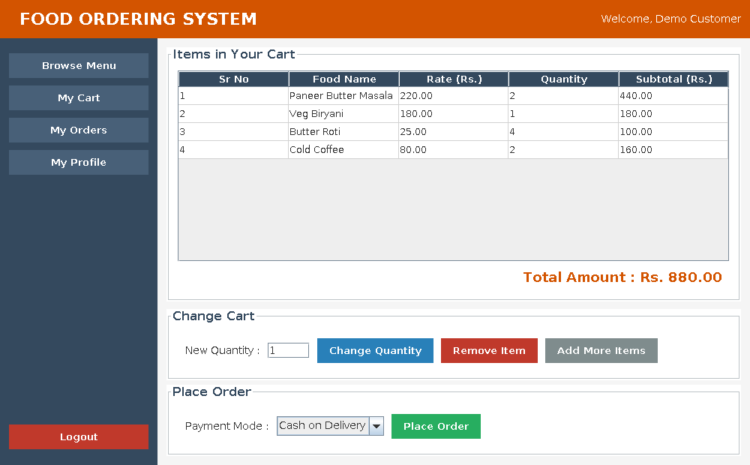
Fig. 3.7 My Cart screen showing the subtotals and the total amount
3.11 Order Module
The order module is the most important part of the project because it writes to two tables at the same time. The placeOrder method of OrderDAO receives the user id, the cart and the payment mode, and does the following work.
1. Takes a connection from DBConnection and switches off auto commit, so that the two inserts become one transaction.
2. Generates a unique order number from the current date and time.
3. Inserts one row into the orders table and reads back the order_id generated by AUTO_INCREMENT using getGeneratedKeys.
4. Inserts one row into order_items for every line of the cart, using addBatch and executeBatch so that all the lines are sent together.
5. Calls commit to make the changes permanent.
6. Builds an Order object with the order number and the ordered items and returns it, so that the bill can be displayed.
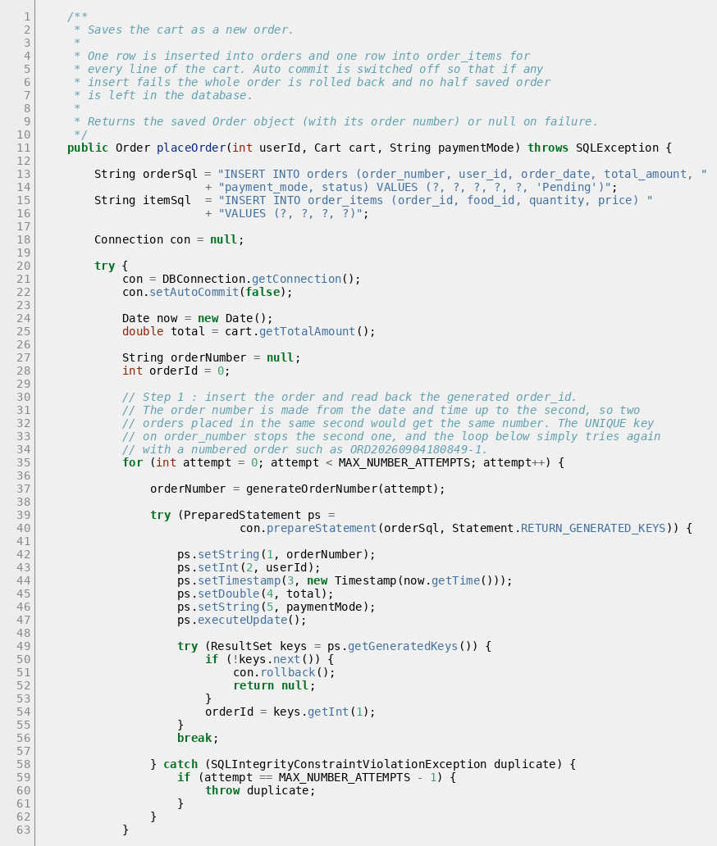
Fig. 3.8 OrderDAO.placeOrder() - part 1, inserting the order
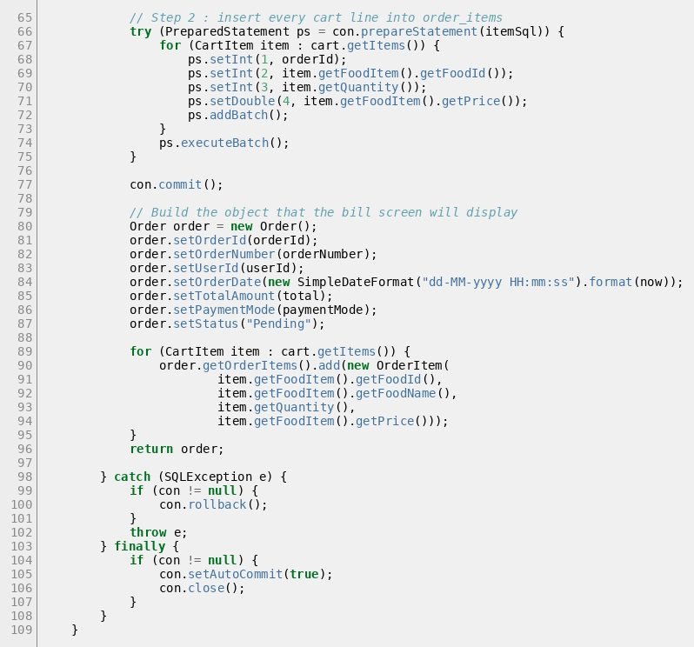
Fig. 3.9 OrderDAO.placeOrder() - part 2, inserting the items and commit
If anything goes wrong while saving, the catch block calls rollback. Because of this the database can never contain an order without its items, or items without their order. The finally block switches auto commit back on and closes the connection.
The order number is made from the date and the time up to the second, giving a value such as ORD20260904181231. Two orders placed inside the same second would get the same number, so the order_number column has a UNIQUE key in the database. If MySQL refuses the number for that reason, the loop in step 1 simply tries again and the second order gets a numbered value such as ORD20260904181231-1. This is why the insert of the order row is written inside a small for loop.
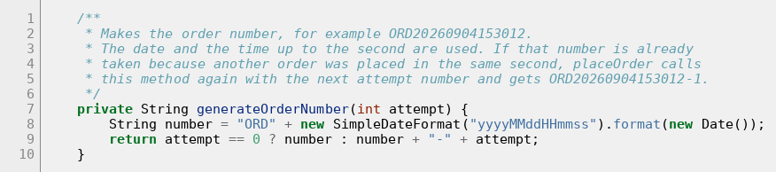
Fig. 3.10 Generating the order number
3.12 Billing Module
The bill is prepared by the BillDialog class. It receives an Order object together with its order items and builds the text of the receipt line by line. String.format is used with fixed column widths so that the numbers stay in a straight line, and the text is displayed in a JTextArea using the monospaced font, which makes it look like a printed receipt.
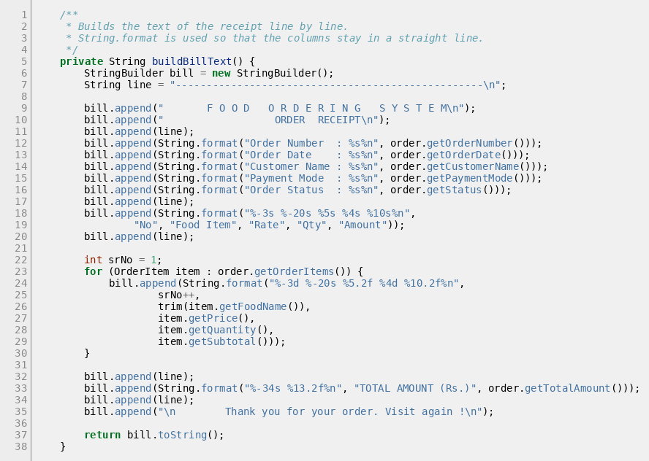
Fig. 3.11 BillDialog.buildBillText() - building the receipt
The bill shows the order number, the order date, the customer name, the payment mode, the order status, then one line for every item with its rate, quantity and amount, and finally the total amount. The same window is used in three places : after an order is placed, when the customer opens an old order from the order history and when the admin clicks View Order Details. The Save Bill as Text File button writes the same text into a .txt file chosen by the user.
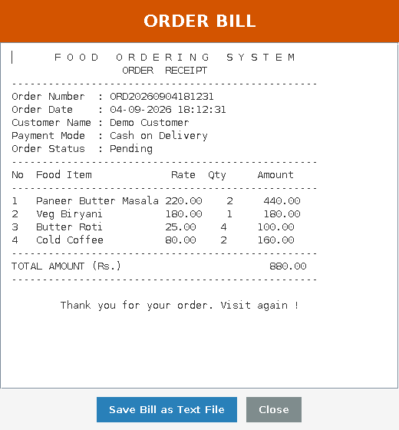
Fig. 3.12 Generated bill of an order
3.13 Admin Order Management
AdminOrderPanel shows the orders of all the customers in one table. The query joins the users table so that the name of the customer is displayed next to every order, and the orders are sorted with the newest one first. A drop down list at the top lets the admin see all the orders or only the orders having one selected status.
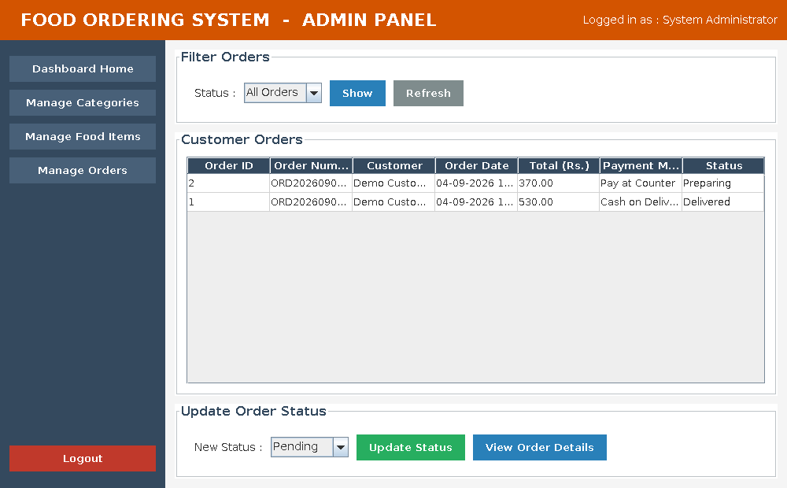
Fig. 3.13 Manage Orders screen of the admin
To change the status of an order the admin selects the row, chooses the new status from the second drop down list and clicks Update Status. The updateOrderStatus method of OrderDAO runs an UPDATE statement on the orders table and the table on the screen is reloaded, so the new status is visible at once. The customer sees the same status in the My Orders screen.
The View Order Details button opens the same BillDialog window, so the admin can see exactly which dishes the customer ordered and in what quantity.
3.14 Database Integration
The database is created by running the script database/food_ordering_db.sql. The script drops the database if it already exists, creates it again with the five tables, defines the primary keys, the unique keys and the foreign keys, and inserts the sample data : one admin account, one demo customer, four categories and twelve food items.
The screenshots below show the tables actually created in MySQL and the rows written by the application while it was being tested.
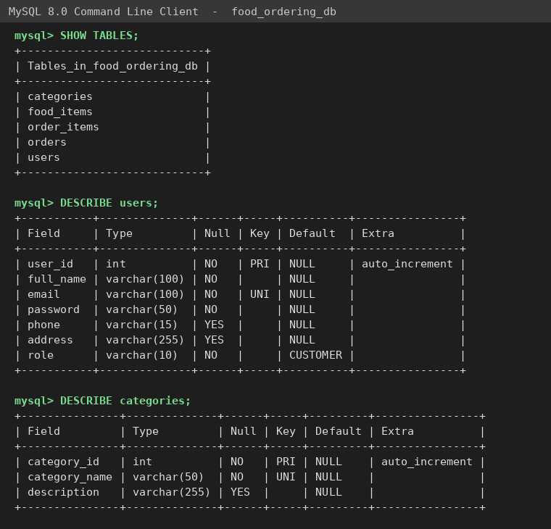
Fig. 3.14 Tables of food_ordering_db and the structure of users and categories
3.15 Module Integration
The modules of the project are not separate programs. They are connected to each other, and the points at which they meet are described below.
1. Login and Customer Module : The registration screen inserts a row in the users table and the login screen reads the same table, so a customer can log in immediately after registering. The role of the returned User decides which dashboard opens, so the admin screens are never reachable from a customer account.
2. Food and Menu Browsing : Every food item belongs to a category, so the category drop down of the food screen is filled from the categories table. The customer menu reads the same food_items table that the admin maintains, so a dish added by the admin appears at once and a dish marked as not available disappears from it.
3. Menu and Cart Module : The item selected on the menu screen is added to the Cart object which CustomerDashboard shares with the cart screen, so the two screens always show the same cart.
4. Cart and Order Module : When the order is placed the contents of the cart are written into the orders and order_items tables, and the cart is cleared so that the next order starts empty.
5. Order and Billing Module : The Order object returned by placeOrder is passed directly to BillDialog, so the bill always shows exactly what was saved. The order history screen reads the same orders table, so an order placed a minute ago appears there immediately.
6. All Modules and the Database : Every DAO class takes its connection from the single DBConnection class, so all the modules work on the same database. The admin order screen reads all the rows of the orders table and joins users to show the customer name, and when the admin changes a status the customer sees it in the order history.

CHAPTER 4 : TESTING
4.1 Introduction to Testing
Testing means running the finished application and checking whether it behaves the way it was supposed to behave. Unless every screen and every calculation is checked with real values, there is no way to be sure that the project works.
The Food Ordering System was tested after all the modules were completed and joined together. Each module was first checked on its own and then the whole flow was tried from beginning to end, that is, register a customer, log in, browse the menu, fill the cart, place the order, look at the bill, check the order history, change the status from the admin side and log out.
Both correct values and wrong values were used while testing. Trying wrong values is important because a program should not stop with an error when the user makes a mistake. It should show a clear message and let the user correct the value.
4.2 Test Strategy
The following kinds of testing were carried out on the project.
• Unit testing : each method of the DAO classes and each screen was checked separately, for example adding a category, updating a price or reading the list of orders.
• Integration testing : the modules were checked together, for example an item added on the menu screen appearing on the cart screen, and an order placed by the customer appearing in the admin order list.
• Functional testing : every functional requirement listed in section 2.4 was tried on the running application, and the complete flow from registration to logout was carried out as a normal user would do it.
• Validation testing : wrong values were typed in every form to check that a proper message is displayed.
• Database testing : the tables were opened in MySQL after every operation to confirm that the rows were really inserted, updated or deleted.
Black box testing was used throughout. That means the application was used through its screens like a normal user, and the result on the screen and in the database was compared with the expected result, without looking at the code while testing.
4.3 Test Environment
Item | Details
Application | Food Ordering System, runnable jar built with Maven
Java | JDK 21
Database | MySQL Server 8.0, database food_ordering_db
Data used | The sample data inserted by food_ordering_db.sql, that is 1 admin, 1 demo customer, 4 categories and 12 food items
Accounts used | admin@food.com / admin123 and customer@food.com / cust123
Number of test cases | 43
4.4 Test Cases
The table below lists all the 43 test cases that were run on the finished application, with the input used, the expected output and the output that was actually obtained.
Test ID | Test Case Name | Scenario (what is tested) | Input Condition | Expected Output | Actual Output | Result
TC_01 | Admin login | Login with the admin account | admin@food.com / admin123 | Admin dashboard opens | Admin dashboard opened | Pass
TC_02 | Customer login | Login with a customer account | customer@food.com / cust123 | Customer dashboard opens | Customer dashboard opened | Pass
TC_03 | Invalid login | Login with a wrong password | customer@food.com / wrong | Message 'Invalid email or password' | Message displayed | Pass
TC_04 | Empty login fields | Click Login with empty boxes | Email and password empty | Message asking for both | Message displayed | Pass
TC_05 | Email format check | Email typed without a domain | abc@ | Message asking for valid email | Message displayed | Pass
TC_06 | Customer registration | Register a new customer | Name, email, password, mobile | Row inserted, login works | Row inserted, login worked | Pass
TC_07 | Duplicate email | Register with an existing email | An email already registered | Message that email exists | Message displayed | Pass
TC_08 | Mobile number check | Mobile number of five digits | 12345 | Message asking for 10 digits | Message displayed | Pass
TC_09 | Add category | Add a category | Category name and description | Category saved and listed | Category saved | Pass
TC_10 | View categories | Open Manage Categories | - | All categories listed | All categories listed | Pass
TC_11 | Update category | Change the name of a category | New category name | New name saved and shown | New name saved | Pass
TC_12 | Delete used category | Delete a category having dishes | Category 'Starters' | Delete refused with a message | Delete refused | Pass
TC_13 | Delete empty category | Delete an empty category | Test category | Category removed from the table | Category removed | Pass
TC_14 | Add food item | Add a dish to the menu | Name, category, price 199.50 | Dish saved in food_items | Dish saved | Pass
TC_15 | Price stored correctly | Check the saved price | 199.50 | Price stored as 199.50 | Price stored as 199.50 | Pass
TC_16 | Update food item | Change price and availability | Price 249.00, Available No | Both values updated | Both values updated | Pass
TC_17 | Availability filter | Menu after marking a dish No | Available = No | Dish hidden from the menu | Dish not shown | Pass
TC_18 | Delete food item | Delete an unused dish | Test dish | Dish removed from food_items | Dish removed | Pass
TC_19 | Delete ordered item | Delete a dish used in an order | Veg Manchurian | Delete refused with a message | Delete refused | Pass
TC_20 | Menu display | Open the Browse Menu screen | - | Only available dishes listed | 11 dishes listed | Pass
TC_21 | Filter by category | Filter the menu by Main Course | Main Course | Only Main Course dishes shown | 4 dishes shown | Pass
TC_22 | Search by name | Search the menu by name | Paneer | Only matching dishes shown | 2 dishes shown | Pass
TC_23 | Search with no match | Search a name that does not exist | zzzz | Empty list with a message | Empty list shown | Pass
TC_24 | Cart total | Check the cart total | 120 x 2 and 160 x 1 | Total = 400.00 | Total = 400.00 | Pass
TC_25 | Same item added again | Add the same dish again | Same dish, quantity 3 | Quantity increases, one line | Quantity became 5 | Pass
TC_26 | Change quantity | Change a cart quantity | New quantity 2 | Subtotal recalculated | Subtotal = 240.00 | Pass
TC_27 | Remove item | Remove a cart line | Second line | Line removed, total reduced | Line removed | Pass
TC_28 | Quantity validation | Quantity 0 and then text | 0 and abc | Message for valid quantity | Message displayed | Pass
TC_29 | Price validation | Price 0 and then text | 0 and abc | Message for valid price | Message displayed | Pass
TC_30 | Place order - orders table | Place an order | Cart with 2 dishes | One new row in orders | One row inserted | Pass
TC_31 | Place order - order_items | Check the items of the order | Cart with 2 dishes | Two new rows in order_items | Two rows inserted | Pass
TC_32 | Order number | Check the order number | - | Starts with ORD, unique | ORD20260904181231, unique | Pass
TC_33 | Order total saved | Compare saved and cart totals | Cart total 310.00 | Same amount in orders | Amount 310.00 saved | Pass
TC_34 | Default status | Status of a new order | - | Status is Pending | Status was Pending | Pass
TC_35 | Bill amounts | Add the bill line amounts | Order of 2 dishes | Sum equals the total amount | Sum 310.00 = total | Pass
TC_36 | Rate stored in order | Rate saved in order_items | Dish of rate 120.00 | Rate at ordering time stored | Rate 120.00 stored | Pass
TC_37 | Order history | Open the My Orders screen | Logged in customer | Only this customer's orders | Only own orders listed | Pass
TC_38 | History order | Order of the rows | - | Newest order at the top | Newest order at the top | Pass
TC_39 | Admin order list | Open Manage Orders | - | All orders with customer name | All orders with names | Pass
TC_40 | Update order status | Change an order status | Pending to Confirmed | New status saved | Status became Confirmed | Pass
TC_41 | Filter orders | Filter orders by status | Confirmed | Only that status shown | Only Confirmed orders shown | Pass
TC_42 | Profile update | Change name and mobile number | New name and mobile | New values saved in users | New values saved | Pass
TC_43 | Transaction rollback | Order with an invalid food id | Wrong food id | Nothing saved | Nothing saved, rolled back | Pass
4.5 Functional Testing
Functional testing checked that every requirement of section 2.4 really works. Test cases TC_01 to TC_03 cover the login, TC_06 and TC_07 the registration, TC_09 to TC_13 the category module, TC_14 to TC_19 the food module, TC_20 to TC_23 the menu browsing, TC_24 to TC_27 the cart, TC_30 to TC_36 the order placing and billing, TC_37 and TC_38 the order history, TC_39 to TC_41 the admin order management and TC_42 the profile update.
Two results are worth mentioning. A dish marked as not available disappeared from the customer menu immediately but stayed on the admin screen, and adding the same dish to the cart twice increased the quantity instead of creating a second line.
4.6 Database Testing
After every operation the tables were opened in MySQL to confirm that the data was really saved. The most important check was the order placing, because it writes to two tables. After placing an order of four dishes, the orders table had one new row and the order_items table had four new rows belonging to that order.
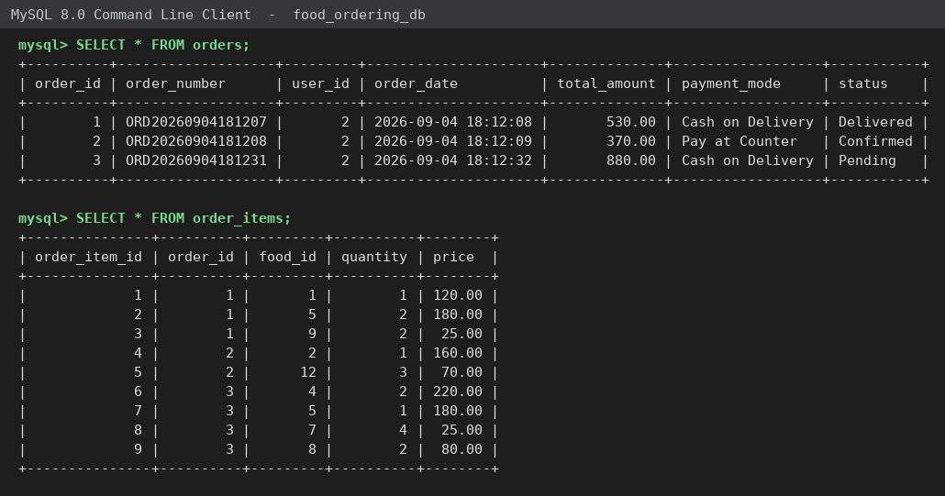
Fig. 4.1 Rows of the orders and order_items tables after testing
The join query below shows the same data in a readable form, with the order number, the customer name and the dishes of every order. This confirms that the foreign keys are correct and that every ordered line points to the right order and the right dish.
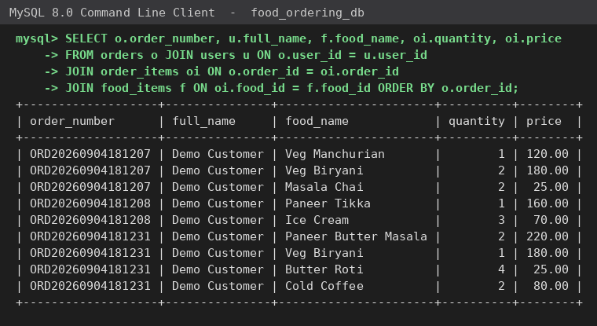
Fig. 4.2 Orders joined with the customer name and the ordered dishes
The foreign key restrictions were also tested. Deleting the category Starters was refused because three dishes belong to it, and deleting Veg Manchurian was refused because it is part of an old order. In both cases a readable message was shown instead of a database error.
Finally the rollback was tested by trying to save an order containing a food id that does not exist in food_items. The insert into order_items failed, rollback was called and the number of rows in the orders table stayed the same, which proves that a half saved order is never left behind (test case TC_43).
4.7 Validation Testing
Validation testing checked the messages shown when wrong values are typed. The table below lists the checks written in the Validator class and in the forms, and the message that appears.
Field | Check applied | Message shown
Email (login) | Must not be empty and must be in name@example.com form | Please enter a valid email address.
Login credentials | Must match a row of the users table | Invalid email or password. Please try again.
Password (registration) | At least 5 characters | Password must be at least 5 characters long.
Confirm password | Must be the same as the password | Password and Confirm Password do not match.
Mobile number | Exactly 10 digits | Mobile number must contain exactly 10 digits.
Email (registration) | Must not already exist in the users table | This email is already registered. Please use another email.
Category name | Must not be empty and must not be repeated | This category name already exists. Please use a different name.
Food price | Must be a number greater than 0 | Please enter a valid price greater than 0.
Quantity | Must be a whole number greater than 0 | Please enter a valid quantity, for example 1 or 2.
Cart before ordering | Must contain at least one item | Your cart is empty. Please add some food items first.
Table selection | A row must be selected before Update or Delete | Please select a food item from the table first.
4.8 Test Results
All the 43 test cases were executed on the finished application. The summary is given below.
Module | Test Cases | Passed | Failed
Login and Authentication | TC_01 to TC_05 | 5 | 0
Customer Registration and Profile | TC_06 to TC_08, TC_42 | 4 | 0
Category Management | TC_09 to TC_13 | 5 | 0
Food / Menu Management | TC_14 to TC_19 | 6 | 0
Menu Browsing, Search and Filter | TC_20 to TC_23 | 4 | 0
Shopping Cart | TC_24 to TC_29 | 6 | 0
Order Placing and Billing | TC_30 to TC_36 | 7 | 0
Order History | TC_37, TC_38 | 2 | 0
Admin Order Management | TC_39 to TC_41 | 3 | 0
Transaction Handling | TC_43 | 1 | 0
Total | 43 test cases | 43 | 0
All the 43 test cases passed and no test case failed. A few problems were found and corrected while the application was being built. The category delete first showed a raw SQL foreign key error, so a count check was added before the delete. The delete of a dish that was part of an old order had the same problem and was handled in the same way. The cart also showed the same dish twice when it was added again, which was corrected by increasing the quantity in the addItem method instead of adding a new line.
4.9 Screenshots of Successful Execution
The screenshots in this section were taken from the running application while the test cases were being executed.
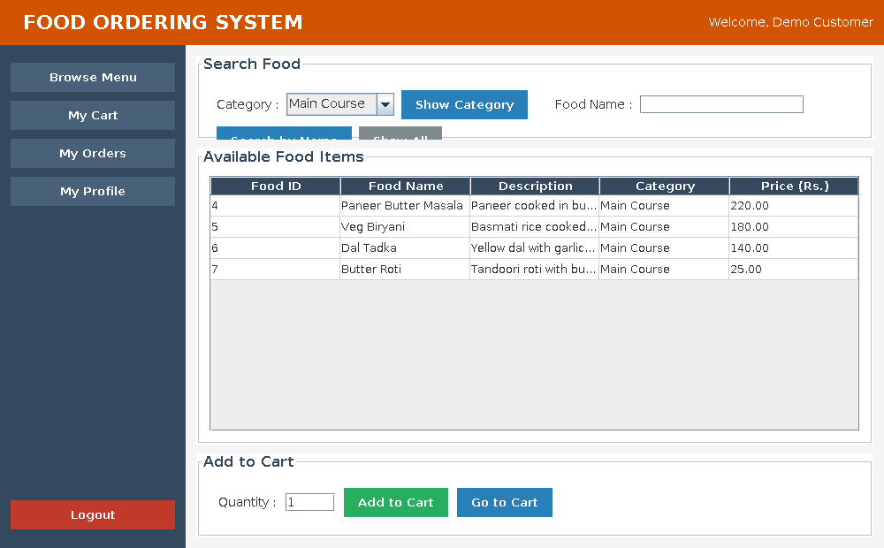
Fig. 4.3 Menu filtered by the category Main Course (TC_21)
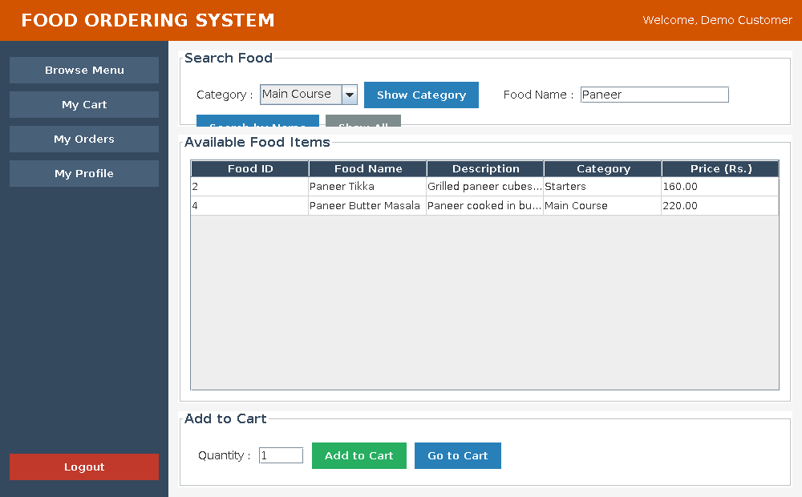
Fig. 4.4 Menu searched for the word Paneer (TC_22)
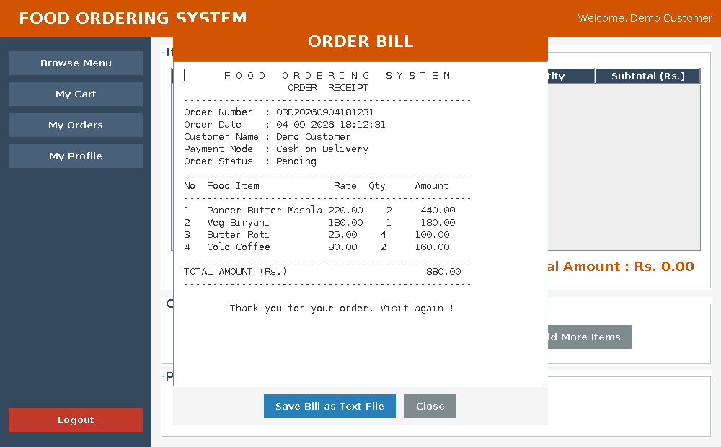
Fig. 4.5 Bill displayed after the order was placed
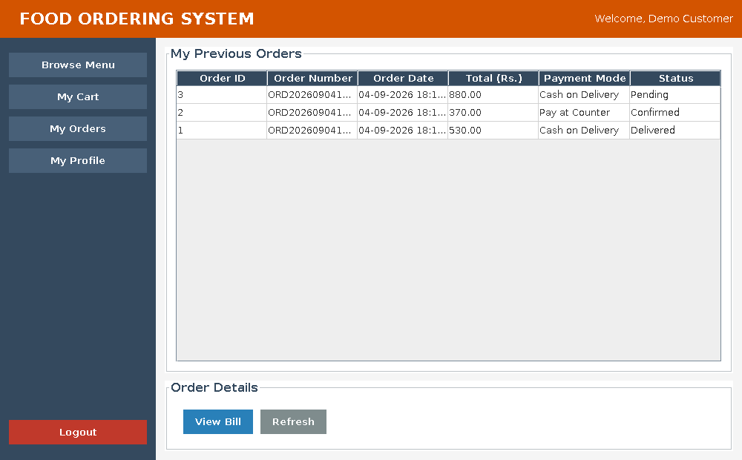
Fig. 4.6 Order history of the customer with the status of each order
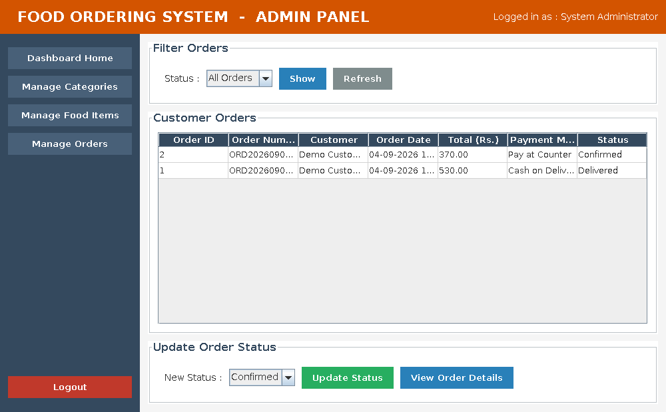
Fig. 4.7 Admin order list after the status was changed to Confirmed (TC_40)

CHAPTER 5 : CONCLUSION
5.1 Conclusion
The Food Ordering System has been developed and tested successfully. The application does the complete work it was meant to do : a customer can register, log in, look at the menu, search a dish, add dishes to a cart, place an order and receive a bill, while the administrator can maintain the categories and the menu and follow every order till it is delivered.
The main aim of the project was to replace the paper slip and the hand written bill with a simple computer application, and that aim has been achieved. Because the program multiplies the rate by the quantity and adds the amounts, the bill is always correct. Because every order and every ordered item is stored in MySQL, the restaurant has a permanent record which can be looked at any time.
While building the project many things were learned in a practical way. Designing five tables with proper keys showed why a relational database keeps the data consistent, and writing the DAO classes showed how the SQL statements can be kept away from the screens so that the code stays organised.
The most useful thing learned was transaction handling. Saving an order means writing to two tables, and if the second write fails the first one must also be undone. Switching off auto commit, doing both inserts and then calling commit, with a rollback in the catch block, is a simple idea but it is what keeps the database correct.
The project is small and it does not try to do everything a commercial restaurant package does. But everything that has been written in this report is actually working in the application, and the code is simple enough to be read and explained line by line. For a BCA level project that was the goal.
5.2 Summary
The Food Ordering System is a Java desktop application built with Swing for the screens, JDBC for the database connection and MySQL for storing the data. It has two types of users, an administrator and customers, and the role stored in the users table decides which dashboard is opened after login.
The database food_ordering_db has five tables. The users table keeps the admin and the customers, categories keeps the food groups, food_items keeps the menu, orders keeps one row for every order and order_items keeps the individual dishes of each order. Foreign keys join these tables so that no order can exist without a customer and no ordered line can exist without an order and a dish.
The customer flow is : register, login, browse or search the menu, add dishes to the cart with a quantity, change or remove lines if needed, place the order, receive the bill and later look at the order history. The admin flow is : login, manage categories, manage food items and their availability, view all the orders, filter them by status and update the status of an order.
The application was tested with 43 test cases covering login, registration, category and food management, menu browsing, cart operations, order placing, billing, order history, admin order management, input validation and transaction rollback. All the 43 test cases passed.
5.3 Benefits of the System
1. Correct bills every time : The subtotal of every line and the total of the order are calculated by the program, so a mistake in multiplication or addition is not possible.
2. Permanent record of every order : Each order is stored with its date, its customer and all its dishes, so the restaurant can check what was ordered on any day and the customer can see all the previous orders.
3. Menu maintained at one place : The price or the description of a dish is changed on one screen and the new value is seen by every customer at once. No menu card has to be reprinted.
4. Items that are finished can be hidden : Marking a dish as not available removes it from the customer menu without deleting it, so the customer never orders something that cannot be prepared and the old orders remain correct.
5. Order status is visible : The admin moves an order through Pending, Confirmed, Preparing, Ready and Delivered, and the customer can see the current stage without asking anybody.
6. Separate work for admin and customer : The role stored with each user decides which screens are available, so a customer cannot reach the admin screens.
7. Fewer mistakes at the time of entry : Every form checks the values that are typed and shows a clear message, so wrong data does not reach the database.
8. Safe database operations : All queries use PreparedStatement and the order is saved inside a transaction, so the data in the tables always stays consistent.
9. Easy to install in a laboratory : The project needs only Java and MySQL, with no web server and no internet connection.
5.4 Limitations of the System
The project was kept simple on purpose, so that it could be completed and understood properly. The following limitations are known and are stated honestly.
1. No online payment : The payment is only recorded as Cash on Delivery or Pay at Counter. There is no payment gateway, so the money is not actually collected through the application.
2. Single computer application : It is a desktop application. A customer cannot order from a mobile phone or from home, the ordering has to be done on the computer where the application is installed.
3. Passwords are stored as plain text : The password is saved in the users table as it is typed. This is enough for a college project but a real system would store an encrypted form of the password.
4. No forgot password option : If a customer forgets the password there is no way to reset it from the application. The admin has to correct it directly in the database.
5. The cart is not saved : The cart is kept in memory only. If the application is closed before the order is placed, the items in the cart are lost.
6. No pictures of the dishes : The menu shows the name, the description and the price as text. Photographs of the dishes are not stored.
7. No reports or graphs : There is no sales report, no daily total and no chart. The admin can only see the list of orders.
8. Single admin account : There is only one administrator account and it is created by the SQL script. New admin accounts cannot be created from the application.
5.5 Future Enhancements
The following improvements can be added to the project later. They have been chosen so that each of them is a reasonable next step from the present code and not a completely different project.
1. Encrypted passwords : Store the password after passing it through a hashing algorithm instead of storing the plain text, and compare the hash at the time of login.
2. Forgot password option : Add a screen where a customer can reset the password after answering a security question set at the time of registration.
3. Printing the bill : Use the Java printing API so that the bill window has a Print button and the receipt can be printed directly.
4. Sales reports : Add a screen for the admin showing the total sales of a day or a month, and the dishes that were ordered the most.
5. Pictures of the dishes : Store the photograph of every dish and show it on the menu screen so that the customer can see the food before ordering.
6. Saving the cart : Keep the cart in a database table so that the items are not lost if the application is closed before the order is placed.
7. Discounts and taxes : Add a discount column and a tax percentage to the bill calculation, which is how a real restaurant bill is prepared.
8. A web or mobile version : Once the database design is proven, the same tables can be used by a web or Android application so that customers can order from their phone.

CHAPTER 6 : REFERENCES
Books
1. Herbert Schildt, “Java : The Complete Reference”, Twelfth Edition, McGraw Hill Education, 2021.
2. Kathy Sierra and Bert Bates, “Head First Java”, Third Edition, O’Reilly Media, 2022.
3. Cay S. Horstmann, “Core Java Volume I – Fundamentals”, Twelfth Edition, Pearson, 2021.
4. Cay S. Horstmann, “Core Java Volume II – Advanced Features”, Twelfth Edition, Pearson, 2022.
5. Abraham Silberschatz, Henry F. Korth and S. Sudarshan, “Database System Concepts”, Seventh Edition, McGraw Hill, 2019.
6. Elmasri and Navathe, “Fundamentals of Database Systems”, Seventh Edition, Pearson, 2016.
7. Vikram Vaswani, “MySQL : The Complete Reference”, McGraw Hill Education, 2017.
8. Roger S. Pressman, “Software Engineering : A Practitioner’s Approach”, Eighth Edition, McGraw Hill, 2019.
9. Grady Booch, James Rumbaugh and Ivar Jacobson, “The Unified Modeling Language User Guide”, Second Edition, Addison-Wesley, 2005.
Websites
1. Java SE 21 API Documentation – https://docs.oracle.com/en/java/javase/21/docs/api/
2. Java Swing Tutorial (Oracle) – https://docs.oracle.com/javase/tutorial/uiswing/
3. JDBC Basics (Oracle) – https://docs.oracle.com/javase/tutorial/jdbc/basics/
4. MySQL 8.0 Reference Manual – https://dev.mysql.com/doc/refman/8.0/en/
5. MySQL Connector/J Developer Guide – https://dev.mysql.com/doc/connector-j/en/
6. Java Swing – JTable and DefaultTableModel – https://docs.oracle.com/javase/tutorial/uiswing/components/table.html
7. Using Prepared Statements – https://docs.oracle.com/javase/tutorial/jdbc/basics/prepared.html
8. Using Transactions in JDBC – https://docs.oracle.com/javase/tutorial/jdbc/basics/transactions.html
9. Apache Maven Documentation – https://maven.apache.org/guides/
10. UML Diagram Reference – https://www.uml-diagrams.org/

CHAPTER 7 : APPENDICES
7.1 Database SQL Script
The complete script used to create the database is given below. It is saved in the project as database/food_ordering_db.sql and can be run from MySQL Workbench or from the MySQL Command Line Client with the command :
mysql -u root -p < food_ordering_db.sql

-- ============================================================
-- Food Ordering System
-- Database script for MySQL
--
-- How to run:
-- mysql -u root -p < food_ordering_db.sql
-- or open this file in MySQL Workbench and execute it.
-- ============================================================

DROP DATABASE IF EXISTS food_ordering_db;
CREATE DATABASE food_ordering_db;
USE food_ordering_db;

-- ------------------------------------------------------------
-- Table 1 : users
-- Stores login details of the admin and of every registered
-- customer. The role column decides which dashboard opens
-- after a successful login.
-- ------------------------------------------------------------
CREATE TABLE users (
user_id INT AUTO_INCREMENT,
full_name VARCHAR(100) NOT NULL,
email VARCHAR(100) NOT NULL,
password VARCHAR(50) NOT NULL,
phone VARCHAR(15),
address VARCHAR(255),
role VARCHAR(10) NOT NULL DEFAULT 'CUSTOMER',
PRIMARY KEY (user_id),
UNIQUE KEY uk_users_email (email)
);

-- ------------------------------------------------------------
-- Table 2 : categories
-- Stores the food categories such as Starters, Main Course,
-- Beverages and Desserts.
-- ------------------------------------------------------------
CREATE TABLE categories (
category_id INT AUTO_INCREMENT,
category_name VARCHAR(50) NOT NULL,
description VARCHAR(255),
PRIMARY KEY (category_id),
UNIQUE KEY uk_categories_name (category_name)
);

-- ------------------------------------------------------------
-- Table 3 : food_items
-- Stores the menu. Every food item belongs to one category,
-- so category_id is a foreign key to the categories table.
-- ------------------------------------------------------------
CREATE TABLE food_items (
food_id INT AUTO_INCREMENT,
food_name VARCHAR(100) NOT NULL,
description VARCHAR(255),
category_id INT NOT NULL,
price DECIMAL(8,2) NOT NULL,
available VARCHAR(3) NOT NULL DEFAULT 'Yes',
PRIMARY KEY (food_id),
CONSTRAINT fk_food_category FOREIGN KEY (category_id)
REFERENCES categories (category_id)
);

-- ------------------------------------------------------------
-- Table 4 : orders
-- One row for every order placed by a customer. It keeps the
-- generated order number, the date, the total amount and the
-- current status of the order.
-- ------------------------------------------------------------
CREATE TABLE orders (
order_id INT AUTO_INCREMENT,
order_number VARCHAR(20) NOT NULL,
user_id INT NOT NULL,
order_date DATETIME NOT NULL,
total_amount DECIMAL(10,2) NOT NULL,
payment_mode VARCHAR(25) NOT NULL DEFAULT 'Cash on Delivery',
status VARCHAR(15) NOT NULL DEFAULT 'Pending',
PRIMARY KEY (order_id),
UNIQUE KEY uk_orders_number (order_number),
CONSTRAINT fk_order_user FOREIGN KEY (user_id)
REFERENCES users (user_id)
);

-- ------------------------------------------------------------
-- Table 5 : order_items
-- Stores the individual food items of an order. One order can
-- contain many rows here, so it has a foreign key to orders
-- and a foreign key to food_items.
-- ------------------------------------------------------------
CREATE TABLE order_items (
order_item_id INT AUTO_INCREMENT,
order_id INT NOT NULL,
food_id INT NOT NULL,
quantity INT NOT NULL,
price DECIMAL(8,2) NOT NULL,
PRIMARY KEY (order_item_id),
CONSTRAINT fk_item_order FOREIGN KEY (order_id)
REFERENCES orders (order_id),
CONSTRAINT fk_item_food FOREIGN KEY (food_id)
REFERENCES food_items (food_id)
);

-- ============================================================
-- Sample data
-- ============================================================

-- Default admin account (used to log in as administrator)
INSERT INTO users (full_name, email, password, phone, address, role) VALUES
('System Administrator', 'admin@food.com', 'admin123', '9876543210', 'Pune', 'ADMIN');

-- A demo customer so the menu and order screens can be checked quickly
INSERT INTO users (full_name, email, password, phone, address, role) VALUES
('Demo Customer', 'customer@food.com', 'cust123', '9812345678', 'Nasarapur, Pune', 'CUSTOMER');

INSERT INTO categories (category_name, description) VALUES
('Starters', 'Soups, snacks and small dishes served before the meal'),
('Main Course', 'Rice, roti and curry items'),
('Beverages', 'Cold drinks, tea, coffee and juices'),
('Desserts', 'Sweet dishes served after the meal');

INSERT INTO food_items (food_name, description, category_id, price, available) VALUES
('Veg Manchurian', 'Fried vegetable balls in spicy sauce', 1, 120.00, 'Yes'),
('Paneer Tikka', 'Grilled paneer cubes with masala', 1, 160.00, 'Yes'),
('Tomato Soup', 'Hot tomato soup served with bread', 1, 70.00, 'Yes'),
('Paneer Butter Masala', 'Paneer cooked in butter gravy', 2, 220.00, 'Yes'),
('Veg Biryani', 'Basmati rice cooked with vegetables', 2, 180.00, 'Yes'),
('Dal Tadka', 'Yellow dal with garlic tempering', 2, 140.00, 'Yes'),
('Butter Roti', 'Tandoori roti with butter', 2, 25.00, 'Yes'),
('Cold Coffee', 'Chilled coffee with milk', 3, 80.00, 'Yes'),
('Masala Chai', 'Indian tea with ginger and spices', 3, 25.00, 'Yes'),
('Fresh Lime Soda', 'Soda with lemon, sweet or salted', 3, 60.00, 'No'),
('Gulab Jamun', 'Two pieces of hot gulab jamun', 4, 60.00, 'Yes'),
('Ice Cream', 'Vanilla or butterscotch scoop', 4, 70.00, 'Yes');

7.2 Important Source Code
The class that connects Java with MySQL and the method that saves an order are given here, because they are the most important parts of the project. The code of the other modules is shown and explained in Chapter 3. The complete code of all the 27 classes is available in the project folder src/main/java/com/foodordering.
7.2.1 DBConnection.java
Creates the JDBC connection to MySQL. It is the only class that knows the database URL, the user name and the password, so these settings are changed at one place only.


7.2.2 OrderDAO.placeOrder() – part 1
Switches off auto commit, generates the order number and inserts the row in the orders table, then reads back the order_id generated by AUTO_INCREMENT.


7.2.3 OrderDAO.placeOrder() – part 2
Inserts one row in order_items for every cart line using a batch, commits the transaction and builds the Order object used by the bill. If anything fails, rollback undoes the whole order.


7.3 Important Screenshots
The screenshots below were taken from the running application. The screens that are already shown in Chapter 3 and Chapter 4 are not repeated here.
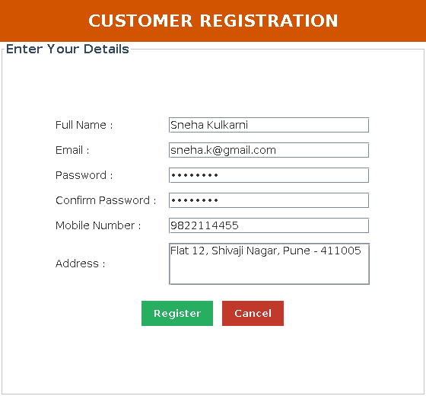
Fig. 7.1 Customer registration screen
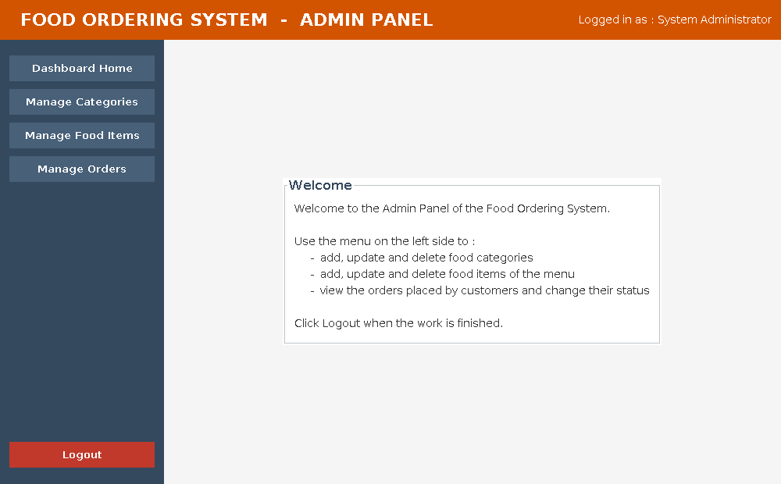
Fig. 7.2 Admin dashboard after login
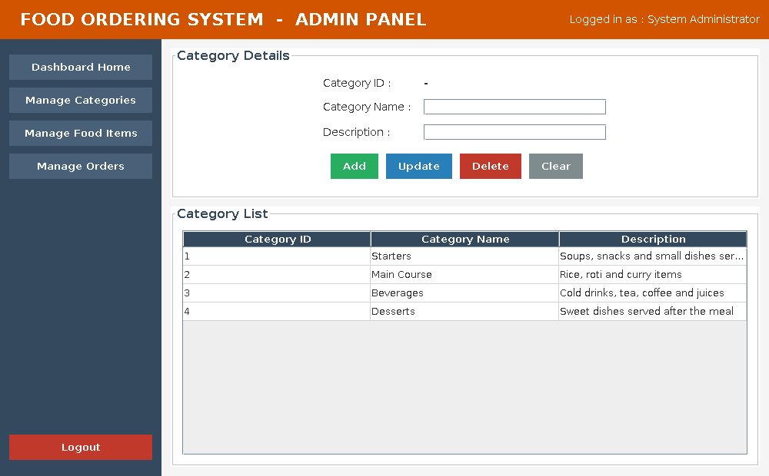
Fig. 7.3 Manage Categories screen
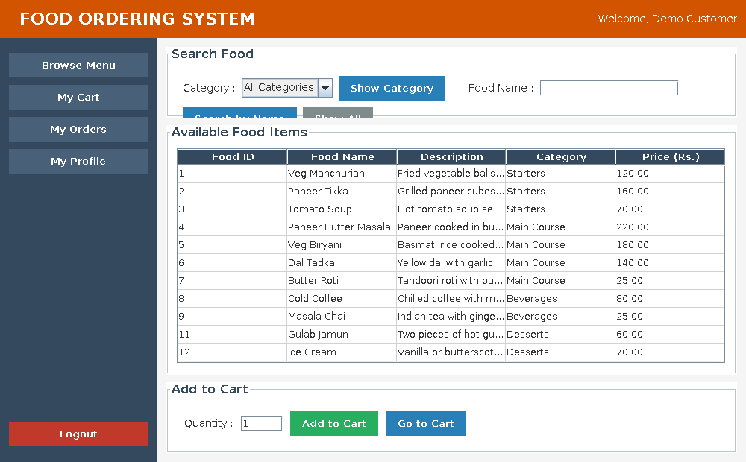
Fig. 7.4 Customer dashboard - Browse Menu
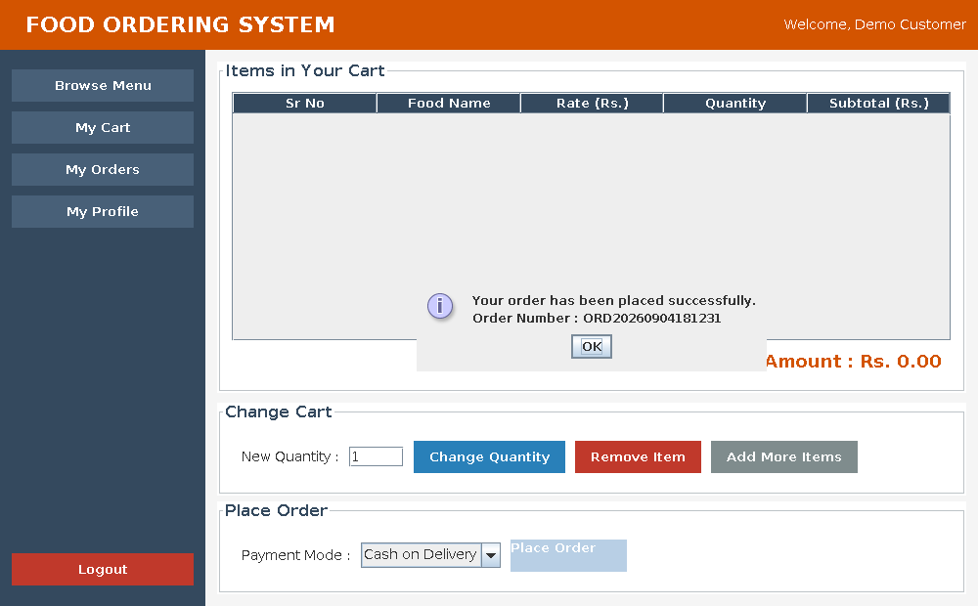
Fig. 7.5 Order placed with the order number
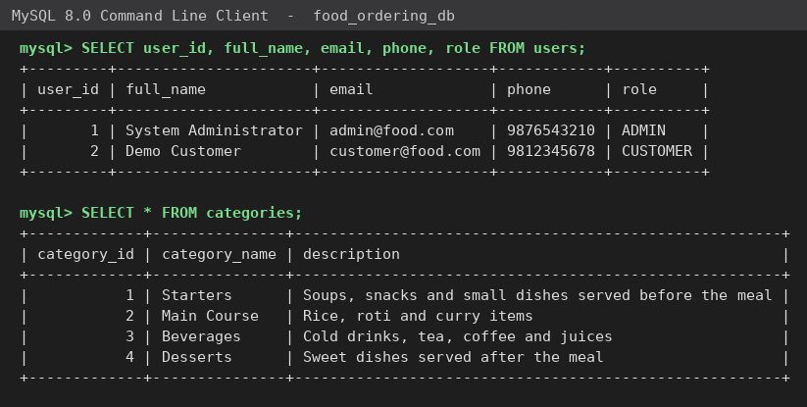
Fig. 7.6 Records of the users and categories tables

CHAPTER 8 : ANNEXURE
8.1 Progress Sheet
The progress sheet below records the stages of the project work as they were completed and signed by the internal project guide.
NAVSAHYADRI GROUP OF INSTITUTIONS
FACULTY OF MANAGEMENT – BCA
BCA-III Sem-V Project Work
Progress Sheet Academic Year (2026-2027)
Name of Student
Class | BCA-III Sem-V
Roll No. / PRN No.
Name of the Project Guide
Project Title | Food Ordering System
Front End | Java Swing
Back End | Java with MySQL (JDBC)

Sr. No. | Activities to be completed | Expected Date of completion | Actual Date of completion | Sign of Student | Sign of Internal Guide
1 | Meeting with the project guide and preliminary discussion
2 | Selection of the project topic and project synopsis
3 | Study of the existing system, objectives, scope and requirements
4 | Database design and ER diagram
5 | UML diagrams (use case, activity, sequence, class, component, deployment)
6 | First presentation – design of the system
7 | Coding of the login, customer and category modules
8 | Coding of the menu, cart, order, billing and admin order modules
9 | Testing of all the modules and correction of errors
10 | Second presentation – working of the project
11 | Preparing the draft copy of the project report
12 | Final submission of the report and the project demonstration

______________________  Internal Project Guide | ______________________  HOD - BCA | ______________________  Director

