A
PROJECT REPORT
ON
“ONLINE EXAMINATION SYSTEM”
IN PARTIAL FULFILMENT OF
BACHELOR OF COMPUTER APPLICATION
BY
MISS. ______________________________________
(Name of the Student)
T.Y. BCA Sem-V
Roll No : ____________ PRN No : ____________________
(A.Y. 2026-2027)
SUBMITTED TO
SAVITRIBAI PHULE PUNE UNIVERSITY, PUNE
THROUGH
Navsahyadri Education Society’s Group of Institutions
Faculty of Management – BCA


 | NAVSAHYADRI GROUP OF INSTITUTIONS  FACULTY OF MANAGEMENT – BCA  Approved by AICTE, New Delhi  Affiliated to Savitribai Phule Pune University  Address : Sr. No. 69, 70, 71 Naigaon, Nasarapur, Pune, Maharashtra – 412 213  Website : https://www.navsahyadri.edu.in | E-mail : director@navsahyadri.edu.in | 

Date: / /2027
CERTIFICATE
This is to certify that Miss. ________________________________________ , student of Navsahyadri Education Society’s Group of Institutions, Faculty of Management – BCA, Pune, of T.Y. BCA Sem-V, Roll No. __________ , PRN No. ____________________ , has satisfactorily completed the project work titled “ONLINE EXAMINATION SYSTEM” in partial fulfilment of the Bachelor of Computer Application course of Savitribai Phule Pune University for the academic year 2026-2027.
The project has been carried out by her under my guidance and supervision. The work submitted in this report is her own work and has not been submitted earlier to this university or to any other university for the award of any degree.
______________________  Prof. ___________________  Project Guide | ______________________  Prof. ___________________  HOD - BCA | ______________________  Dr. ____________________  Director

Internal / External Examiners
1. ______________________________ 2. ______________________________

DECLARATION
I, the undersigned, hereby declare that the project report titled “ONLINE EXAMINATION SYSTEM”, submitted to Savitribai Phule Pune University, Pune, in partial fulfilment of the requirement for the award of the degree of Bachelor of Computer Application, is my own work.
The Java desktop application described in this report, the MySQL database used by it and the diagrams, screenshots and test results given in this report are prepared by me during the project work. The information taken from books and websites has been properly listed in the References chapter.
This report has not been submitted earlier to this university or to any other university for the award of any degree, diploma or certificate.
Place : _______________
Date : _______________
______________________________
(Signature of the Student)
Miss. ______________________
T.Y. BCA Sem-V

ACKNOWLEDGEMENT
It gives me great pleasure to present this project report on the “Online Examination System”. Completing this project has helped me understand how a real desktop application is planned, designed, coded and tested, and I am thankful to everyone who helped me during this work.
First of all, I would like to thank my project guide Prof. ____________________ for the constant guidance and encouragement. Whenever I was stuck in the design of the database or in the Java code, the suggestions given by my guide helped me to solve the problem in a simple way.
I am also thankful to Prof. ____________________ , Head of the BCA Department, and to Dr. ____________________ , Director of Navsahyadri Education Society’s Group of Institutions, for providing the laboratory facilities and the environment needed to complete this project.
I would like to thank all the teaching and non-teaching staff of the BCA department for their help during the project work. I am also thankful to my friends and classmates who wrote the sample examinations in the application, pointed out mistakes in the screens and gave useful suggestions to improve it.
Finally, I am grateful to my parents for their support and patience throughout the duration of this project.

Miss. ______________________
T.Y. BCA Sem-V

INDEX
Chapter | Content | Page Number
Chapter 1 | Introduction
1.1 | Problem Statement
1.2 | Objectives
1.3 | Scope
1.4 | Modules
Chapter 2 | Design
2.1 | System Architecture
2.2 | UML Diagram
2.3 | Database Design
Chapter 3 | Implementation
3.1 | Frontend Development
3.2 | Backend Development
3.3 | Database Tables
Chapter 4 | Testing
4.1 | Test Cases
4.2 | Results
Chapter 5 | User Manual
5.1 | User Interface Screens (Input)
5.2 | Output Screens with Data
 | References

CHAPTER 1 : INTRODUCTION
The Online Examination System is a desktop application written in Java that lets a college conduct multiple choice examinations on a computer instead of on paper. The application is used by two kinds of people. The administrator creates the subjects, the examinations and the questions, and looks at the results of every student. The student registers an account, logs in, writes the examinations that are open, and sees the marks together with the full answer sheet as soon as the paper is submitted.
The application is built with Java Swing for the screens, JDBC for the database connection and MySQL for storing the data. Everything the application needs is kept in one database called online_exam_db, which has six tables. The application runs from a single executable JAR file, so it can be taken to any computer that has Java and MySQL installed.
The most important part of the project is what happens when a student presses the Submit button. The application has to write one row in the results table and one row in the answers table for every question of the paper. These rows belong together, so they are written inside a single database transaction. If any one of them fails, the whole attempt is rolled back and the database is left exactly as it was before the student pressed Submit. This is explained in detail in Chapter 3.
1.1 Problem Statement
In the traditional examination system almost all the work is done by hand. The teacher has to type the question paper, take printouts for every student, arrange the examination hall, collect the answer sheets, check every sheet one by one, add up the marks and then prepare the result list. The same question paper also has to be stored somewhere so that it can be used again later.
This way of working creates several problems :
• It takes a lot of time. Checking fifty answer sheets of a twenty question paper means two hundred and fifty individual comparisons, and every one of them is done by a person.
• Mistakes happen. A tick mark can be missed, a total can be added wrongly, or a mark can be written in the wrong row of the result list.
• A large amount of paper is used for every examination, and the printed papers have to be stored for years.
• The student has to wait for several days to know the result, and usually never gets to see which particular questions were answered wrongly.
• Old question papers, old answer sheets and old result lists are kept in separate files, so finding the record of one student of one examination takes a long time.
Because of these problems there is a need for a system that keeps the questions in a database, shows them on the screen one at a time, checks the answers by itself, calculates the marks immediately and stores every attempt so that the result can be looked at again at any time. That is exactly what this project does.
1.2 Objectives
The objectives of the Online Examination System were fixed before the coding was started. Each one of them is implemented in the application and can be checked on the screen.
No | Objective | How it is achieved in the project
1 | To conduct examinations on a computer | The ExamWindow screen shows one question at a time with its four options and a countdown timer.
2 | To reduce paperwork and manual effort | No paper is used at all. Questions, answers and results are stored in MySQL.
3 | To provide a secure login for both kinds of user | The users table keeps a role column. The same login screen opens the admin dashboard or the student dashboard according to that role.
4 | To let the administrator manage the question bank | The Manage Questions screen can add, update and delete questions of any examination.
5 | To evaluate objective type answers automatically | Question.isCorrect() compares the selected letter with the correct_option column of the questions table.
6 | To calculate the marks and show the result at once | ResultDAO.submitExam() counts the correct answers, works out the percentage and the pass or fail status, and the result window opens immediately.
7 | To keep a permanent record of every attempt | One row is written in results and one row per question in answers, so the whole answer sheet can be opened again later.
8 | To manage student information | Students register themselves and can change their own details on the My Profile screen. The administrator can see the list of all registered students.
9 | To improve the accuracy of the examination process | The marks are calculated by the program from the stored correct options, so no addition mistake is possible.
10 | To keep the data consistent even when something goes wrong | The result row and the answer rows are written inside one transaction, which is rolled back completely if any statement fails.
1.3 Scope
The scope of the project describes what the application does and, just as importantly, what it does not do. Being clear about this was useful while coding, because it kept the project at a size that could actually be finished and tested properly.
What the system does
• A student can create an account from the login screen. The email must be unique, which is enforced by a unique key in the database as well as by a check in the code.
• The administrator logs in with the same screen and gets a different dashboard.
• The administrator can add, update and delete subjects, examinations and questions.
• Every examination belongs to one subject and carries a duration in minutes, the marks of one question and a status of Active or Inactive.
• A student sees only the examinations that are Active and that actually contain at least one question.
• During an examination a countdown timer runs at the top of the screen, the numbered buttons on the right show which questions have been answered, and the student can move freely between the questions.
• When the time runs out the paper is submitted automatically.
• The marks, the percentage and the pass or fail status are calculated by the application and stored.
• Both the student and the administrator can open the full answer sheet of any attempt, which shows every question, the option that was chosen and the correct option.
• A student can change the own name, roll number, course and password.
What is outside the scope
• The system supports multiple choice questions with exactly four options. Descriptive answers are not handled.
• It is a desktop application that connects to a MySQL server. It is not a website and does not work over the internet.
• The passwords are stored as plain text in the database, which keeps the project simple enough for a first database application. Hashing the passwords is listed as a future improvement.
• There is no email or SMS notification, no online payment and no printing of certificates.
• Images and mathematical formulas cannot be put inside a question, only plain text.
1.4 Modules
The application is divided into six modules. The division follows the modules that were listed in the project synopsis, and each module corresponds to one or more screens and to one DAO class in the code.
No | Module | What the module does | Main classes
1 | Admin Module | Lets the administrator log in and reach every management screen from one dashboard. | LoginFrame, AdminDashboard, UserDAO
2 | Student Module | Registration, login, the student dashboard and the My Profile screen. | RegisterFrame, StudentDashboard, ProfilePanel, UserDAO
3 | Question Management Module | Adding, updating, deleting and viewing the questions of an examination together with their four options and the correct answer. | QuestionPanel, QuestionDAO, Question
4 | Examination Module | Creating examinations under a subject, and the examination screen itself with the timer, the question palette and the submit confirmation. | SubjectPanel, ExamPanel, AvailableExamPanel, ExamWindow, ExamSession, ExamDAO
5 | Result Module | Checking the answers, calculating the marks and the percentage, deciding pass or fail, and showing the result and the answer sheet. | ResultDAO, Result, AnswerRecord, ResultDialog, MyResultsPanel, AdminResultPanel
6 | Database Management Module | Opening the JDBC connection, running every SQL statement through a PreparedStatement and controlling the transaction of a submitted paper. | DBConnection, all five DAO classes
The six modules are not separate programs. They are separate parts of the same application, and they all use the same database connection class. How they are arranged in layers is shown in the System Architecture in Chapter 2.

CHAPTER 2 : DESIGN
2.1 System Architecture
The application follows a three layer architecture. Each layer has one job, and a layer only talks to the layer directly below it. This keeps the code tidy and makes it easy to find where a change has to be made.
Layer | What it contains | Rule that is followed
Presentation Layer | The fourteen Swing screens : LoginFrame, RegisterFrame, the two dashboards and the panels and dialogs inside them. | A screen never writes SQL. It reads what the user typed, checks it and then calls a DAO method.
Business Layer | The five DAO classes, the seven model classes and the two helper classes Validator and UITheme. | The DAO classes hold every SQL statement of the project. The model classes only carry data between the layers.
Data Access Layer | DBConnection and the JDBC classes it uses : DriverManager, Connection, PreparedStatement and ResultSet. | Only this layer knows the database URL, the user name and the password. Changing the database means changing one file.
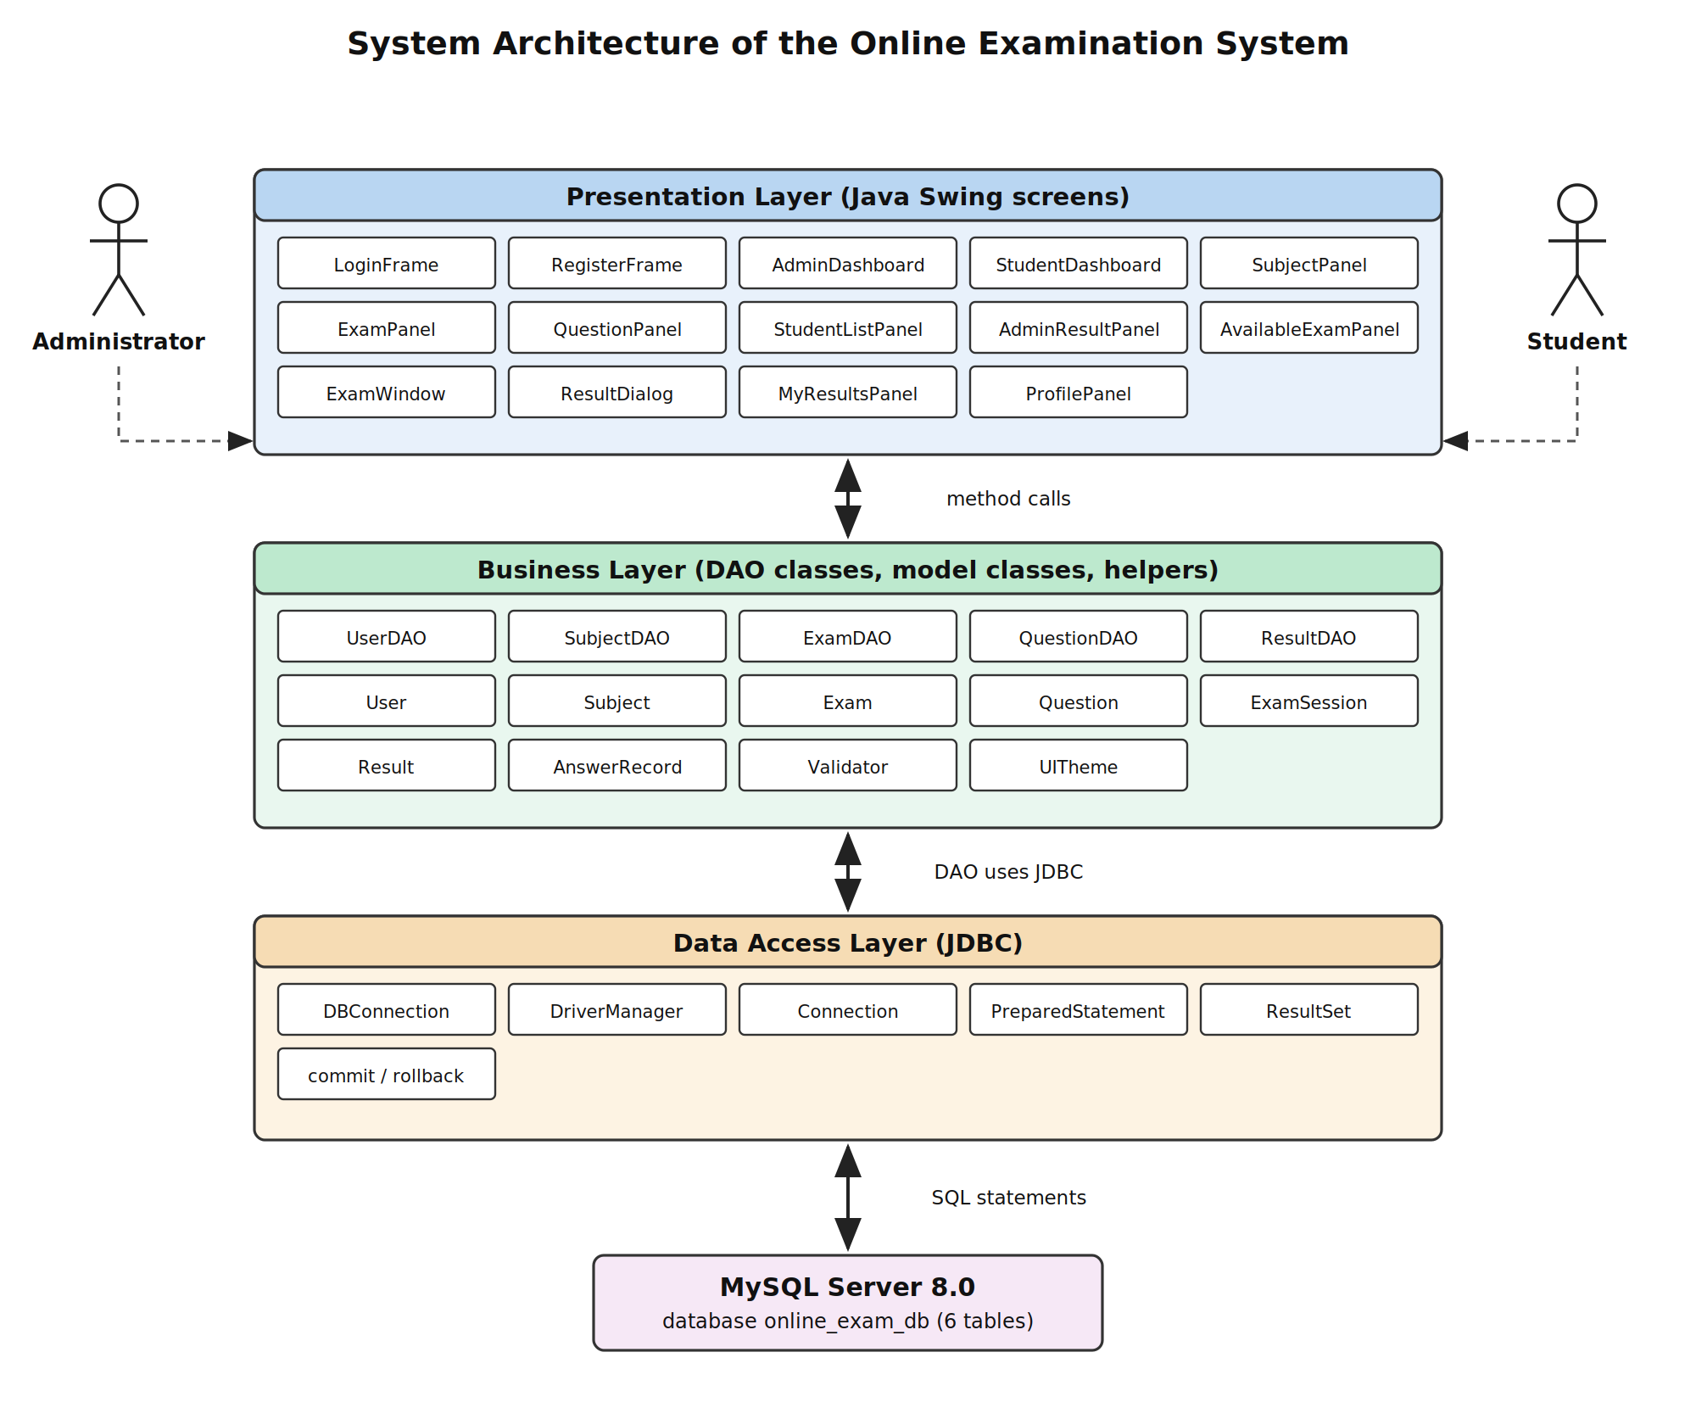
Fig 2.1 : Three layer architecture of the Online Examination System
The arrows in the figure show that the flow is always downwards and then back up again. A student clicks a button on a screen, the screen calls a DAO, the DAO runs a SQL statement through JDBC, MySQL answers, the DAO turns the rows into model objects and the screen displays them. No screen ever opens a database connection of its own.
Why this arrangement was chosen
• If a SQL query has to be changed, only one DAO method changes and no screen has to be touched.
• If a screen has to be redesigned, the DAO methods it calls stay exactly the same.
• The same DAO method is reused by more than one screen. For example ResultDAO.getAnswerSheet() is used by the student result window and by the administrator result screen.
• Testing is easier, because the DAO classes can be called from a small test program without opening any window. This is how the tests in Chapter 4 were run.
2.2 UML Diagram
Four UML diagrams were drawn for this project. The use case diagram shows what the two actors can do, the class diagram shows the classes and how they are connected, the sequence diagrams show the order of the method calls for the two most important operations, and the activity diagram shows the flow of an examination from start to finish.
2.2.1 Use Case Diagram
There are two actors. The administrator manages the content of the system, the student uses it. Login, Logout and View Answer Sheet are shared, because both actors use them. Submitting the paper is shown with an include relationship, because a student can never write an examination without finishing it in one of the two ways : by pressing Submit or by letting the time run out.
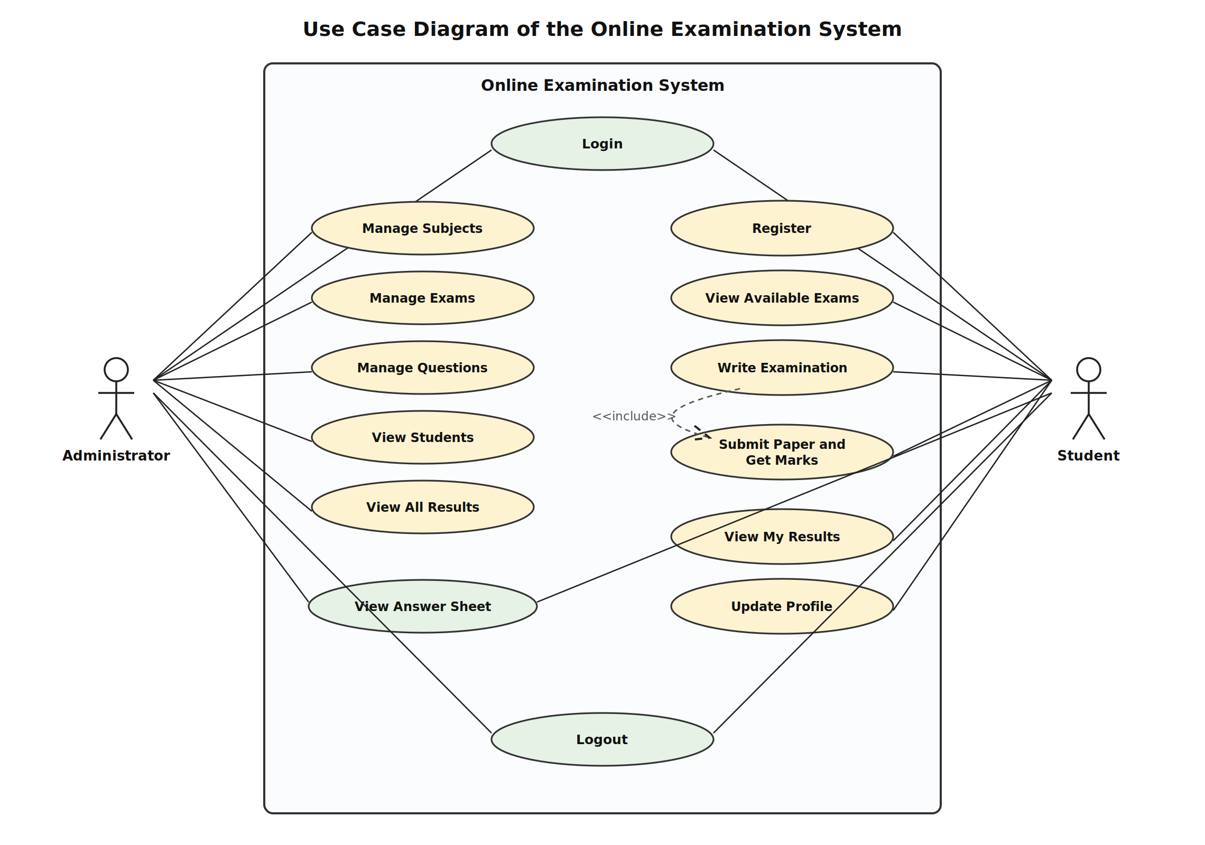
Fig 2.2 : Use case diagram
Actor | Use cases
Administrator | Login, Manage Subjects, Manage Exams, Manage Questions, View Students, View All Results, View Answer Sheet, Logout
Student | Register, Login, View Available Exams, Write Examination, Submit Paper and Get Marks, View My Results, View Answer Sheet, Update Profile, Logout
2.2.2 Class Diagram
The class diagram shows the seven model classes in blue and the five DAO classes in green. Every model class carries one row of a table, except ExamSession, which does not correspond to any table. ExamSession exists only in memory while a student is writing a paper. It holds the examination, the list of questions and a map that remembers which option was selected for which question. When the paper is submitted this map is turned into rows of the answers table.
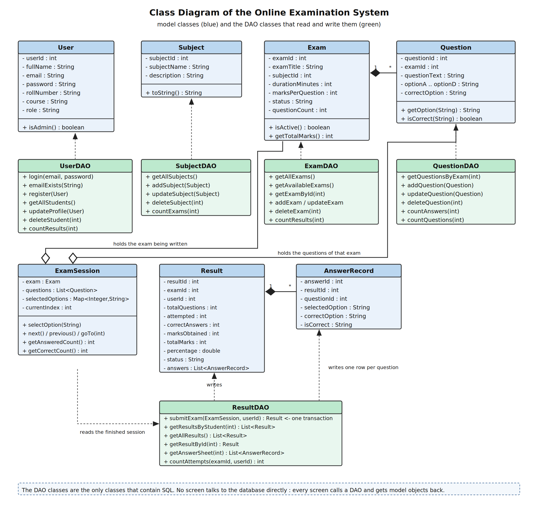
Fig 2.3 : Class diagram
The filled diamonds are composition. One Exam is made up of many Question objects, and one Result is made up of many AnswerRecord objects. If the Exam is deleted its questions have no meaning any more, which is why ExamDAO.deleteExam() removes both of them in one transaction. The hollow diamonds are aggregation : ExamSession holds an Exam and its questions, but it does not own them, they exist in the database before and after the examination.
2.2.3 Sequence Diagram – Login
The login sequence is short but it shows the rule of the architecture clearly. The screen never writes SQL. It passes the email and the password to UserDAO, and UserDAO is the only object that talks to MySQL.
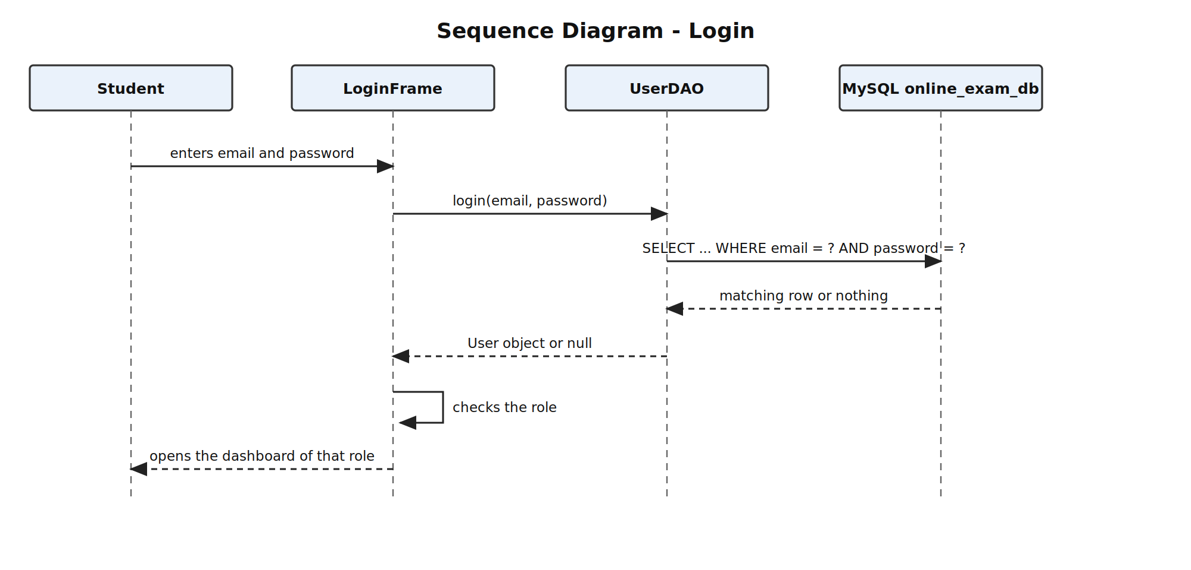
Fig 2.4 : Sequence diagram of the login
2.2.4 Sequence Diagram – Writing and Submitting an Examination
This is the main sequence of the whole project. It starts when the student selects an examination and ends when the Result object comes back to the screen. The dashed box near the bottom is the transaction : four JDBC calls that either all succeed or all get undone.
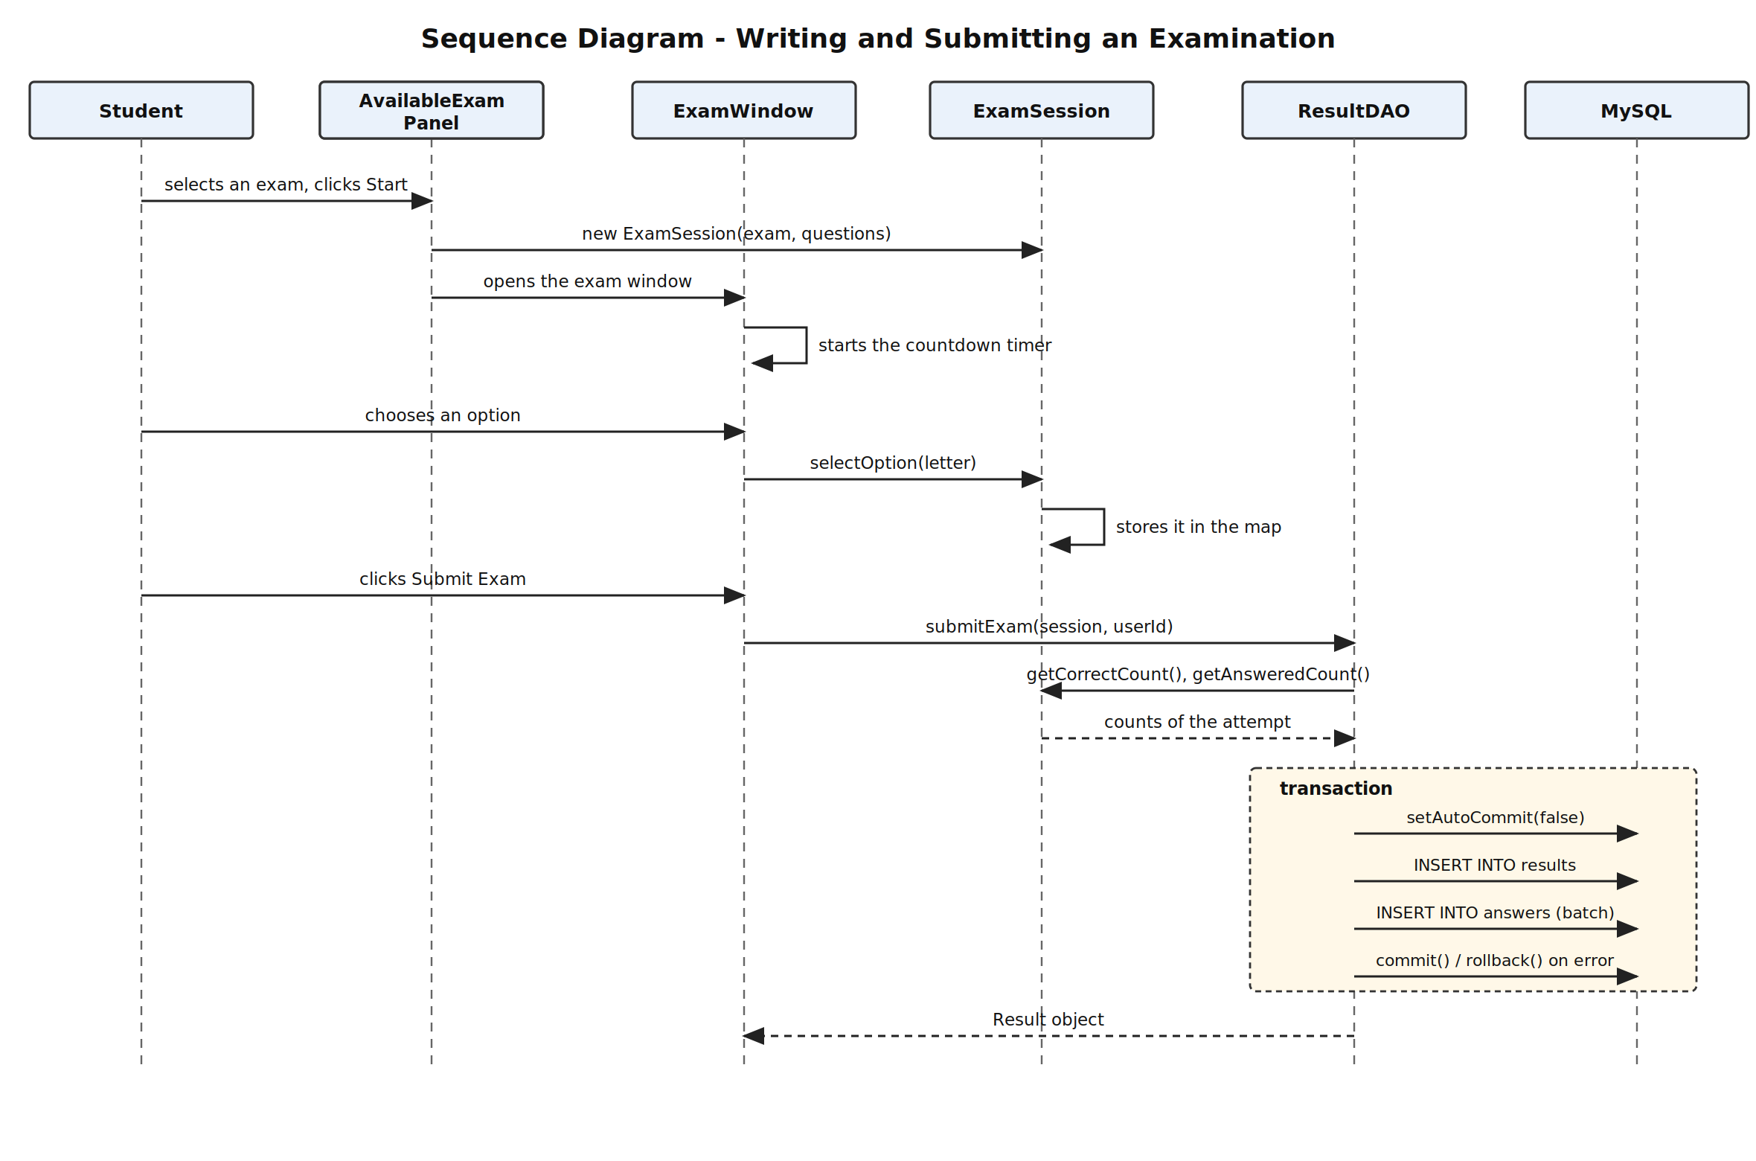
Fig 2.5 : Sequence diagram of writing and submitting an examination
2.2.5 Activity Diagram
The activity diagram shows the same operation as a flow of decisions. The three diamonds are the three checks the application makes : is the examination still Active, has the student selected an option, and has the time run out or has Submit been pressed. The last diamond is the important one, because it shows that the student sees a result only if both inserts succeeded.
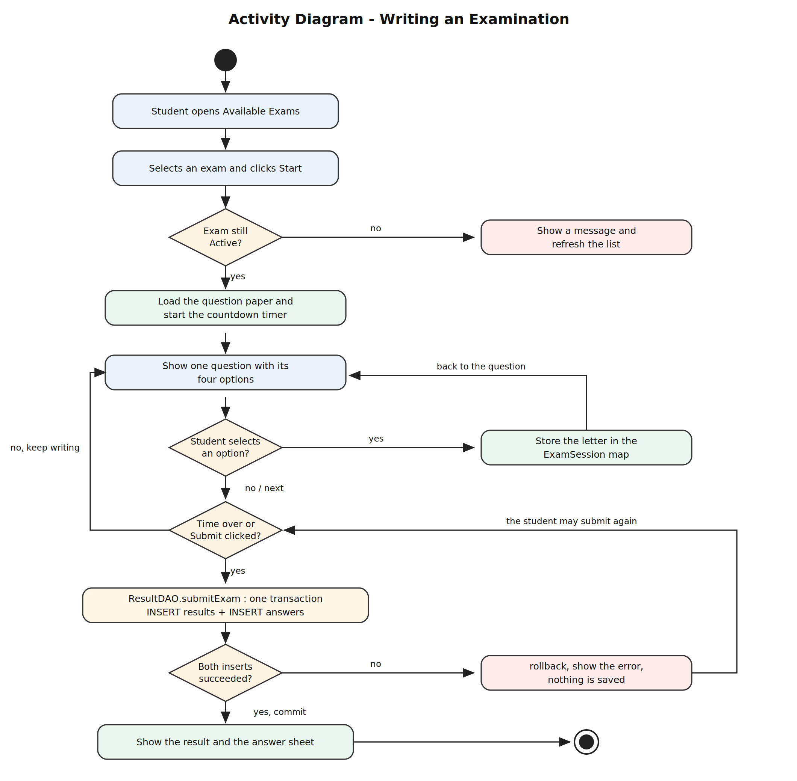
Fig 2.6 : Activity diagram of writing an examination
2.3 Database Design
The database is called online_exam_db and it has six tables. Every table has an auto increment integer as its primary key, which keeps the foreign keys simple. There are six foreign keys and two unique keys.
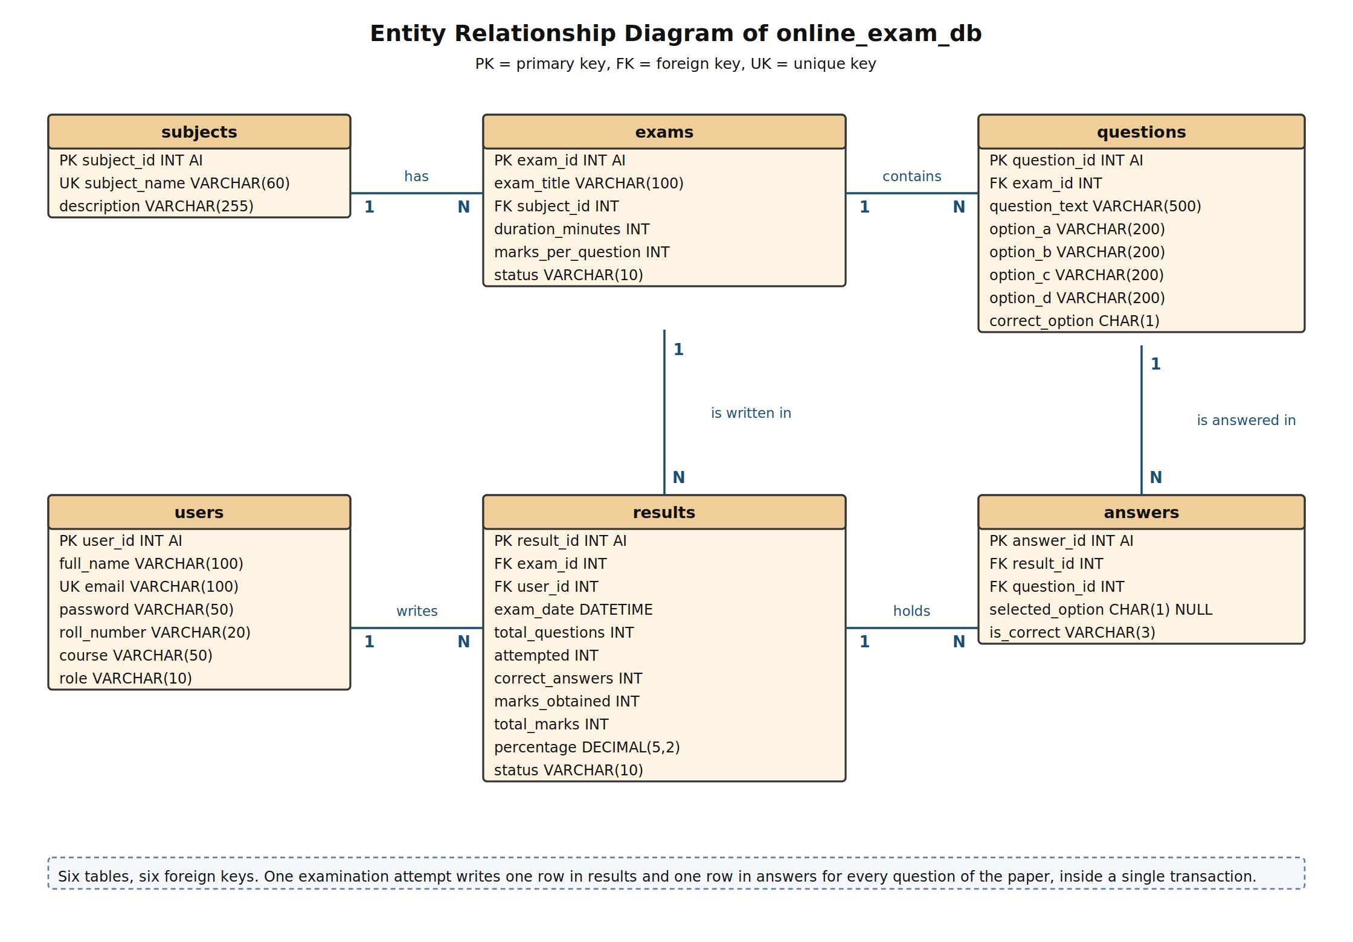
Fig 2.7 : Entity relationship diagram of online_exam_db
Relationships between the tables
Relationship | Type | Meaning
subjects – exams | One to many | One subject can have many examinations. Every examination belongs to exactly one subject.
exams – questions | One to many | One examination contains many questions. A question belongs to only one examination.
users – results | One to many | One student can write many examinations, so one user row can have many result rows.
exams – results | One to many | One examination is written by many students, so one exam row can have many result rows.
results – answers | One to many | One attempt has exactly as many answer rows as there were questions in the paper.
questions – answers | One to many | The same question appears on the answer sheet of every student who wrote that paper.
Normalisation
The design was checked against the first three normal forms.
Normal form | Rule | How the design satisfies it
First normal form | Every column holds a single value and there are no repeating groups. | The four options of a question are four separate columns, not one column with commas in it. A student writing three examinations produces three rows in results, not three columns.
Second normal form | The table is in 1NF and every non key column depends on the whole primary key. | Every primary key is a single auto increment column, so a partial dependency is not possible anywhere in this design.
Third normal form | The table is in 2NF and no non key column depends on another non key column. | The name of the subject is stored only in subjects. The exams table keeps only subject_id. In the same way the name of a student is stored only in users, and results keeps only user_id.
One design decision is worth explaining. The results table stores total_questions, attempted, correct_answers, marks_obtained, total_marks and percentage, even though all of them could be worked out again from the answers table. They are stored on purpose. A result is a permanent record of what happened on that day. If the administrator later changes the marks per question of the examination, or corrects a wrong answer key, the old results must not change. Keeping the calculated values in the results row makes the old result safe.
Constraints used in the database
• Six primary keys, all of them AUTO_INCREMENT integers.
• Six foreign keys : exams.subject_id, questions.exam_id, results.exam_id, results.user_id, answers.result_id and answers.question_id.
• Two unique keys : users.email and subjects.subject_name, so no two accounts can share an email and no two subjects can share a name.
• NOT NULL on every column that the application always fills.
• DEFAULT values on users.role, exams.marks_per_question and exams.status, so a row inserted without them still makes sense.
• answers.selected_option is the only column that is allowed to be NULL. A NULL there means that the student did not answer that question at all, which is different from answering it wrongly.

CHAPTER 3 : IMPLEMENTATION
This chapter describes how the design of Chapter 2 was turned into working code. The project contains thirty Java classes arranged in six packages, and one SQL script that creates the database. The code shown in this chapter is taken directly from the project, it is not rewritten for the report.
Package | Classes | Purpose
com.onlineexam | MainApp | Checks the database connection and opens the login window.
com.onlineexam.db | DBConnection | Opens the JDBC connection to MySQL.
com.onlineexam.model | User, Subject, Exam, Question, ExamSession, Result, AnswerRecord | Carry the data between the layers.
com.onlineexam.dao | UserDAO, SubjectDAO, ExamDAO, QuestionDAO, ResultDAO | Hold every SQL statement of the project.
com.onlineexam.ui | LoginFrame, RegisterFrame, AdminDashboard, StudentDashboard, SubjectPanel, ExamPanel, QuestionPanel, StudentListPanel, AdminResultPanel, AvailableExamPanel, ExamWindow, ResultDialog, MyResultsPanel, ProfilePanel | The fourteen Swing screens.
com.onlineexam.util | Validator, UITheme | Input checks, and the common colours, fonts and formatting helpers.
3.1 Frontend Development
The user interface is built with Java Swing, which is part of the standard Java library, so no extra library has to be installed. Every window is a JFrame or a JDialog, and the screens inside a dashboard are JPanel objects held in a CardLayout.
3.1.1 Swing components used
Component | Where it is used
JFrame | LoginFrame, AdminDashboard and StudentDashboard are the three main windows.
JDialog | RegisterFrame, ExamWindow and ResultDialog are modal dialogs, so the window behind them cannot be used until they are closed.
CardLayout | Both dashboards keep every screen in one panel and show only one at a time when a menu button is clicked.
GridBagLayout | Every form, so the labels and the boxes line up in two columns.
BorderLayout | The overall shape of each screen : title at the top, table in the middle, buttons at the bottom.
BoxLayout | The vertical menu strip on the left of the dashboards and the list of the four options in the examination window.
JTable with DefaultTableModel | Every list in the application. isCellEditable() is overridden to return false, so the user can read the table but cannot type into it.
JRadioButton with ButtonGroup | The four options of a question. The button group makes sure that only one of them can be selected.
javax.swing.Timer | The countdown of the examination. It fires once a second on the event dispatch thread.
JOptionPane | Every message, warning and confirmation in the application.
JComboBox | Choosing the subject of an examination, the examination whose questions are being edited, and the correct option A, B, C or D.
3.1.2 The examination screen
The examination screen is the most detailed screen of the project. It is built from four parts inside a BorderLayout : the blue header with the title and the timer, the question and its options in the middle, the numbered question palette on the right and the four buttons at the bottom.
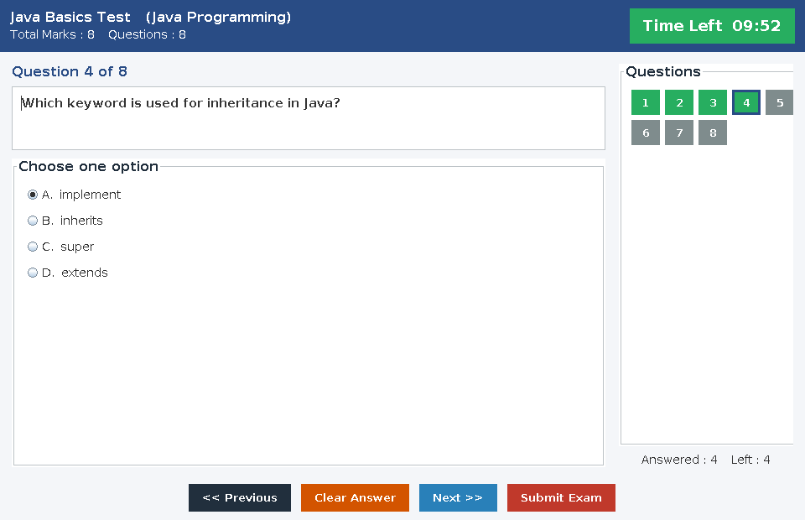
Fig 3.1 : The examination screen while a paper is being written
showQuestion() is the method that puts one question on the screen. It reads the current question from the ExamSession, fills the four radio buttons, selects the option that was chosen earlier if the student is coming back to this question, and switches the Previous and Next buttons on or off.
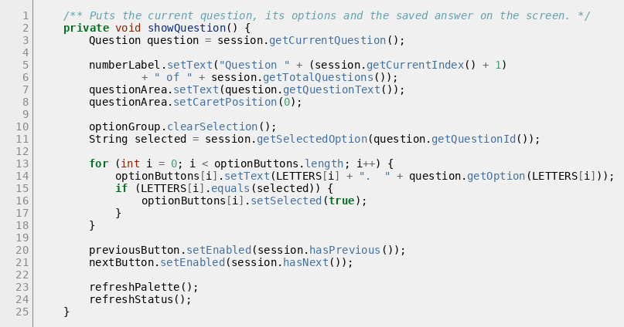
Fig 3.2 : ExamWindow.showQuestion()
3.1.3 The countdown timer
The timer is a javax.swing.Timer, not a normal Java thread. This matters, because a Swing timer fires its action on the event dispatch thread, which is the only thread that is allowed to change what is on the screen. So the label can be updated straight from inside the timer without any extra code. When the remaining time reaches one minute the label changes colour, and when it reaches zero the paper is submitted by the application itself.
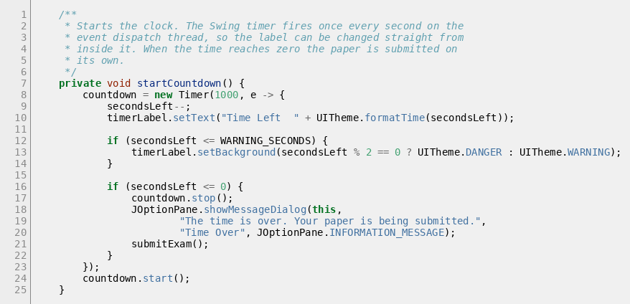
Fig 3.3 : ExamWindow.startCountdown()
3.1.4 Input validation on the screens
Nothing is sent to the database before it has been checked. The Validator class holds the checks that are used by more than one screen.
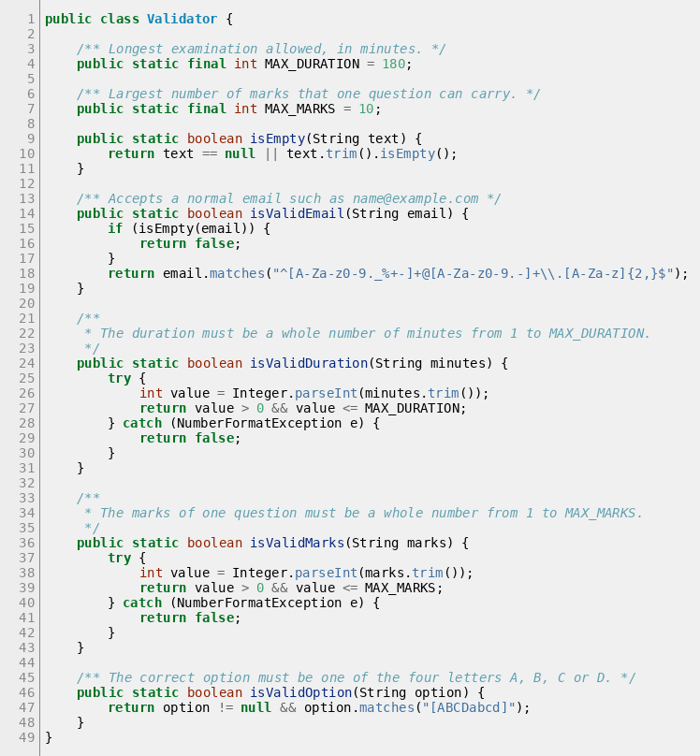
Fig 3.4 : The Validator class
Field | Check that is made | Message the user sees
Email on the login screen | Must not be empty | Please enter both the email and the password.
Email on the registration screen | Must match the pattern name@example.com | Please enter a valid email address, for example name@example.com
Password on registration | At least 4 characters and both boxes must be the same | The two passwords do not match.
Duration of an examination | A whole number from 1 to 180 | The duration must be a whole number of minutes between 1 and 180.
Marks per question | A whole number from 1 to 10 | The marks of one question must be a whole number between 1 and 10.
Question text | Not empty and at most 500 characters | The question is too long. Please keep it under 500 characters.
The four options | None of them may be empty | All the four options are required.
Correct option | Must be A, B, C or D | The correct option must be A, B, C or D.
The login method of the screen shows how a check and a DAO call are put together. Notice that the screen decides which dashboard to open by asking the User object for its role, so the same screen serves both kinds of user.
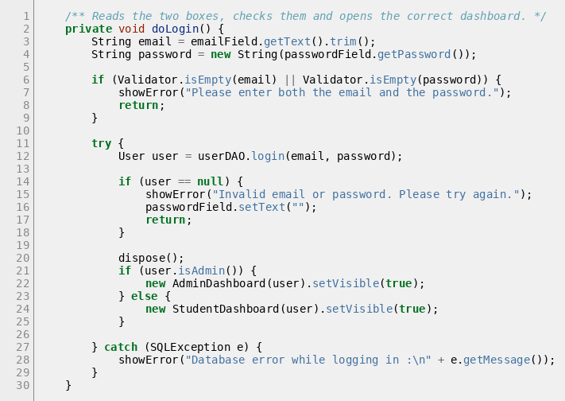
Fig 3.5 : LoginFrame.doLogin()
3.2 Backend Development
The backend is the DAO layer together with the JDBC connection. Every SQL statement in the project is in one of the five DAO classes, and every one of them is run through a PreparedStatement.
3.2.1 The database connection
DBConnection is the only class that knows the URL, the user name and the password of the database. Changing the database server therefore means changing one file.
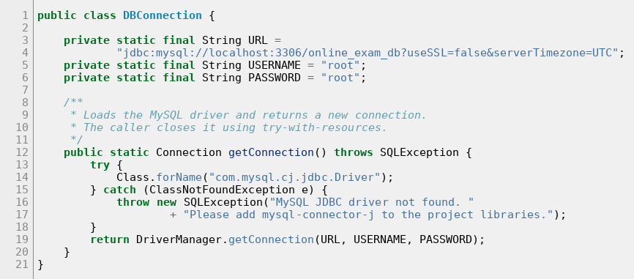
Fig 3.6 : The DBConnection class
3.2.2 Why PreparedStatement is used everywhere
A PreparedStatement sends the SQL and the values separately. The value never becomes part of the SQL text, so it cannot change the meaning of the statement. This is what stops SQL injection. If a user types admin@exam.com' OR '1'='1 into the email box, the whole string is compared with the email column as one value, and no row matches. This was tested and is reported as test case TC-07 in Chapter 4.
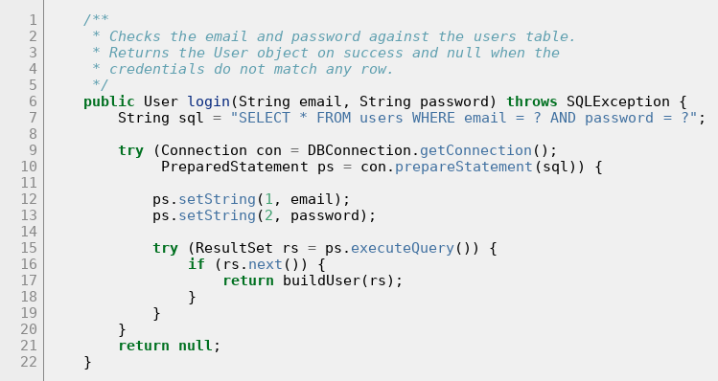
Fig 3.7 : UserDAO.login() uses a PreparedStatement
The registration method is written in the same way. The role is fixed inside the SQL text as STUDENT and is not taken from the screen, so a person who registers cannot make themselves an administrator.
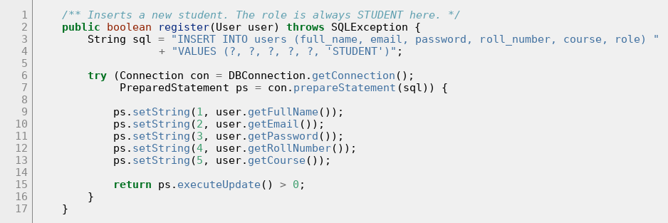
Fig 3.8 : UserDAO.register() always creates a student
3.2.3 Reading the examinations a student may write
ExamDAO builds one SELECT that is used by all the exam screens. It joins the subjects table so that the subject name can be shown, and it counts the rows of the questions table in a subquery so that the number of questions and the total marks can be displayed without running another query for every examination. getAvailableExams() adds two conditions to that SELECT : the examination must be Active and it must have at least one question.
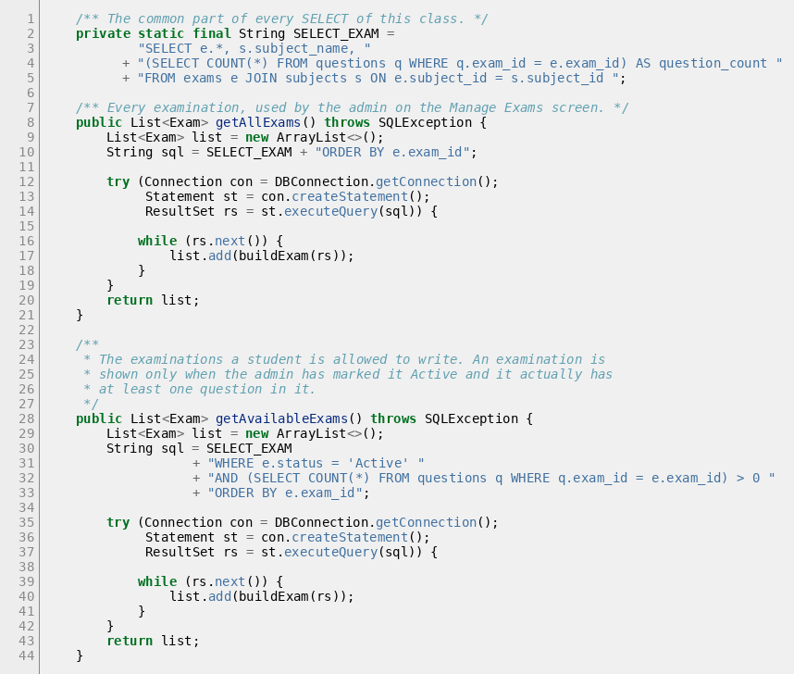
Fig 3.9 : The SELECT used by ExamDAO
3.2.4 Submitting a paper : the transaction
ResultDAO.submitExam() is the most important method in the project. One finished attempt produces one row in the results table and one row in the answers table for every question of the paper. A result with only half of its answers stored would be wrong, so the rows are written inside a single transaction.
The method works in five steps. First it counts the answers and works out the marks, the percentage and the pass or fail status. Then it switches off auto commit, so that nothing is saved on its own. Then it inserts the results row and reads back the result_id that MySQL generated for it. Then it inserts one answers row per question as a single batch. Finally it commits, or, if any step threw an exception, it rolls everything back.
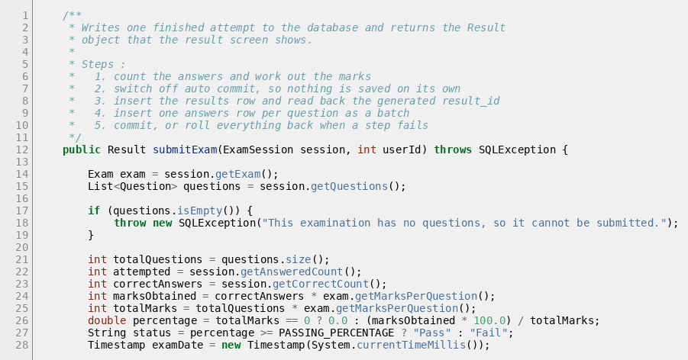
Fig 3.10 : submitExam() part 1 – counting the answers and working out the marks
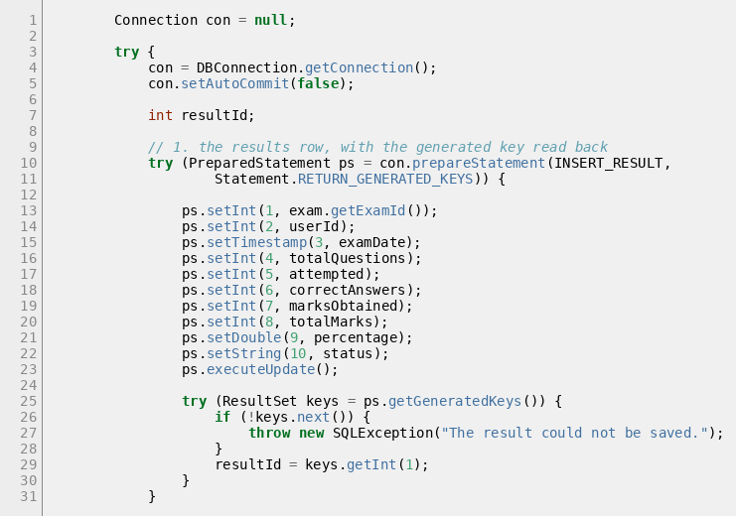
Fig 3.11 : submitExam() part 2 – the results row and its generated key
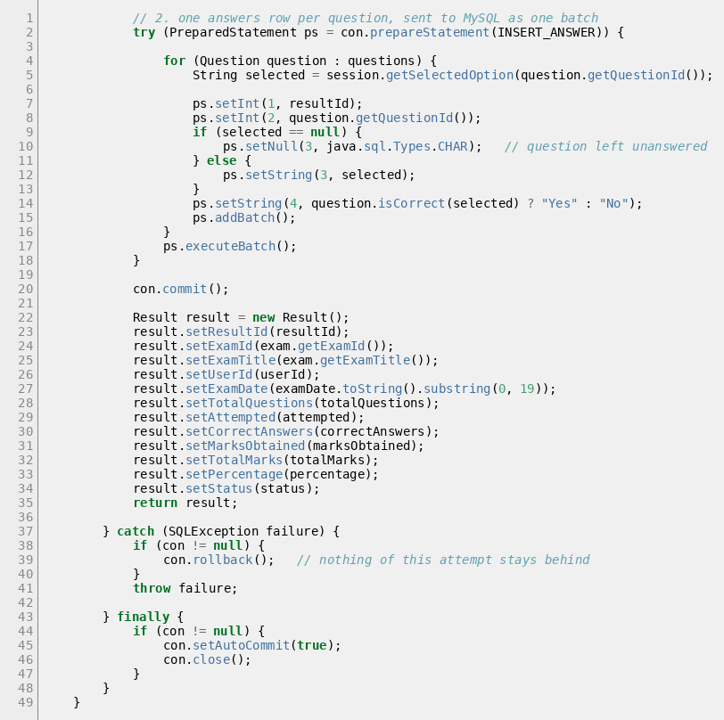
Fig 3.12 : submitExam() part 3 – the batch of answer rows, the commit and the rollback
Three JDBC features are used here and each of them is worth pointing out :
• Statement.RETURN_GENERATED_KEYS makes MySQL send back the result_id of the row that was just inserted. Without it the application would have to run another SELECT to find out which row it had created, and between the two statements another student could have submitted a paper.
• addBatch() and executeBatch() send all the answer rows to the server in one round trip instead of one statement per question. For an eight question paper this is one call instead of eight.
• setNull(3, Types.CHAR) is used for a question the student did not answer. Storing NULL is different from storing an empty string, and it is what lets the answer sheet show “Not Attempted” instead of “Wrong”.
The rollback was tested on purpose and not only assumed to work. The test is described as test case TC-24 in Chapter 4 : an attempt was submitted for an examination whose marks per question was set so high that marks_obtained could not fit in the column. The insert failed, the exception was thrown, and counting the rows of both tables afterwards showed that nothing at all had been written.
3.2.5 Checking the answers
The checking itself is done in two small methods. ExamSession.getCorrectCount() walks through the questions and asks each one whether the option the student selected is the right one. Question.isCorrect() does the comparison and returns false for a question that was never answered, because a null option can never be correct.
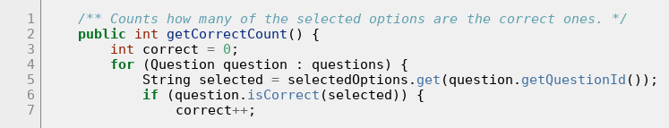
Fig 3.13 : ExamSession.getCorrectCount()
The marks are then a simple multiplication : marks obtained is the number of correct answers times the marks of one question, and the percentage is the marks obtained out of the total marks. A student passes with forty percent or more, which is kept in one constant named PASSING_PERCENTAGE so that the rule appears in only one place in the code.
3.2.6 Protecting the data before a delete
MySQL would refuse to delete a row that another table still points at, and the user would see a foreign key error message that means nothing to them. So every delete screen counts the depending rows first and shows a clear message instead.
Delete | Method that is called first | Message when it is not allowed
A subject | SubjectDAO.countExams() | This subject cannot be deleted because N examination(s) belong to it.
An examination | ExamDAO.countResults() | This examination cannot be deleted because N student result(s) belong to it. Mark it Inactive instead.
A question | QuestionDAO.countAnswers() | This question cannot be deleted because it already appears on N answer sheet(s).
A student | UserDAO.countResults() | This student cannot be deleted because N examination result(s) belong to this account.
Deleting an examination that has no results is allowed, and it also removes the questions of that examination. Those are two DELETE statements, so ExamDAO.deleteExam() runs them inside a transaction as well. The questions must go first because their foreign key points at the examination.
3.3 Database Tables
The database is created by running the script database/online_exam_db.sql. The script drops the database if it already exists, creates the six tables in the correct order and inserts the sample data that is used for testing.
Table 1 : users
Column | Data type | Key | Description
user_id | INT AUTO_INCREMENT | PK | Number given by MySQL to every account.
full_name | VARCHAR(100) |  | Name of the administrator or of the student.
email | VARCHAR(100) | UK | Used as the login name. No two accounts may share it.
password | VARCHAR(50) |  | Password of the account.
roll_number | VARCHAR(20) |  | Roll number of the student. Empty for the administrator.
course | VARCHAR(50) |  | Course of the student, for example T.Y. BCA.
role | VARCHAR(10) |  | ADMIN or STUDENT. Decides which dashboard opens.
Table 2 : subjects
Column | Data type | Key | Description
subject_id | INT AUTO_INCREMENT | PK | Number of the subject.
subject_name | VARCHAR(60) | UK | Name of the subject, for example Java Programming.
description | VARCHAR(255) |  | Short description of what the subject covers.
Table 3 : exams
Column | Data type | Key | Description
exam_id | INT AUTO_INCREMENT | PK | Number of the examination.
exam_title | VARCHAR(100) |  | Title shown to the student, for example Java Basics Test.
subject_id | INT | FK | Points at subjects.subject_id.
duration_minutes | INT |  | How long the examination lasts. The timer counts this down.
marks_per_question | INT |  | Marks carried by one question. Default 1.
status | VARCHAR(10) |  | Active or Inactive. A student sees only the Active ones.
Table 4 : questions
Column | Data type | Key | Description
question_id | INT AUTO_INCREMENT | PK | Number of the question.
exam_id | INT | FK | Points at exams.exam_id.
question_text | VARCHAR(500) |  | The question itself.
option_a | VARCHAR(200) |  | Text of option A.
option_b | VARCHAR(200) |  | Text of option B.
option_c | VARCHAR(200) |  | Text of option C.
option_d | VARCHAR(200) |  | Text of option D.
correct_option | CHAR(1) |  | A, B, C or D. Always stored in upper case.
Table 5 : results
Column | Data type | Key | Description
result_id | INT AUTO_INCREMENT | PK | Number of the attempt.
exam_id | INT | FK | Which examination was written.
user_id | INT | FK | Which student wrote it.
exam_date | DATETIME |  | Date and time at which the paper was submitted.
total_questions | INT |  | Number of questions in the paper.
attempted | INT |  | How many of them the student answered.
correct_answers | INT |  | How many of the answers were right.
marks_obtained | INT |  | correct_answers multiplied by marks_per_question.
total_marks | INT |  | total_questions multiplied by marks_per_question.
percentage | DECIMAL(5,2) |  | Marks obtained out of the total marks.
status | VARCHAR(10) |  | Pass when the percentage is 40 or more, otherwise Fail.
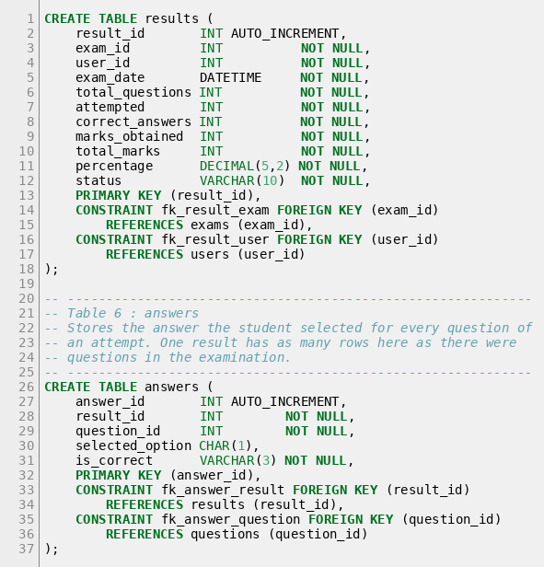
Fig 3.14 : The CREATE TABLE statements of the results and answers tables
Table 6 : answers
Column | Data type | Key | Description
answer_id | INT AUTO_INCREMENT | PK | Number of the answer row.
result_id | INT | FK | Which attempt this answer belongs to.
question_id | INT | FK | Which question was answered.
selected_option | CHAR(1) NULL |  | The letter the student chose. NULL when the question was left unanswered.
is_correct | VARCHAR(3) |  | Yes or No, worked out when the paper is submitted.
Sample data loaded by the script
Table | Rows inserted | What they contain
users | 3 | One administrator and two students.
subjects | 3 | Java Programming, Database Management, Computer Networks.
exams | 3 | Java Basics Test (Active), SQL Fundamentals Test (Active), Networking Basics Test (Inactive, used to test that a student does not see it).
questions | 20 | Eight, eight and four questions for the three examinations.
results | 0 | Empty. The rows are created when a student writes a paper.
answers | 0 | Empty, for the same reason.
Account | Email | Password
Administrator | admin@exam.com | admin123
Student 1 | student@exam.com | stud123
Student 2 | ankita@exam.com | ankita123

CHAPTER 4 : TESTING
Testing was done in two ways. First every screen was used by hand, the way a student or an administrator would use it. Then a test program was written that calls the DAO classes directly, and a second test program was written that drives the real Swing screens by clicking the buttons and typing into the boxes. Writing the test programs took time, but it meant that after every change the whole application could be checked again in a few minutes instead of being clicked through by hand.
Item | Detail
Java version | JDK 21
Database | MySQL 8.0, database online_exam_db
Build tool | Apache Maven 3.9, producing online-examination-system.jar
Automated database checks | 166 checks in the test program FunctionalTest
Automated screen checks | 95 steps in the test program DemoFlowTest
Total automated checks | 261
Result of the final run | 261 passed, 0 failed
4.1 Test Cases
The table below lists the test cases that were designed for the project. Every one of them was actually executed on the finished application, and the Result column records what really happened, not what was expected to happen.
A. Login and registration
ID | Test case | Input | Expected result | Result
TC-01 | Administrator login | admin@exam.com / admin123 | The admin dashboard opens | Pass
TC-02 | Student login | student@exam.com / stud123 | The student dashboard opens | Pass
TC-03 | Login with a wrong password | student@exam.com / wrongpass | Message “Invalid email or password”, the login window stays open | Pass
TC-04 | Login with an unknown email | nobody@exam.com / anything | The same message, no dashboard opens | Pass
TC-05 | Login with empty boxes | nothing typed | Message “Please enter both the email and the password” | Pass
TC-06 | Login with an empty password | student@exam.com and no password | The login is refused | Pass
TC-07 | SQL injection in the login boxes | admin@exam.com' OR '1'='1 and x' OR '1'='1 | The login is refused, because the whole string is compared as one value | Pass
TC-08 | Register a new student | A complete correct form | “Registration successful”, the row appears in the users table with role STUDENT | Pass
TC-09 | Register with a badly formed email | not-an-email | The registration window stays open with a message about the email format | Pass
TC-10 | Register with two different passwords | demo123 and different | Message “The two passwords do not match” | Pass
TC-11 | Register with an email that already exists | student@exam.com | Message that the email is already registered, no second row is created | Pass
TC-12 | Register with an empty field | Course left blank | Message “All the fields are required” | Pass
B. Administrator screens
ID | Test case | Input | Expected result | Result
TC-13 | Add a subject | Subject name and description | The subject appears in the table at once | Pass
TC-14 | Add a subject with an empty name | Name left blank | Message “Please enter the subject name”, no row is added | Pass
TC-15 | Add a duplicate subject name | A name that already exists | Message “A subject with this name already exists” | Pass
TC-16 | Delete a subject that has examinations | Java Programming | The delete is refused and the number of examinations is shown | Pass
TC-17 | Create an examination with a bad duration | Duration abc | Message about the duration, no row is added | Pass
TC-18 | Create an examination with too long a duration | Duration 500 | Message that the duration must be between 1 and 180 | Pass
TC-19 | Add a question with the correct option in lower case | b | The question is stored with correct_option B in upper case | Pass
TC-20 | Change the examination in the question screen | Second examination | The table reloads with the questions of that paper | Pass
TC-21 | Delete a question that is on an answer sheet | A question already used | The delete is refused and the number of answer sheets is shown | Pass
TC-22 | Delete a student who has written an examination | The demo student | The delete is refused, the student is still in the database | Pass
TC-23 | Student list shows only students | Manage Students screen | The administrator account itself is not in the list | Pass
C. Writing and submitting an examination
ID | Test case | Input | Expected result | Result
TC-24 | A failing insert is rolled back | An attempt whose marks do not fit in the column | An exception is thrown and counting the rows of results and answers afterwards shows that nothing was written | Pass
TC-25 | Submit a paper with every answer correct | 8 of 8 correct | 8 out of 8 marks, 100.00 %, status Pass | Pass
TC-26 | Submit a paper with every answer wrong | 8 wrong answers | 0 out of 8, 0.00 %, status Fail, attempted is 8 | Pass
TC-27 | Submit a paper without answering anything | No option selected | 0 marks, attempted 0, and eight answer rows are still written with NULL | Pass
TC-28 | Submit a half answered paper | 4 of 8 answered correctly | 4 out of 8 marks, 50.00 %, status Pass | Pass
TC-29 | An empty examination cannot be submitted | A paper with no questions | The submit is refused with a clear message | Pass
TC-30 | The answer already chosen is remembered | Answer Q1, go to Q2, come back | The option chosen for Q1 is still selected | Pass
TC-31 | Clear Answer | Click Clear Answer on an answered question | The selection is removed and the counter goes down by one | Pass
TC-32 | Changing an answer does not add a second one | Choose A, then choose C | The answered count stays 1 and the stored option is C | Pass
TC-33 | The question palette | Click the last numbered button | The last question is shown and Next is switched off | Pass
TC-34 | Previous on the first question | Open the exam | The Previous button is switched off | Pass
TC-35 | The countdown timer runs | Watch the timer for two seconds | The remaining time on the label goes down | Pass
TC-36 | Inactive examinations are hidden | Networking Basics Test is Inactive | It does not appear in the student’s list of available examinations | Pass
TC-37 | An examination with no questions is hidden | A newly created examination | It appears for the student only after the first question is added | Pass
TC-38 | Start Exam with nothing selected | Click Start Exam | Only a message is shown, no examination window opens | Pass
D. Results and profile
ID | Test case | Input | Expected result | Result
TC-39 | The result appears in My Results | After submitting a paper | The attempt is in the list with the marks and the percentage | Pass
TC-40 | A student sees only the own results | Second student logs in | Only the results of that student are listed | Pass
TC-41 | The answer sheet has one row per question | Open the answer sheet | Eight rows for an eight question paper | Pass
TC-42 | Unanswered questions on the answer sheet | A half answered paper | Those rows show a dash and the words Not Attempted | Pass
TC-43 | The administrator sees every result | View Results screen | The attempts of all the students are listed with their roll numbers | Pass
TC-44 | The administrator can open a student’s answer sheet | Select a row | The full sheet of that attempt opens | Pass
TC-45 | Update the profile | Change the course to S.Y. BCA | The new value is stored and is read back after logging in again | Pass
TC-46 | Change the password | A new password | The old password no longer works and the new one does | Pass
TC-47 | The email cannot be changed | My Profile screen | The email box is read only | Pass
TC-48 | Logout | Click Logout and confirm | The dashboard closes and the login window comes back | Pass
4.2 Results
4.2.1 Summary of the automated runs
The two test programs were run again on the finished application. The first one checks the database layer by calling the DAO methods directly. The second one opens the real windows and clicks the real buttons, so it tests the screens as well.
Test program | What it checks | Checks | Passed | Failed
FunctionalTest | Connection, login, registration, subjects, exams, questions, the ExamSession, marking, the submit transaction, the rollback, the delete guards, validation and formatting | 166 | 166 | 0
DemoFlowTest | The real Swing screens : logging in, every admin screen, registering, writing a complete examination, submitting it and reading the result back | 95 | 95 | 0
Total |  | 261 | 261 | 0
The 166 checks of the first program are grouped into eighteen sections. The 95 steps of the second program follow one complete story : the administrator logs in, adds a subject, tries to create an examination with a wrong duration, looks at the questions and the students, logs out; a new student registers, logs in, writes an examination, submits it, reads the answer sheet and changes the profile; and finally the administrator logs in again and finds that student’s result.
4.2.2 Defects found during testing and how they were corrected
Testing is only useful if it actually finds something. Three defects were found while the screens were being checked, and all three were corrected and the tests were run again afterwards.
No | Defect | Cause | Correction
1 | The numbered buttons of the question palette were stretched over the whole height of the panel instead of staying small squares. | The GridLayout that holds them was placed directly in the centre of a BorderLayout, so it was given all the free height. | The grid was put at the top of a holder panel, so it now keeps its natural height.
2 | On the Manage Exams screen the columns of the table were too narrow to read and the right hand form was cut off at the edge of the window. | The form was placed on the right of the table, which left the table too little width, and no preferred column widths had been set. | The form was moved below the table so the table now has the full width, and a preferred width was set for every column of every table in the application.
3 | On the result window the summary block floated in the middle of the box and the “Correct Answer” column of the answer sheet was cut short. | The GridBagLayout had nothing to take up the spare width, so it centred the two columns, and the table columns had no preferred widths. | An empty third column with weight was added to push the labels to the left, and the five columns of the answer sheet were given preferred widths.
Two more problems were found in the test program itself rather than in the application. One test compared the number of rows of two question papers to prove that changing the examination reloaded the table, but both sample papers happen to have eight questions, so the check could never pass. It was rewritten to compare the text of the first question instead. The other was a deadlock : the test clicked a button that opens a modal window and then waited for that click to finish, which can never happen while the modal window is open. The test now clicks those buttons without waiting. Neither of these was a defect in the application, but both are worth recording, because a test that cannot fail is as useless as a test that is never run.
4.2.3 What the tests prove about the transaction
The transaction in ResultDAO.submitExam() is the part of the project that would be hardest to trust without a test, because in normal use it always succeeds. Test case TC-24 forces it to fail on purpose. An examination is given a marks per question value so large that marks_obtained cannot fit in its column. The number of rows in results and in answers is counted, the attempt is submitted, the exception is caught, and the rows are counted again. Both counts are exactly the same as before. This proves that the rollback really happens and that a failed submission never leaves half of an attempt behind in the database.
4.2.4 What was not tested
It would not be honest to say that the application is free of every possible error. The following were outside what could be tested during this project :
• The application was tested on the computer on which it was developed. It was not tried on several different computers or operating systems.
• Only one student wrote an examination at a time. Two students writing the same paper at the same instant was not tested.
• The behaviour when the MySQL server stops in the middle of a submission was not tested, because the server could not be stopped at exactly that moment.
• The largest paper that was tested had eight questions. Papers with a hundred questions were not tried, so nothing can be said about the speed in that case.
• The passwords are stored as plain text, so no test of password security was possible. Hashing the passwords is listed in the future improvements.
What can be said is this : every one of the 48 test cases listed in section 4.1 was executed on the finished application, and all of them behaved as expected, together with the 261 automated checks.

CHAPTER 5 : USER MANUAL
This chapter shows every screen of the finished application. All the pictures are screenshots of the running program with real data from the database, they are not drawings. Section 5.1 shows the screens where the user types something in, and section 5.2 shows the screens where the application gives an answer back.
How to start the application
1. Start the MySQL server.
2. Create the database by running the script database/online_exam_db.sql, either from MySQL Workbench or with the command mysql -u root -p < online_exam_db.sql
3. Build the application with the command mvn clean package
4. Run it with the command java -jar target/online-examination-system.jar
5. The login window opens. If MySQL is not running, a clear message is shown instead and the application closes.
5.1 User Interface Screens (Input)
5.1.1 Login screen
This is the first screen of the application. The administrator and the students use the same screen. The email and the password are checked against the users table, and the role column of the row that matches decides which dashboard opens. Pressing the Enter key in the password box does the same as clicking Login.
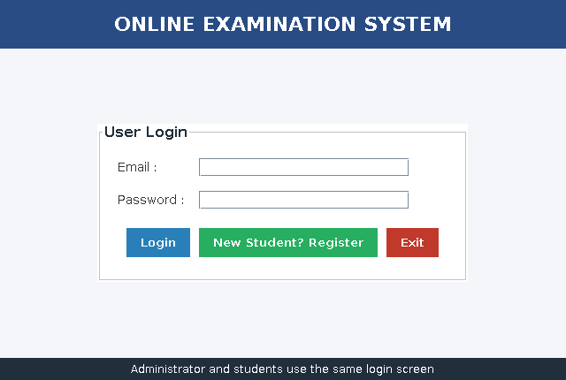
Fig 5.1 : Login screen
If the email or the password is wrong, the application does not say which of the two was wrong. It shows one message for both cases, so that somebody trying different email addresses cannot find out which accounts exist.
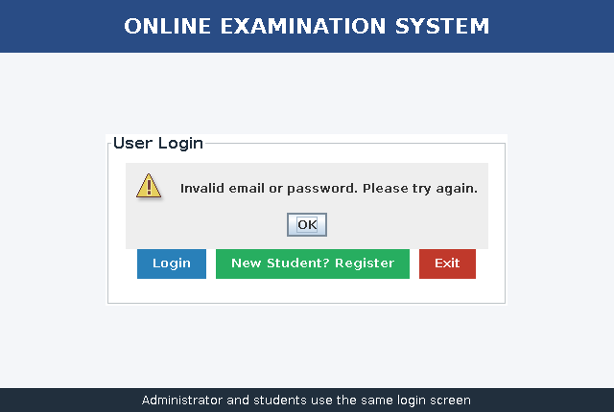
Fig 5.2 : Message shown for a wrong password
5.1.2 Student registration screen
A new student opens this screen from the login window. All six boxes are required. The email must have the form name@example.com and must not already belong to another account, the password must be at least four characters long and the two password boxes must match. The account is always created with the role STUDENT.
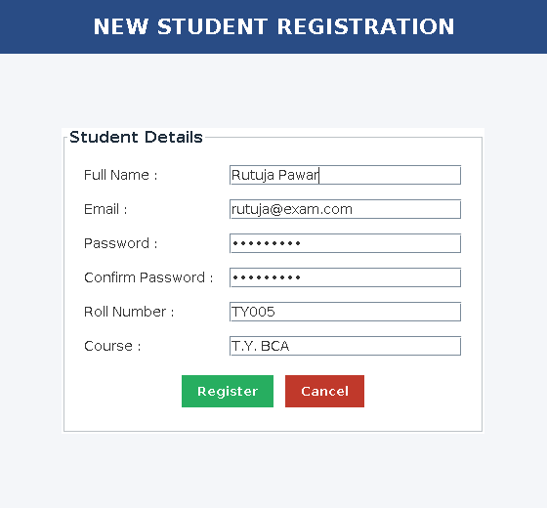
Fig 5.3 : Student registration screen
5.1.3 Administrator dashboard
After the administrator logs in, this window opens. The menu on the left stays on the screen all the time and the panel on the right changes when a menu button is clicked. Every screen reloads its data from the database each time it is opened, so what is on the screen is always current.
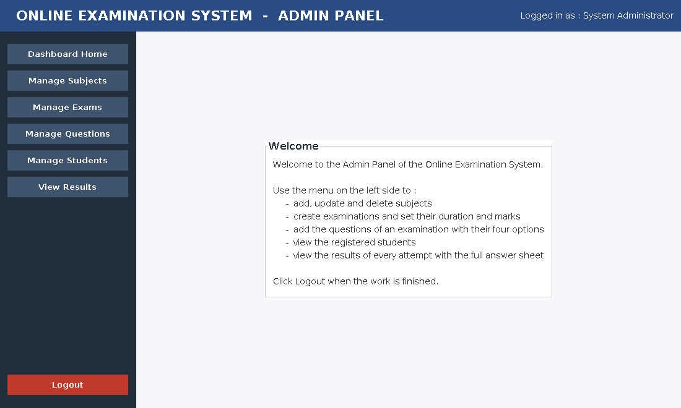
Fig 5.4 : Administrator dashboard
5.1.4 Manage Subjects
A subject is the group under which examinations are created. Clicking a row of the table copies it into the form on the right so that it can be changed or deleted. A subject that already has examinations under it cannot be deleted, and the application says how many examinations are in the way.
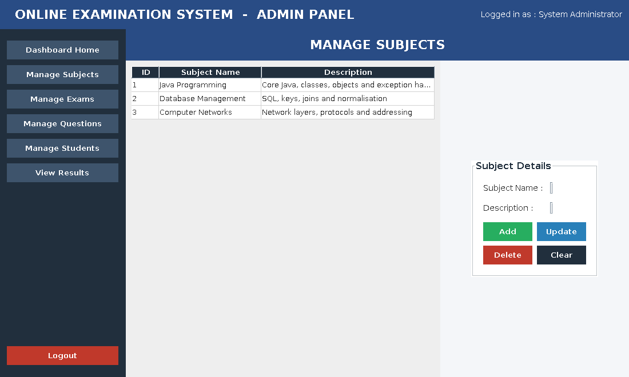
Fig 5.5 : Manage Subjects screen
5.1.5 Manage Exams
An examination belongs to one subject, which is chosen from the combo box. The duration is in minutes and is what the countdown timer counts down. The marks per question decide the total marks, which the table works out and shows. An examination that is Inactive is never shown to a student, which is useful for preparing a paper before the day of the examination.
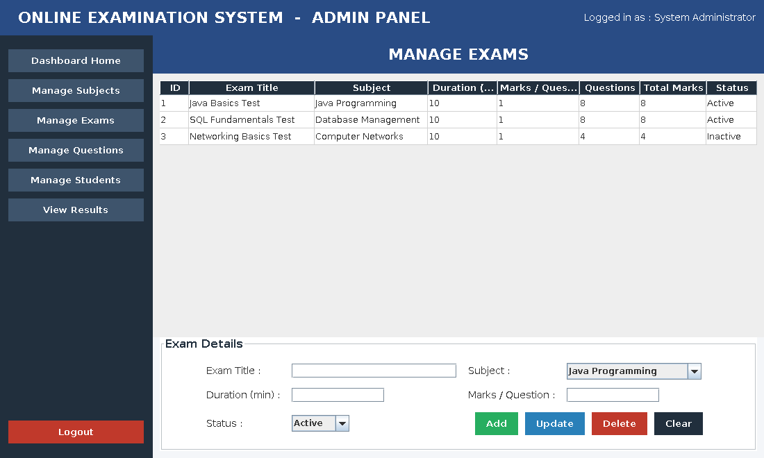
Fig 5.6 : Manage Exams screen
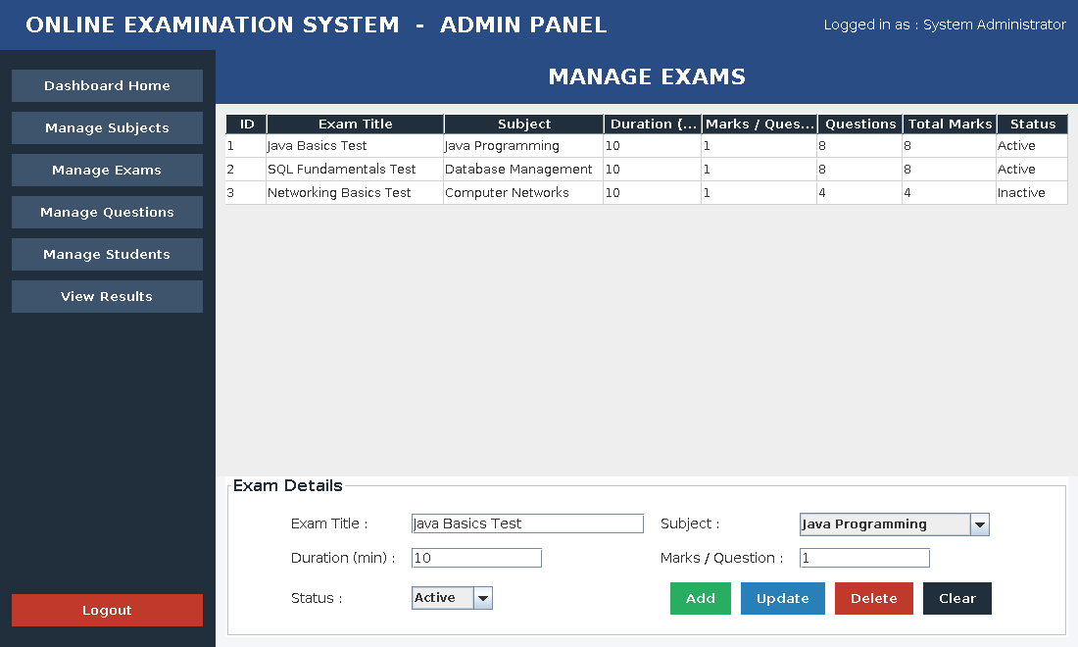
Fig 5.7 : The form filled in before an examination is saved
5.1.6 Manage Questions
The examination whose questions are being edited is chosen at the top. The table then shows the questions of that paper with their four options and the letter of the correct answer. A question that already appears on the answer sheet of a student cannot be deleted, because changing it afterwards would make the old result wrong.
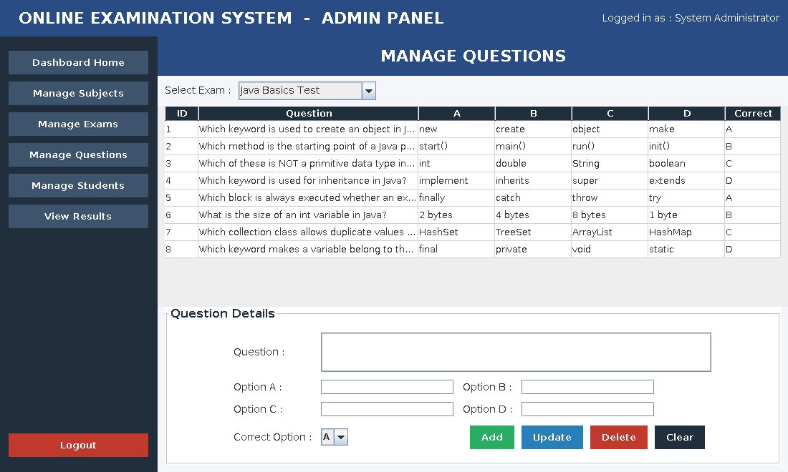
Fig 5.8 : Manage Questions screen
5.1.7 Student dashboard
A student gets a different dashboard with only three menu entries. The screens that manage subjects, examinations, questions and students are not on this menu at all, so a student cannot reach them.
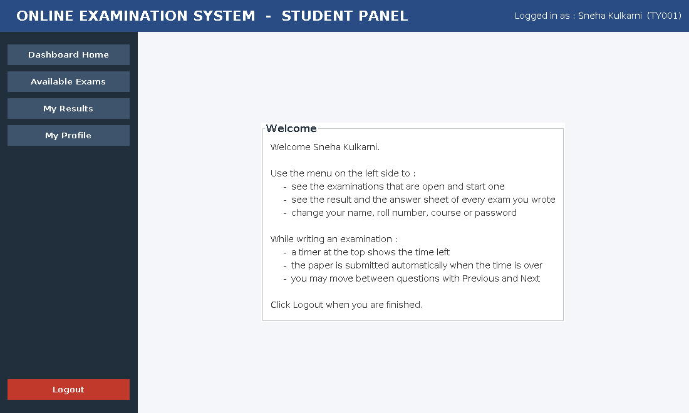
Fig 5.9 : Student dashboard
5.1.8 Available Exams
Only examinations that the administrator has marked Active and that contain at least one question appear here. The last column shows how many times this student has already written that paper.
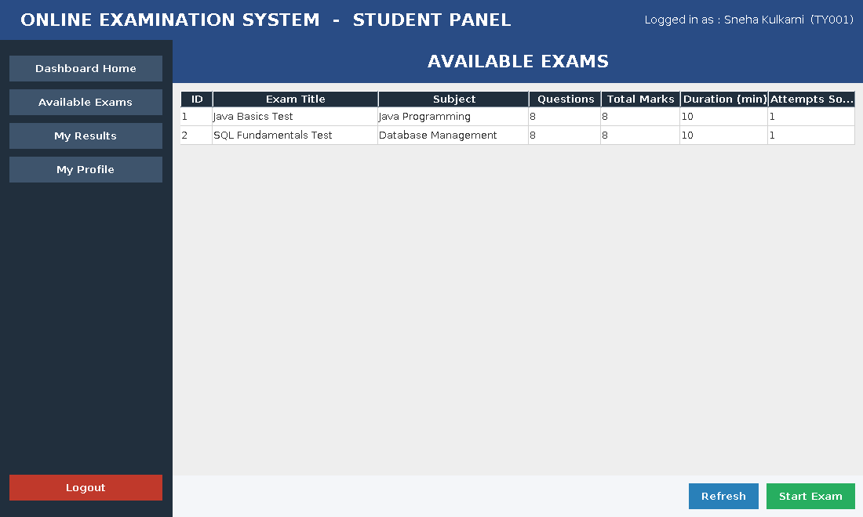
Fig 5.10 : Available exams
Clicking Start Exam first shows a confirmation, because the timer starts as soon as the examination window opens.
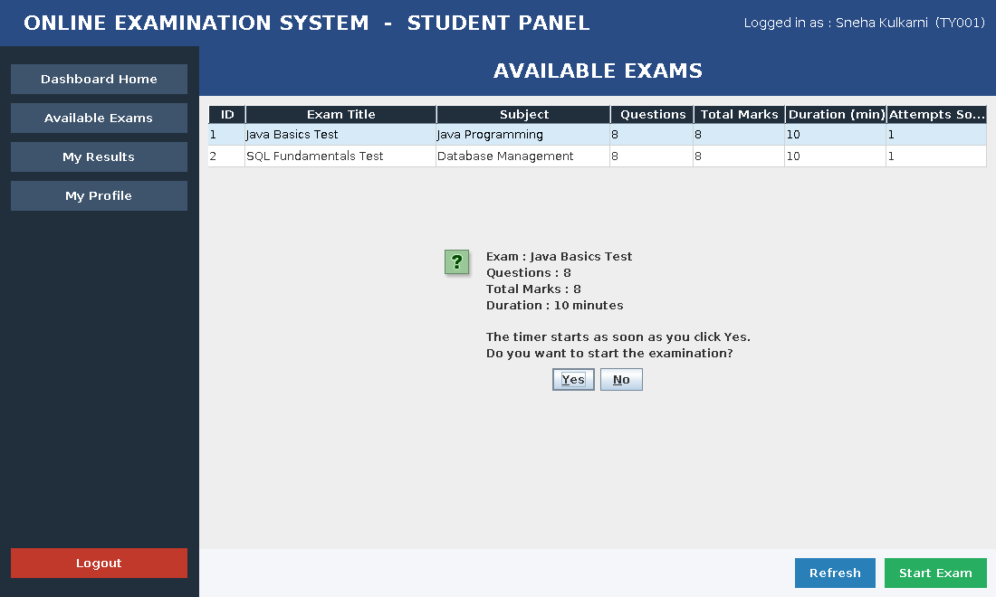
Fig 5.11 : Confirmation before the examination starts
5.1.9 The examination screen
This is the screen on which the paper is written. The title and the total marks are on the left of the blue header and the remaining time is on the right. One question is shown at a time with its four options as radio buttons, so only one of them can be selected.
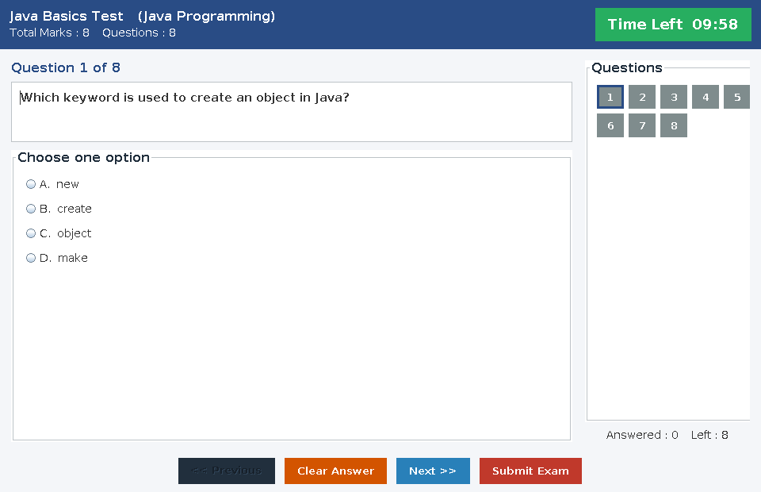
Fig 5.12 : The examination screen at the first question
As soon as an option is selected the numbered button of that question turns green and the counter under the palette changes. The student can jump to any question by clicking its number, or move one at a time with Previous and Next.
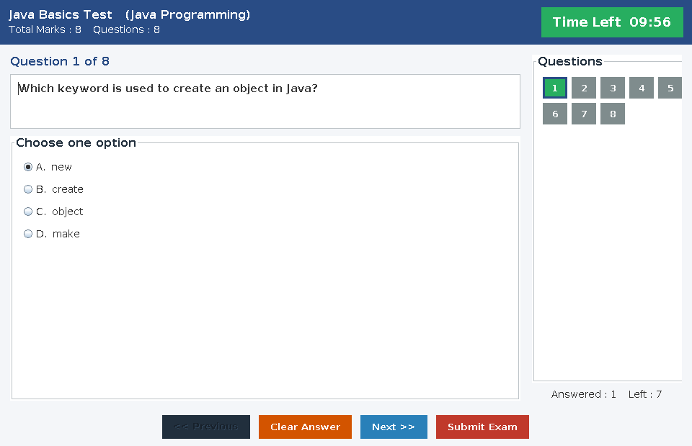
Fig 5.13 : The first question after an option has been selected
Fig 5.14 : The fourth question, with four questions already answered
Clicking Submit Exam shows how many questions were answered and how many were left, so that the student does not submit by mistake. If the time runs out first, the paper is submitted by the application without asking.
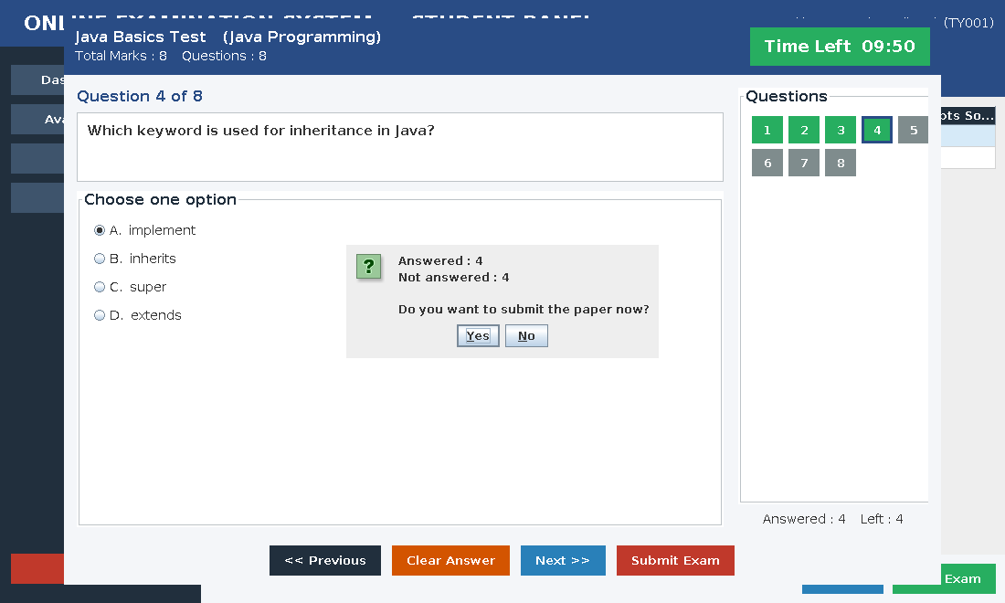
Fig 5.15 : Confirmation before the paper is submitted
5.1.10 My Profile
A student can change the own name, roll number, course and password here. The email box is read only, because the email is the login name of the account. Leaving both password boxes empty keeps the present password.
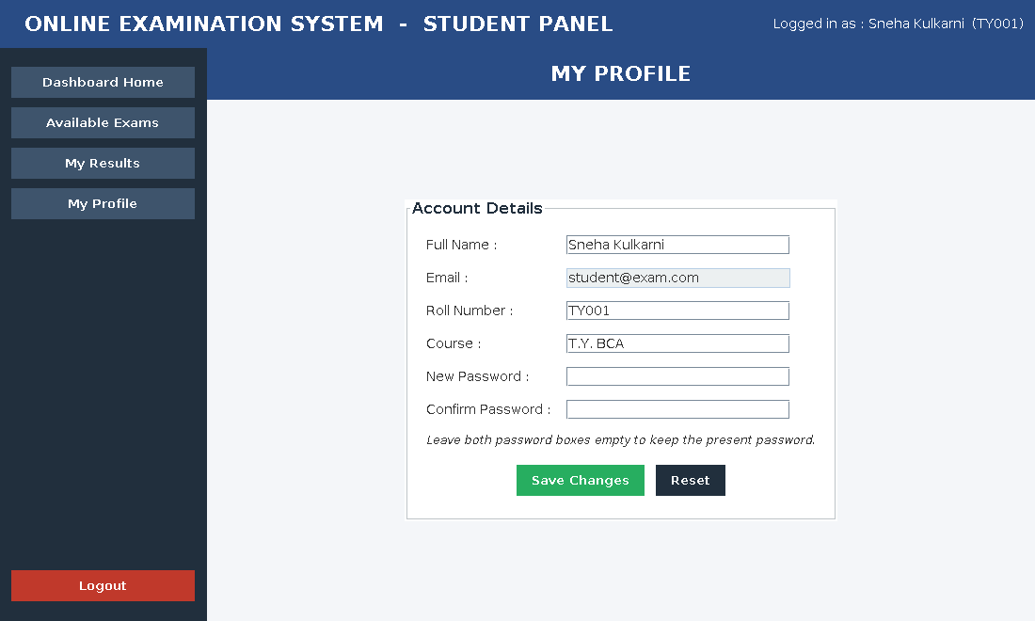
Fig 5.16 : My Profile screen
5.2 Output Screens with Data
5.2.1 The result of an attempt
This window opens as soon as a paper is submitted. The summary at the top is read from the row that was just written into the results table. The answer sheet below it is read from the answers table, one row for every question of the paper. The word FAIL is printed in red and PASS in green.
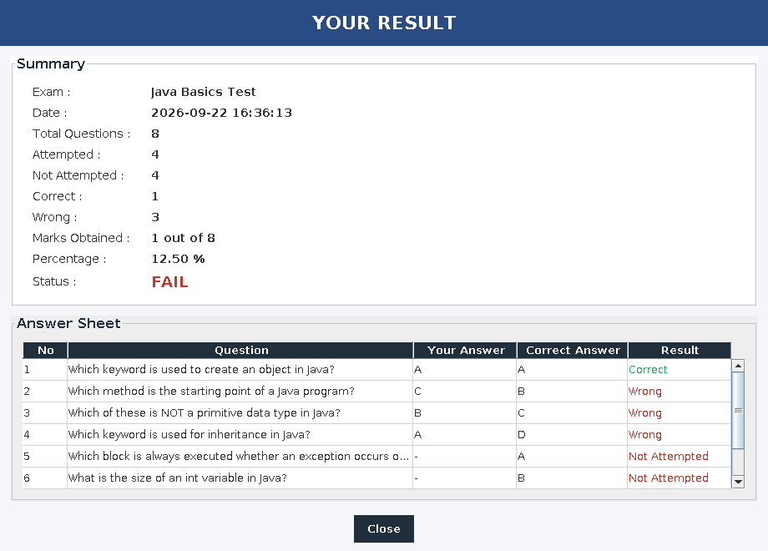
Fig 5.17 : Result window shown immediately after submitting
The Result column of the answer sheet has three possible values. Correct means the selected option matched the correct one, Wrong means it did not, and Not Attempted means that the student never answered that question. The application can tell the difference because an unanswered question is stored as NULL in the selected_option column.
5.2.2 My Results
Every examination the student has written is listed here, newest first. The line at the bottom counts how many were passed and how many were failed. Selecting a row and clicking View Answer Sheet opens the same window as Fig 5.17 for that older attempt.
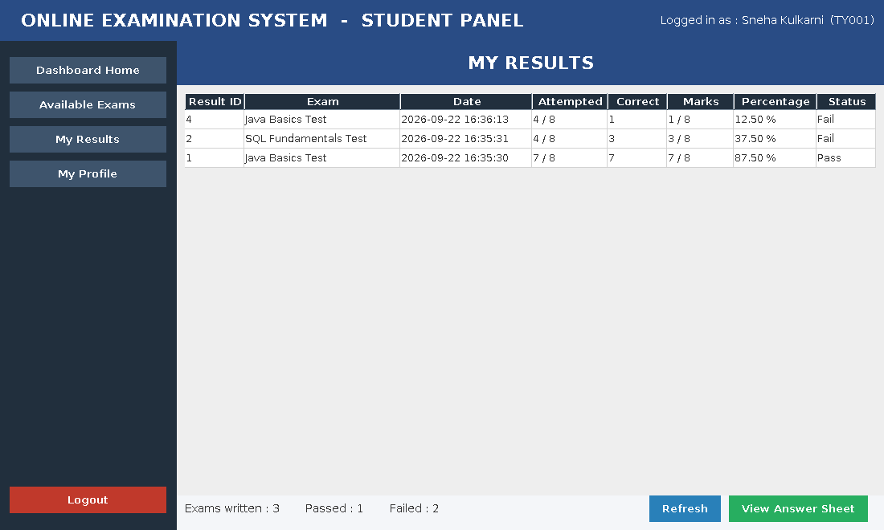
Fig 5.18 : My Results screen
5.2.3 Registered students
The administrator sees every account whose role is STUDENT. The administrator account itself is not in this list. The number of students is shown at the bottom left of the screen.
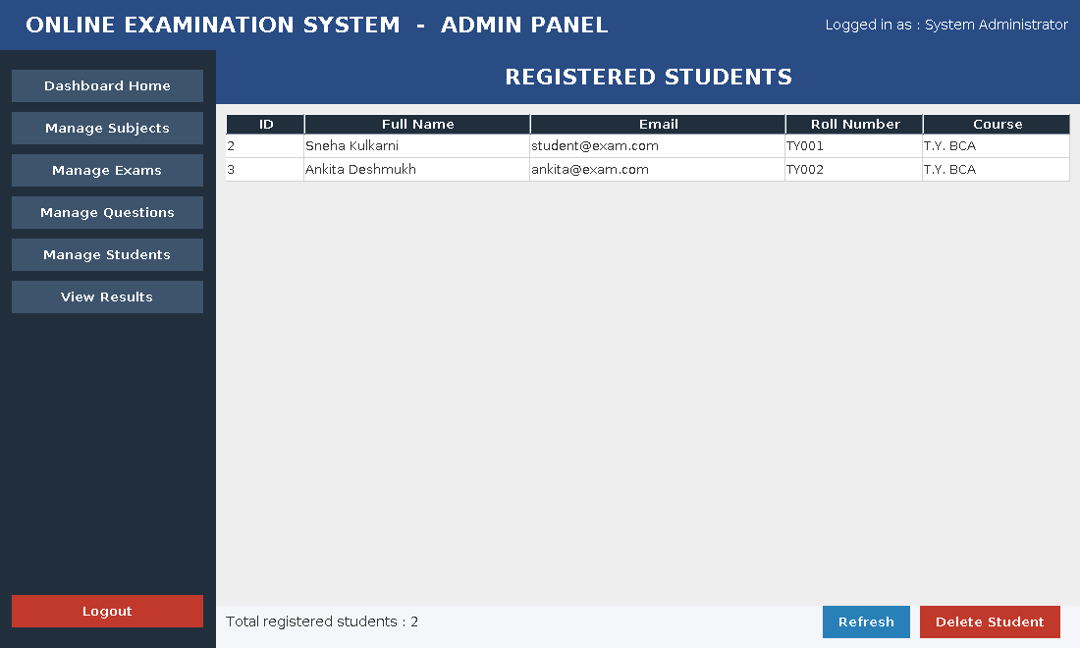
Fig 5.19 : Registered students
5.2.4 Examination results of all students
This is the screen the administrator uses after an examination. Every attempt of every student is listed with the roll number, the date and time, how many questions were attempted, how many were correct, the marks, the percentage and the status. The summary line counts the passes and the failures.
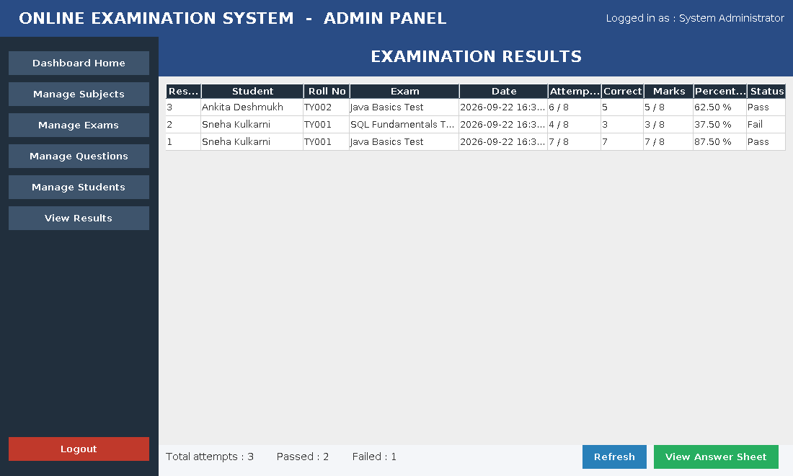
Fig 5.20 : Examination results screen
5.2.5 A student’s answer sheet seen by the administrator
Selecting a result and clicking View Answer Sheet opens the full sheet of that attempt. It is the same window that the student sees, with the name and the roll number of the student added at the top.
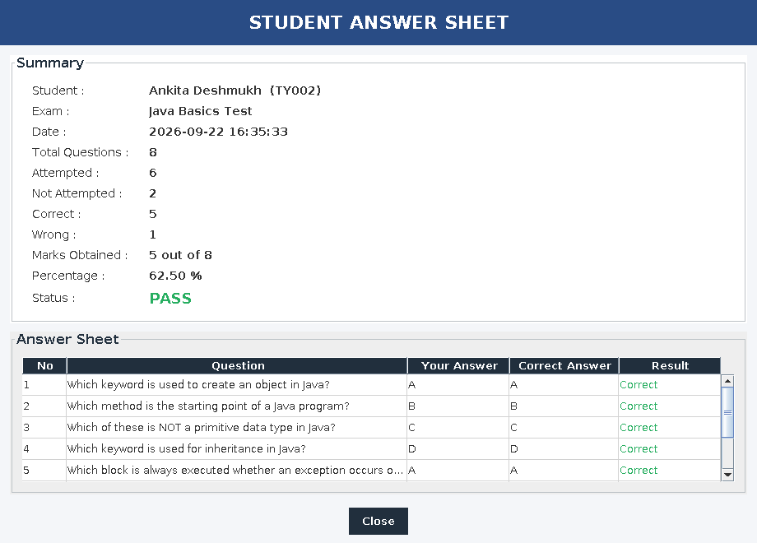
Fig 5.21 : Answer sheet of one attempt, opened by the administrator
5.2.6 Summary of the screens
Screen | Who uses it | What it shows
Login | Both | Email and password boxes.
Registration | Student | The six boxes needed to create an account.
Admin dashboard | Administrator | Menu of the six management screens.
Manage Subjects | Administrator | Table of subjects and a form.
Manage Exams | Administrator | Table of examinations with their questions and total marks, and a form.
Manage Questions | Administrator | Questions of the chosen examination with their four options.
Manage Students | Administrator | List of the registered students.
View Results | Administrator | Every attempt of every student.
Student dashboard | Student | Menu of the three student screens.
Available Exams | Student | The examinations that are open.
Examination window | Student | One question at a time, the timer and the question palette.
Result window | Both | The marks and the full answer sheet of one attempt.
My Results | Student | Every attempt of that student.
My Profile | Student | The student’s own details.

REFERENCES
Books
1. Herbert Schildt, “Java : The Complete Reference”, Twelfth Edition, McGraw Hill Education.
2. Kathy Sierra and Bert Bates, “Head First Java”, Third Edition, O’Reilly Media.
3. Abraham Silberschatz, Henry F. Korth and S. Sudarshan, “Database System Concepts”, Seventh Edition, McGraw Hill Education.
4. Grady Booch, James Rumbaugh and Ivar Jacobson, “The Unified Modeling Language User Guide”, Second Edition, Addison Wesley.
5. Roger S. Pressman, “Software Engineering : A Practitioner’s Approach”, Eighth Edition, McGraw Hill Education.
Websites
6. Java Platform, Standard Edition documentation – https://docs.oracle.com/en/java/javase/21/
7. Java Swing tutorial – https://docs.oracle.com/javase/tutorial/uiswing/
8. JDBC basics tutorial – https://docs.oracle.com/javase/tutorial/jdbc/basics/
9. MySQL 8.0 Reference Manual – https://dev.mysql.com/doc/refman/8.0/en/
10. MySQL Connector/J developer guide – https://dev.mysql.com/doc/connector-j/en/
11. Apache Maven documentation – https://maven.apache.org/guides/
Software used
Software | Version | Used for
Java Development Kit | 21 | Writing and compiling the application.
Java Swing | Part of the JDK | All the screens of the application.
JDBC | Part of the JDK | Connecting the application to MySQL.
MySQL Community Server | 8.0 | Storing the data of the application.
MySQL Connector/J | 8.4.0 | The JDBC driver for MySQL.
Apache Maven | 3.9 | Building the executable JAR file.
MySQL Workbench | 8.0 | Running the SQL script and looking at the tables.

