**Synopsis**

**on**

**T-CENTER**

**to be developed to fulfill the requirements for**

**Major Project (22CA015)**

**Submitted to**

**Department of Computer Applications**

**Chitkara University, Punjab**



**under the supervision of**

**Vikas Ratan Noopur Tyagi**

**Designation Designation**

**Submitted by**

**Yuvraj Singh Vaibhav Singla Vaibhav 2210997282 2210997262 2210997261**

**Shivam Nainwal**

**2210997221**

**Bachelor of Computer Applications**

**(Batch 2022-25)**

**TABLE OF CONTENTS**

**1. Abstract**

**2. Introduction**

2.1 Project Aim and Objectives

2.2 Technology to be Used

2.3 Hardware and Software Requirement

**3. System Analysis**

3.1 Software Requirement Specification

3.2 Existing v/s Proposed System

**4. Data Flow Diagram**

**5. Timeline**

**6. References**

**Abstract**

“t-center" offers a variety of size and fit options to cater to the various needs of users. choices, making it possible to play around with dimensions and proportions using the 3D modeling interface. Users of the platform can also precisely align design elements with their vision by giving them complete control over positioning and rotation. Smooth animations further enhance the visual appeal of T-shirt designs by bringing them to life with colors that blend in harmony, images that transition smoothly, and a focus on creativity. The save and share feature makes it simple to store and distribute designs, encouraging the growth of a creative community where users can exhibit their inventiveness, motivate others, and honor the craft of custom T-shirt design as a whole.

**Introduction**

Step into a world of personalized style with T-center – your ultimate destination for custom T-shirts! At T-center, we celebrate the art of self-expression, offering you the freedom to design and wear your story. Our platform empowers you to create bespoke T-shirts that reflect your personality, passions, and creativity. Dive into the design process with ease, using our user-friendly customization tools. Experiment with colors, graphics, and text until your vision comes to life on high-quality fabric. We believe in more than just looking good. We ensure your custom T-shirts feel comfortable and stand the test of time.

**Aim & Objective**

Using the user-friendly 3D modeling feature, you can personalize every inch of your T-shirt and manipulate its shape to create a distinctive look.

Custom Colors: Choose from a wide variety of colors to precisely customize each area of your T-shirt. This palette includes both bold and soft tones for the ideal combination of colors.

Image Personalization: Turn your design into a wearable masterpiece that captures your unique style and narrative by artfully integrating uploaded images onto the T-shirt.

Options for Size and Fit: "t-center" offers a variety of sizes to accommodate all body types and permits experimenting with dimensions and proportions within the 3D modeling interface.

Rotation and Positioning Control: Ensure exact alignment with your vision by having complete control over the orientation and positioning of each element on your T-shirt.

Smooth Animations: Using dynamic and smooth animations, you can bring your T-shirt design to life. This will improve its visual appeal by letting creativity take center stage, colors blend together seamlessly, and images transition gracefully.

**Technologies to be used**

A variety of tools and technologies are available for our project, the "T-center" web application, to address different project aspects. The following are some necessary technologies to be utilized:

**Front-end Programming:**

* HTML, CSS, and JavaScript: Essential technologies for developing user interfaces and incorporating interactive elements.
* Front-end frameworks: React, Vue, and Angular are examples of frameworks for front-end development. This project has chosen to use React JS.

**Development of Backend:**

* Firebase: Firebase is a comprehensive mobile and web application development and backend as service platform by Google, offering features like real-time database, authentication, hosting, and cloud functions. It simplifies backend development, enabling developers to focus on frontend and user experience.

**Libraries and Integration:**

* Tailwind CSS: A utility-first CSS framework that streamlines web design by using pre-defined classes for effective styling and layout.
* Framer Motion: A library for React JS that allows for smooth animations, improving user interfaces with more fluid motion effects.
* React Three Fiber: A React JS library that makes it easier to integrate and manipulate 3D models for realistic graphics in online applications.
* Paytm Gateway integration: Paytm Gateway integration in react JS allows businesses to securely accept online payments on their websites or applications by connecting to Paytm's payment infrastructure, offering a streamlined and reliable payment processing solution.

**Software Requirements**

The software package manager NPM (node package manager) is a popular tool for managing and distributing open-source packages and dependencies in JavaScript.

Tools for developing browsers: Chrome Developer Tools, Firefox Developer Tools. During development, debug and examine frontend code.

The purpose of text editors/IDEs is to write, edit, and manage code. Some examples of these programs are Atom, Visual Studio Code, and Sublime Text.

Collaborative editing tools, such as Microsoft Office Online or Google Workspace (which includes Google Docs, Sheets, and other products), enable real-time collaboration on documents and code.

Code review tools, such as GitHub Pull Requests, GitLab Merge Requests, or Bitbucket Code Review, help to expedite the peer review process for code modifications.

Web browsers: Cross-browser compatibility is guaranteed.

Examples include Microsoft Edge, Safari, Mozilla Firefox, and Google Chrome Examples: Google Chrome, Mozilla Firefox, Microsoft Edge, Safari.

**Software Requirements Specification (SRS) for t-center E-commerce Store**

**1. Introduction**

**1.1 Purpose**

The purpose of this document is to provide a comprehensive Software Requirements Specification for the development of the t-center E-commerce Store, a web application that specializes in 3D modeling, shirt customization, and online shirt sales.

**1.2 Scope**

The t-center E-commerce Store aims to offer users the ability to customize shirts in 3D with features such as color selection, image placement, size adjustment, rotation, and positioning. Additionally, the application will include smooth animations, the ability to save customized shirts, and a marketplace for users to upload and sell their custom designs.

**2. Overall Description**

**2.1 Product Perspective**

* The t-center E-commerce Store will function as a standalone web application. It will interact with external payment gateways for transaction processing for order placing and include a user-friendly interface for easy navigation and customization.

**2.2 Features**

* 3D Modeling: Users can visualize and customize shirts in a 3D environment.
* Shirt Customization: Users can customize shirts by adjusting color, uploading

images, changing size, rotating, and positioning elements

* Smooth Animations: The application will include animations for a seamless user experience during customization.
* Saving T-Shirts: Users can save their customized shirt designs for future reference and purchase.
* Purchase from Marketplace: Users can purchase t-shirts from marketplace

**3. User Specific Requirements**

**3.1 User Interfaces**

* Homepage: Featuring product categories, promotions, and a login option
* 3D Customization Interface: A visually appealing and interactive 3D modeling tool for shirt customization.
* Marketplace: A dedicated section where users can upload, view, and purchase custom shirt designs.

**3.2 Functional Requirements**

* User Registration and Authentication: Users must be able to create accounts and log in securely.
* 3D Shirt Customization Tool: Enable users to customize shirts in 3D, adjusting color, size, image placement, rotation, and position.
* Smooth Animations: Implement animations to enhance the overall user experience during customization.
* Save Customized Shirts: Users should have the ability to save their customized shirt designs.
* Purchase from Marketplace: Allow users to purchase t-shirts from the marketplace.
* Transaction Processing: Integration with secure payment gateways for seamless and secure transactions.

**3.3 Non-functional Requirements**

* Performance: The system should handle concurrent users and provide a responsive experience.
* Security: Implement security measures to protect user data and transactions.
* Scalability: The system should be scalable to accommodate a growing number of

users and designs.

* Compatibility: Ensure compatibility with major web browsers and devices.

**4. System Models**

**4.1 Use Case**

* User Registration
* 3D Shirt Customization
* Save Customized Shirt
* Purchase Shirt from Marketplace

**4.2 Activity**

* User Interaction Flow during Shirt Customization

**Data Flow Diagram**

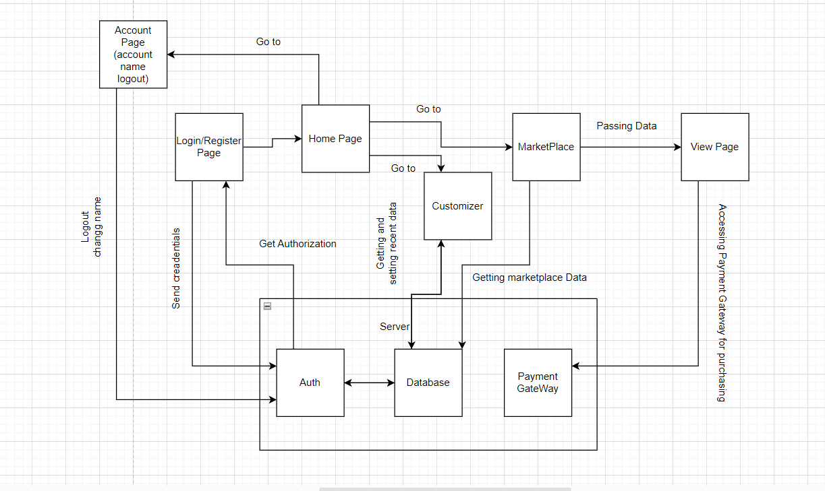

**Timeline**

|  |  |  |  |  |
| --- | --- | --- | --- | --- |
| Synopsis | 2 – 2 – 2024 |  |  |  |
| Implementation |  |  |  |  |
| Report Writing |  |  |  |  |
| Submission |  |  |  |  |

## **References**

https://www.spreadshirt.com/custom/t-shirts