**How to work with Former2**

**First go to former2 site**

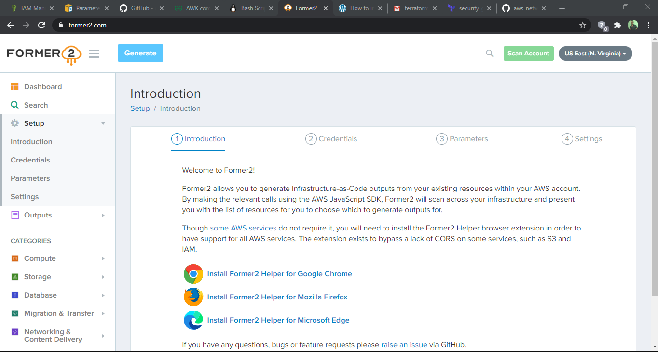

**2- Go to AWS console and add role with read only policy to add secter id and access key**

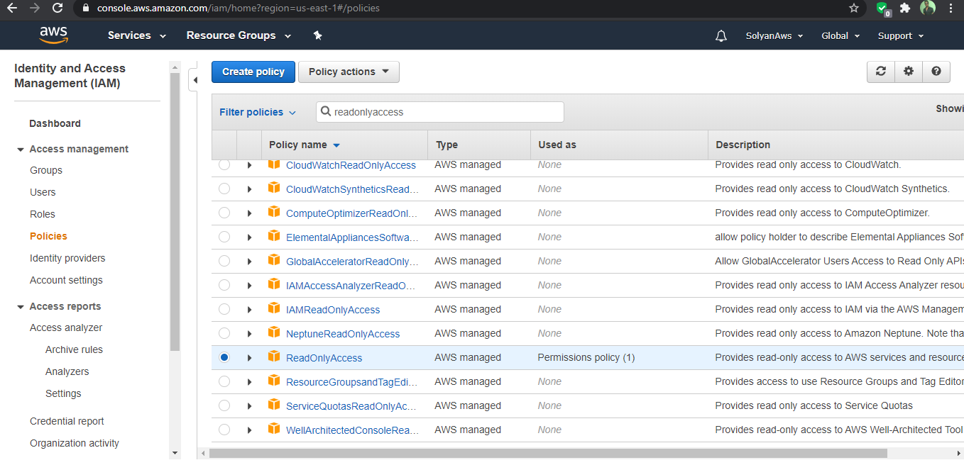

**3- Add cred of created roles**

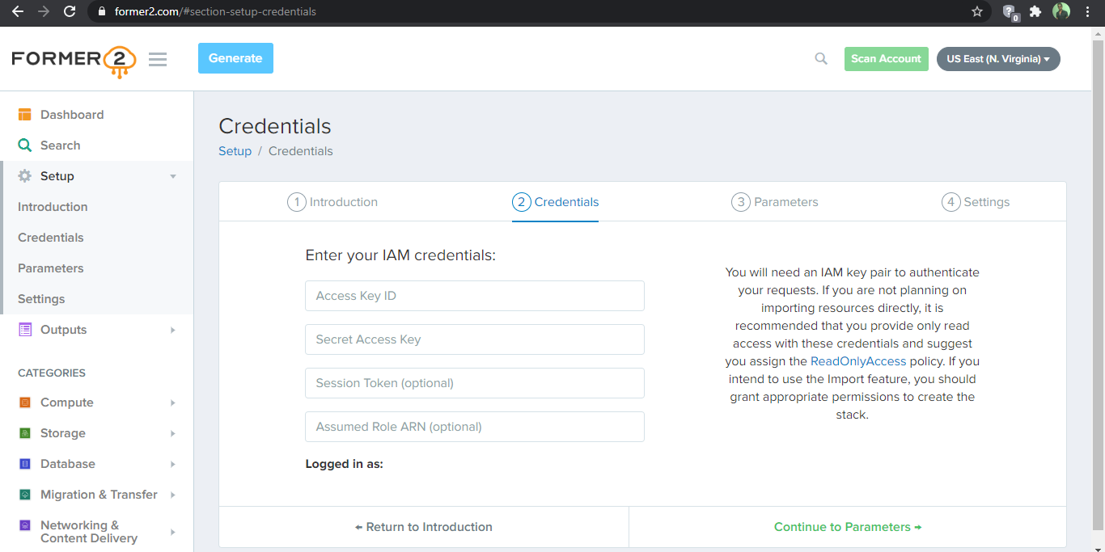

**4- Now scan account for getting the resources from aws console into former2 dashboard**

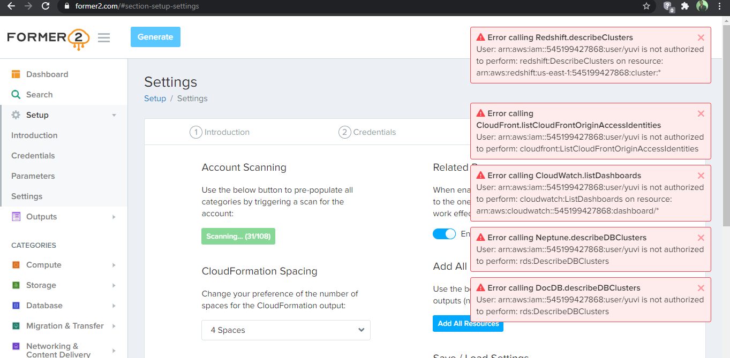

**5- Now go to former2 dashboard for selecting the resources for which you want to create terraform code**

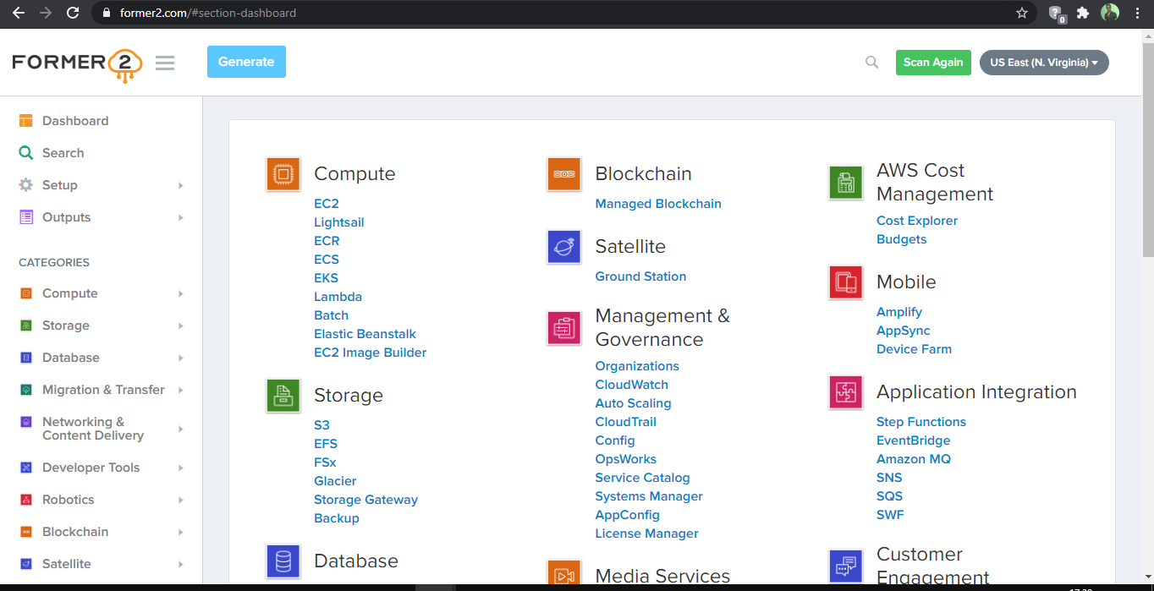

**6- now add the selected resources for generating terraform code**

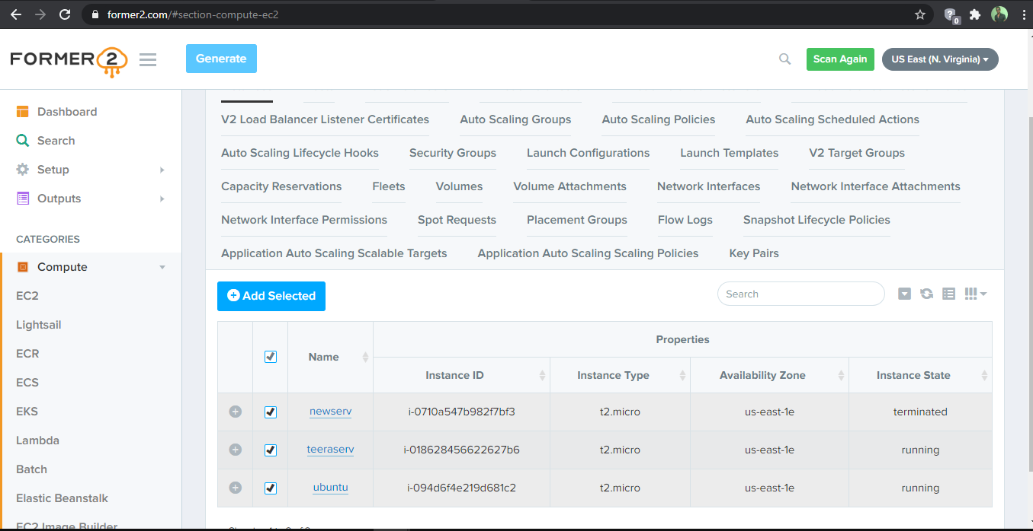

**7- Generate the terraform code**

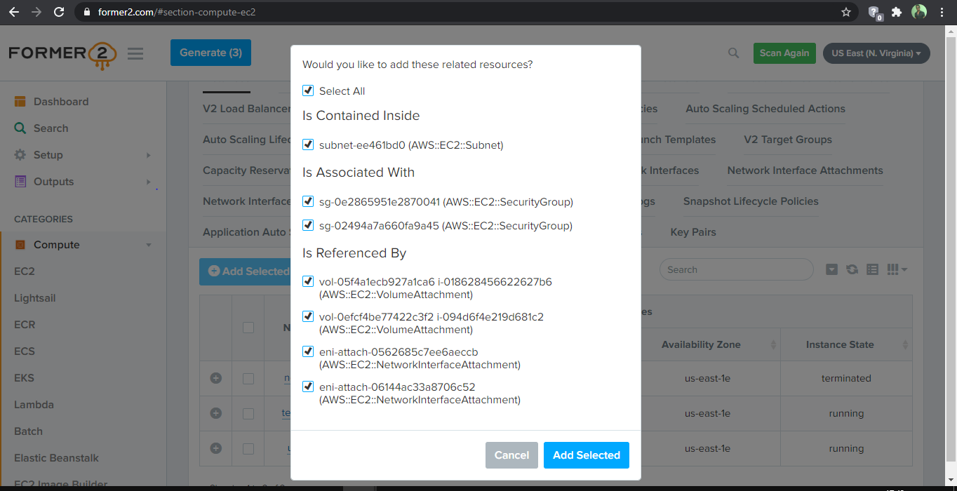

**8- Now Copy the terraform code in your tf file**

