Customer Shopping Behavior Analysis

1. Project Overview
This project analyzes customer shopping behavior using transactional data from 3,900 purchases across diverse product categories. The objective is to get actionable insights from spending habits, customer segments, product preferences, and subscription trends to make data-driven business strategies and enhance decision-making efficiency.
1.1 Data Loading
The dataset was loaded using Python's pandas library.
2. Dataset summary

2.1 Dataset features
- Customer demographics (Age, Gender, Location)
- Product details (Item Purchased, Category, Color, Season, Size)
- Transactional attributes (Purchase Amount, Shipping Type, Payment Method, Discount Applied, Promo Code Used, Previous Purchases, Subscription Status, Review Rating, Frequency of Purchases).

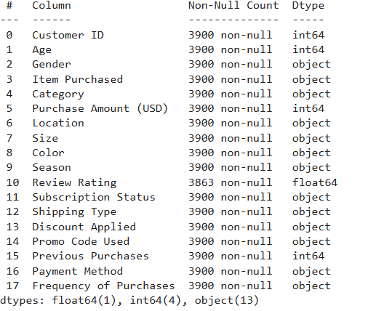
​2.2 Key descriptive statistics
- Age range: 18 to 70 years, mean age is around 44.
- Purchase amounts ranged from 20 to 100 USD, with a mean of about 60 USD.
- Review ratings had a mean near 3.75 out of 5, post-imputation.
- The most frequent item category was "Clothing", with "Male" being the most common

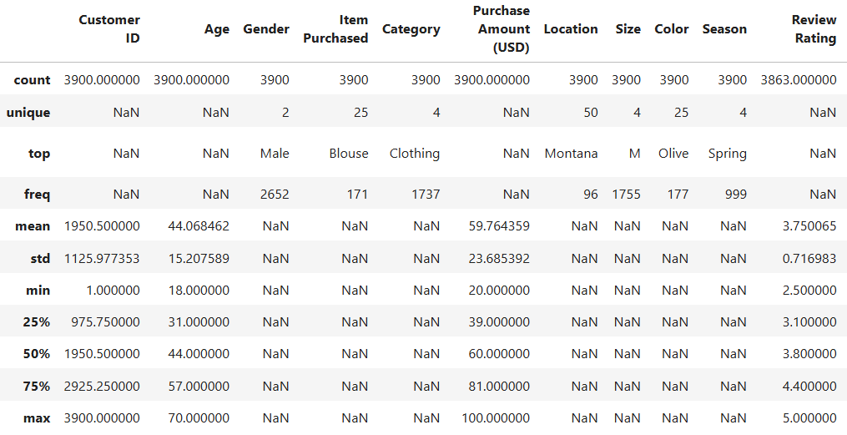

3. Data preparation
The preparation of data focused on cleaning missing values, feature engineering, and preparing it for further modeling or business intelligence tasks.

3.1. Data cleaning
The first data quality check revealed 37 missing values in the "Review Rating" column.
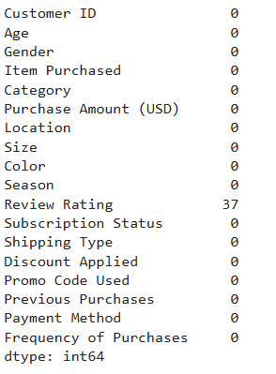
These null values were filled with the median review rating within each product category, which preserved distributional integrity and prevented the bias.
Unnecessary or redundant columns (like “Promo Code Used” since it was always 'Yes') were dropped to streamline analysis.
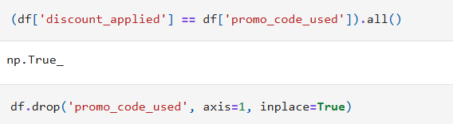
Column names were converted to a consistent format (snake case) for better accessing and readability.​

3.2. Feature Engineering
Age groups were created by segmenting customers into quartiles:
- Young Adult
- Adult
- Middle Aged
- Senior​
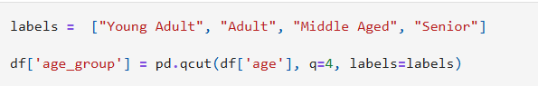
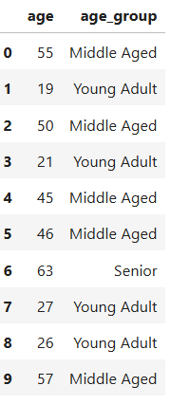
A numeric mapping for purchase frequency was added (e.g., "Fortnightly" to 14, "Weekly" to 7), enabling quantitative analysis of repeat customer value and retention.​
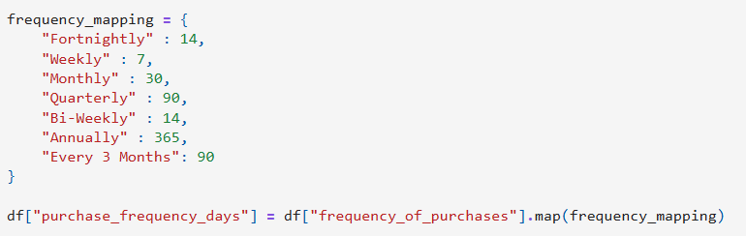

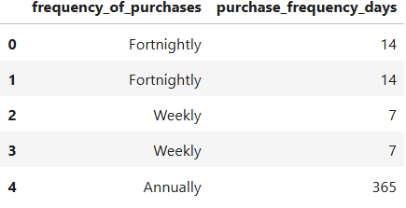
3.3. Publishing to MySQL database
The final step in your workflow involves publishing the cleaned and engineered dataset to a MySQL database so we can gather better business insights with SQL queries.
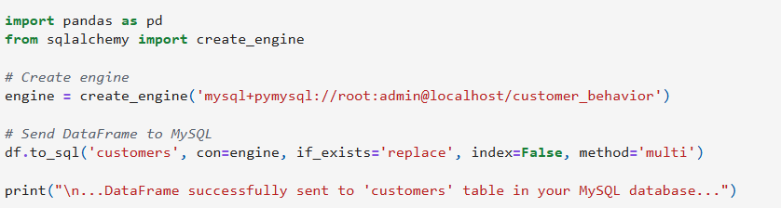

4. Business analysis using MySQL
This report presents a comprehensive analysis of customer purchase behavior using transactional data from the store’s customer dataset. The objective is to analyze meaningful insights about revenue patterns, product performance, customer segmentation, discount effectiveness, and subscription engagement. By examining multiple dimensions such as gender, age, product category, and customer loyalty, the analysis provides actionable findings to guide marketing, pricing, and retention strategies.

4.1. Revenue by Gender
Male customers generated a total revenue of 157,890, while female customers generated 75,191. This shows that male buyers contribute more than double the revenue compared to female buyers.
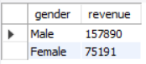
4.2. Discount Users Spending Above Average
There are 839 customers who used a discount and still spent more than the average purchase amount. This indicates that discounted items do not necessarily lead to low-value transactions, suggesting strong product appeal.
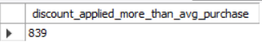
4.3. Top Products by Average Review Rating
The top-rated products based on customer reviews are gloves with an average rating of 3.86, followed by sandals with 3.84, and boots with 3.82, hat with 3.8 and skirt with 3.78. These items demonstrate customer satisfaction, particularly in the footwear and accessories.
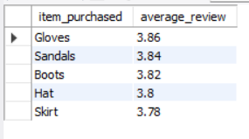

4.4. Purchase Amount Comparison by Shipping Type
The average purchase amount for express shipping is 60.48, slightly higher than standard shipping at 58.46. Customers opting for express delivery tend to spend marginally more overall.
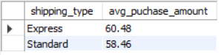
4.5. Subscription Impact on Spending
Subscribed customers have an average spend of 59.49, contributing a total revenue of 62,645. Unsubscribed customers spend slightly more on average at 59.87, contributing total revenue of 170,436. This shows that unsubscribed customers not only spend more but also generate higher total sales, implying the subscription program may not be influencing spending behavior effectively.
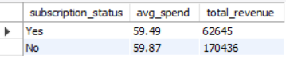
4.6. Products with the Highest Discount Application
Hats have the highest percentage of discounted purchases at 50 percent, followed closely by sneakers at 49.66 percent, coats at 49.07 percent, sweaters at 48.17 percent, and pants at 47.37 percent. This suggests discounts are most frequently applied to apparel and outerwear items.
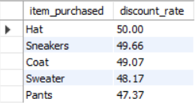
4.7. Customer Segmentation by Purchase History
The customer segmentation analysis shows there are 83 new customers with only one prior purchase, 701 returning customers with between two and ten purchases, and 3,116 loyal customers who made more than ten purchases. The large number of loyal customers indicates strong retention and positive customer experience.
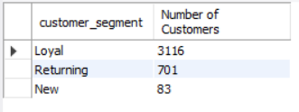
4.8. Top 3 Products within Each Category
In accessories, the most popular items are jewelry, sunglasses, and belts. For clothing, the leading products are belts, blouses, and pants. In footwear, sandals, shoes, and sneakers dominate, while in outerwear, jackets and coats rank highest. These findings highlight specific products that drive sales within each category.
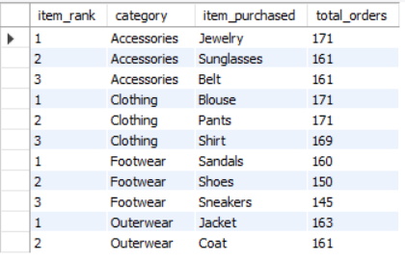
4.9. Subscription Status Among Repeat Buyers
Among customers with more than five previous purchases, 958 are subscribed, but most repeat buyers remain unsubscribed. This indicates that customers who frequently buy are not significantly motivated to subscribe, suggesting the subscription offer may need enhancements.
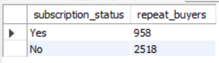
4.10. Revenue Contribution by Age Group
Young adults are the largest contributors to total revenue, accounting for 62,143. This age group forms the core of the customer base and represents the primary driver of sales performance.
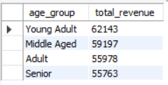

5. Power Bi Dashboard for customer analysis
This dashboard delivers a concise view of retail customer activity, segmenting data by subscription status, purchase category, and age group to spotlight participation and spending trends.
- 4,000 customers contribute to an average purchase value of $59.76 and a review rating of 3.75.​

- Most customers are not subscribed or using discounts, suggesting opportunities for loyalty or promotional strategies.​

- Clothing is the leading category by both customer engagement and revenue, followed by accessories and footwear.​

- Young adults are the top spenders among age groups, making them an influential segment for marketing focus.​

- The customer base is widely distributed but shows concentration in certain regions, helping drive targeted outreach efforts.
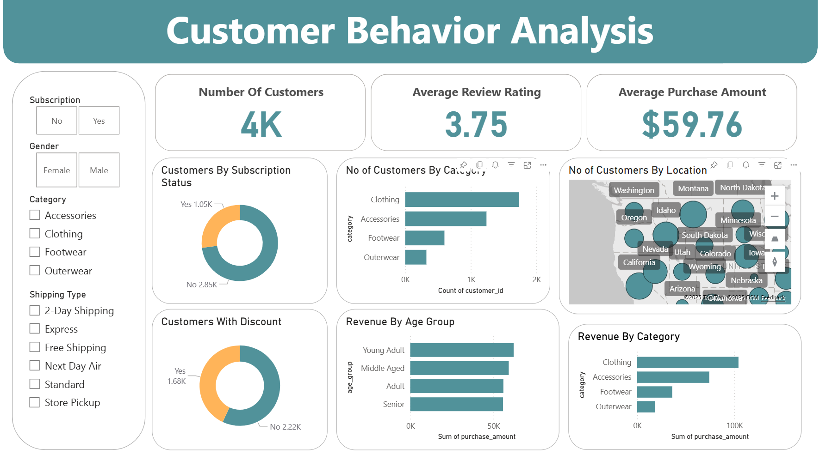
6. Conclusion
In conclusion, these insights offer a strategic framework for driving sustainable growth in the retail sector. By leveraging targeted marketing strategies, enhancing customer retention initiatives, and implementing effective product management practices, businesses can establish a competitive advantage and achieve long-term success in an retail market.

7. Business Recommendations
- Target Young Adults: Focus marketing on young adults using social media and influencer channels.
- Revise Subscription Strategy: Add new perks to boost subscription sign-ups and spending.
- Expand Discount Offers: Offer discounts and bundle deals on popular apparel items.
- Enhance Top Products: Prioritize inventory investment in highly rated items.
- Nurture Loyal Customers: Reward loyal customers with personalized programs.
- Encourage Subscriptions: Target repeat buyers with tailored subscription offers.
- Optimize Shipping: Incentivize express shipping to increase high-value purchases.
- Regional Marketing: Use localized campaigns in high-density customer areas.

