Restaurant Sales Analysis

1. Introduction

1.1. Domain Background
The restaurant and food service industry is one of the most dynamic sectors in the global economy. Businesses in this industry continuously strive to improve profitability, optimize menu performance, and enhance customer satisfaction. With the growing importance of data-driven decision-making, analytics tools like Power BI allow restaurants to visualize trends, track performance, and identify opportunities for improvement in real time.

1.2. Dataset Description
The Restaurant Sales Dataset used in this project contains transactional data representing restaurant orders.
- Dataset Size: 1,111 records (representing total quantity sold)
- Variables: Includes fields such as Order ID, Item Name, Category, Quantity, Price, Rating, and Date of Sale.
- Key Fields:
  - Order ID – Unique identifier for each order
  - Item – Name of the item sold (e.g., Burger, Juice, Pasta)
  - Category – Type of food (e.g., Fast Food, Beverages, Main Course)
  - Sum of Price – Total revenue per item or category
  - Average Rating – Customer satisfaction measure (on a scale of 1 to 5)
  - Date – Day of transaction (used for trend analysis)

1.3. Objective
The primary objective of this project is to analyze restaurant sales data to uncover actionable insights that can help management make informed decisions. The analysis aims to answer the following key questions:
- What is the total revenue, total quantity sold, and average rating for the restaurant?
- Which food items and categories generate the highest revenue and sales volume?
- How do daily sales fluctuate over time?
- What are the major trends and performance insights across product categories?
- What areas need improvement, particularly concerning customer satisfaction?

2. Date Preparation
There are a lot a lot of missing and unformatted values in the columns such as rating and feedback
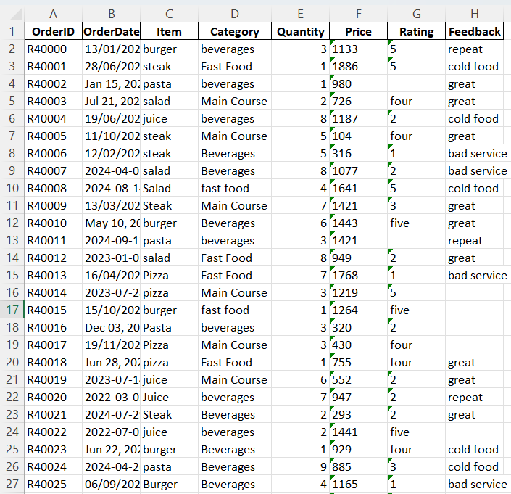

We have used microsoft excel and power query editor to prepare or transform data into usable format
2.1. Formatting
renamed numerical values written in words to numbers
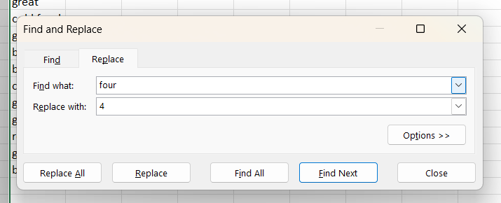
There are some numbers stored as text so we converted them to numbers
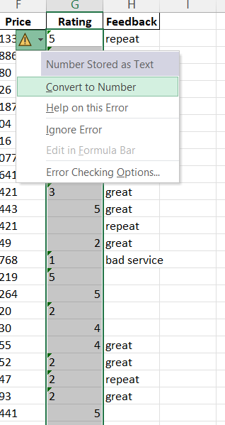

We also Captialize each word in order to maintain consistent format in power query editor
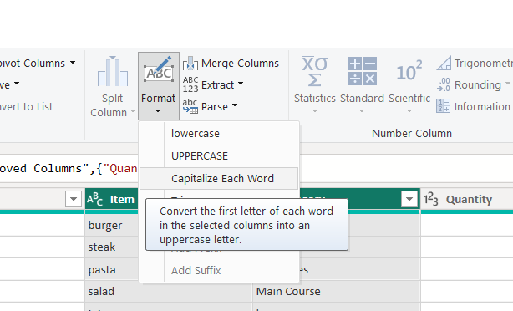
Now we convert the date into consistent format using USE LOCALE in power query editor

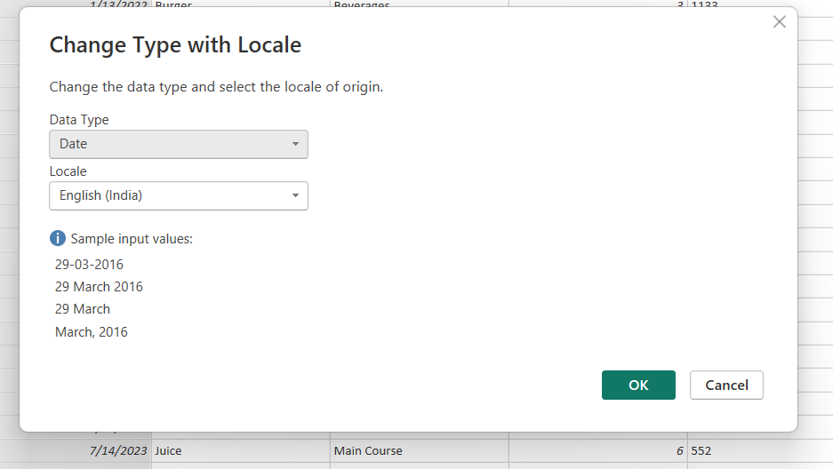

2.2 Handling missing values
For feedback and rating, we use the most frequently occurring elements and median
Formulas used
Formula for rating
=MEDIAN(G2:G211)
Formula for feedback
=INDEX(H2:H211, MATCH(MAX(COUNTIF(H2:H211,H2:H211)), COUNTIF(H2:H211,H2:H211), 0))
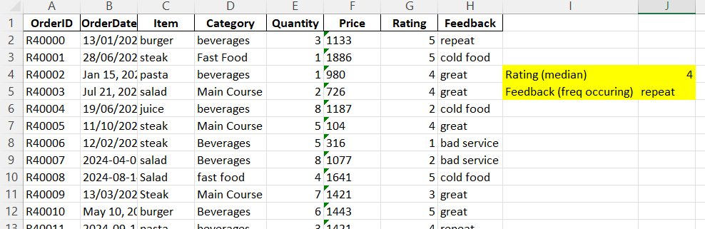
For pricing there are only 2 null values, so we simply fill down the price

3 Visualization & Analysis

3.1. KPI Cards (Total Revenue, Total Quantity, Avg Revenue per Item, Average Ratings)
- Visualization Type: KPI Cards
- Interpretation: These cards display quick, at-a-glance business metrics — total revenue ($213.54K), total quantity sold (1,111), average revenue per item ($35.59K), and overall average rating (3.52).
- Reason for Use: KPI cards are ideal for summarizing performance indicators and providing a snapshot of overall business health in a single glance.

3.2. Line Graph (Sales by Day)
- Visualization Type: Line Chart
- Interpretation: The graph shows how total daily sales fluctuate throughout the period. There are noticeable peaks and troughs, indicating inconsistent daily performance.
- Reason for Use: A line chart effectively displays trends over time, helping identify demand patterns, volatility, and possible operational inefficiencies.

3.3. Bar Chart (Sales by Category)
- Visualization Type: Horizontal Bar Chart
- Interpretation: Beverages lead with the highest sales (around $90K), followed by Fast Food and Main Course. This shows which product categories drive the most revenue.
- Reason for Use: Bar charts provide a clear visual comparison of categorical data, making it easy to compare revenue across different product types.

3.4. Pie Chart (Quantity by Category)
- Visualization Type: Pie Chart
- Interpretation: Fast Food accounts for 41.22% of total quantity sold, Beverages 38.43%, and Main Course 20.34%. This highlights the proportion of items sold per category.
- Reason for Use: A pie chart is suitable for illustrating the relative share of each category within the total, making proportions visually intuitive.

3.5. Table (Top 5 Items)
- Visualization Type: Tabular View
- Interpretation: The top five items — Burger, Juice, Pasta, Salad, and Steak — contribute $184,670 in sales, with Burger being the top seller.
- Reason for Use: Tables are best for presenting detailed item-level data and exact figures for sales and quantities, which complement the visual summaries.

3.6. Table with Conditional Formatting (Details Section)
- Visualization Type: Data Table with Color Scale
- Interpretation: Displays order-level details, including ratings and prices. Low ratings (1.0 or 2.0) are highlighted in red, signaling poor customer feedback.
- Reason for Use: Conditional formatting quickly draws attention to performance issues and helps identify problem areas in service or product quality.

3.7. Text Box (Summary Insights)
- Visualization Type: Text/Annotation Box
- Interpretation: Provides narrative insights summarizing the dashboard findings — sales performance, trends, and key concerns like customer satisfaction.
- Reason for Use: A text box helps communicate analysis in plain language, connecting data visuals to actionable business meaning.

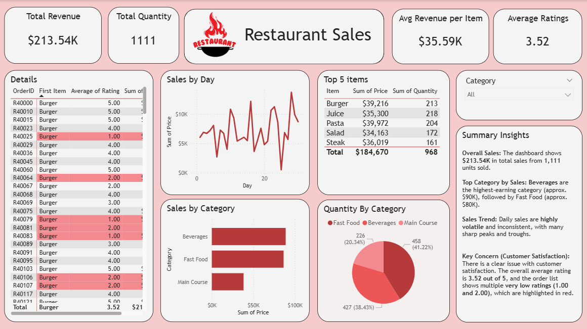

4. Insights & Findings
4.1. Beverages have high revenue
Beverages have the highest revenue (~$90K), showing strong demand.
The restaurant can add more drink options or combo deals to boost profits.
4.2. Inconsistent Daily sales
Daily sales are inconsistent with many ups and downs.
Offer weekday discounts or promotions to maintain steady sales.
4.3. Average customer rating is low
Average customer rating is low at 3.52/5.
Improve food quality and service to increase customer satisfaction.
4.4. Focus on quality
Top five items make up 86% of total sales.
Focus on promoting and maintaining quality of these popular dishes.
5. Conclusion & Recommendations
5.1 Conclusion
The Restaurant Sales Dashboard shows that total sales reached $213.54K from 1,111 items sold. Beverages and Fast Food are the top-performing categories, while Main Courses are less popular. Customer satisfaction is moderate with an average rating of 3.52/5, showing room for improvement. Daily sales also fluctuate, suggesting inconsistent demand.
5.2 Recommendations
  - Improve Customer Satisfaction:
Focus on food quality and service to raise customer ratings. Collect regular feedback to identify and fix issues quickly.
  - Promote Best-Selling Items:
Highlight popular items like Burgers and Juices through combos or special offers to increase sales.
  - Boost Low Sales Days:
Use weekday promotions or discounts during slow periods to keep sales steady.

