AICTE | IBM SkillsBuild
Data Analytics with AI Internship 2026
Conducted by BharatCares in association with AICTE
PROJECT REPORT
Student Performance Analytics and Prediction
From raw student data to early-warning insights
Submitted by
Yuvraj Sharadchandra Patil
B.E. Computer Engineering
Sinhgad College of Engineering, Vadgaon, Pune (SPPU)
Dataset: Student Performance Data Set (Kaggle / UCI)
Code: Yuvraj_StudentPerformance.ipynb

1. Introduction and Problem Statement
Schools usually discover that a student is struggling only when the final results are published, which is too late to help. Teachers already hold useful information such as past failures, study habits, attendance and family background, but it is rarely used to look ahead.
This project analyses a secondary-school student dataset to answer three practical questions:
- What is happening? How are students performing overall?
- Why? Which factors are linked to better or worse final grades?
- What should we do? Which students are most at risk, and can a machine learning model predict their final grade early enough to act?
The project follows the business-intelligence flow taught in the internship: Data → KPIs → Trends → Drivers → Risks and Opportunities → Recommended Actions.

2. Objectives
- Clean and understand the student dataset.
- Define KPIs that summarise academic performance.
- Identify the factors that influence the final grade (G3).
- Find which groups of students are at the highest risk of failing.
- Build and evaluate machine learning models that predict the final grade.
- Convert the findings into clear, actionable recommendations.

3. Dataset
The project uses the Student Performance Data Set (Portuguese language course file, student-por.csv), downloaded from Kaggle. It is a mirror of the UCI Machine Learning Repository dataset collected from two Portuguese secondary schools using school reports and questionnaires.
Property | Details
Source | https://www.kaggle.com/datasets/larsen0966/student-performance-data-set
File used | student-por.csv
Size | 649 students, 33 columns
Feature types | Demographic, family, social, school-related and lifestyle attributes
Grades | G1 (period 1), G2 (period 2), G3 (final grade), each from 0 to 20
Target variable | G3 (final grade). Pass = G3 of 10 or more
Citation | P. Cortez and A. Silva (2008), Using Data Mining to Predict Secondary School Student Performance

4. Tools and Technologies
Tool | Purpose
Python 3 | Programming language
Pandas, NumPy | Data loading, cleaning and calculations
Matplotlib, Seaborn | Data visualisation
Scikit-learn | Machine learning models and evaluation
Jupyter Notebook (VS Code) | Development environment
GitHub | Version control and project hosting
AI assistant (Claude by Anthropic) | Support for drafting code and documentation

5. Methodology
- Load and inspect the data and check its structure.
- Clean the data: check for missing values and duplicates.
- Engineer features: create a pass/fail flag, an at-risk flag and grouped absence bands.
- Compute KPIs that summarise performance.
- Explore trends and drivers using charts and correlations.
- Analyse risk by comparing failure rates across student groups.
- Model: train Linear Regression and Random Forest to predict G3, with and without the earlier grades.
- Evaluate using MAE, RMSE, R² and 5-fold cross-validation.
- Recommend actions from the evidence.

6. Data Cleaning and Preparation
The dataset is clean. It has no missing values and no duplicate rows, so no records needed to be removed or imputed. Three helper columns were created:
- pass_fail: 1 if G3 is 10 or more, otherwise 0.
- at_risk: 1 if G3 is below 10 (the student failed).
- absence_band: absences grouped into 0, 1-5, 6-10 and 10+.
For modelling, text columns (such as school, sex and address) were converted to numeric indicator columns using one-hot encoding. The data was split 80% for training and 20% for testing with a fixed random seed for reproducibility.

7. Key Performance Indicators (KPIs)
KPIs show at a glance what is happening. Five were chosen to describe the size, quality and risk profile of the student group.
KPI | Value
Total students | 649
Average final grade (G3, out of 20) | 11.91
Pass rate | 84.6%
At-risk students (G3 below 10) | 15.4%
Average absences per student | 3.7

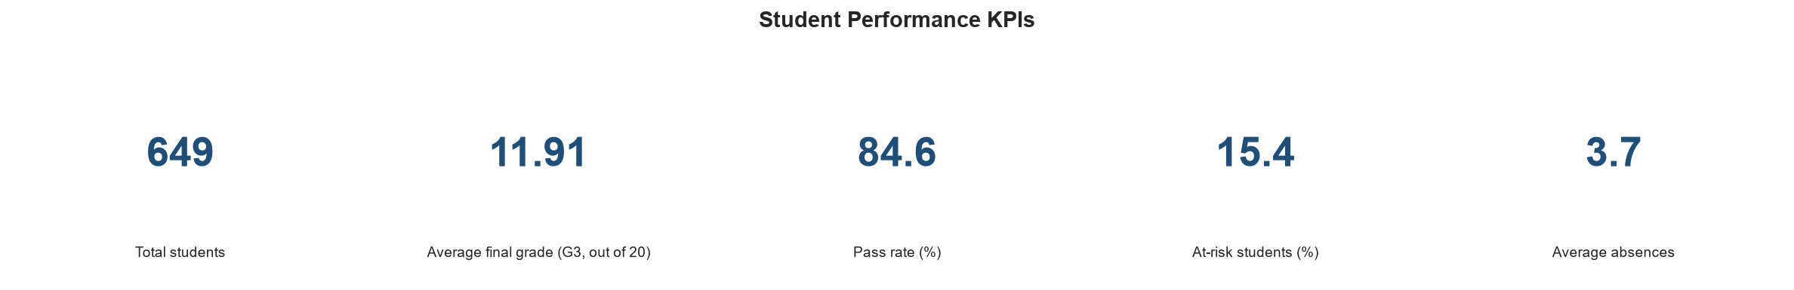
Figure 1: Student performance KPIs
Most students pass, but roughly one in six (15.4%) fails. That is about 100 students who could have benefited from earlier support.

8. Trends in Grades
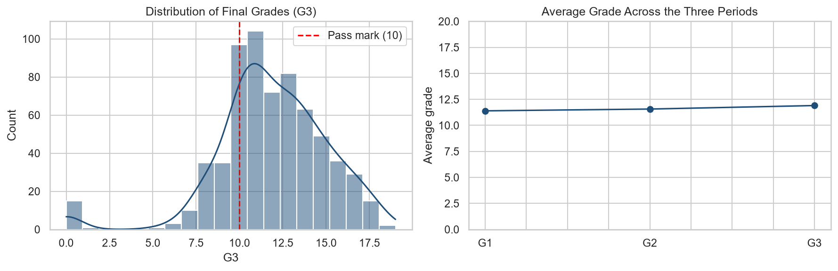
Figure 2: Distribution of final grades and average grade across the three periods
Final grades are centred around 10 to 14, with a tail of high achievers up to 19. A small group of students scored 0, which is visible as a separate bar at the left of the histogram. The average grade rises slightly across the three periods, from 11.40 (G1) to 11.57 (G2) to 11.91 (G3), so performance is stable and improves slightly over the year.

9. Drivers: What Influences the Final Grade?
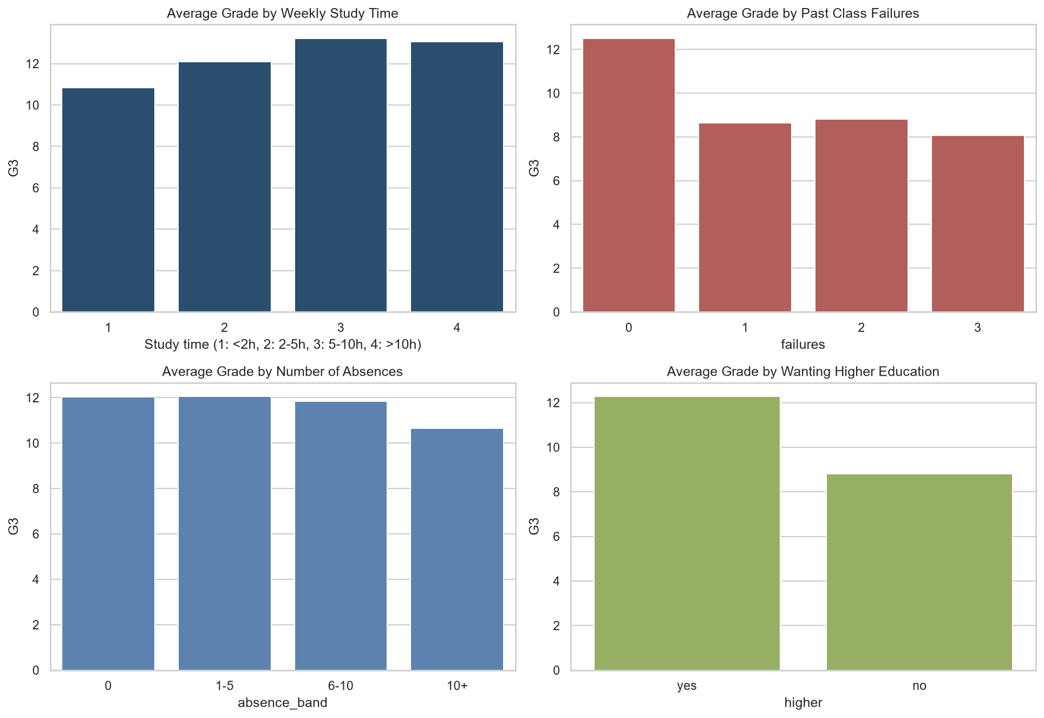
Figure 3: Average final grade by study time, past failures, absences and higher-education intention
The charts show clear patterns in the average final grade:
- Study time: grades rise from about 10.8 for students studying under 2 hours a week to about 13 for those studying 5 hours or more.
- Past failures: students with no past failures average about 12.5, compared with 8 to 9 for those with one or more.
- Absences: grades stay close to 12 up to 10 absences, then drop to about 10.6 above 10 absences.
- Higher education: students who plan to continue studying average about 12.3, compared with about 8.8 for those who do not.
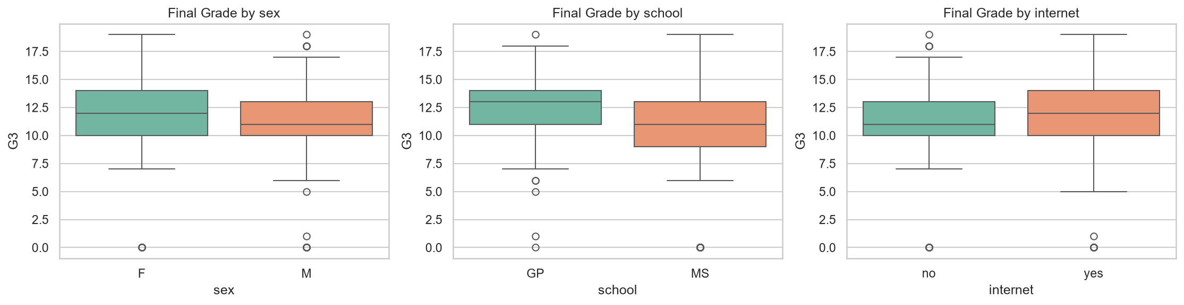
Figure 4: Final grade by sex, school and internet access
Median grades are slightly higher for female students (12 vs 11), students at school GP (13 vs 11 at school MS) and students with home internet access (12 vs 11).
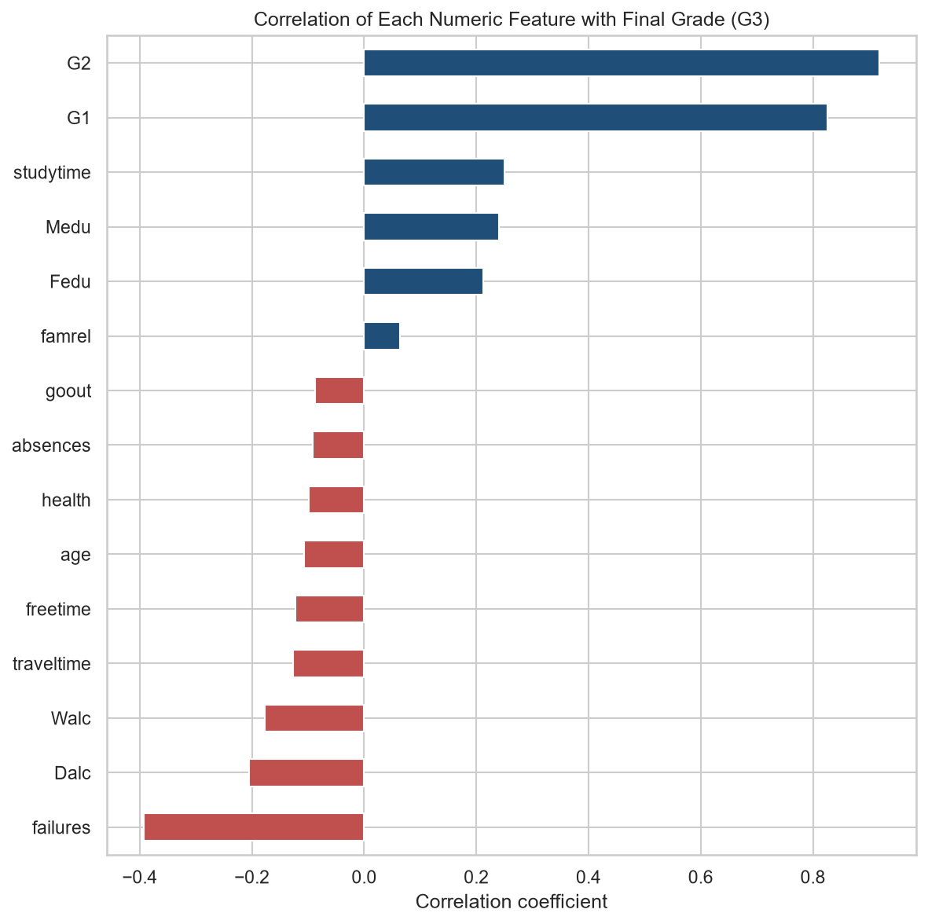
Figure 5: Correlation of each numeric feature with the final grade
The earlier grades are by far the strongest signals: G2 (0.92) and G1 (0.83). Among other factors, study time (0.25), mother's education (0.24) and father's education (0.21) are positively related to G3, while past failures (about -0.39), weekday alcohol use (Dalc) and weekend alcohol use (Walc) are negatively related. Correlation shows association only and does not prove cause.

10. Risk Analysis
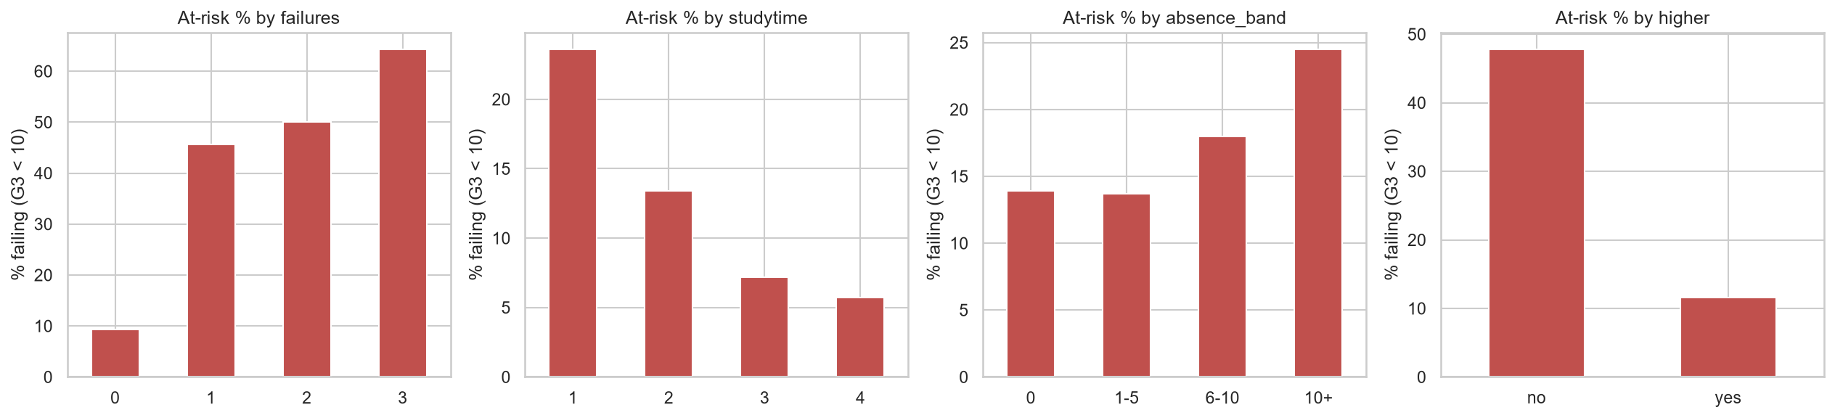
Figure 6: Percentage of students failing, by past failures, study time, absences and higher-education intention
Factor | Higher-risk group | Lower-risk group
Past class failures | 49.0% fail (1 or more failures) | 9.3% fail (none)
Weekly study time | 23.6% fail (under 2 hours) | 6.8% fail (5+ hours)
Absences | 24.5% fail (more than 10) | 13.8% fail (5 or fewer)
Plans for higher education | 47.8% fail (no) | 11.6% fail (yes)

The failure rate rises steeply with past failures: 9.3% with none, 45.7% with one, 50.0% with two and 64.3% with three. The single biggest risk signals are past failures and lack of intention to pursue higher education, each associated with roughly a 40-point higher failure rate.

11. Prediction Model
Two model setups were compared, because the earlier grades G1 and G2 are only available after part of the year has passed:
- A. Full model: uses all features, including G1 and G2. Best accuracy, available later in the year.
- B. Early-warning model: uses everything except G1 and G2. Usable at the start of the year, when intervention is most valuable.
Two algorithms were used in each setup: Linear Regression (a simple baseline) and Random Forest (which captures non-linear patterns). Results on the 20% test set:
Model | MAE | RMSE | R²
A. Linear Regression (with G1, G2) | 0.765 | 1.215 | 0.849
A. Random Forest (with G1, G2) | 0.751 | 1.247 | 0.841
B. Linear Regression (without G1, G2) | 2.156 | 2.862 | 0.160
B. Random Forest (without G1, G2) | 2.057 | 2.820 | 0.185

MAE is the average prediction error in grade points, and R² is the share of variation in grades the model explains (1.0 is perfect).
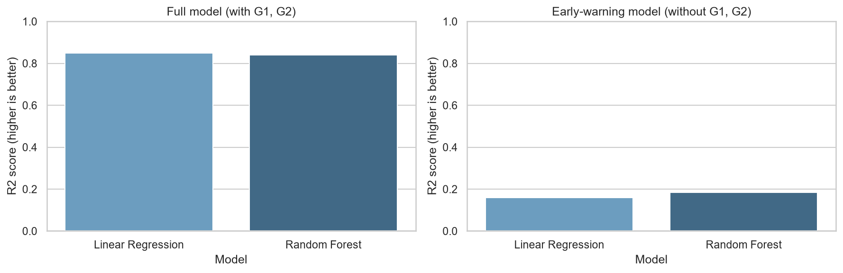
Figure 7: R² score of each model in both setups
With G1 and G2, the models are accurate: the Linear Regression model reaches R² = 0.849 with an average error of only 0.77 grade points, and Random Forest performs almost identically. 5-fold cross-validation on the full model gave R² scores of 0.752, 0.699, 0.826, 0.831 and 0.790, with a mean of 0.78, which confirms that the result is stable and not caused by one lucky split.
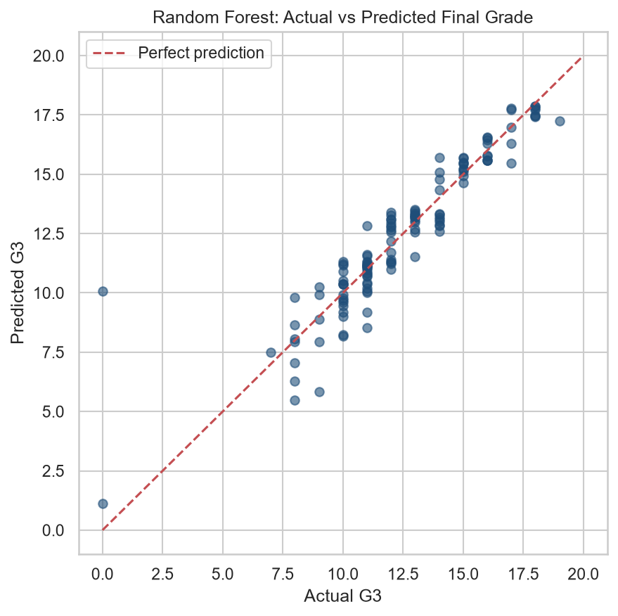
Figure 8: Random Forest: actual versus predicted final grade (full model)
Predictions lie close to the diagonal line for most students. A few students with an actual grade of 0 are predicted much higher, since a sudden zero is hard to anticipate from the available data.
Without G1 and G2, accuracy drops sharply (R² about 0.16 to 0.19, error about 2.1 grade points). Background factors alone explain only a small part of the final grade. The early-warning model is therefore best treated as a screening aid, not a precise predictor.
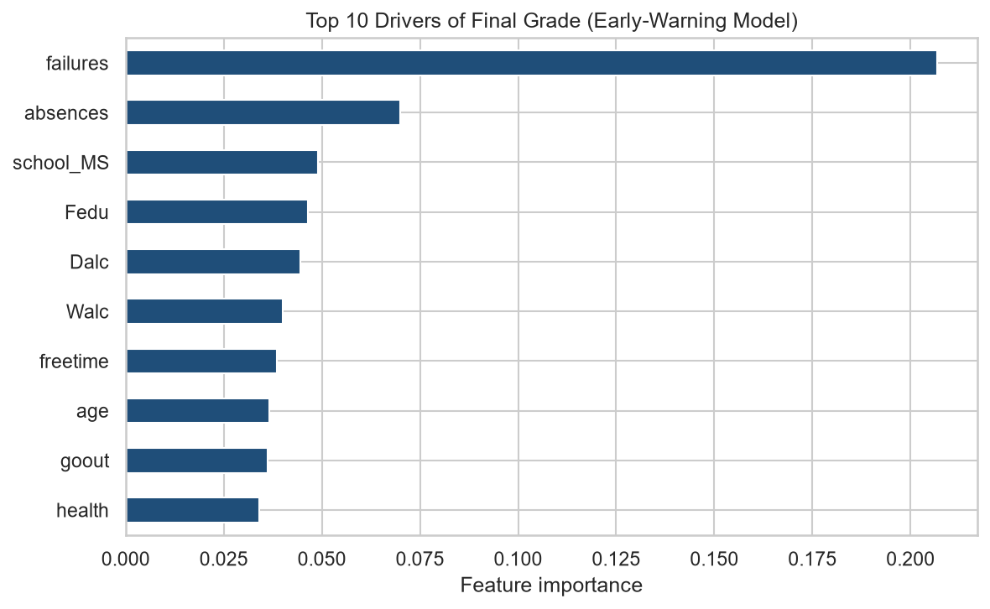
Figure 9: Top 10 drivers of final grade in the early-warning model
In the early-warning model, past failures (0.207) is the most important feature by a wide margin, followed by absences (0.070), school (0.049), father's education (0.046) and weekday alcohol use (0.045).

12. Insights: Risks, Opportunities and Actions

Risks
- Students with past failures fail 49.0% of the time versus 9.3% for those without.
- Students studying under 2 hours a week fail 23.6% of the time versus 6.8% for those studying 5 hours or more.
- Students with more than 10 absences fail 24.5% of the time versus 13.8% for those with 5 or fewer.

Opportunities
- Students who do not plan higher education fail 47.8% of the time versus 11.6% for those who do, so motivation and career counselling can make a difference.
- The full model predicts final grades within about 0.77 grade points, so checkpoint grades G1 and G2 give a reliable early view.
- Study habits are something students can change: more study time is linked with a much lower failure rate.

Recommended Actions
- Early-warning programme: flag students with past failures or low study time in the first weeks of the year. Use the model only as a supporting screening tool.
- Attendance monitoring: start a parent and teacher conversation when a student approaches about 10 absences.
- Targeted tutoring: offer extra classes to students with past failures, the highest-risk group.
- Motivation and career counselling: support students who do not plan to pursue higher education.
- Use G1 and G2 checkpoints: the first two period grades are the strongest predictors, so intervene right after G1 rather than waiting for the final grade.

13. Conclusion
Final grades can be predicted well once earlier grades are known (R² = 0.85, average error about 0.77 grade points). Without them, prediction is much weaker (R² about 0.18), so the model works as a screening aid and not as a replacement for teacher judgement. The clearest and most actionable drivers of failure are past class failures, low study time, high absences and no intention of pursuing higher education. Acting on these signals early, especially right after the first period grade, gives schools the best chance to help students before the final result.

14. Limitations and Future Work

Limitations
- The dataset is small (649 students from two Portuguese schools), so results may not generalise to other schools or countries.
- Correlation is not causation: the analysis shows association, not proof that changing a factor changes a grade.
- The early-warning model has limited accuracy and should support, not replace, teachers' judgement.
- Only the Portuguese language course data was used.

Future Work
- Add the Mathematics course dataset and compare results between subjects.
- Try gradient boosting and tune model settings.
- Build a classification model that directly predicts pass or fail.
- Create an interactive dashboard so teachers can explore risk groups themselves.

15. References
- P. Cortez and A. Silva. Using Data Mining to Predict Secondary School Student Performance. Proceedings of the 5th Future Business Technology Conference (FUBUTEC 2008), Porto, Portugal, pp. 5-12.
- UCI Machine Learning Repository: Student Performance dataset. https://archive.ics.uci.edu/dataset/320/student+performance
- Kaggle: Student Performance Data Set. https://www.kaggle.com/datasets/larsen0966/student-performance-data-set
- Scikit-learn documentation. https://scikit-learn.org

