

MINOR PROJECT I
ANALYSIS AND DESIGN OF CONTROL SYSTEM WITH MATLAB
PROJECT REPORT
UNDER THE GUIDANCE OF
DR. Ruchi Agarwal
Submitted by
Yuvraj Singh Roll no. 1702001
Divya Gaurav Roll no. 1602045
Harender Yadav Roll no. 1602058

1 Dr. Ruchi Agarwal

ACKNOWLEDGEMENT

The success and final outcome of this project required a lot of guidance and assistance from many people and I am extremely privileged to have got this all along the completion of my project. All that I have done is only due to such supervision and assistance and I would not forget to thank them.

We would like to pay our sincere thanks to our guide “Dr. Ruchi Agarwal”, Professor of Electrical Engineering of NIT Patna for her guidance and encouragement.

2

ABSTRACT

In this Project we have implemented the theoretical behaviour of Continuous System and various Plant that need to be controlled with the help of MATLAB software and designed the different control technique to be implemented. We also plot the step response with unity feedback of each plant function input by the user. We also used the time domain analysis (Root Locus) to search for the stability of the system. After learning basic Matlab programming and Matlab based control system designing we have programmed a M-file which basicall take the Plant transfer function as input and provide the Step response, Root locus and behavior of system with lead and lag compensator which also give the change of rise time, settling time, peak overshoot and other parameter required for analysis of system.

3

CONTENTS

NAME PAGE

Chapter 1 Introduction 05

Chapter 2 Continuous System 06

Chapter 3 Step Response 07

Chapter 4 Root Locus 08

Chapter 5 Bode Plot 10

Chapter 6 Lead Compensator 12

Chapter 7 Lag Compensator 14

Result and Discussions 16

Summary and Conclusions 21

Appendix 22

References 24

4

CHAPTER 1: INTRODUCTION

The study of control systems involves how components are integrated together to control a parameter such as velocity, torue, and pressure to force an output parameter to remanin at a specific value.

MATLAB, over the years, has evolved into a tool that has aided professionals, scientists and engineers immensely to diversify their understanding of fields associated with nearly all discourses presently available for study and research.

Control System analysis requires the use of complex applied mathematics that is often difficult to solve. Here comes the importance of matlab which has library for each calculation that can be called using the function and passing the value in it. Such as laplace, z-transform , root locus, bode plot and many more.

The determination of the roots of a characteristic equation is a tiresome job, if the degree of the characteristicpolynomial is three or higher. That is why, a simple technique, i.e. the root locus technique as established by W>R. Evans is most widely used. This method is nothing but a graphical method of plotting the locus of the roots in the s-plane as the system parameter is varied over the complete range of values starting from zero to infinity.

It is the matter of interest of any control engineer to ascertain the performance of the control system and study its behaviour. Study and analysis of a control system with respect of time,is one of the methods employed to describe the performance of a feedback control system.
5

CHAPTER 2 : CONTINUOUS SYSTEM

A continuous system is one in which the condition of the system is known from instant to instant. The system is considered to be a real-time system, which means that any change in the desired output variable of the system is known instantaneously.

A change in the output variable is sensed using a transducing device that generates an analog of the variable being controlled. An example is the control of the velocity of an electric motor. A small electric generator, called a transducer, whose output voltage is proportional to the velocity of the motor, called the plant, is coupled to the motor. The transducer signal voltage is applied to another device called a summing junction. The summing junction compares the transducer voltage to an input reference voltage, called the setpoint. If there is a difference between the setpoint and the motor velocity, a voltage called the error signal is generated and applied to the plant control device (amplifiers and power source) to increase or decrease the velocity according to the polarity of the summing junction output voltage.

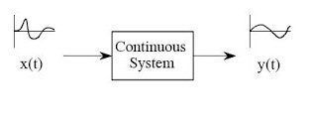

6

CHAPTER 3 : STEP RESPONSE

The step response of a system in a given initial state consists of the time evolution of its outputs when its control inputs are Heaviside step functions. In control theory, step response is the time behaviour of the outputs of a general system when its inputs change from zero to one in a very short time. The concept can be extended to the abstract mathematical notion of a dynamical system using an evolution parameter.
From a practical standpoint, knowing how the system responds to a sudden input is important because large and possibly fast deviations from the long term steady state may have extreme effects on the component itself and on other portions of the overall system dependent on this component. In addition, the overall system cannot act until the component's output settles down to some vicinity of its final state, delaying the overall system response. Formally, knowing the step response of a dynamical system gives information on the stability of such a system, and on its ability to reach one stationary state when starting from another.

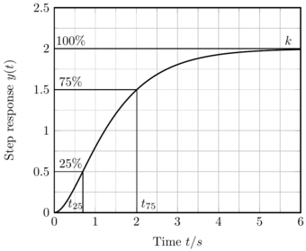

7 Step response of system with x(t)=1

CHAPTER 4 : ROOT LOCUS

The concept of root locus was first introduced by Evans. Its purpose in design is to evaluate the effect on the stability of a system as some system parameter (usually a value of gain) is changed.
Values such as the minimum damping ratio of the system, the gain at a specific pole, or the tendency toward oscillation can be predicted using the root locus.

The characteristic equation contains both the poles and zeros of a system obtained from the open-loop transfer function, but it is the poles that determine the stability of the system. For a system to be stable, all of the poles must be in the left-half plane or must migrate toward the left-half plane.

The influence of the poles of a system in system response cannot be understand. The poles give insight into how the system stability is influenced by changes in gain. The system may be stable for all values of gain greater than zero, it may be stable for values of gain greater or less than a specific value, or it may be stable for gains between two values.

The use of the root locus in conjunction with a Routh table provides a comprehensive understanding of how a system will react to changes in gain. The root locus gives insight into what the system damping ratio and radian velocity are at closed-loop poles and how the placement of zeros will affect the time response of a system.

Let us now draw the root locus of the control system having open loop transfer function,
G(s)H(s)=k/(s*(s+1)*(s+5))
8

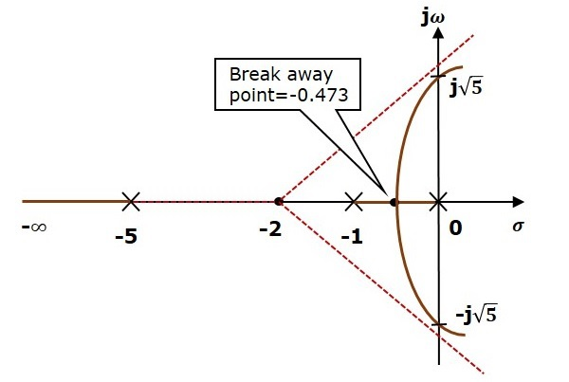

9

CHAPTER 5 : BODE PLOT

The Bode Plot consists of two plots :
1. Magnitude Plot
2. Phase Plot

In both the plots, x-axis represents angular frequency (logarithmic scale). Whereas, yaxis represents the magnitude (linear scale) of open loop transfer function in the magnitude plot and the phase angle (linear scale) of the open loop transfer function in the phase plot.

The magnitude of the open loop transfer function in dB is -
M = 20 log | G(jw)H(jw) |

The phase angle of the open loop transfer function in degrees is -
A = /_G(jw)H(jw)

As the magnitude and the phase plots are represented with straight lines, the Exact Bode plots resemble the asymptotic Bode plots. The only difference is that the Exact Bode plots will have simple curves instead of straight lines.

From the Bode plots, we can say whether the control system is stable, marginally stable or unstable based on the values of these parameters.
1. Gain cross over frequency and phase cross over frequency
2. Gain margin and phase margin

The stability of the control system based on the relation between the phase cross over frequency and the gain cross over frequency is listed below.
10
1. If the phase cross over frequency ω_{pc} is greater than the gain cross over frequency ω_{gc}, then the control system is stable.

2. If the phase cross over frequency ω_{pc} is equal to the gain cross over frequency ω_{gc}, then the control system is marginally stable.

3.If the phase cross over frequency ωpc is less than the gain cross over frequency ωgc, then the control system is unstable.

11

CHAPTER 6 : LEAD COMPENSATOR

A system which has one pole and one dominating zero(the zero which is closer to the origin than all over zeros is knowm as dominating zero.) is knowm as lead network. If we want to add a dominating zero for compensation in control system then we have to select lead compensator network.

The basic requirement of the phase lead network is that all poles and zeros of the transfer function of the network must lie on (-)ve real axis interlacing each other with a zero located at the origin of nearest origin.

Given below is the circuit diagram for the phase lead compensator network.
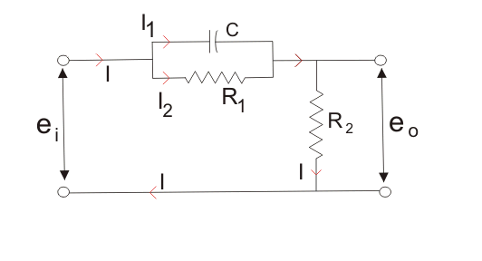

12

Effect of Phase Lead Compensation :-

1. The velocity constant K_{v} increases.

2. The slope of the magnitude plot reduces at the gain crossover frequency so that relative stability improves and error decrease stability improves and error decrease due to error is directly proportional to the slope.

3. Phase margin increases.

4. Response become Faster.

Advantages of Phase Lead Compensation :-

1. Due to the presence of the phase lead network the speed of the system increases because it shifts
gain crossover frequency to a higher value.

2. Due to the presence of phase lead compensation maximum overshoot of the system decreases.

Disadantages of the Phase Lead Compensation :-

1. Steady state error is not improved.

13

CHAPTER 7 : LAG COMPENSATOR

A system which has one zero and one dominating pole ( the pole which is closer to the origin that all other poles is known as dominating pole) is known as lag network. If we want to add a dominating pole for compensation in control system then, we have to select a lag compensation network.

The basic requirement of the phase lag network is that all poles and zeros of the transfer function of the network must lie in (-)ve real axis interlacing each other with a pole located or on the nearest to the origin.

Given below is the circuit diagram fot the phase lag compensation network.

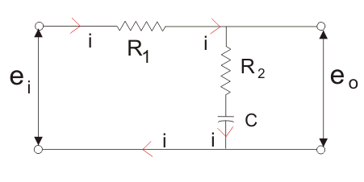

14

Effect of Phase Lag Compensation :-

1. Gain crossover frequency increases.

2. Bandwidth decreases.

3. Phase margin will be increase.

4. Response will be slower before due to decreasing bandwidth, the rise time and the setting time
become larger.

Advantages of Phase Lag Compensation :-

1. Phase lag network allows low frequencies and high frequencies are attenuated.

2. Due to the presence of phase lag compensation the steady state accuracy increases.

Disadvantages of Phase Lag Compensation :-

1. Due to the presence of phase lag compensation the speed of the system decreases.

15

RESULT AND DISCUSIONS

The purpose of this project is to create a Matlab code for generating Root locus and Step response of continuous system with Lead/Lag Compensator. Matlab code is given below:-

%Root locus & Step response of continuous system with lead/lag compensator
clear;
close all;
clc;
s=tf('s');
num=input('please enter the numerator of your plant transfer function ex. [1 2 3]');% here s is %assigned as variable in transfer function
den=input('please enter the denominator of your plant transfer function ex. [1 2 5]');
OLTF=tf(num,den); % here open loop transfer function is written
LeadCompensator=(s+1)/(s+3); % here lead compensator equation is written
LagCompensator=(s+5)/(s+2); % here lag compensator equation is written
fprintf('enter 1 for root locus of CLTF \n');
fprintf('enter 2 for step response of CLTF \n');
fprintf('enter 3 for root locus of CLTF with lead compensator \n');
fprintf('enter 4 for step response of CLFT with lead compensator \n');
fprintf('enter 5 for root locus of CLTF with lag compensator \n');
fprintf('enter 6 for step response of CLTF with lag compensator \n');
fprintf('enter 7 for bode plot response of CLTF with Lead compensator');
fprintf('enter 8 for bode plot response of CLTF with Lag compensator');
x=input('please enter your choice \n');
if x==1
rlocus(feedback(OLTF,1));
elseif x==2
step(feedback(OLTF,1));
elseif x==3
16
rlocus(feedback(OLTF*LeadCompensator,1));
elseif x==4
step(feedback(OLTF*LeadCompensator,1));
elseif x==5
rlocus(feedback(OLTF*LagCompensator,1));
elseif x==6
step(feedback(OLTF*LagCompensator,1));
elseif x==7
bodeplot(feedback(OLTF*LeadCompensator,1));
elseif x==8
bodeplot(feedback(OLTF*LagCompensator,1));
end

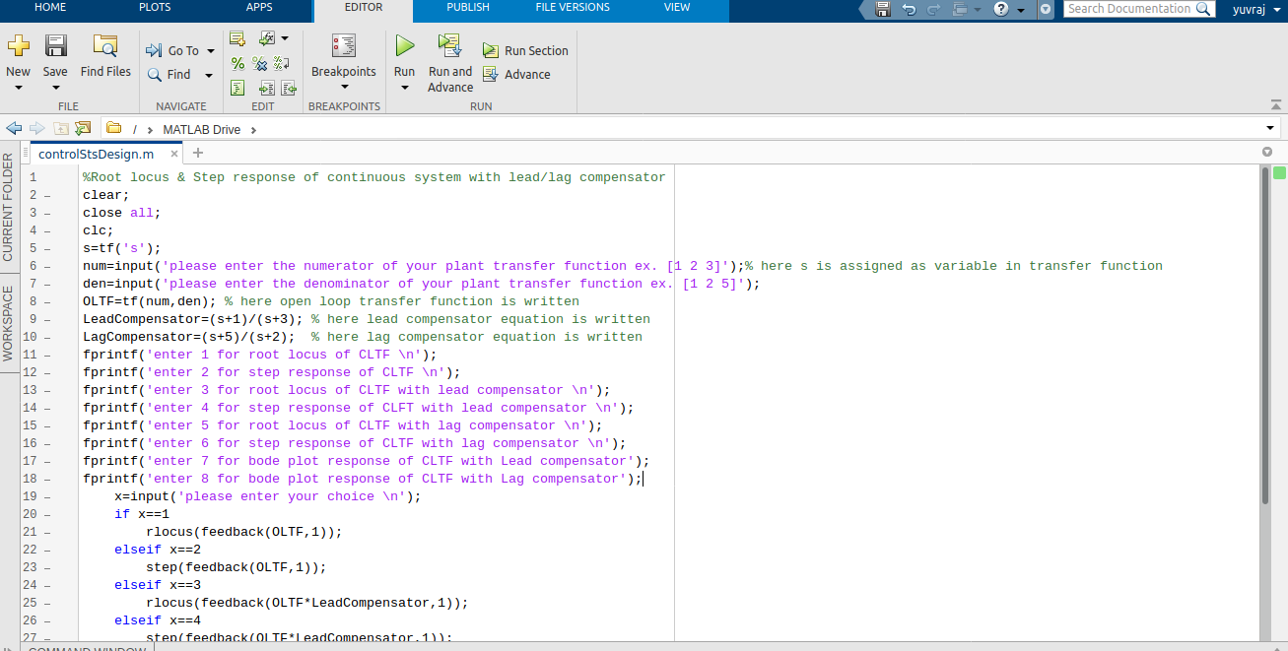

Part 1 Matlab Code of Control System Design

17

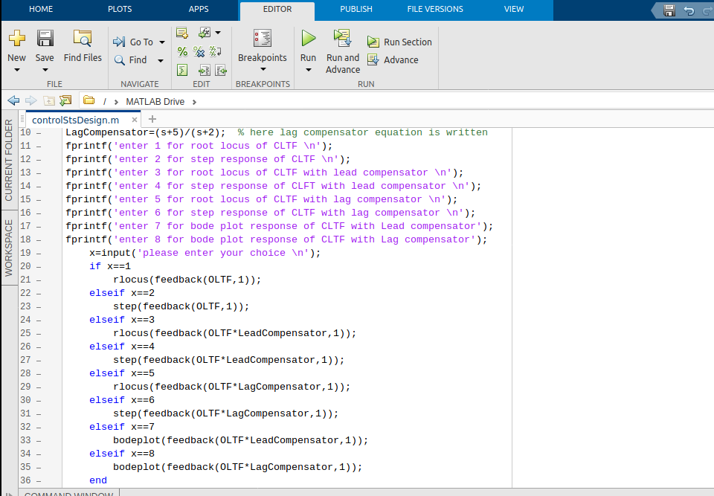

Part 2 Matlab Code of Control System Design

18

When the open loop transfer function (OLTF) is 1/(7*s) the following result is shown below:-

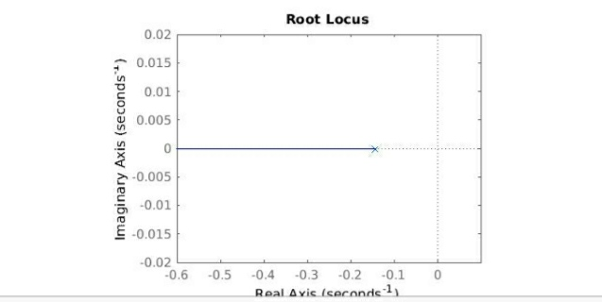
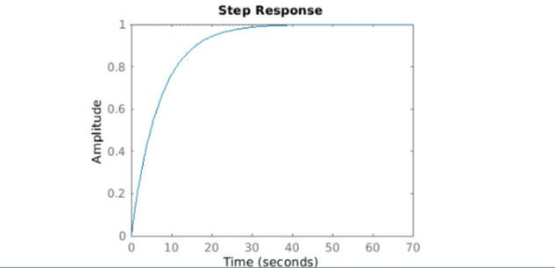

key 1 is pressed (i) key 2 is pressed (ii)

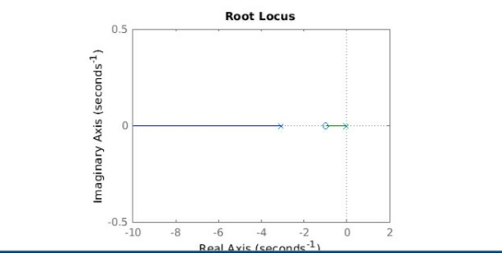
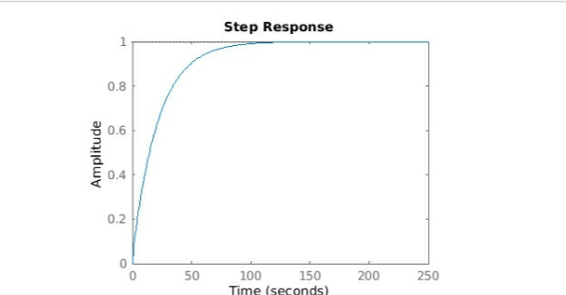

key 3 is pressed (iii) key 4 is pressed (iv)

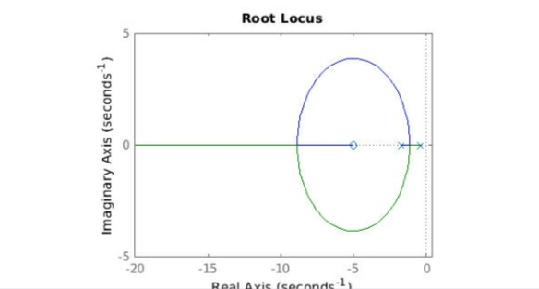
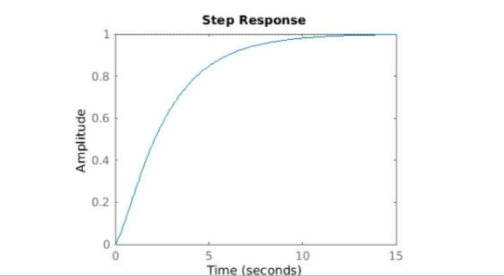

key 5 is pressed (v) key 6 is pressed (vi)
19

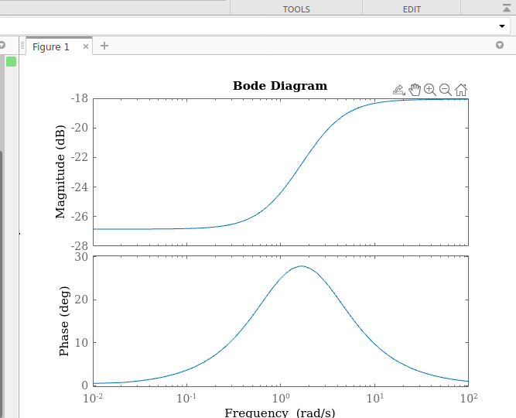
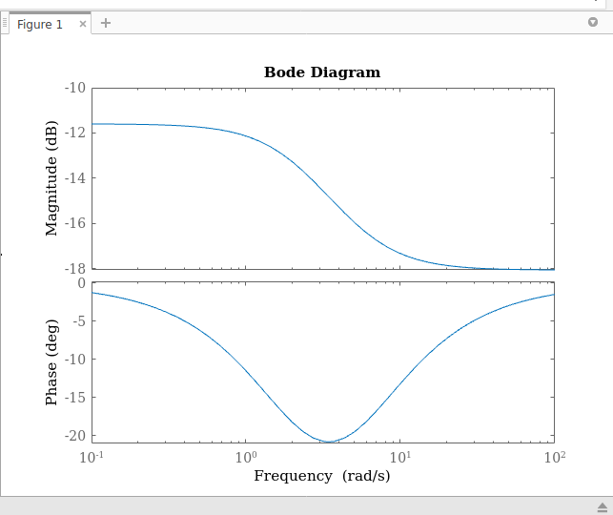

Key 7 is Pressed (vii) Key 8 is Pressed (viii)

20

SUMMARY AND CONCLUSION :-

Summary

In order to obtain the desired performance of the system, we use compensating networks. Compensating networks are applied to the system in the form of feed forward path gain adjustment.
Compensating a unstable system to make it stable. A compansating network is used to minimize overshoot.

These compensating networks increase the steady state accuracy of the system. An important point to be noted here is that the increase in the steady state accuracy brings instability to the system.

Compensating networks also introduces poles and zeros in the system thereby causes changes in the transfer function of the system. Due to this, performance specifications of the system change.

Conclusion

The Phase Lead Compensation makes the response faster but the steady state error is not improved.
In the Phase Lag Compensation response becomes slower but the steady state accuracy increases.

21

APPENDIX

Matlab Featues

s = tf(‘s’) % it assign the s as the transfer function variable

‘%’ is used to comment in matlab

GH=1/(s*(s+1)) % transfer function defination

it is also defined seprately by numerator and denominator and then passing in function

GH = tf(numerator,denominator)\

and also by passing zero, pole and gain of the transfer function in below function

GH = zpk([ ], [ ], [ ])

p = pole(GH) % this function is used to calculate the pole of the transfer function

Z = zero(GH) % this function is used to calculate the zero of thye transfer function

pzmap(GH) % this function is used to plot the pole and zero map

feedback(GH,1) % this function is used to provide the feedback value to the open loop transfer function
22
rlocus(GH) % this function is used to calculate the root locus of the transfer function

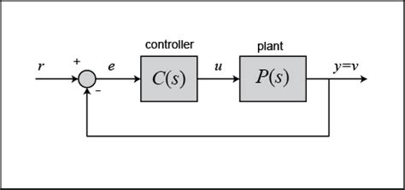

Block diagram of Control System with Unity feedback fig (A)

23

REFERENCE

1. K.M Soni, Signal and System, KATSON Book, 4885/109, Prakash Mahal, Dr. Subhash Bhargav Lane, Near Gurudwara, Daryaganj, New Delhi-110002

2. Les Fenical, Control System Technology, THOMSON DELMAR LEARNING, Cengage Distribution Center 10650 Toebben Dr Location 2 Independence, KY 41051

3. M.N. Bandyopadhyay, Control Engineering, Prentice-Hall of India Pvt. Ltd, Rimjhim House, 111, Patparganj Industrial Estate, Delhi - 110 092, India.

4. K K SARMA MATLAB Demystified Basic Concept and Applications, VIKAS PUBLICATION, A-27, 2nd Floor, Mohan Co-operative Industrial Estate,
New Delhi-110044

5. A.K. Jairath Problem and Solution of Control Systems, CBS Publishers & Distributors Pvt. Ltd, CBS PLAZA, 4819/XI, Prahlad Street, 24 Ansari Road, Darya Ganj, New Delhi-110002

24

