**D. Y. Patil College of College of Engineering and Technology, Kolhapur**

**Department of Computer Science & Engineering**

**Class: SY-A Subject: AOOC**

**Experiment no: 15**

**Group No. G14 Mini Project**

**Title of Mini-Project: Smart Case Paper – Legal Case Management System**

**Problem Statement:**

**To design and develop a Java application that helps manage and track legal case records digitally, enabling users to add, search, and display cases efficiently through a console-based interface.**

**Introduction:**

**The Smart Case Paper application is a console-based Java mini project designed to simplify the management of legal case files. It demonstrates core Java concepts like classes, objects, encapsulation, and ArrayLists. The system helps users enter new cases, view all stored cases, and search by case number, reducing the need for physical records.** **The Case Management System is a console-based Java application designed to help small legal firms maintain records of client cases. The system enables users to add new cases, view all existing cases, and search for specific cases using their case numbers. It uses object-oriented programming principles to encapsulate case data and manage operations effectively.**

**System Architecture:**

**Case.java – model class to store case data.**

**CaseManager.java – manages list of cases and operations.**

**Main.java – provides user interface and menu-based control.**

**Module description or working of system:**

**Case.java:**

**A class that defines attributes like caseNumber, clientName, and caseDetails.**

**CaseManager.java:**

**Contains functions to add cases, search cases by case number, and list all cases.**

**Main.java:**

**Provides the user interface with menu options for interacting with the application. Users can select from options like Add Case, List Cases, Search Case, and Exit.**

**Screenshots:**

**Screenshots for java console application:**

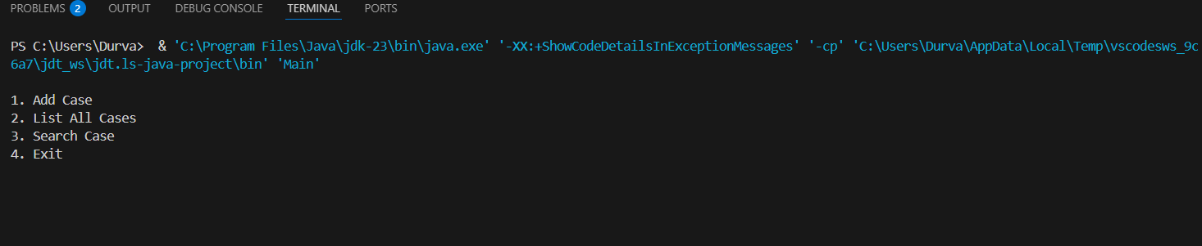

**Screenshot to show sample data like:**

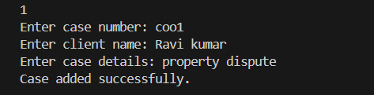

**Group Members:**

|  |  |  |  |
| --- | --- | --- | --- |
| **Unique id** | **Roll No** | **Name of Student** | **Sign** |
| **EN23163769** | **51** | **Shreya Sandip khamitkar** |  |
| **EN23183685** | **52** | **Sanika Sunil Kumbhar** |  |
| **EN23235319** | **53** | **Durva Nandkumar Ghodake** |  |
| **EN23186580** | **54** | **Jyotiraditya Yashwantrao Ghatge** |  |
| **EN23230440** | **56** | **Yuvraj Prakash Mali** |  |