Report
Of
Summer Internship at We For Education Welfare Society, Meerut
Submitted
To
School of Computer Science and Engineering
IILM University, Greater Noida, U.P.
In partial fulfilment of the requirement of degree of
B.Tech CSE

By
Roll Number of Student: 25SCS1003001222
Name of Student (All Capital): YUVRAJ PRATAP SINGH
Batch:
2025-2029

CANDIDATE'S DECLARATION
I, Yuvraj Pratap Singh do hereby declare that the internship report titled “Summer Internship at We For Education Welfare Society, Meerut” has been completed by me to fulfil the requirement for the award of the degree of Bachelor of Technology in CSE. All the references have been quoted and I have not taken as such any material from any other source. I affirm to you that this report is my own and has not been submitted to any other institute for any degree/diploma requirement and further I shall be solely responsible for any kind of copyright violation in this regard.

Signature : 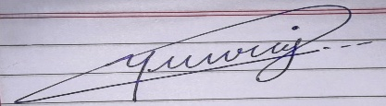
Student Name: Yuvraj Pratap Singh
Roll No.: 25SCS1003001222

ACKNOWLEDGEMENT
I am using this opportunity to express my gratitude to everyone at We For Education Welfare Society, Meerut, who supported me throughout the Internship Program. I am thankful for their aspiring guidance, invaluably constructive criticism and friendly advice during this work. I am sincerely grateful to them for sharing their truthful and illuminating views on a number of issues related to this work.
I would especially like to thank Mr. Piyush Agarwal, Treasurer at the NGO for their constant guidance and support.
I express my gratitude to my parents for their blessings.

Signature: 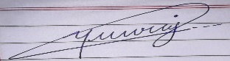
Student Name: Yuvraj Pratap Singh
Roll No.: 25SCS1003001222

INTERNSHIP COMPLETION CERTIFICATE
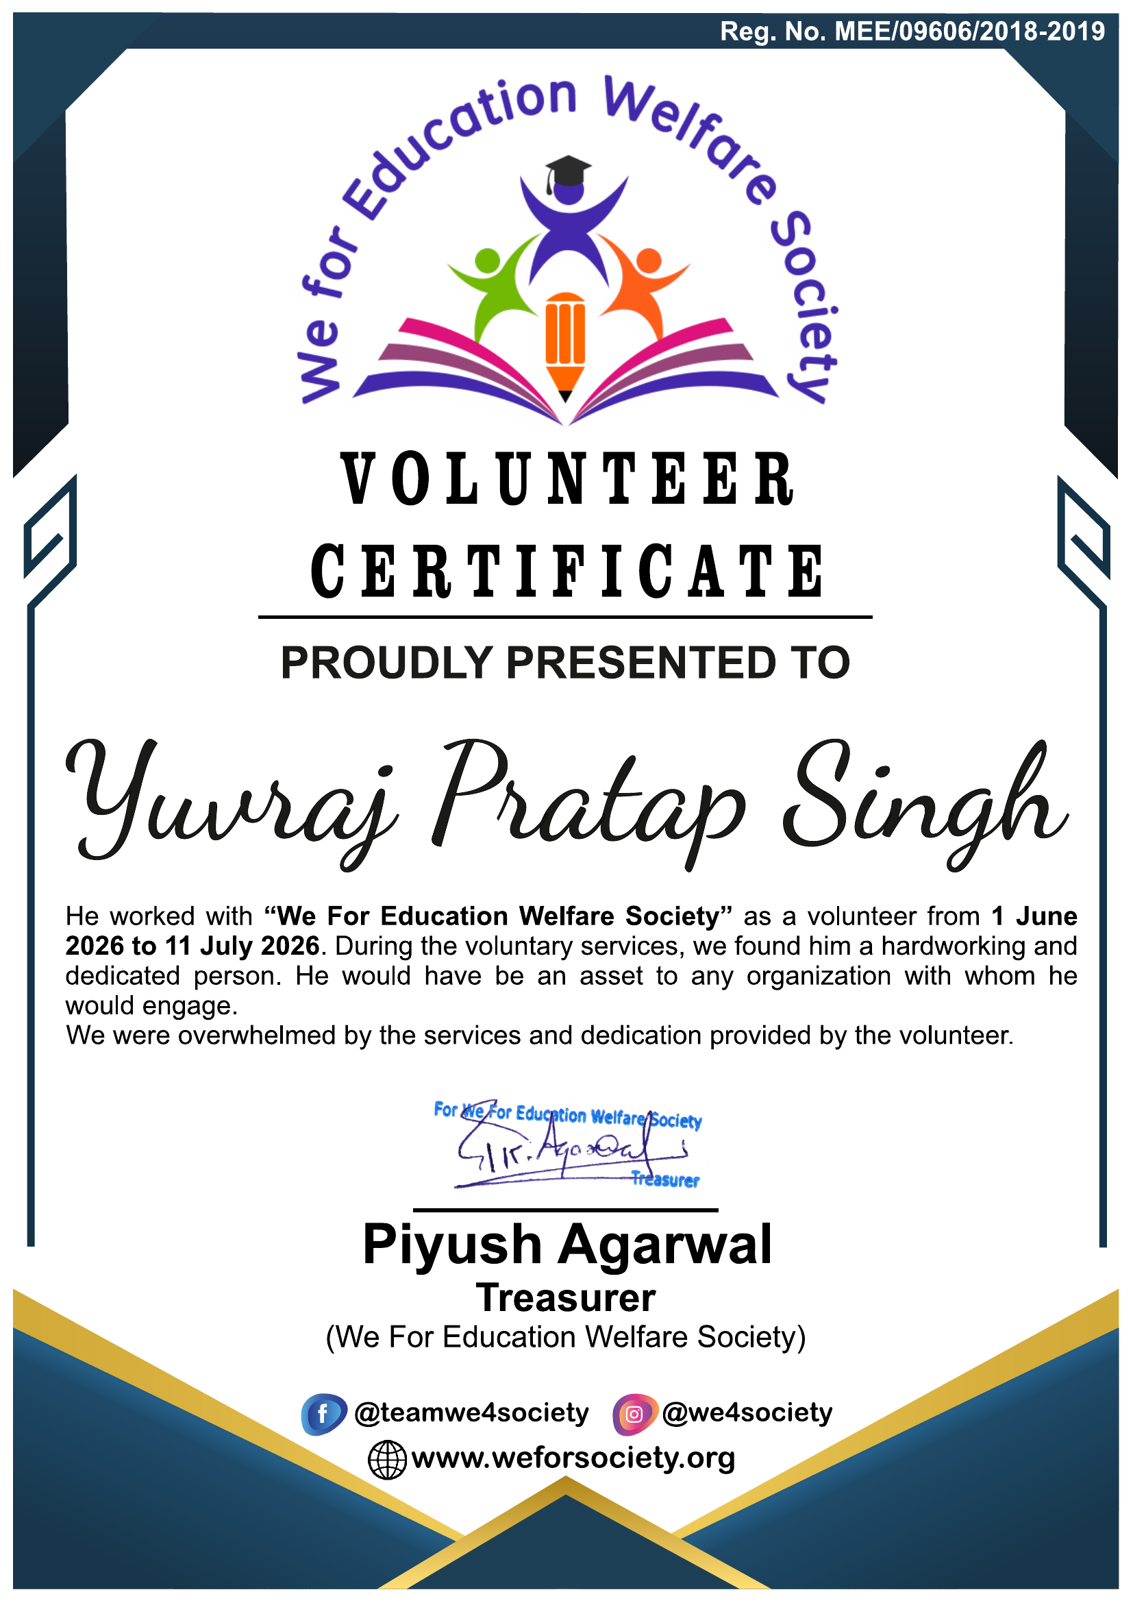

TABLE OF CONTENTS
Chapter No. | Chapter Name | Page Nos.
 | Cover Page | ---
1. | Candidate's Declaration | i
2. | Acknowledgment | ii
3. | Internship Completion Certificate | iii
4. | Project Description
 | 4.1 Introduction | 1
 | 4.2 Organization Profile | •
 | 4.3 Problem Statement | •
 | 4.4 Project Objectives | •
 | 4.5 Scope of the Project | •
 | 4.6 Technologies and Tools Used | •
 | 4.7 System Architecture | •
 | 4.8 Methodology | •
 | 4.9 Expected Outcomes | •
 | 4.10 Certificates of completion | •
5. | Bibliography/References | •

4. PROJECT DESCRIPTION
4.1 Introduction
As part of the curriculum of B.Tech CSE at IILM University, Greater Noida, students are required to undergo a summer internship to gain first-hand exposure to real-world work environments outside the classroom. This report presents an account of the internship I completed at We For Education Welfare Society, a non-governmental organisation based in Shastri Nagar Meerut, Uttar Pradesh, during my summer vacations of 2026.
The internship, spanning nearly six weeks (from 1 June 2026 to 11 July 2026), gave me the opportunity to move beyond textbook learning and contribute directly to the education-support activities run by the NGO for underprivileged children in Meerut. Although the internship was in the field of teaching and education support rather than software development, it gave me valuable exposure to how a community-driven organisation plans, executes and monitors a social programme — an experience that complements my technical education with a real-world understanding of process, coordination and problem-solving.
4.2 Organization Profile
We For Education Welfare Society is a non-governmental organisation established in 2019 by a group of like-minded individuals in Meerut, Uttar Pradesh, with the aim of giving back to the community. The NGO is headquartered at 1073, Sector-2, Shastri Nagar, Meerut, Uttar Pradesh - 250004.
The organisation works primarily in the areas of education, skill development, healthcare awareness, and animal welfare, focusing on providing free and low-cost technical and digital education to underprivileged children and to sections of society such as housewives. Key initiatives include:
- Vidhya Vikas Yojana — a scholarship programme providing financial assistance (up to 80% of fees) to deserving students from economically weaker backgrounds.
- Computer, career and entrepreneurship training programmes for underprivileged children and youth.
- A digital marketing course designed for housewives, to help them build new skills and income opportunities.
- Periodic health awareness and check-up camps for the local community.
- The Birds Care Programme — an animal welfare initiative distributing water pots for birds across the city, along with climate-change awareness drives.
4.3 Problem Statement
A large number of children from economically weaker families in and around Meerut lack consistent access to quality education, learning support, and basic digital literacy. Financial constraints, limited access to trained teachers, and lack of learning resources often widen the education gap for these children. We For Education Welfare Society works to address this gap through free/subsidised education, scholarships and skills training, and the internship was aimed at contributing to this ongoing effort by supporting the NGO's teaching and education programmes on the ground.
4.4 Project Objectives
- To assist the NGO in delivering learning sessions for underprivileged children under its education programmes.
- To support one-on-one and small-group learning for students who needed additional academic help.
- To help prepare teaching aids, worksheets and simple activity material for classroom use.
- To understand and document how a grassroots NGO plans, organises and delivers an education-support programme with limited resources.
- To gain practical exposure to teaching, coordination, and community engagement outside a formal classroom setting.
4.5 Scope of the Project
The internship was limited to the education-support vertical of We For Education Welfare Society and was carried out over a period of nearly six weeks (1 June 2026 to 11 July 2026) at the NGO's centre in Shastri Nagar, Meerut. The scope covered assisting with ongoing teaching sessions, preparing basic learning material, supporting record-keeping of student attendance/progress, and observing the broader functioning of the NGO. It did not extend to the NGO's other verticals such as health camps or the animal welfare programme, though general exposure to these was gained through observation.
4.6 Technologies and Tools Used
As this internship was in the field of teaching and education support rather than software development, the “technologies” used were largely basic digital and office tools rather than programming tools. These included:
- MS Word / MS Excel — for preparing worksheets, attendance sheets and basic progress records.
- MS PowerPoint — for preparing simple visual teaching aids for classroom sessions.
- WhatsApp / Google Forms — used by the NGO for communication with volunteers and for collecting basic student information
4.7 System Architecture
Since this was a non-technical, education-based internship, there was no software system architecture involved. Instead, this section describes the working structure of the NGO's education programme:
- NGO Core Team — plans the overall education programme, allocates resources, and coordinates with schools/community members.
- Teachers/Volunteers (including interns) — deliver classroom sessions, prepare material, and provide one-on-one support to students.
- Students/Beneficiaries — underprivileged children who attend the sessions and receive learning support.
- Feedback Loop — attendance and progress records are maintained and reviewed periodically to adjust the teaching approach.
4.8 Methodology
The internship followed an observation-then-participation approach. In the first week, I primarily observed ongoing classes and the NGO's working style. In the following weeks, I actively assisted teachers in conducting sessions, prepared basic teaching material, and provided individual support to students who needed extra help. Progress was informally tracked through attendance and simple performance notes, and the approach for each student was adapted based on their learning pace. Regular feedback from the supervising staff at the NGO helped refine how sessions were conducted through the internship period.
4.9 Expected Outcomes
- Improved learning support and engagement for the underprivileged children involved in the NGO's education programme during the internship period.
- Development of practical teaching, communication and organisational skills.
- A clearer, first-hand understanding of how a grassroots NGO functions and delivers social impact with limited resources.
- Greater awareness of educational inequality and a stronger sense of social responsibility.
- A documented internship experience (this report) that can support future academic and professional applications.
4.10 Certificates of completion
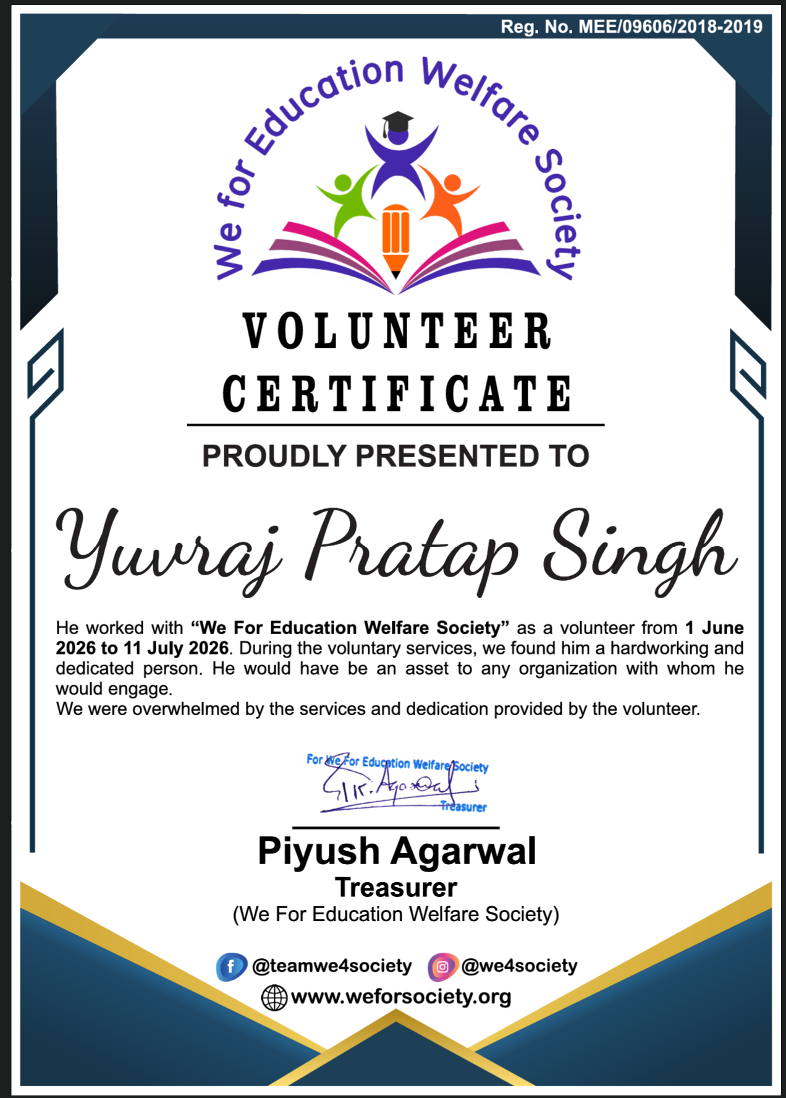
5. BIBLIOGRAPHY / REFERENCES
1. We For Education Welfare Society — Official Website: weforsociety.org
2. We For Education Welfare Society — Instagram: instagram.com/we4society
3. We For Education Welfare Society — Facebook Page: @teamwe4society
4. Personal observations, notes and records maintained during the internship period (1June 2026–11 July 2026).

