7/5/2024

Yuvraj Vaghela

[Tops technologies]

Module : 1 - SE – Overview of IT Industry

[Assignment]

Q – 1. What is software? What is software engineering?

* The software is basically a set of instructions provided to the system for execution.

For Example : MS-Word, MS-Excel, PowerPoint etc.

* Software engineering is the process of developing, testing, and maintaining software to solve real-world problems using software.

Q – 2. Explain types of software.

* There are two main types of software :

1.system software :

* + System software is a type of computer program that is designed to run a computer's hardware and application programs.
  + System software includes operating systems like Windows or macOS.

2.application software :

* + Application software is computer program that helps user perform their task easily.
  + Application software, on the other hand, includes programs like Microsoft Office or Adobe Photoshop.

Q – 3. What is SDLC? Explain each phase of SDLC?

* SDLC stands for Software Development Life Cycle, which is a process used by software developers to design, develop, and test software applications.
* The phases of SDLC :
  + 1. Planning: Planning is very important phase in SDLC.

Planning includes analysis, timing, budget, resources etc.

Example: A whole team developers creating an application so, They have decide first which type of features they want to add in the application.

* + 2. Analysis: During this phase, the software team will analysis the planning phase and reduce the workforce.

Example: The developers will break down the features

of the app into smaller parts and assign them to team

members.

* + 3. Design: In this phase, designers will analyze the requirements of the client and gives the best design to create a software.

Example: The developers will make the design of the app.

* + 4. Implementation: This phase involves coding and development according to the design specifications.

Example: Programmers writing the code for the app based on the design.

* + 5. Testing: In this phase, the development team tests the software for bugs and errors.

Example: Testers testing the app before launching for any bugs, errors or issue.

* + 6. Deployment: The application will be deployed to the production environment and will be available to users.

Q – 4. What is DFD? Create a DFD diagram on flipkart.

* DFD is abbreviation of Data Flow Diagram. It is a graphical tool.

DFD have 4 components :

1. Process
2. Data store
3. Data flow
4. External entity
   * DFD diagram on flipkart :

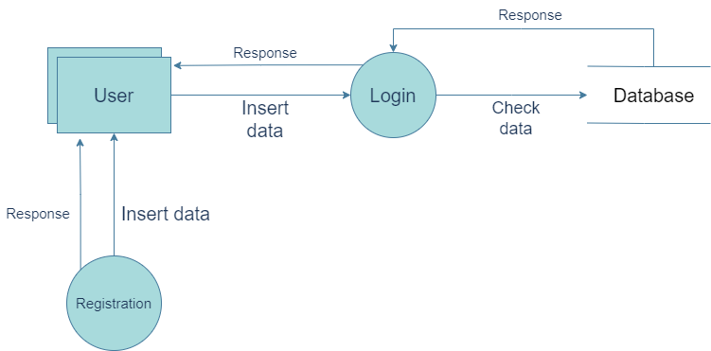Diagram : Level-0 DFD of Registration and Login in flipkart

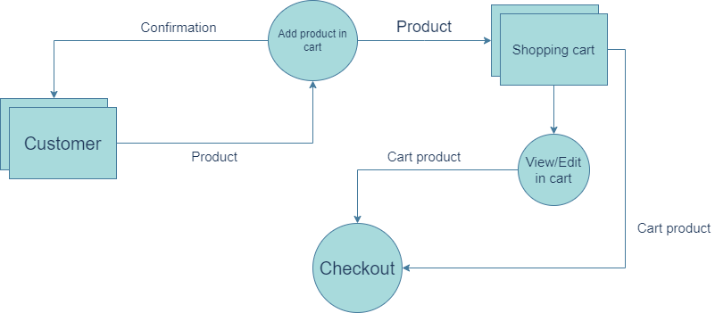

Diagram : Level-1 DFD of carting any product/item in flipkart

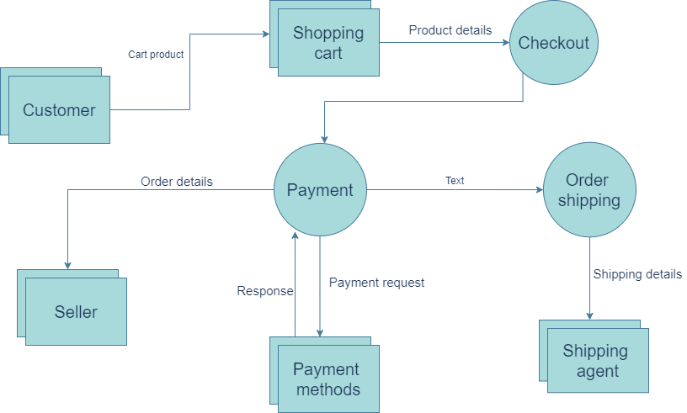

Diagram : Level-2 DFD of buying a product from cart

Q – 5. What is Flow chart? Create a flowchart to make addition of two numbers.

* A Flowchart is a type of diagram that represents the workflow or process. A Flowchart can also be defined as a graphical representation of an algorithm. It is a step-by-step approach.

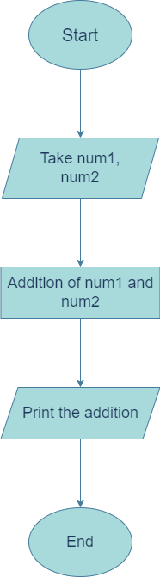

Flowchart : Addition of two numbers

Q – 6. What is Use case Diagram? Create a use-case on bill payment on paytm.

* An use case is written flow of how user will perform tasks in your website.

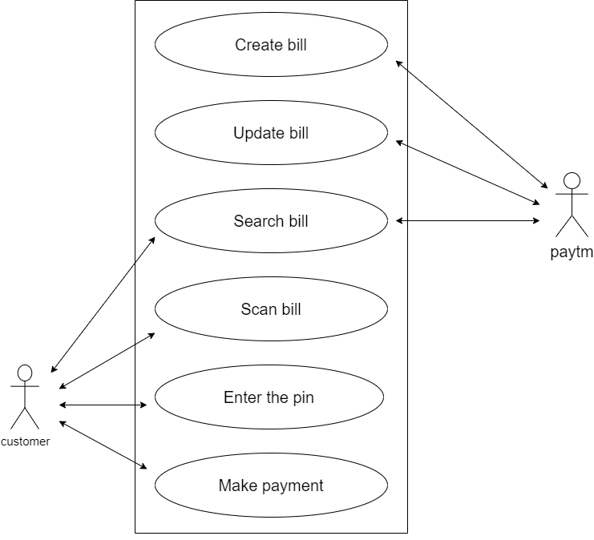

Use case Diagram : use-case on bill payment on paytm.