**CS F241: MICROPROCESSORS INTERFACING DESIGN PROJECT REPORT**

**‘CASH REGISTER’**

**BY**

**BATCH NO. 34**

Student ID Number  -Name of the Student

2020A7PS1711G – Rout Sandeepkumaar Rudranarayan

2020A7PS1719G – Shreeyash Gowaikar

2020A7PS1716G – Rishabh Raj

2020A7PS1718G – Shreyash Jha

2020A7PS1715G – Ayush Mishra

2020A7PS1704G – Yuvraj Ahuja



**BIRLA INSTITUTE OF TECHNOLOGY AND SCIENCE, PILANI K. K. BIRLA GOA CAMPUS**

**SEM II, 2021-22**

Table of Contents

User Requirements & Technical Specifications 2

Technical Specifications 2

Assumption 2

Components used with their usage 3

Address Map 4

ROM: 4

I/O Map 4

Flowcharts 5

Flowchart for the main program 5

Flowchart for the ISR 6

Bibliography 7

# User Requirements & Technical Specifications

The system is a standalone ‘Cash Register’ with inputs provided through a 24 key keyboard and which interacts with the user through a ‘Liquid Crystal Display’.

Technical Specifications  
The Technical Specifications are as follows

* System gets power via the standard power outlet.
* The system comes with a rechargeable battery that is utilised as a battery backup of the RAM.
* The battery charges itself when the system is on.
* A fully charged battery has a 36-hour life span.

## Assumption

1. Item Number is always a 3-digit number.
2. Quantity is always single digit number.
3. Price is single digit number.
4. While the system is locked and any key is pressed, the buzzer remains on for 60 seconds after the last key press.
5. By default, there is one item in the item bank.

# Components used with their usage

* 8086 – The main driver of the system.
* 8255 – Used for Interfacing keyboard, LCD, lock-unlock switch with the microprocessor.
* 8253 – Used to generate a 60 seconds signal for the buzzer.
* 8259 - Interrupts from EOC from ADC and Timer Interrupt every 2 Minute. Timer given higher priority as the timer is the one that enables the ADC for conversion.
* 2732 – 2 nos. ROM chip available is 4K which is used to create even and odd banks.
* 6116 – 2 nos. Smallest RAM chip available is 2 K and we need odd and even bank. We need RAM for stack and temporary storage of data.
* LM020L – LCD display used in 16 x 1 mode with HD44780 driver.
* LS 138 – 1 decoder
* LS 373, LS 245 – Latches
* VCC + Ground
* Relay Switch
* Switches
* Buzzer
* And Required Gates

# Address Map

## ROM:

ROM1-even: 0x00000 to 0x01FFE

ROM1-odd: 0x00001 to 0x01FFF

RAM1-even: 0x02000 to 0x02FFE

RAM1-odd: 0x02001 to 0x02FFF

I/O Map  
8255 – Port Address 00H -06H  
8253 – Port Address 08H -0EH

8259 – Port Address 10H -12H

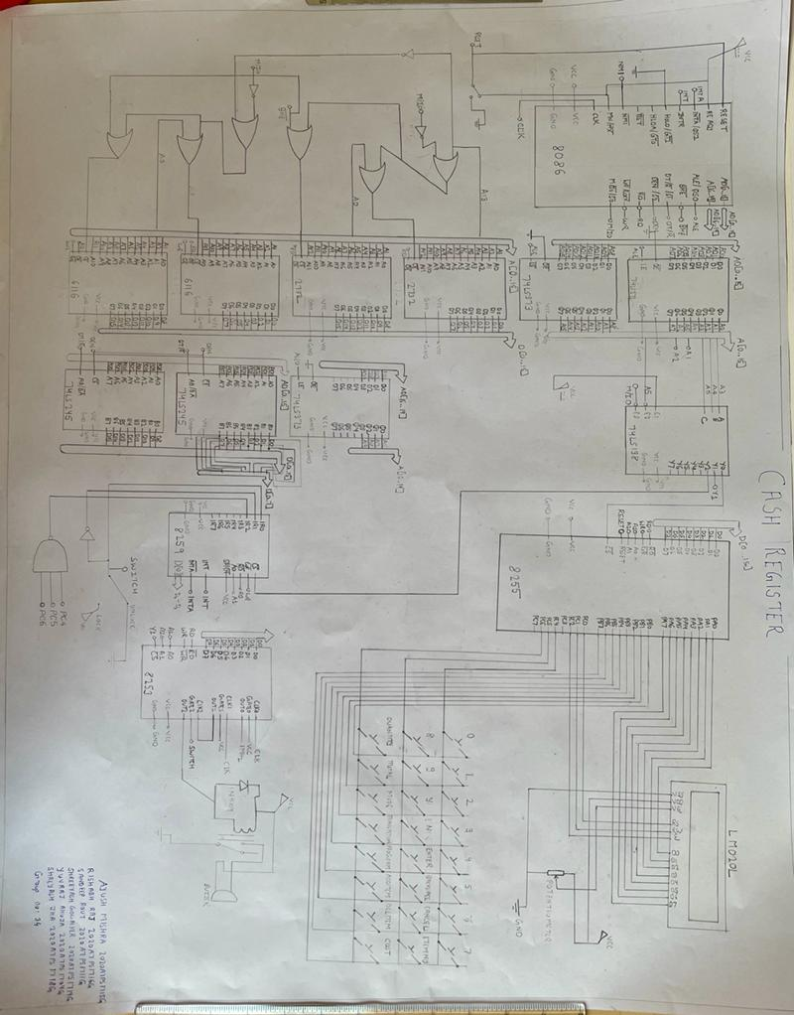

# Flowcharts

## Flowchart for the main program

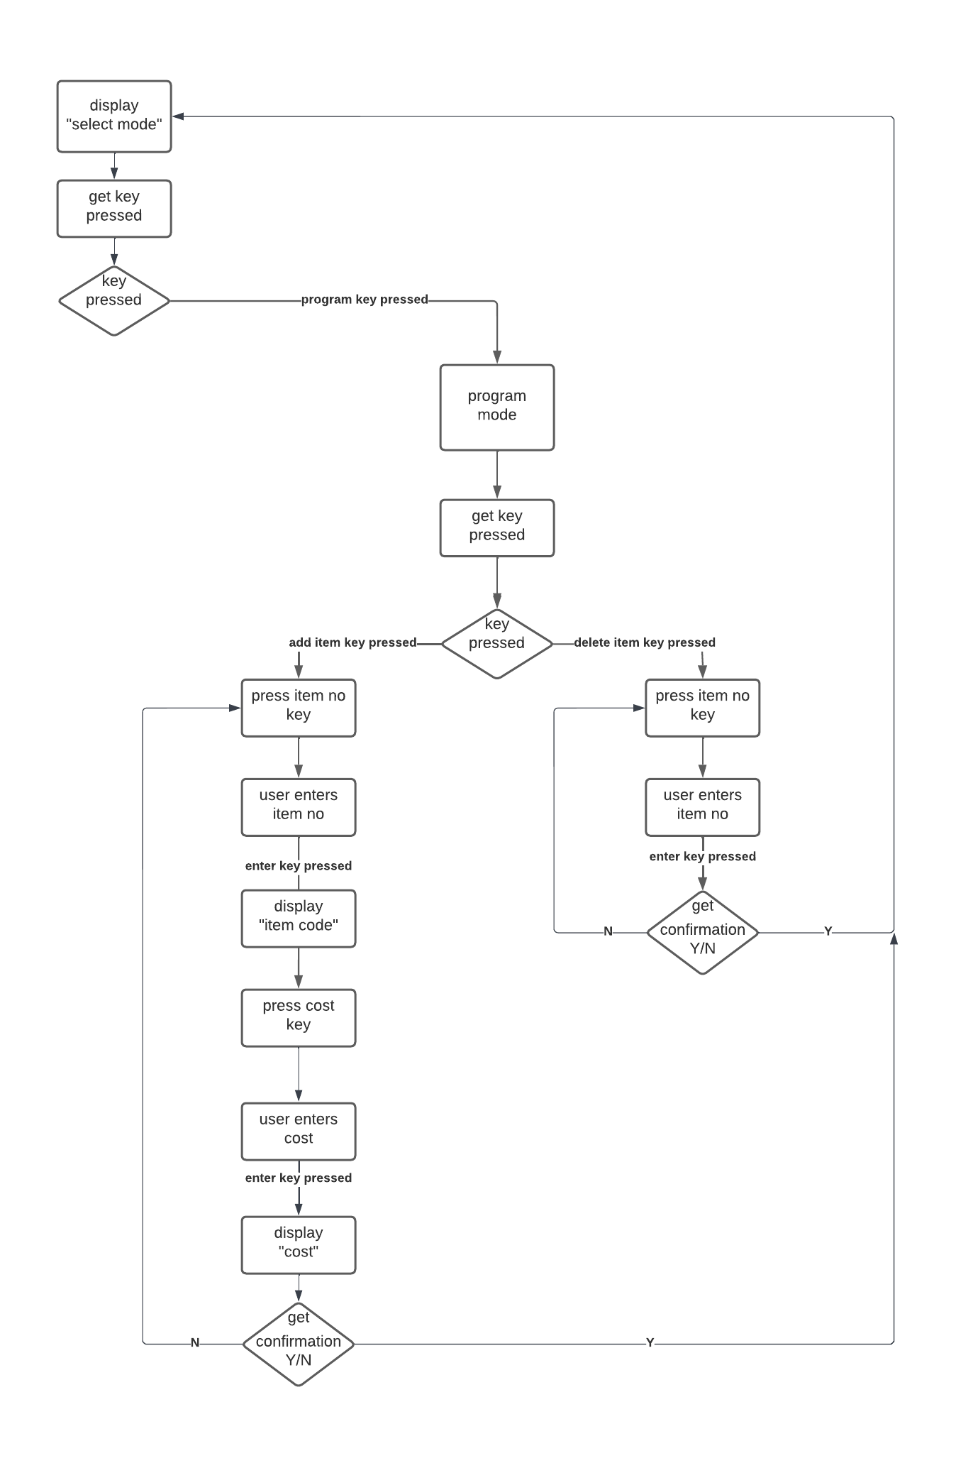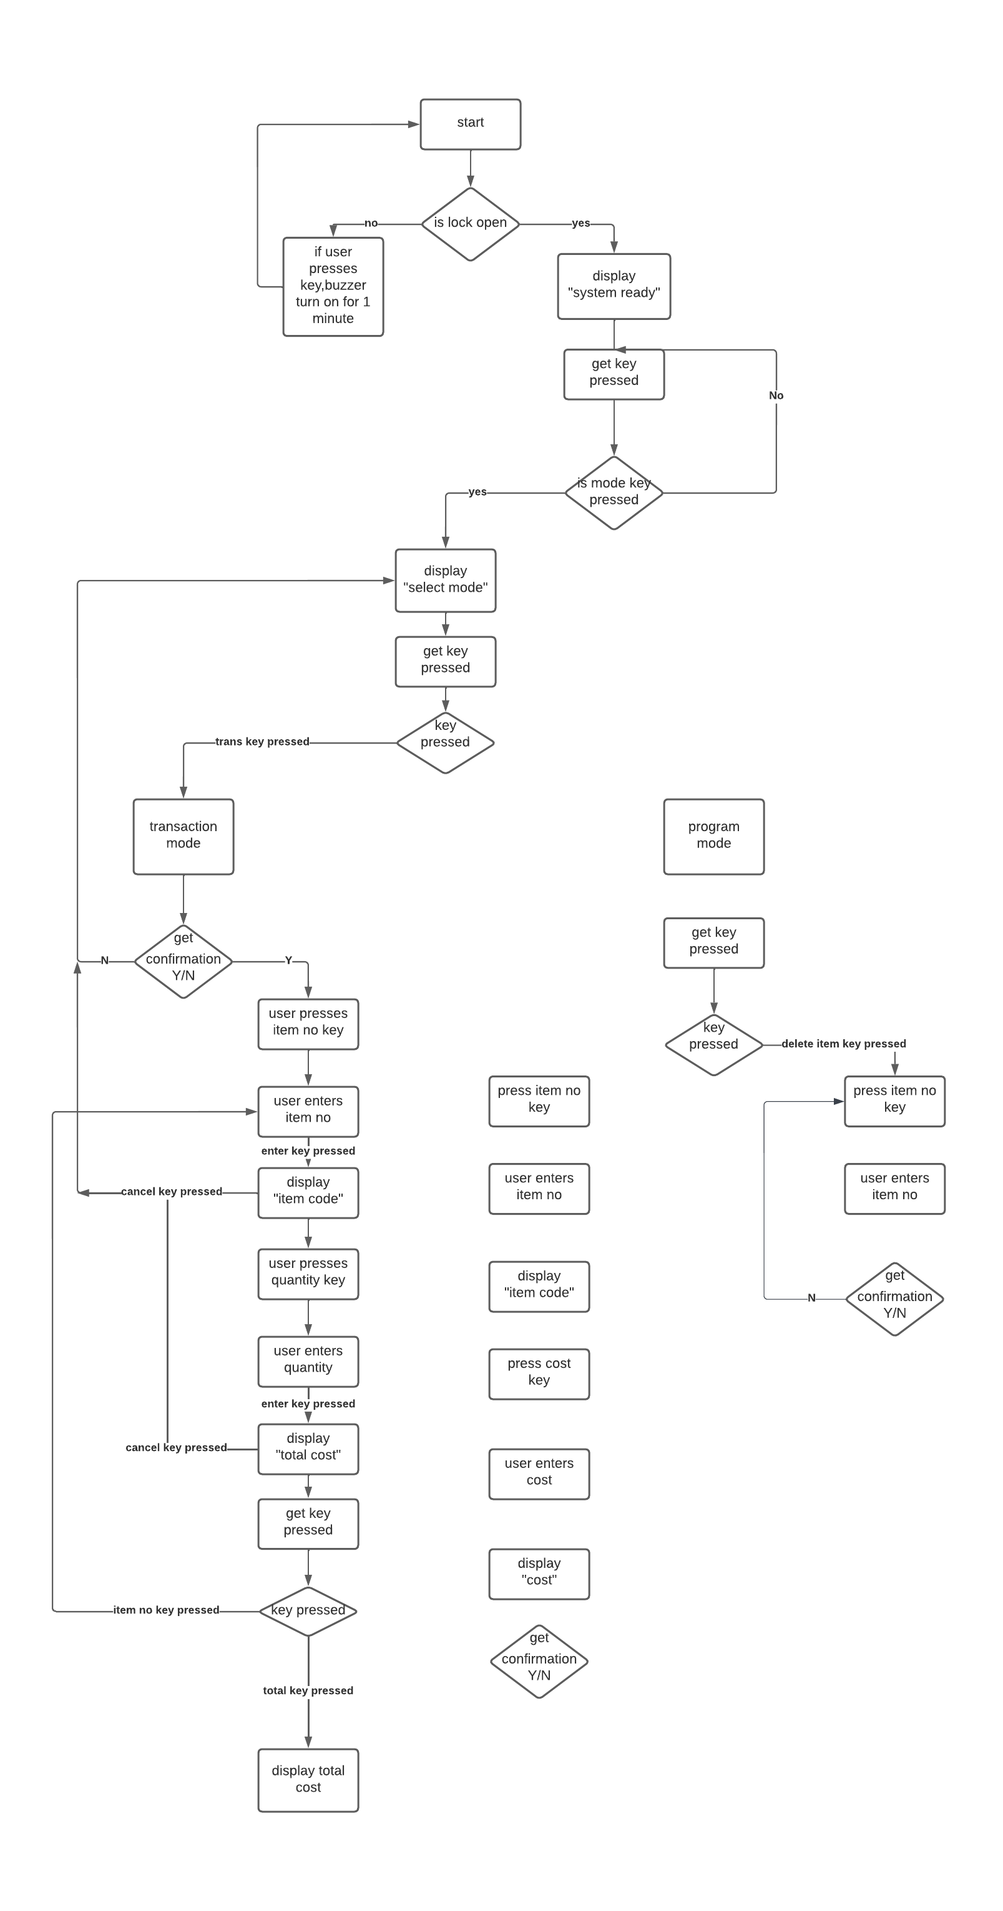

## Flowchart for the ISR

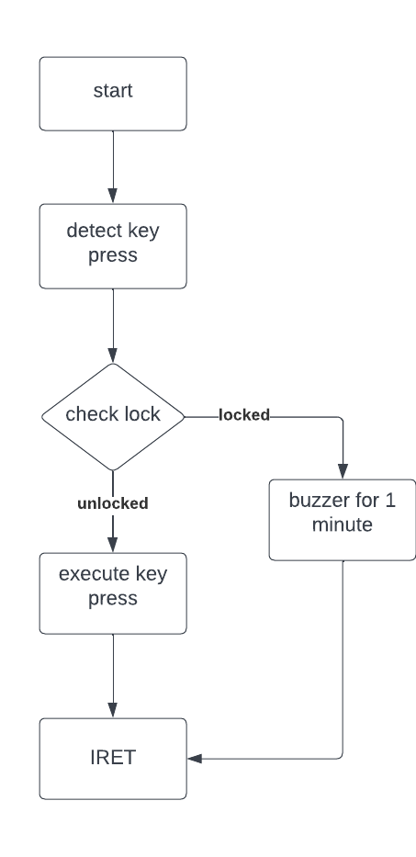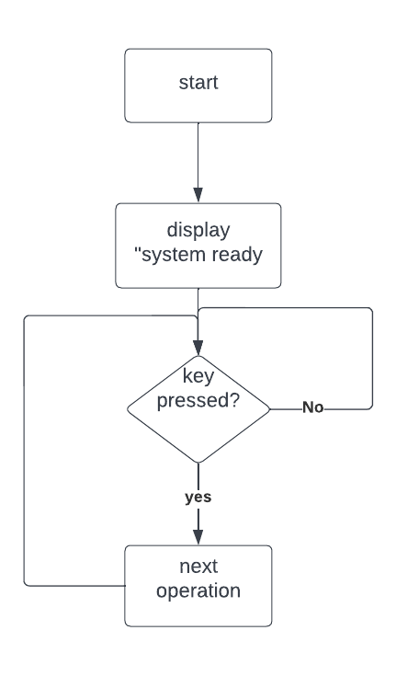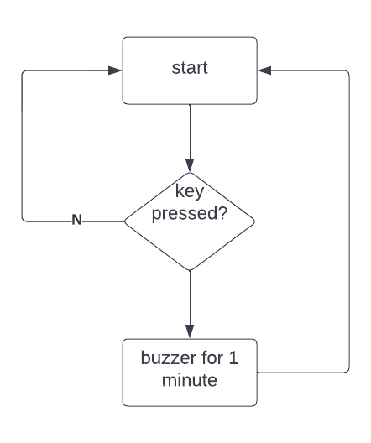  
IR0  IR1

IR2

# Bibliography

* The Intel Microprocessors by Barry B. Brey
* Microprocessors and Interfacing by Douglas V. Hall
* Hitachi HD44780 Manual