TASK2:  
  
APP and Mysql Deployment:  
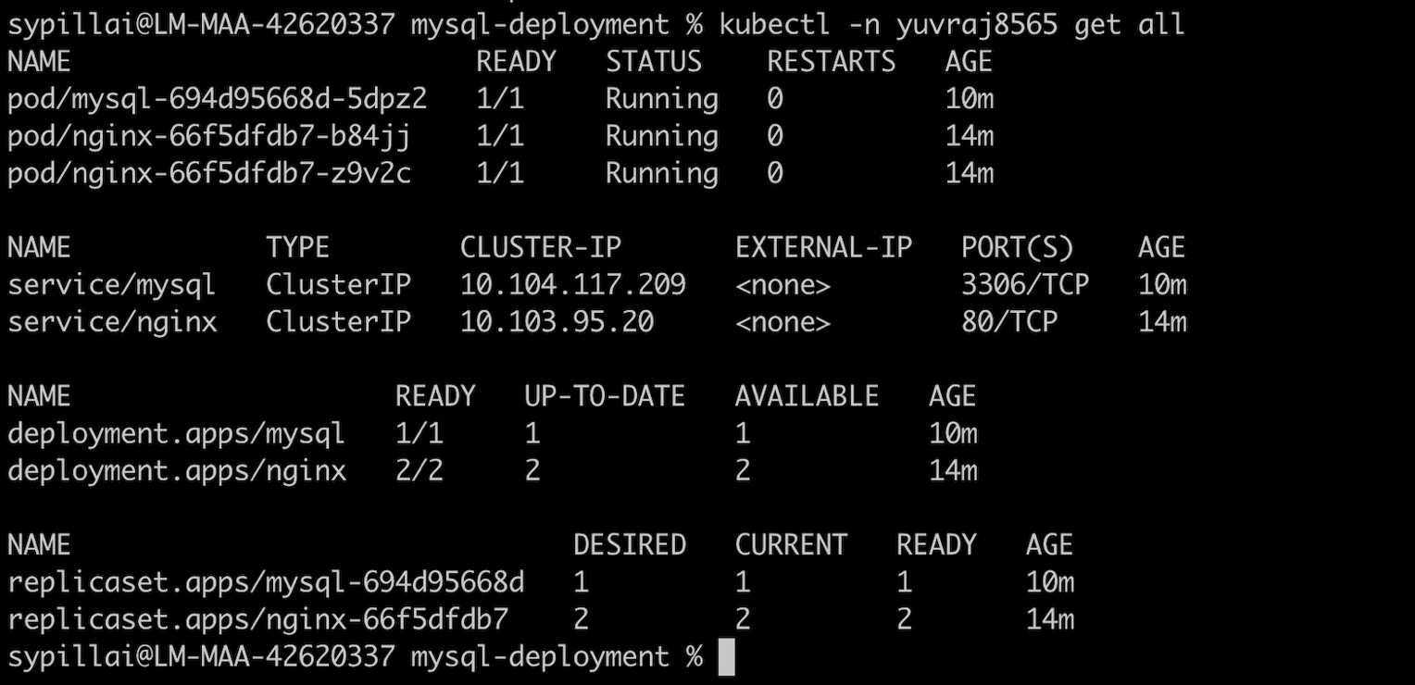

Nginx Working status:  
  
DB Creation and Connection status:

DB Connection:

Prometheus Deployment:  
  
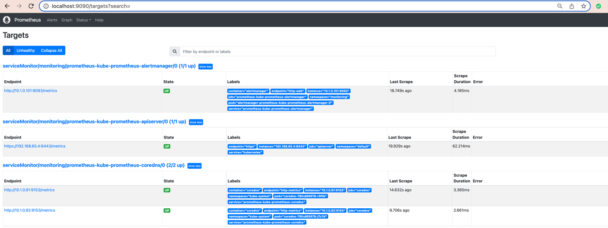

Grafana Dashboard:  
