Task1

Project Title: Academic Management System ( using SQL)

1.Database Creation:

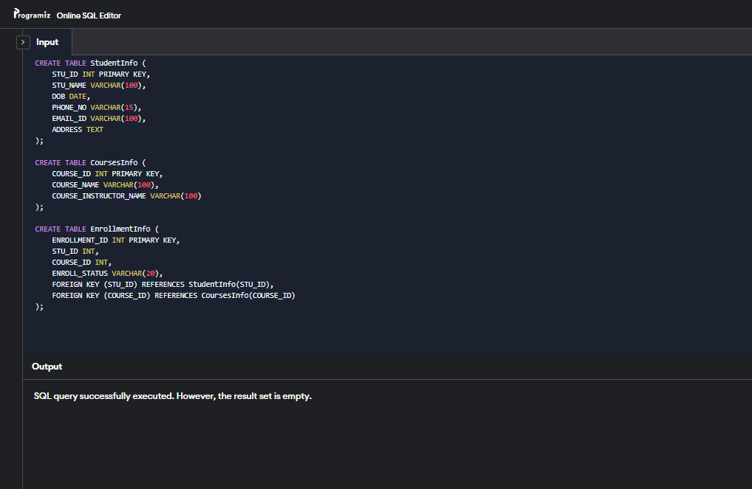

2.Data Creation:

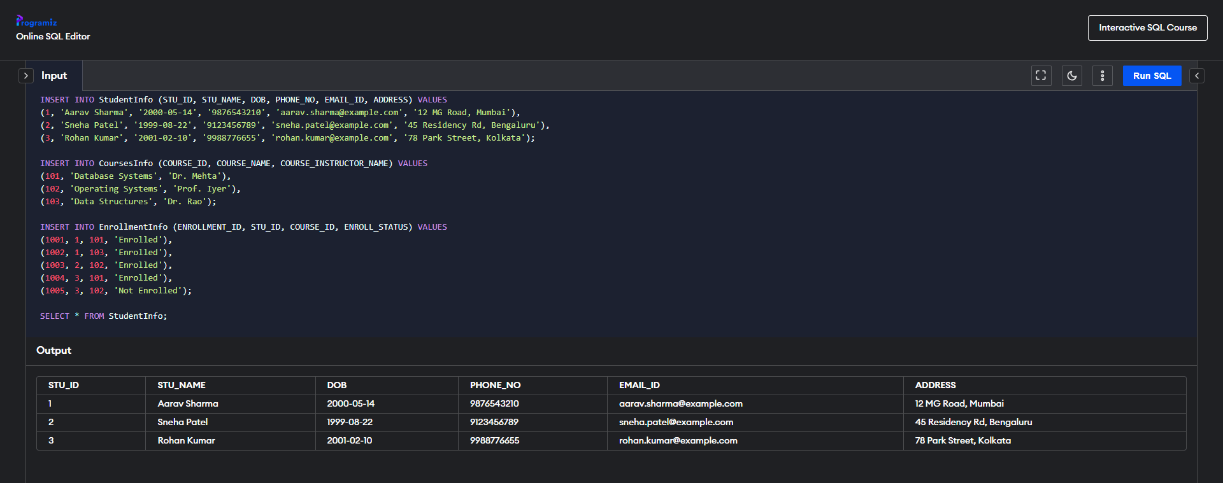

3) Retrieve the Student Information

a) Write a query to retrieve student details, such as student name, contact informations, and Enrollment status.  
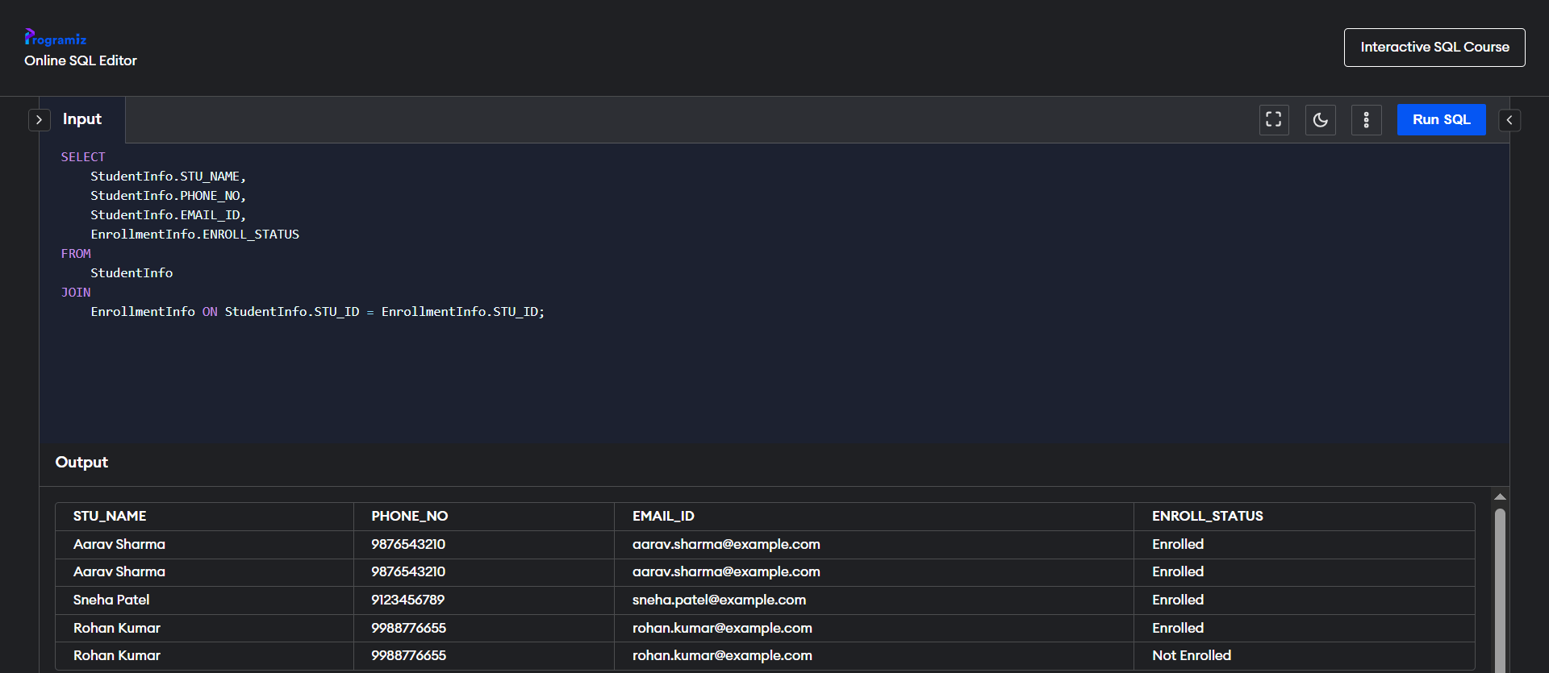

b) Write a query to retrieve a list of courses in which a specific student is enrolled.   
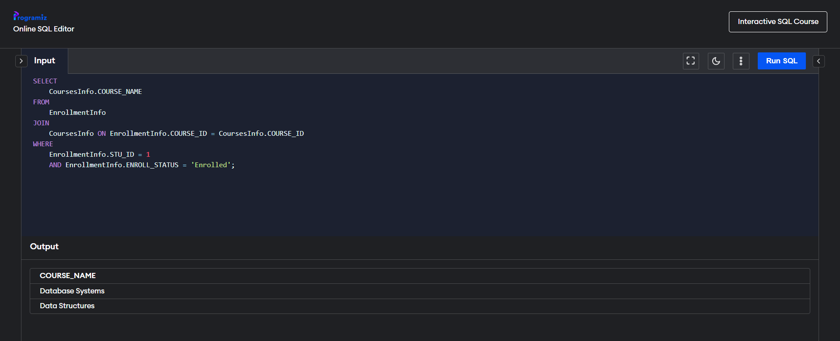

c) Write a query to retrieve course information, including course name, instructor information.

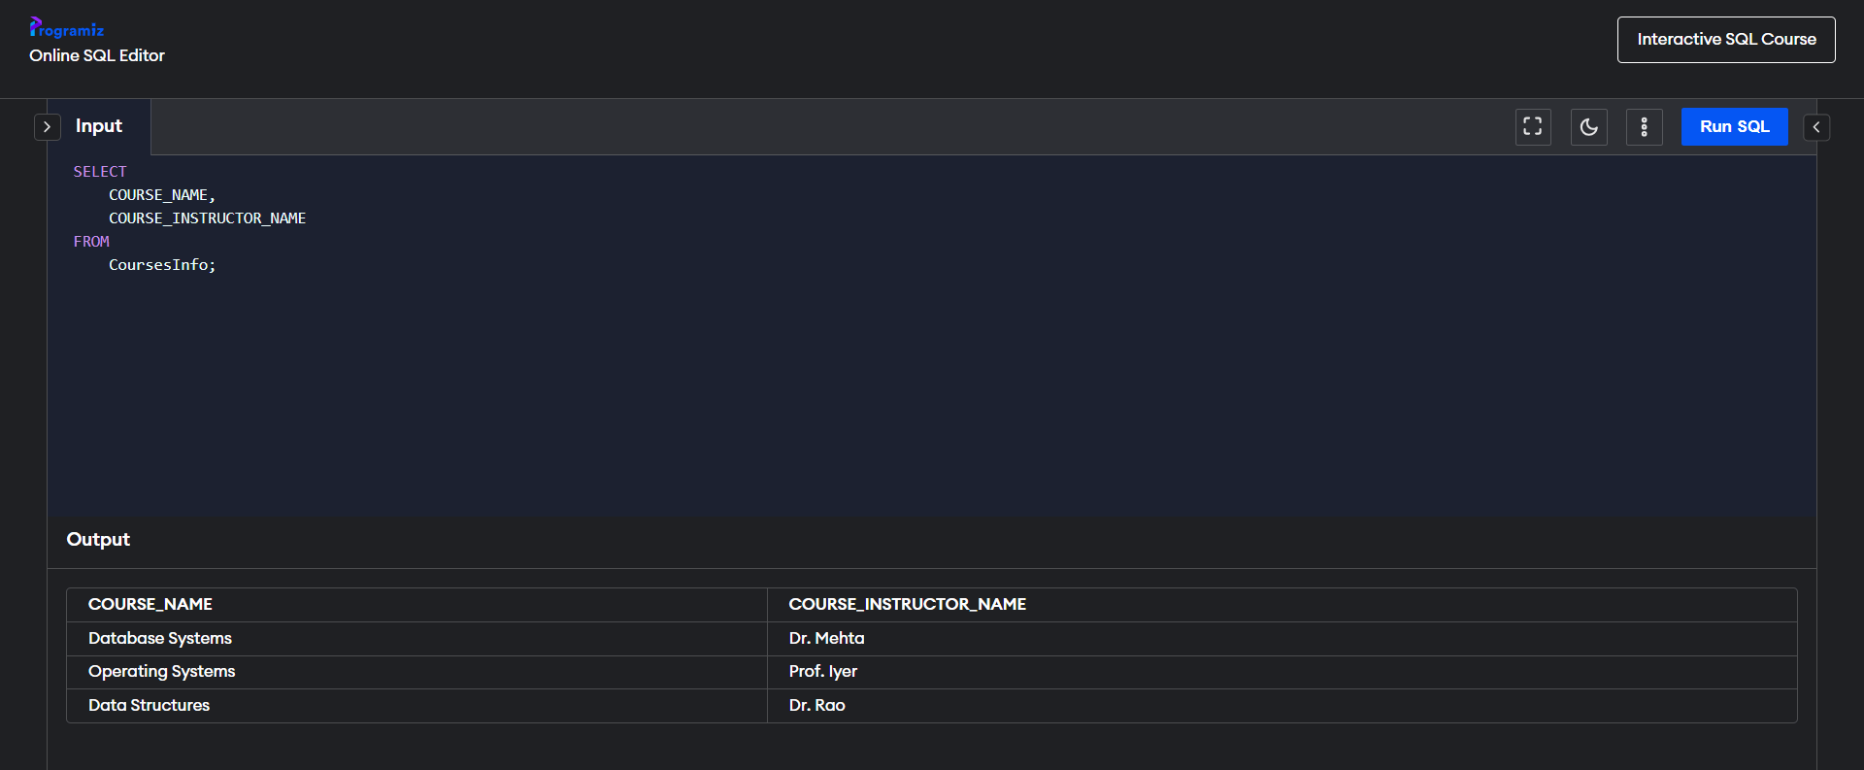

d) Write a query to retrieve course information for a specific course.

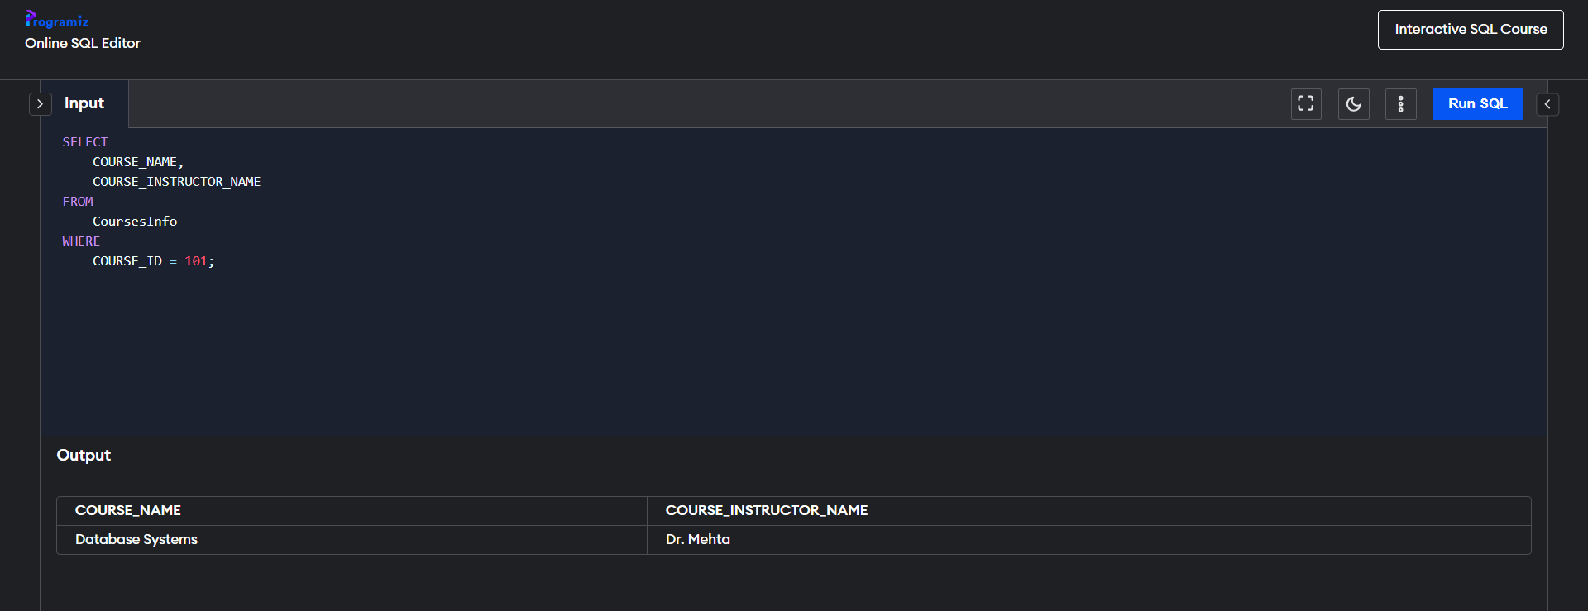

e) Write a query to retrieve course information for multiple courses.

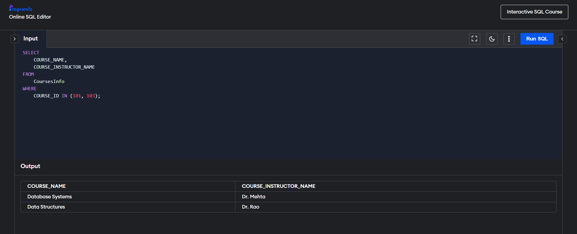

f) Test the queries to ensure accurate retrieval of student information (execute the queries and verify the results against the expected output)

Ans: Outputs already shared with the queries.

4. Reporting and Analytics (Using joining queries)

a) Write a query to retrieve the number of students enrolled in each course.

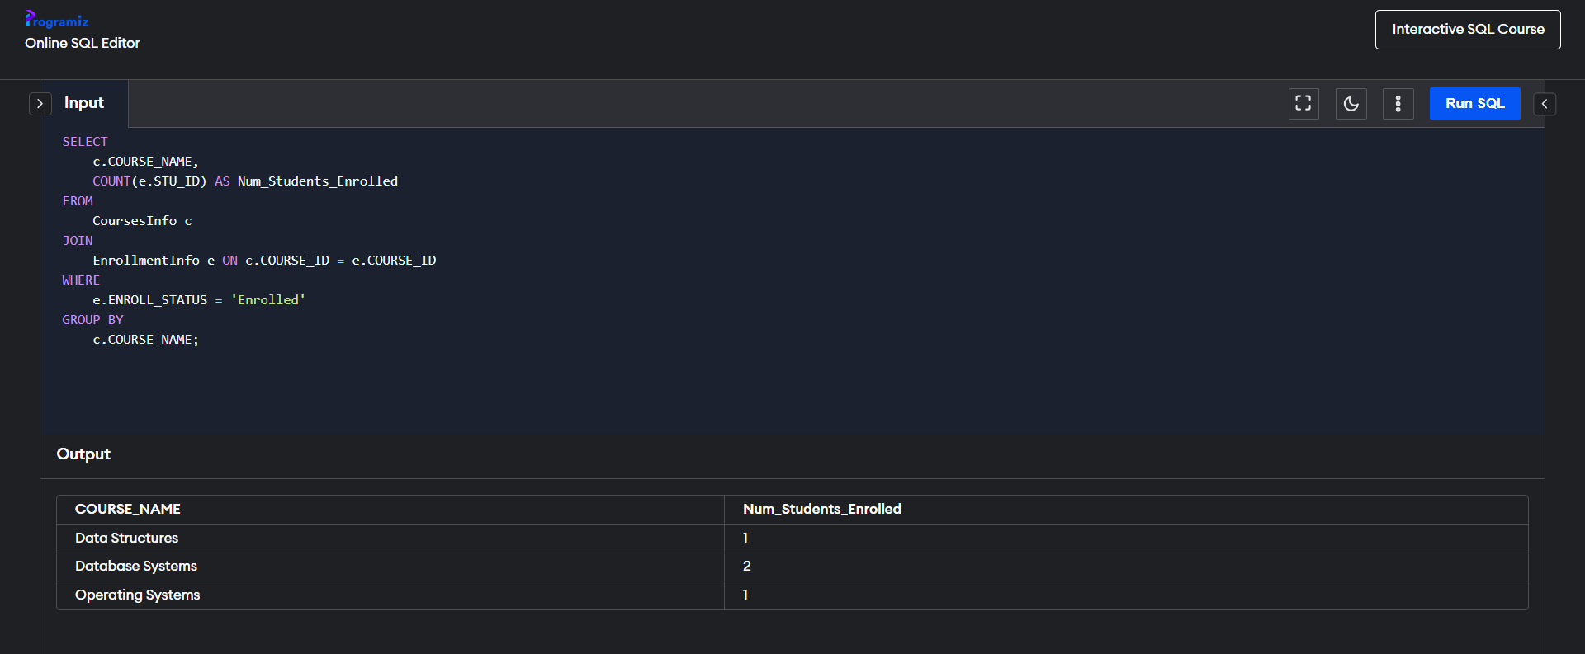

b) Write a query to retrieve the list of students enrolled in a specific course.  
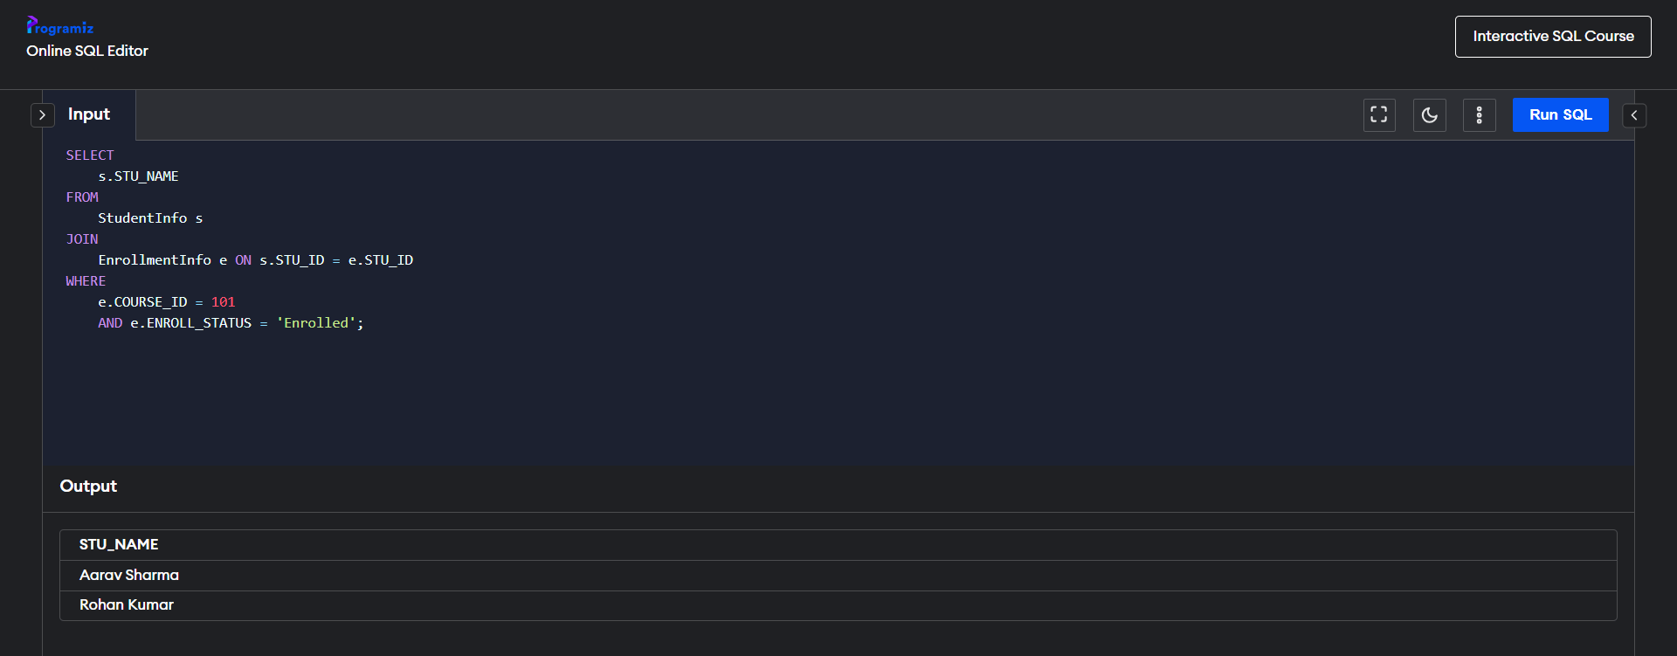

c) Write a query to retrieve the count of enrolled students for each instructor.   
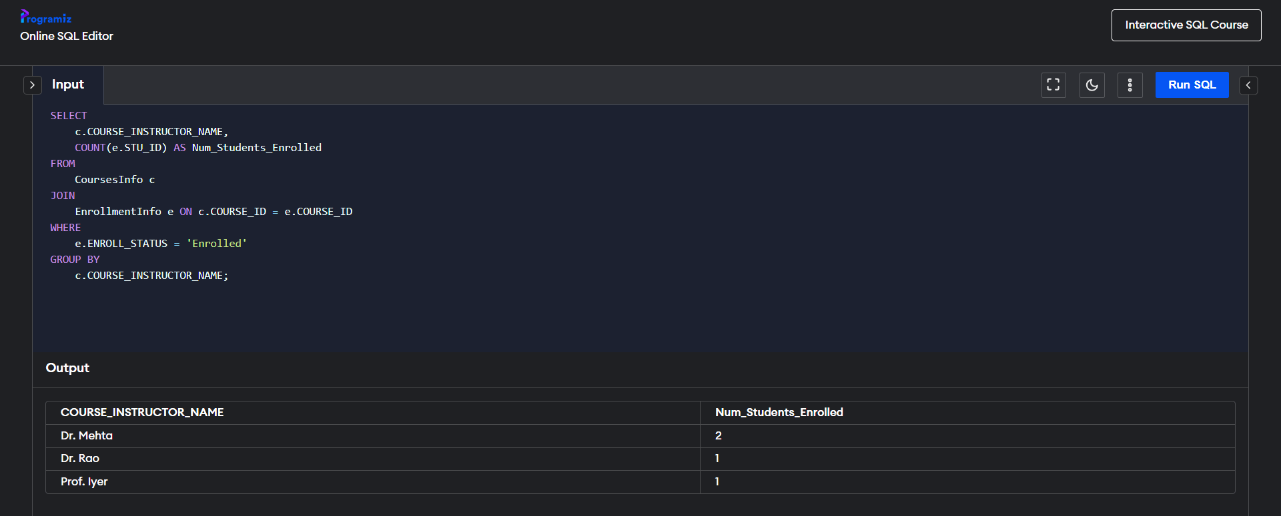

d) Write a query to retrieve the list of students who are enrolled in multiple courses.  
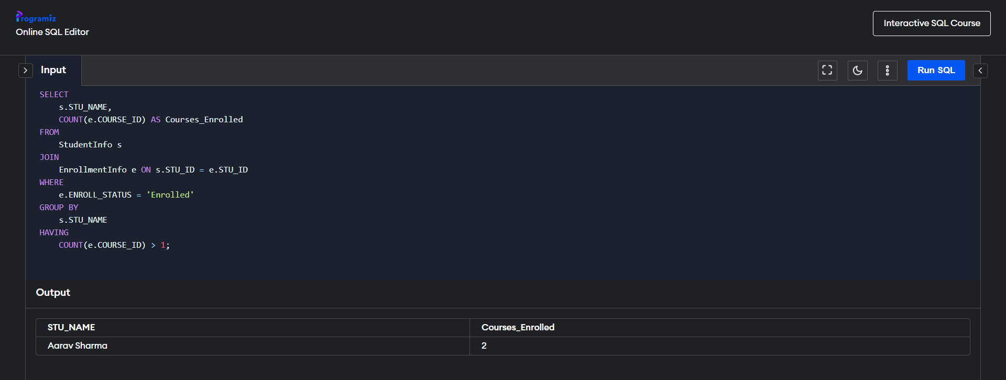

e) Write a query to retrieve the courses that have the highest number of enrolled

students(arranging from highest to lowest)

