Task2:

Project: Student Database Management System(PostgreSQL)

Part 1: Database Setup

Create a database named "student_database."

Create a table called " student_table " with the following columns: Student_id (integer), Stu_name (text), Department (text), email_id (text ),Phone_no (numeric), Address (text), Date_of_birth (date), Gender (text), Major (text), GPA (numeric),Grade (text) should be A,B,C etc.  
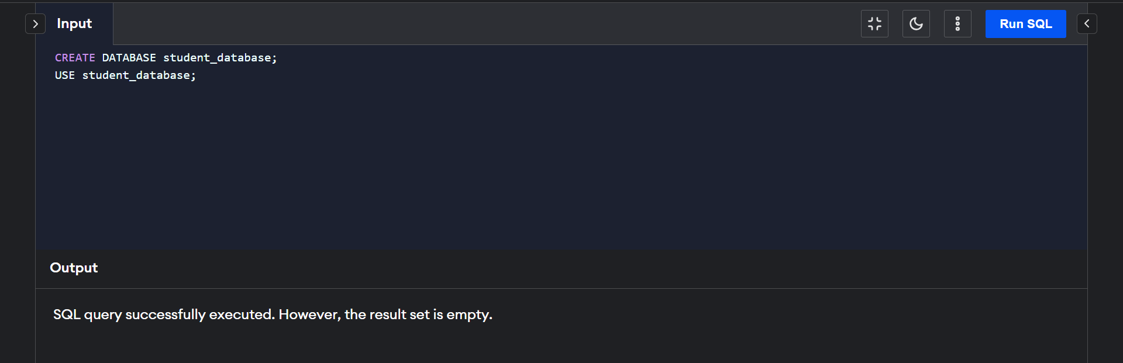

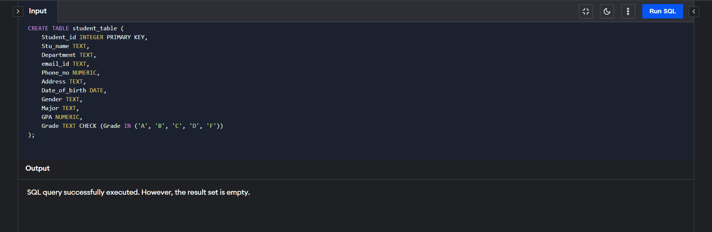

Part 2: Data Entry

Insert 10 sample records into the "student_table" using INSERT command.

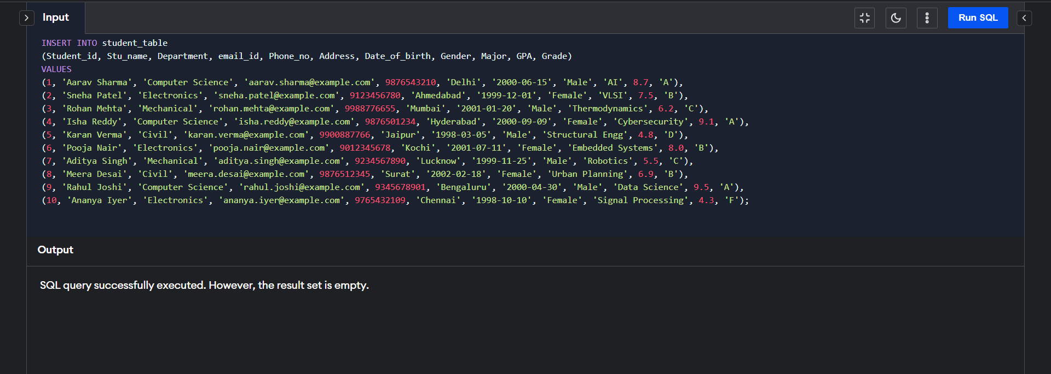

Part 3: Student Information Retrieval

Develop a query to retrieve all students' information from the "student_table" and sort them in descending order by their grade.  
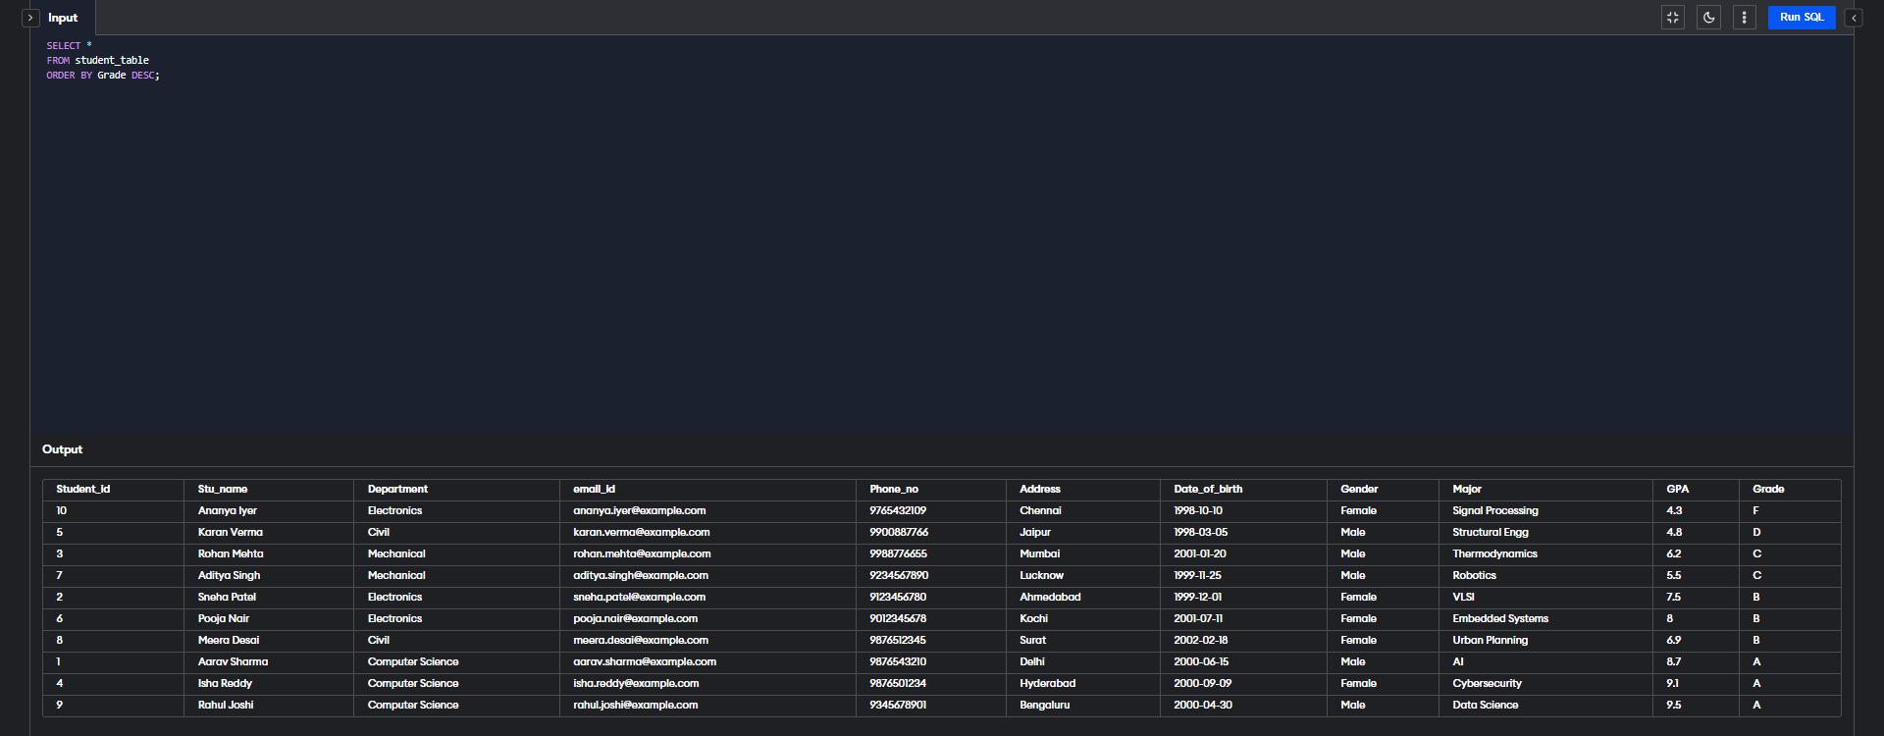

Part 4: Query for Male Students:

Implement a query to retrieve information about all male students from the "student_table."

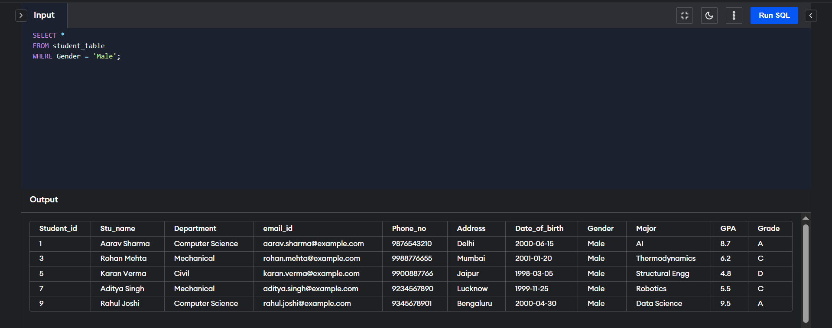

Part 5: Query for Students with GPA less than 5.0

Create a query to fetch the details of students who have a GPA less than 5.0 from the "student_table."

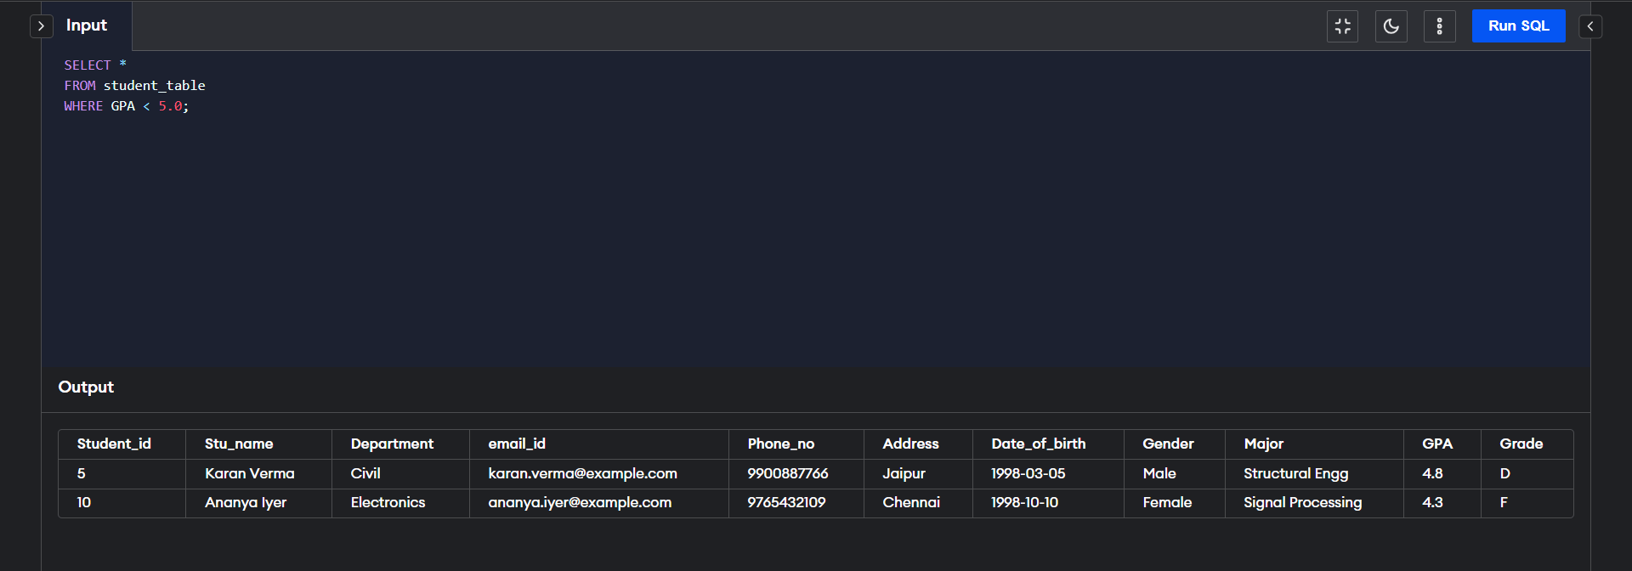

Part 6: Update Student Email and Grade

Write an update statement to modify the email and grade of a student with a specific ID in the "student_table."

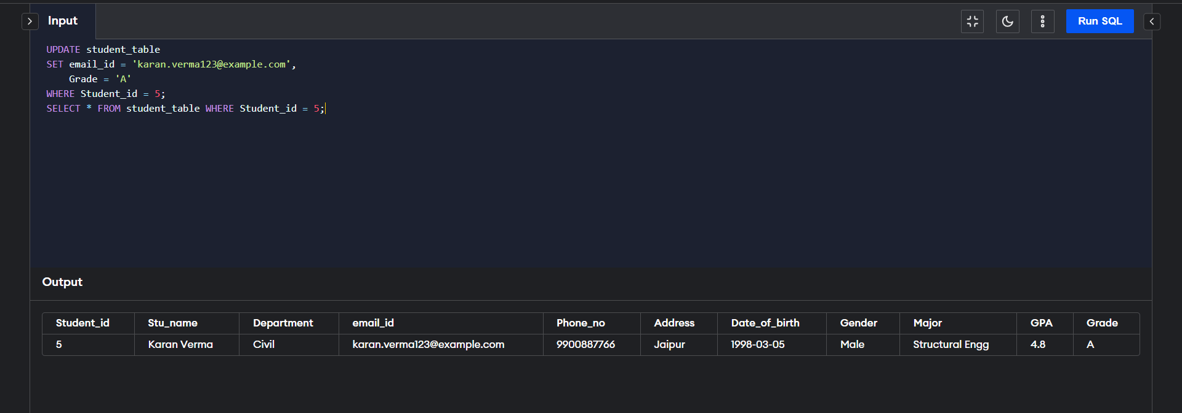

Part 7: Query for Students with Grade "B"

Develop a query to retrieve the names and ages of all students who have a grade of "B" from the "student_table."

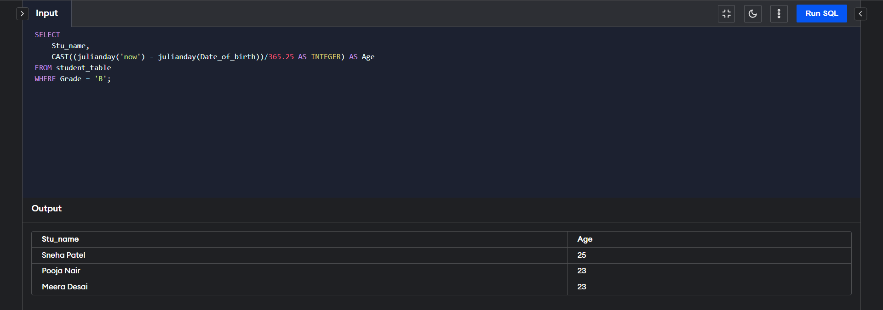

Part 8: Grouping and Calculation

Create a query to group the "student_table" by the "Department" and "Gender" columns and calculate the average GPA for each combination.   
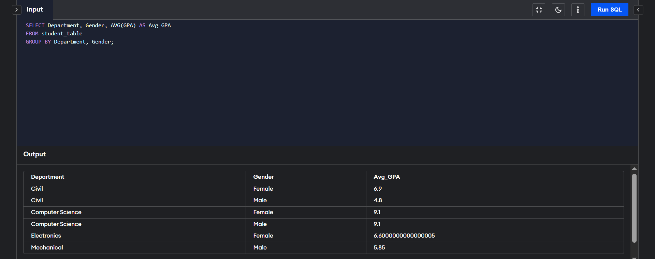

Part 9: Table Renaming

Rename the "student_table" to "student_info" using the appropriate SQL statement.  
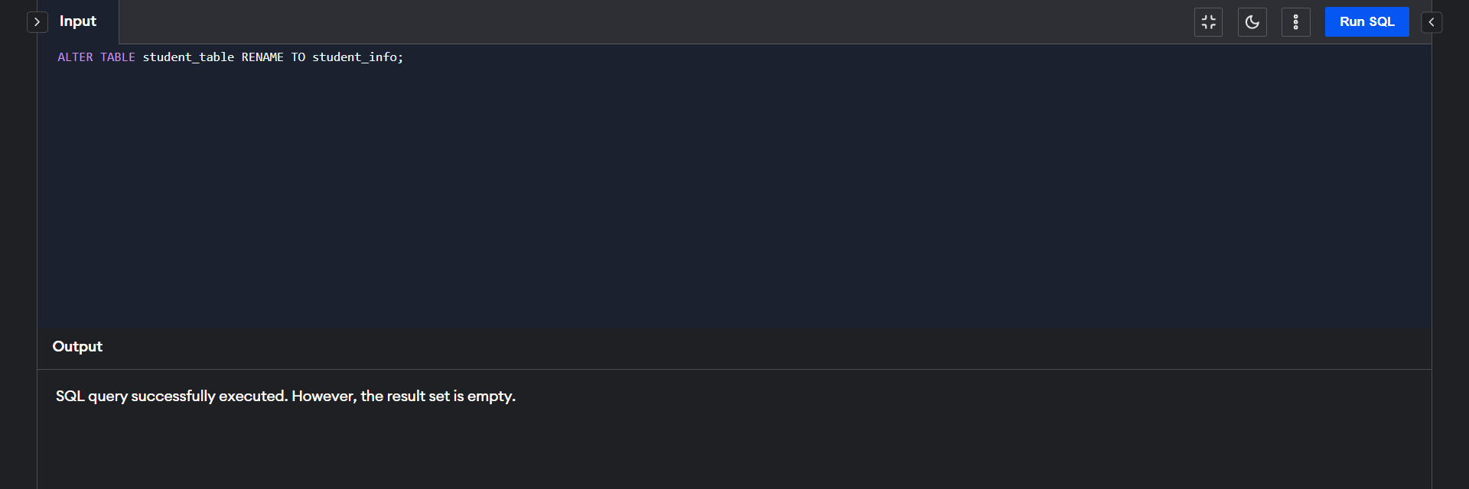

Part 10: Retrieve Student with Highest GPA

Write a query to retrieve the name of the student with the highest GPA from the

"student_info" table.  
  
