Task4

Develop the queries to retrieve information from the OLAP operations performed and to gain a deeper understanding of the sales data through different dimensions, aggregations, and filters.

Project: OLAP Operations (using Redshift or PostgreSQL)

Part 1: Database Creation

Create a database to store the sales data (Redshift or PostgreSQL).

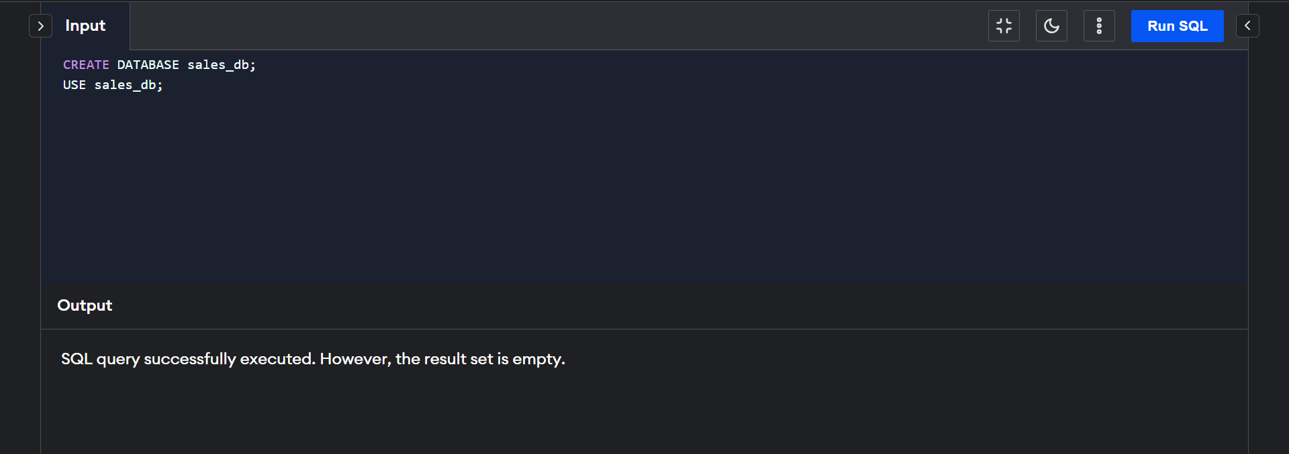

Create a table named "sales_sample" with the specified columns:

Product_Id (Integer)

Region (varchar(50))-like East ,West etc

Date (Date)

Sales_Amount (int/numeric)

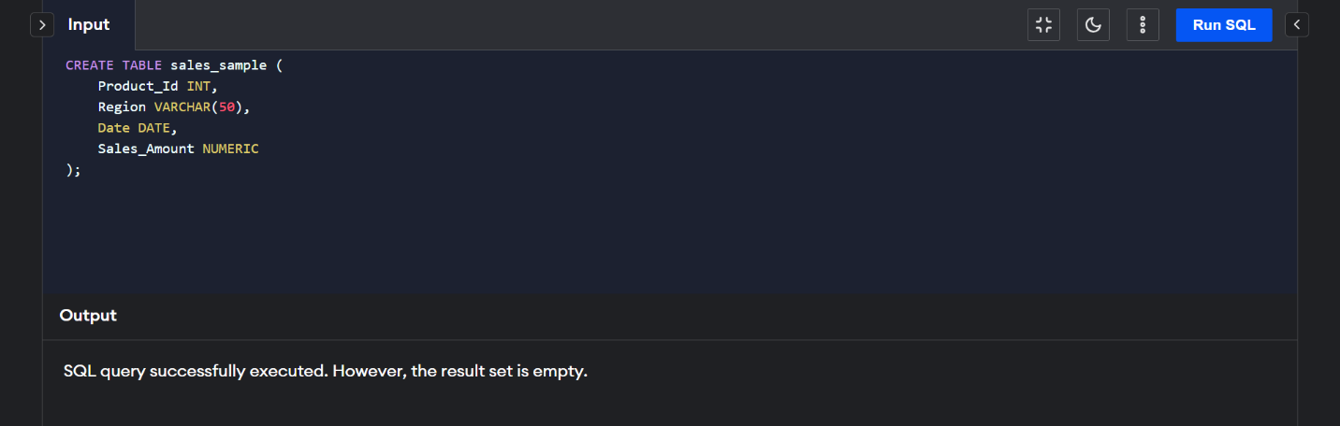

Part 2: Data Creation

Insert 10 sample records into the "sales_sample" table, representing sales data.

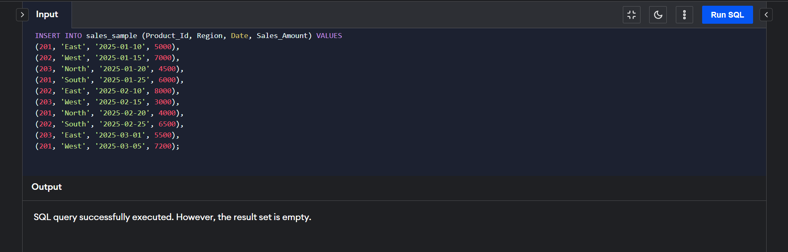

Part 3: Perform OLAP operations

a)Drill Down-Analyze sales data at a more detailed level. Write a query to perform drill down from region to product level to understand sales performance.

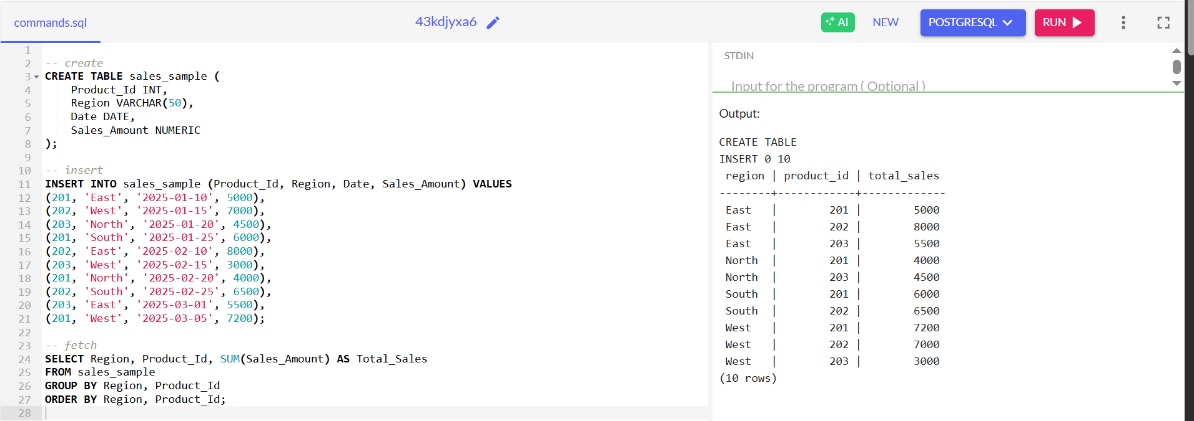

b)Rollup- To summarize sales data at different levels of granularity. Write a query to perform roll up from product to region level to view total sales by region.

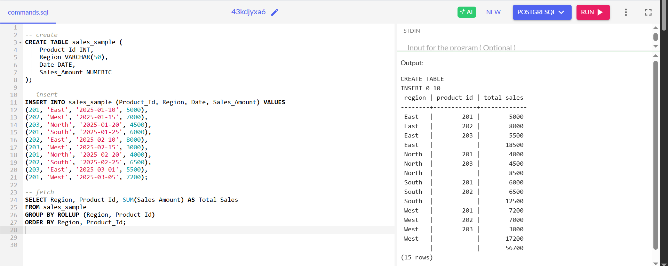

c)Cube - To analyze sales data from multiple dimensions simultaneously. Write a query to Explore sales data from different perspectives, such as product, region, and date.

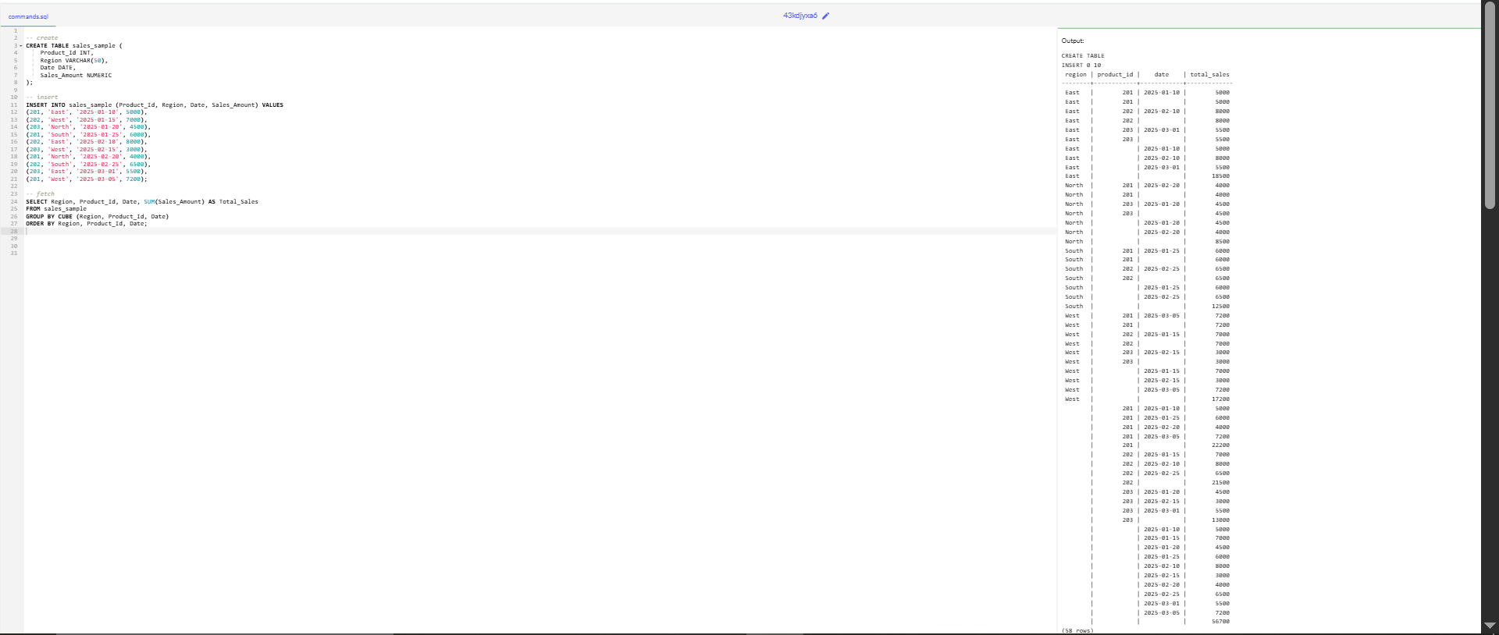

d)Slice- To extract a subset of data based on specific criteria. Write a query to slice the data to view sales for a particular region or date range.

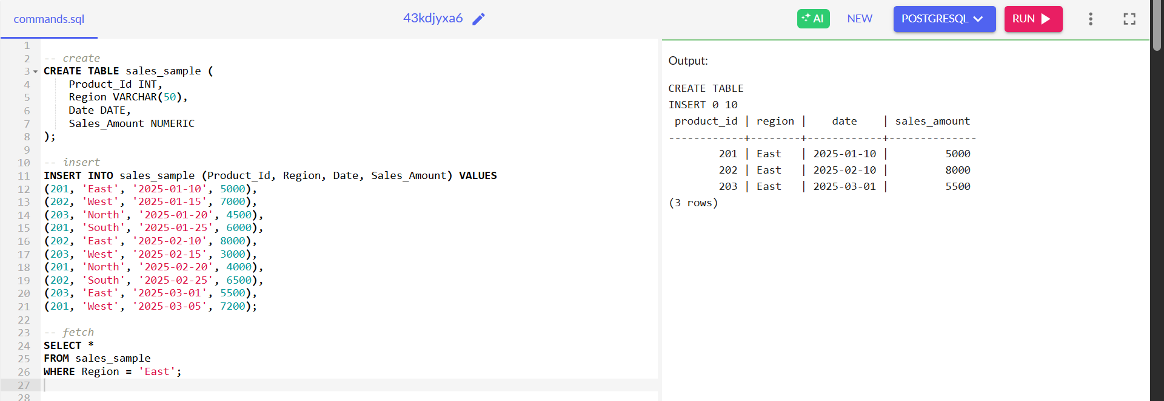

e)Dice - To extract data based on multiple criteria. Write a query to view sales for specific combinations of product, region, and date.

