Dataset Identification:-
- Dataset: Facebook Social Circles (SNAP)
- Source File: facebook_edges.csv
- 4,039 Total Nodes
- 88,234 Total Edges

Key Network Influencers:-
- Centrality analysis was performed to identify highly connected hubs and influential bridges within the network.

Rank | Top 5 by Degree (Popularity) | Top 5 by Betweenness (Influence)
1 | Node 107 (1045) | Node 107
2 | Node 1684 (792) | Node 1684
3 | Node 1912 (755) | Node 1912
4 | Node 3437 (547) | Node 1085
5 | Node 0 (347) | Node 0

Visualizations:-
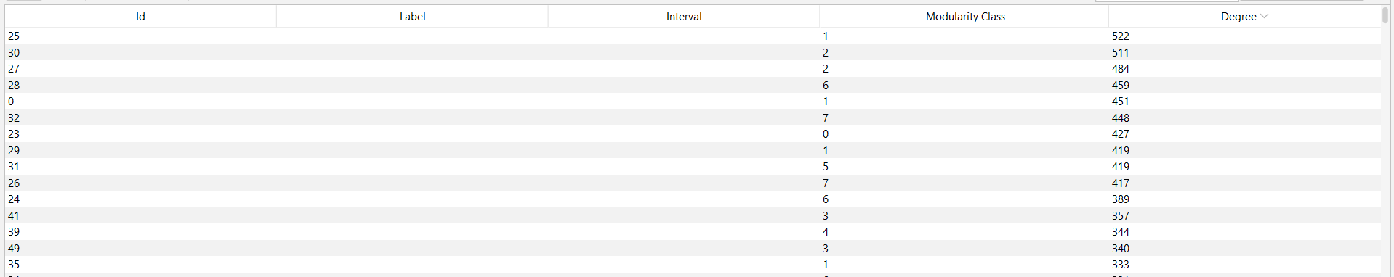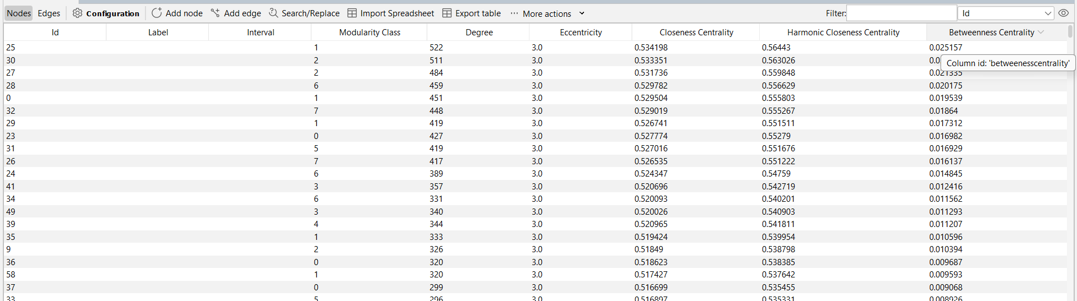
Interpretation of Results:-
- The network exhibits a clear "Small-World" structure. The presence of large hubs (like Node 107) suggests that a few individuals hold significant power in connecting disparate groups. The high clustering coefficient observed in the community visualization indicates that users are likely grouped into real-world social circles (colleagues, students, etc.).
- Betweenness centrality identified Node 1085 as a key "bridge." While this user doesn't have the highest number of friends, they are essential for information flow between different clusters. Removing such bridges would fragment the network more severely than removing average nodes.

Lessons Learned:-
- Structural Importance: Learned that a node's value isn't just about direct connections (Degree) but its position in the broader path (Betweenness).
- Tool Proficiency: Gained experience using Gephi for spatial layouts and modularity calculations to reveal hidden social patterns.
- Data Narratives: Discovered how to translate complex CSV edge-lists into visual stories that explain human interaction.

