RAGMedX-MA
Application Flow Document
A Multi-Agent Iterative Retrieval Framework with Peer-Reviewed Generation for High-Confidence Medical Question Answering

1. Purpose of this Document
This document describes the end-to-end application flow of RAGMedX-MA, the upgraded, research-grade version of the original RAGMedX system. It traces exactly what happens from the moment a user submits a medical question to the moment a verified, evidence-backed answer is displayed on the dashboard. It is intended to guide implementation, support the Methodology section of the research paper, and serve as a shared reference for the team while building the multi-agent pipeline.
The original RAGMedX design (FAISS + LangChain + PubMedBERT + a single local LLM) is a solid engineering baseline, but a single-pass semantic retrieval pipeline is not, by itself, a strong research contribution. This flow upgrades that baseline into a dynamic, reasoning-driven system: it adds an iterative retrieval loop, evidence re-ranking, a multi-agent generate-and-critique step, and a knowledge-driven abstention mechanism, so the system can recognize when it does not have enough evidence and say so instead of guessing.

2. High-Level Flow Diagram
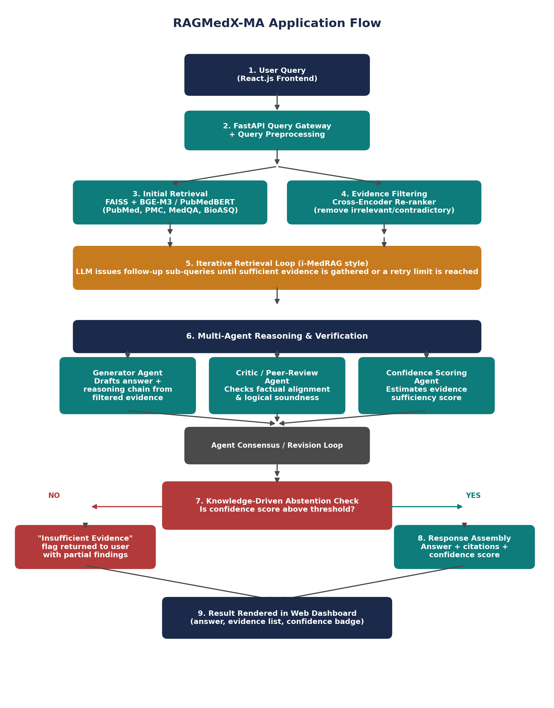

3. Detailed Step-by-Step Flow
Step 1: User Query Input
The user (clinician, student, or patient-facing coach) types a medical question into the React.js dashboard, e.g. “What are the first-line treatments for community-acquired pneumonia in adults?” The frontend sends the raw query to the FastAPI backend.
Step 2: Query Preprocessing & Routing
FastAPI receives the request and normalizes it: spelling/abbreviation expansion, language detection, and light intent classification (e.g. diagnostic question vs. treatment question vs. drug-interaction question). The cleaned query is then handed to the retrieval layer.
Step 3: Initial Retrieval
The query is embedded using BGE-M3 / PubMedBERT and matched against the FAISS vector index built over PubMed, PMC Open Access, MedQA, and BioASQ. This returns an initial top-K set of candidate passages, ranked purely by semantic similarity.
Step 4: Evidence Filtering & Re-ranking
A lightweight cross-encoder re-ranks the top-K candidates against the query and drops passages that are contradictory, off-topic, or low-quality. This directly targets the “lost-in-the-middle” effect, where an LLM is distracted by irrelevant retrieved chunks, and ensures only high-signal evidence moves forward.
Step 5: Iterative Retrieval Loop
Rather than stopping at one retrieval pass, the system follows the i-MedRAG pattern: if the filtered evidence does not yet cover the full clinical question (e.g. a multi-part question about diagnosis AND treatment), the Generator Agent formulates a follow-up sub-query, which goes back through Steps 3-4. This repeats until evidence is sufficient or a retry limit is hit, preventing infinite loops.
Step 6: Multi-Agent Reasoning & Verification
This is the core upgrade over a vanilla RAG pipeline. Three cooperating roles, orchestrated with LangGraph or AutoGen on top of the existing LangChain setup, work on the same evidence set:
- Generator Agent - drafts a candidate answer and an explicit reasoning chain, citing which retrieved passages support each claim.
- Critic / Peer-Review Agent - independently checks the draft against the retrieved literature, flags unsupported claims or logical gaps, and requests a revision if needed.
- Confidence Scoring Agent - estimates how well the surviving evidence actually supports the (possibly revised) answer, producing a numeric confidence score.
If the Critic Agent flags an issue, the Generator revises and the two agents iterate (the “Agent Consensus / Revision Loop”) until they converge or a revision limit is reached.
Step 7: Knowledge-Driven Abstention Check
The confidence score from Step 6 is compared against a calibrated threshold, mirroring real-world clinical safety protocols:
- Below threshold -> the system does not fabricate an answer. It returns an “Insufficient Evidence” flag along with whatever partial findings it does have, and optionally suggests a narrower follow-up question.
- At or above threshold -> the answer proceeds to final assembly.
Step 8: Response Assembly
For answers that pass the confidence check, the backend assembles the final payload: the verified answer text, the specific supporting passages (with source and citation metadata), and the confidence score/badge.
Step 9: Result Rendered in the Dashboard
The React.js frontend displays the answer alongside its supporting evidence list and a visible confidence indicator, so the end user can see not just what the system answered, but why, and how sure it is.

4. Component-to-Technology Mapping
The table below ties each stage of the flow back to the specific technology already defined in the project's tech stack, so the architecture stays grounded in what is feasible to build.
Component | Technology / Model | Role in the Flow
Frontend / Dashboard | React.js | Captures the clinician/user query and renders the final answer, citations, and confidence badge.
API Gateway | FastAPI | Receives the query, orchestrates the pipeline, and routes results back to the frontend.
Vector Database | FAISS | Stores dense embeddings of PubMed, PMC Open Access, MedQA, and BioASQ passages for similarity search.
Embedding Models | BAAI BGE-M3, PubMedBERT | Converts the query and documents into dense vectors for retrieval.
Re-ranking / Filtering | Cross-Encoder model | Re-scores top-K FAISS results and discards irrelevant or contradictory evidence before generation.
Orchestration Framework | LangChain / LlamaIndex + LangGraph or AutoGen | Coordinates the iterative retrieval loop and the multi-agent workflow.
Generator Agent | Local LLM (Qwen 3 / Llama 3.1) | Drafts the evidence-grounded answer and reasoning chain.
Critic / Peer-Review Agent | Local LLM (separate role/prompt) | Reviews the draft against retrieved evidence for factual alignment and logical soundness.
Confidence & Abstention Module | Custom scoring logic (KnowGuard / MedConf-style) | Estimates whether retrieved evidence is sufficient; triggers the abstention path if not.

5. Why This Flow Strengthens the Research Contribution
- Iterative retrieval (Step 5) addresses the single-pass limitation of standard RAG, in line with i-MedRAG-style approaches.
- Evidence filtering (Step 4) directly mitigates the lost-in-the-middle effect documented in large-scale evaluations such as MIRAGE.
- Multi-agent peer review (Step 6) gives the system an internal check on factual alignment before anything reaches the user, rather than trusting a single LLM pass.
- Knowledge-driven abstention (Step 7) is the clearest safety-relevant contribution: the system can say “I don't know” instead of hallucinating, which is exactly the behavior top-tier venues (ACL, IEEE JBHI) look for in clinical NLP work.
- Every added stage maps to an existing, already-selected technology (LangGraph/AutoGen, cross-encoder re-ranking, LangChain), so the added complexity is feasible without introducing a new tech stack.

6. Validation Hooks Built Into the Flow
Each stage above produces a measurable artifact that supports the paper's validation strategy:
- Step 3-4: Retrieval Precision/Recall - how often the true supporting evidence appears in the top-5 filtered chunks.
- Step 6: Accuracy on MedQA/PubMed questions run through the MIRAGE benchmark suite, compared against vanilla RAG and Chain-of-Thought baselines.
- Step 7: Abstention Rate / Calibration - how accurately the system identifies cases where it does not know the answer.

7. Summary
RAGMedX-MA keeps the original project's proven tech stack (FastAPI, React, FAISS, local LLMs) but restructures the flow from a single-pass retrieve-then-generate pipeline into a dynamic loop: retrieve, filter, iterate, generate, critique, and only then answer or abstain. That restructuring is what turns a solid engineering build into a defensible research contribution.

