Source code -int main()
{
int a, b;
scanf("%d\n%d", &a, &b);

for (int i = a; i <= b; i++) {
if (i >= 1 && i <= 9) {
if (i == 1) printf("one\n");
else if (i == 2) printf("two\n");
else if (i == 3) printf("three\n");
else if (i == 4) printf("four\n");
else if (i == 5) printf("five\n");
else if (i == 6) printf("six\n");
else if (i == 7) printf("seven\n");
else if (i == 8) printf("eight\n");
else if (i == 9) printf("nine\n");
} else {
if (i % 2 == 0) {
printf("even\n");
} else {
printf("odd\n");
}
}
}
}

Screenshot-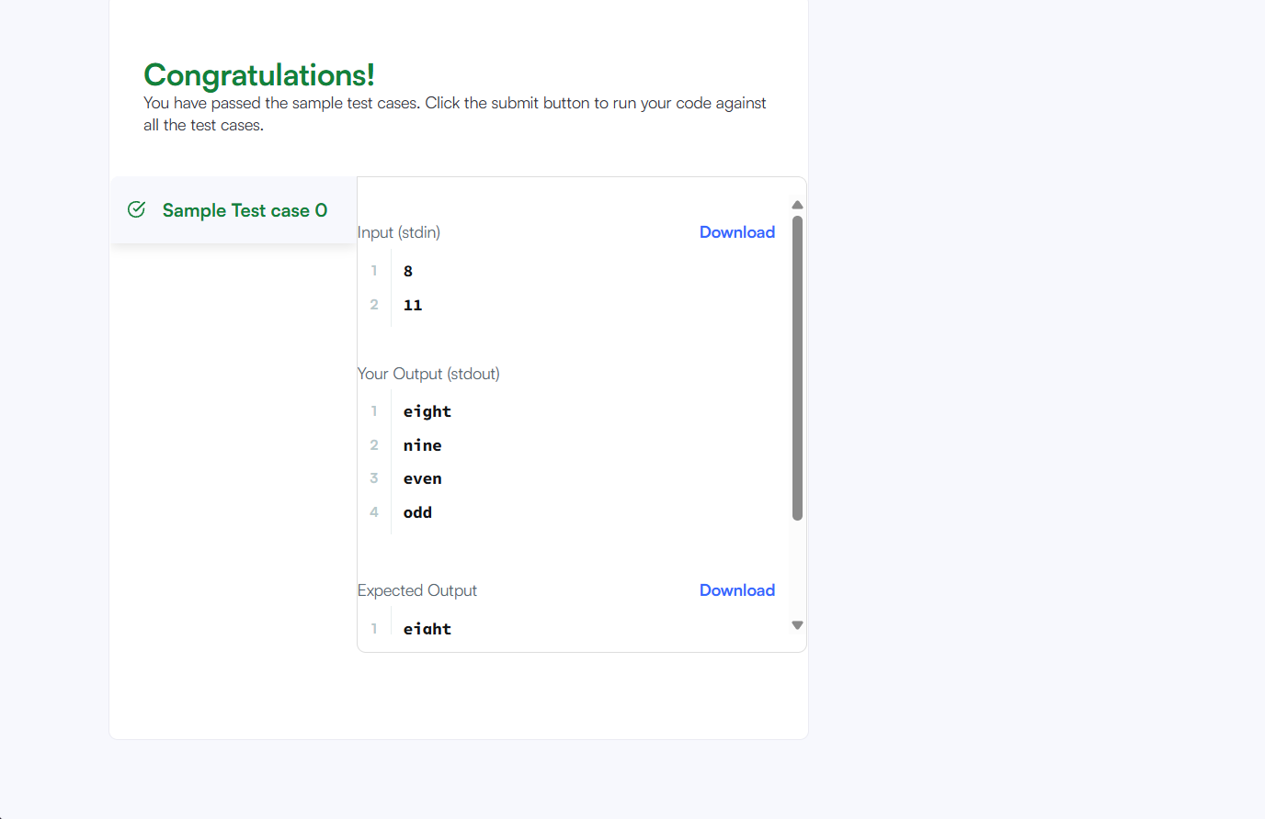

Problem link - https://www.hackerrank.com/challenges/for-loop-in-c/problem

