C source code - int numberOfSteps(int num) {
int steps = 0;

while (num > 0) {
if (num % 2 == 0) {
num = num / 2; // Agar even hai toh 2 se divide karein
} else {
num = num - 1; // Agar odd hai toh 1 minus karein
}
steps++; // Har step ko count karein
}

return steps;
}

Screenshot - 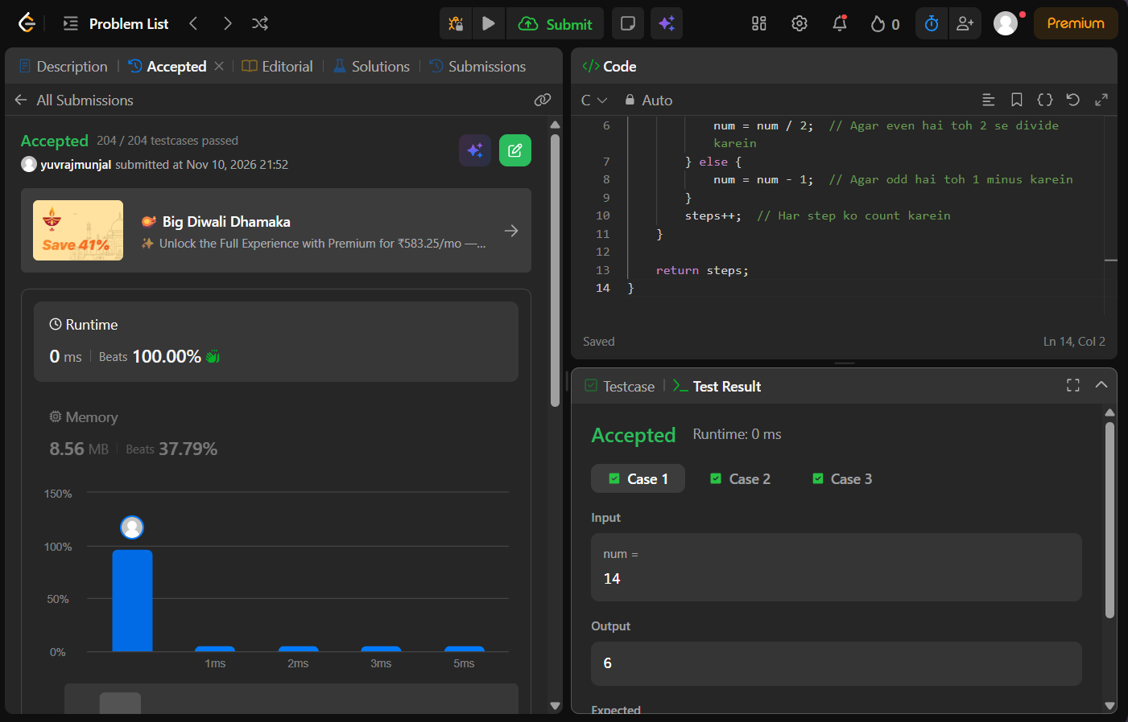
Problem link -https://leetcode.com/problems/number-of-steps-to-reduce-a-number-to-zero/

