Source code -int countOperations(int num1, int num2) {
int ops = 0;

// Jab tak dono mein se koi ek bhi 0 na ho jaye
while (num1 > 0 && num2 > 0) {
if (num1 >= num2) {
num1 -= num2;
} else {
num2 -= num1;
}
ops++;
}

return ops;
}

Screenshot -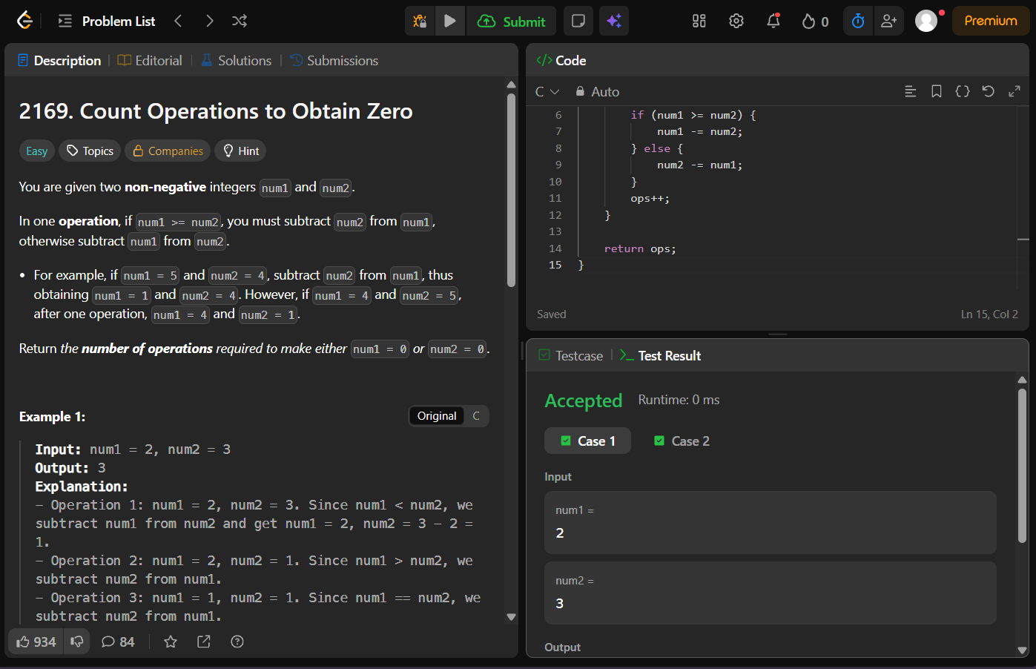

Problem link -https://leetcode.com/problems/count-operations-to-obtain-zero/

