C source code -int countOdds(int low, int high) {
// Agar low aur high dono even hain, toh odd numbers ka count (high - low) / 2 hoga.
// Agar inmein se koi ek bhi odd hai, toh count mein +1 jud jayega.
return (high - low) / 2 + (low % 2 != 0 || high % 2 != 0);
}

Screenshot 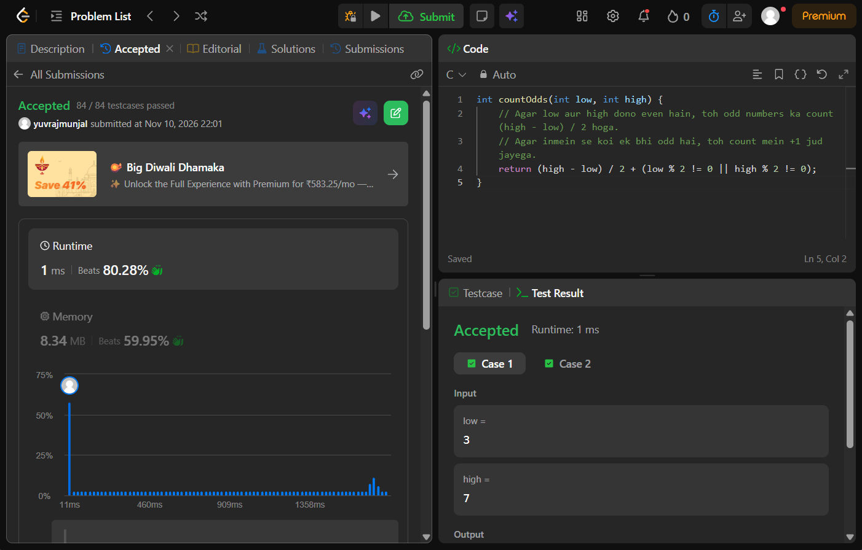

Problem link -https://leetcode.com/problems/count-odd-numbers-in-an-interval-range/

