C source code -int sumOfMultiples(int n) {
int sum = 0;

// 1 se lekar n tak saare numbers ko check karte hain
for (int i = 1; i <= n; i++) {
// Agar number 3, 5, ya 7 se divisible hai
if (i % 3 == 0 || i % 5 == 0 || i % 7 == 0) {
sum += i; // Use sum mein add kar lete hain
}
}

return sum;
}

Screenshot - 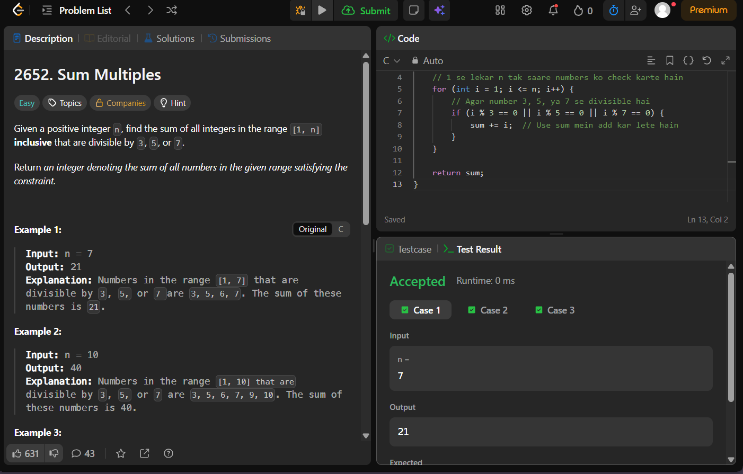
Problem link - https://leetcode.com/problems/sum-multiples/

