1)C source code - #include <stdio.h>

int main() {
int i = 0;
for (; i++ < 100;)
i % 3 ? i % 5 ? printf("%d\n", i) : printf("Buzz\n") : i % 5 ? printf("Fizz\n") : printf("FizzBuzz\n");
}

2)screenshot-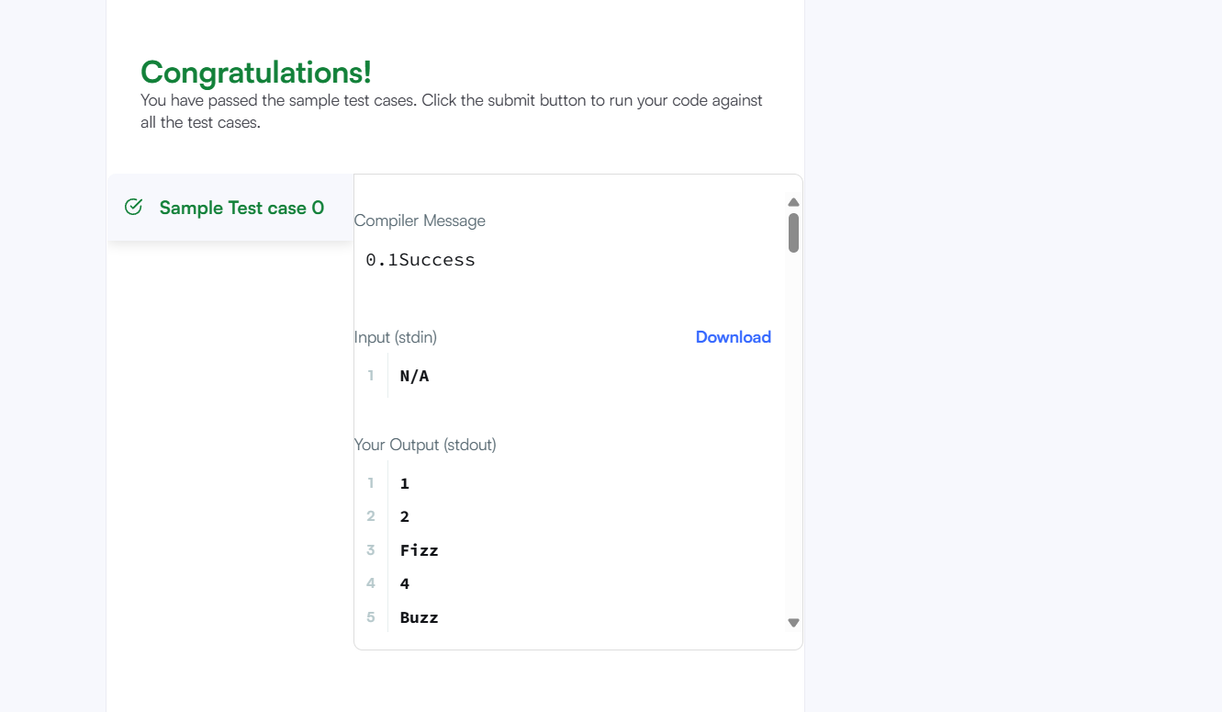
3)problem -https://www.hackerrank.com/challenges/fizzbuzz/problem

