1)Code Source-int distanceTraveled(int mainTank, int additionalTank) {
int totalKm = 0;

while (mainTank >= 5) {
mainTank -= 5;
totalKm += 50; // 5 liters * 10 km per liter

if (additionalTank > 0) {
mainTank += 1;
additionalTank -= 1;
}
}
totalKm += mainTank * 10;

return totalKm;
}
2)screenshot-

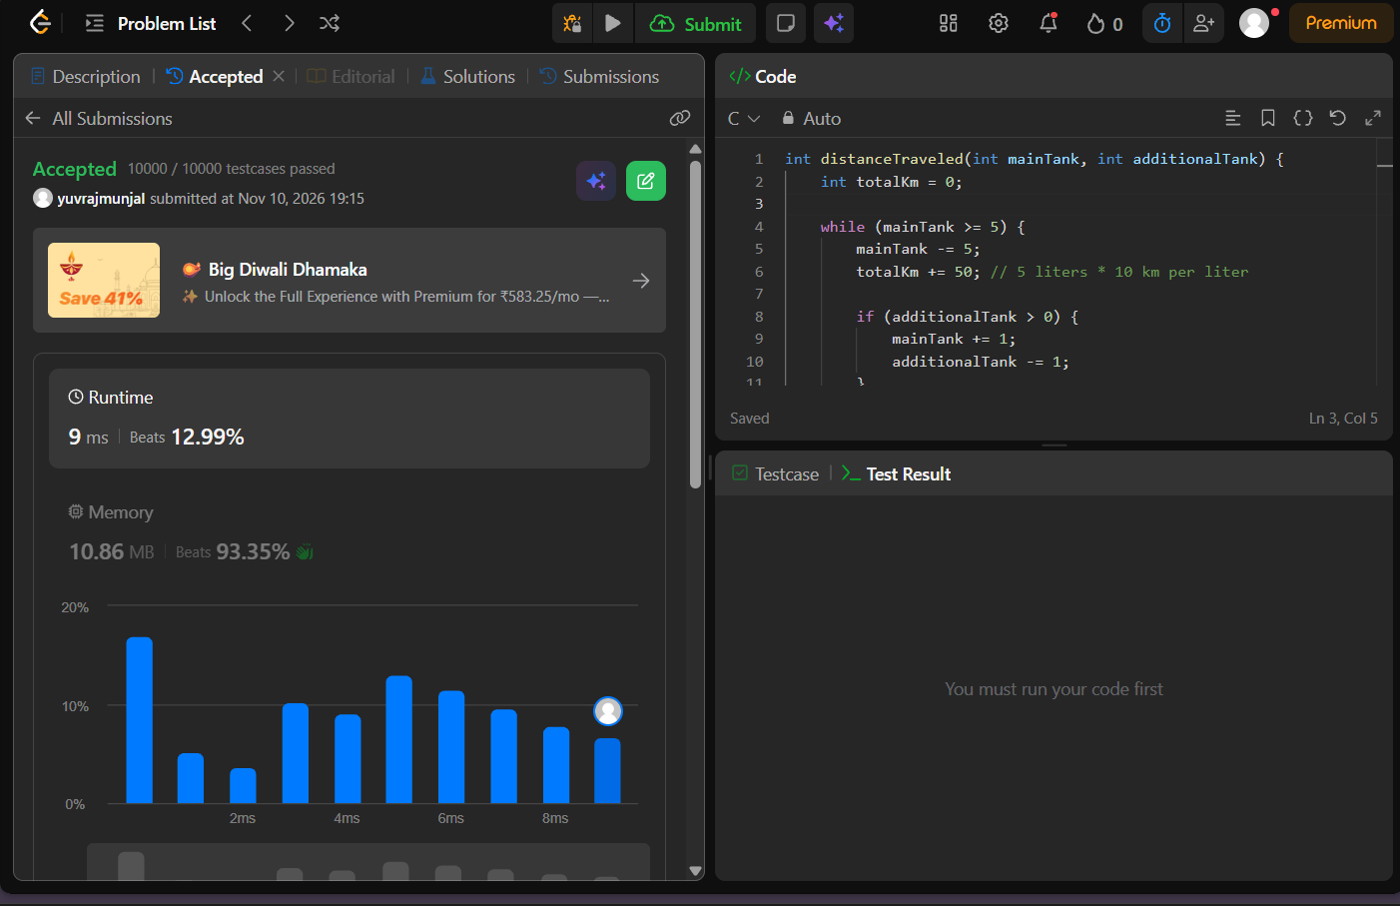
3)problem link-https://leetcode.com/problems/total-distance-traveled/

