1)C source code –#include <stdio.h>

int main(){
int num;
char name[15] ;
scanf("%d", &num);
scanf("%s",&name) ; // Reading input from STDIN
printf(" %d\n", num*2);
printf("%s\n", name); // Writing output to STDOUT
}

2)screenshot-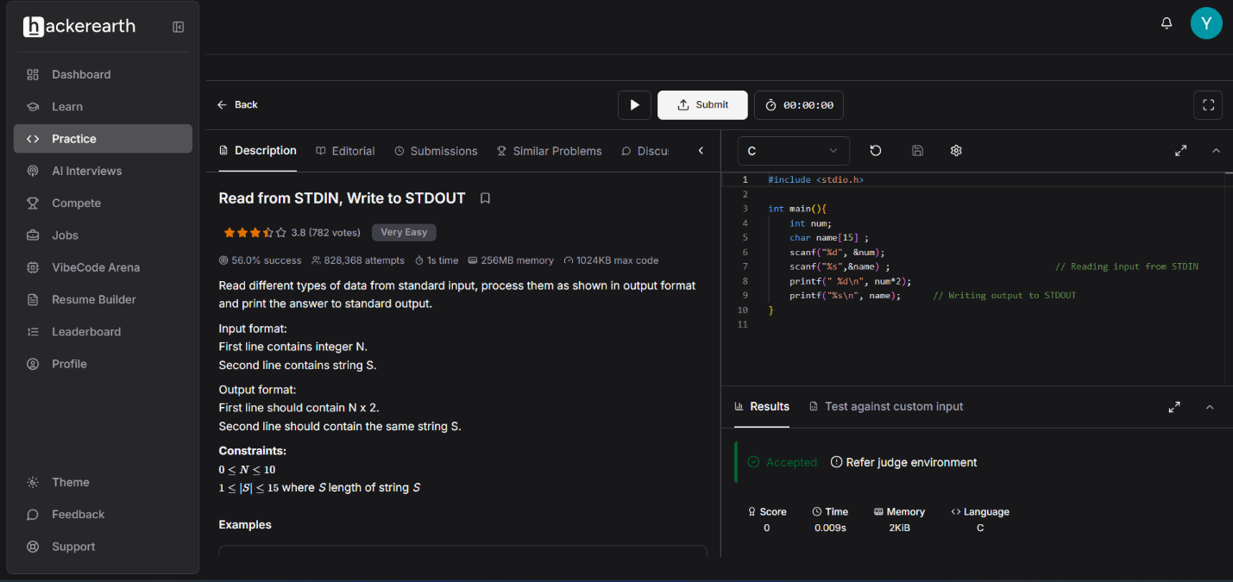
3)problem statement link-https://www.hackerearth.com/practice/basic-programming/input-output/basics-of-input-output/practice-problems/algorithm/io-exercise/

