WEEK 2 TASK REPORT
Exploratory Data Analysis and Visualization
Titanic Passenger Dataset

Prepared using Python, Pandas, Matplotlib, and Seaborn

Dataset | Titanic Passenger Dataset
Original Dataset | 891 rows × 12 columns
Final Analysis Dataset | 891 rows × 16 columns
Environment | Jupyter Notebook / Python 3

1. Objective
The objective of this Week 2 task was to perform exploratory data analysis (EDA) and visualization on the Titanic passenger dataset. The analysis was designed to understand the distribution of the data, identify patterns associated with survival, compare survival across passenger characteristics, examine relationships between numerical variables, and communicate the findings through clear visualizations.

2. Dataset Overview
The dataset contains 891 passenger records and 12 original columns. Important fields include passenger ID, survival status, passenger class, name, sex, age, family relationships, ticket, fare, cabin, and embarkation port.
Category | Value | Purpose
Rows | 891 | Passenger records
Original columns | 12 | Raw dataset fields
Target variable | Survived | 0 = did not survive, 1 = survived
Numerical focus | Pclass, Age, SibSp, Parch, Fare | Statistical/correlation analysis
Categorical focus | Sex, Embarked | Group-wise survival analysis

3. Data Quality and Preprocessing
Initial inspection identified missing Age values (177), missing Cabin values (687), and two missing Embarked values. The cleaning strategy was chosen according to the type and amount of missing information rather than replacing values blindly.
Column | Initial Missing | Treatment | Final Status
Age | 177 | Filled with median age (28.0) | 0 missing
Embarked | 2 | Filled with mode (S) | 0 missing
Cabin | 687 | Retained; very sparse, plus CabinKnown indicator created | 687 missing retained
Cabin was deliberately retained in the analysis dataset because cabin availability itself can be represented by the derived CabinKnown feature. This is an important difference from a simple drop-column approach: the original Cabin information is preserved while a clean binary indicator is available for analysis.

3.1 Feature Engineering
Three additional analytical features were created: FamilySize, AgeGroup, and FamilyCategory. CabinKnown was also created to indicate whether a cabin value was available.
df["FamilySize"] = df["SibSp"] + df["Parch"] + 1
df["CabinKnown"] = df["Cabin"].notna().astype(int)
df["AgeGroup"] = pd.cut(
df["Age"],
bins=[0, 12, 18, 30, 50, 80],
labels=["Child", "Teen", "Young Adult", "Adult", "Senior"]
)
FamilyCategory was defined as Alone (family size 1), Small Family (2–4), Medium Family (5–7), and Large Family (8 or more). These grouped features make the survival patterns easier to interpret.

3.2 Validation
After preprocessing and feature engineering, the analysis dataset contained 891 rows and 16 columns. Duplicate rows were checked and none were found. Age and Embarked had zero missing values after cleaning. Cabin remained sparse by design because it was not imputed; CabinKnown captures whether cabin information was available.

4. Exploratory Data Analysis

4.1 Overall Survival Distribution
Overall, 342 of 891 passengers survived, giving a survival rate of 38.38%. The remaining 549 passengers did not survive (61.62%).
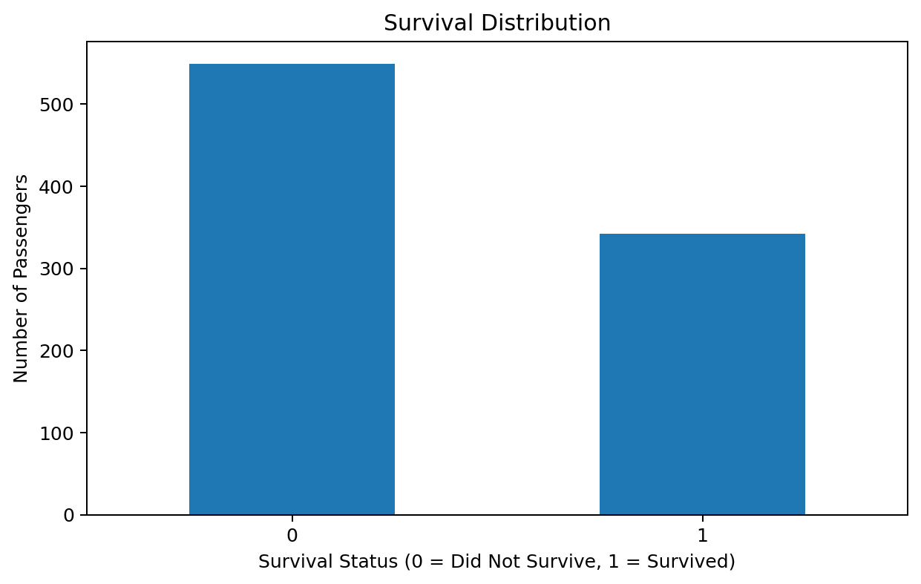

4.2 Survival Rate by Gender
Female passengers had a survival rate of 74.20%, compared with 18.89% for male passengers. The large difference shows that gender was strongly associated with survival in this dataset.
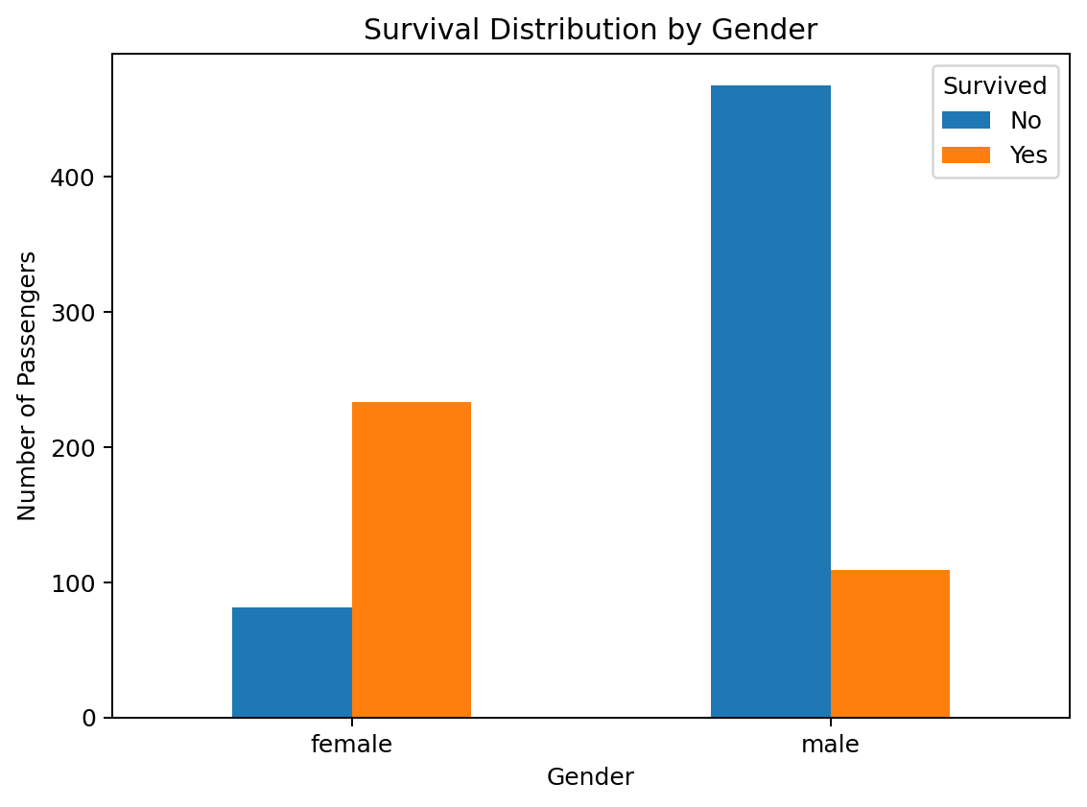

4.3 Survival Rate by Passenger Class
First-class passengers had the highest survival rate (62.96%), followed by second class (47.28%), while third class had the lowest (24.24%). This indicates a strong association between passenger class and survival.
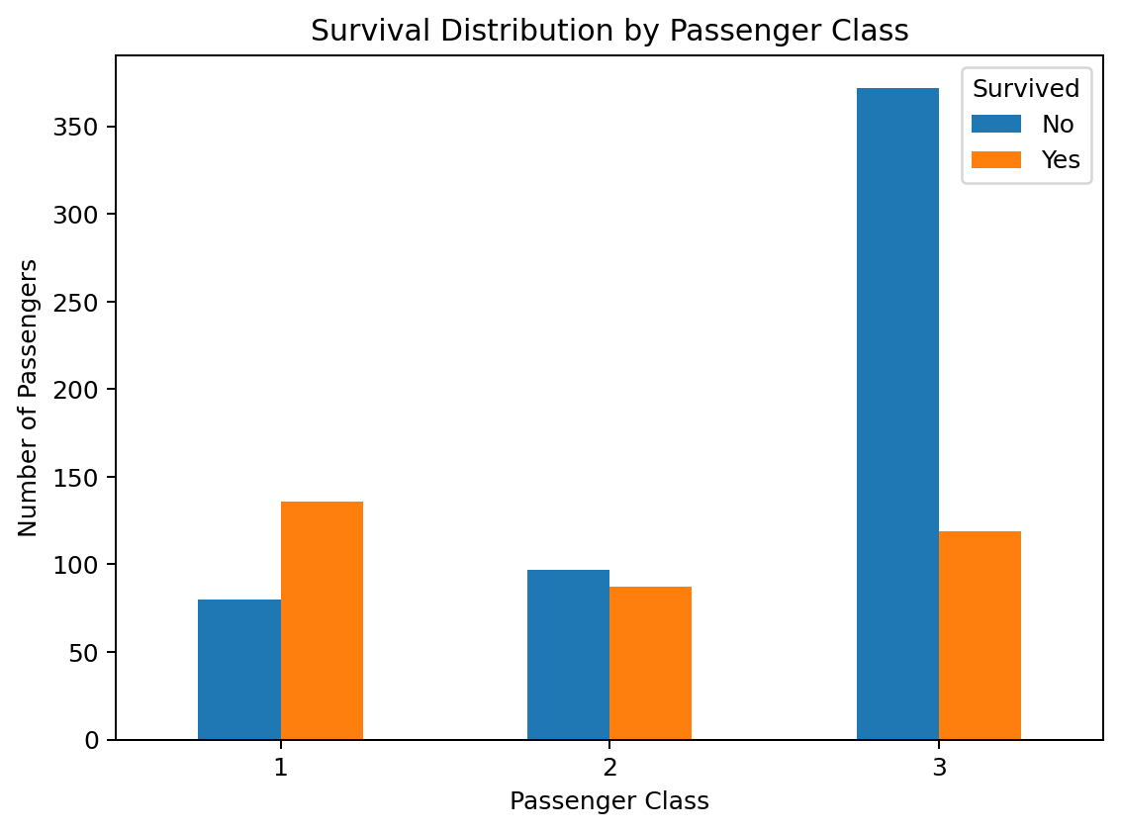

4.4 Age Distribution
The age histogram shows that passengers were concentrated mainly in the young-adult and adult ranges, with many observations around the twenties and thirties. The age variable was median-imputed before the grouped survival analysis.
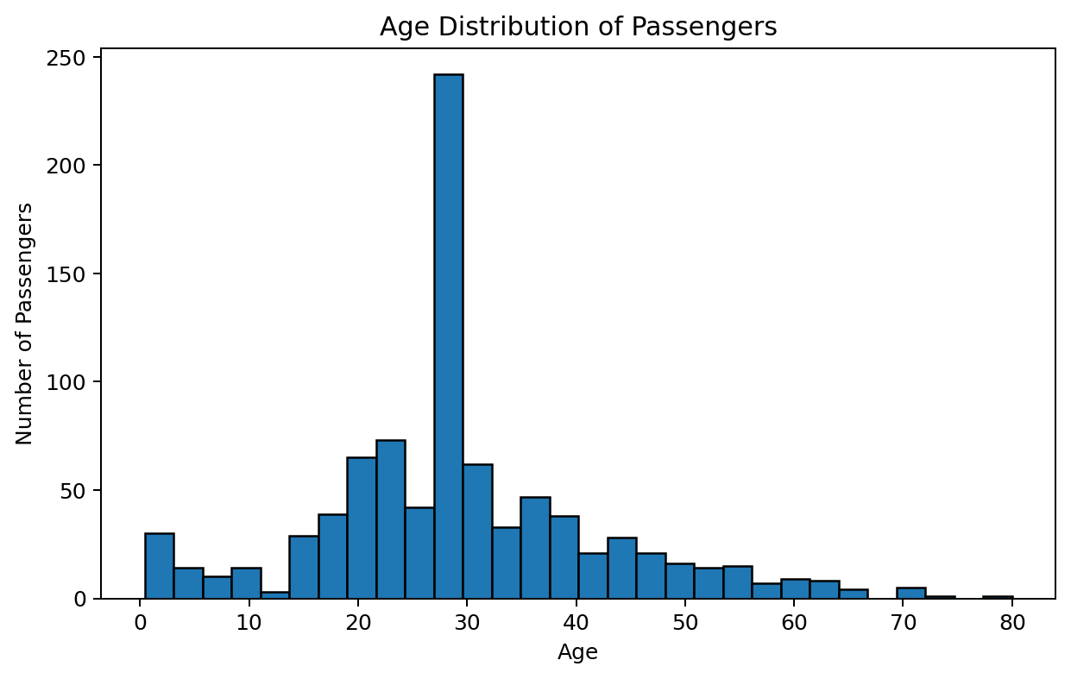

4.5 Survival Rate by Age Group
Children had the highest survival rate among the defined age groups at 57.97%. Teen passengers had 42.86%, young adults 33.11%, adults 42.32%, and seniors 34.38%.
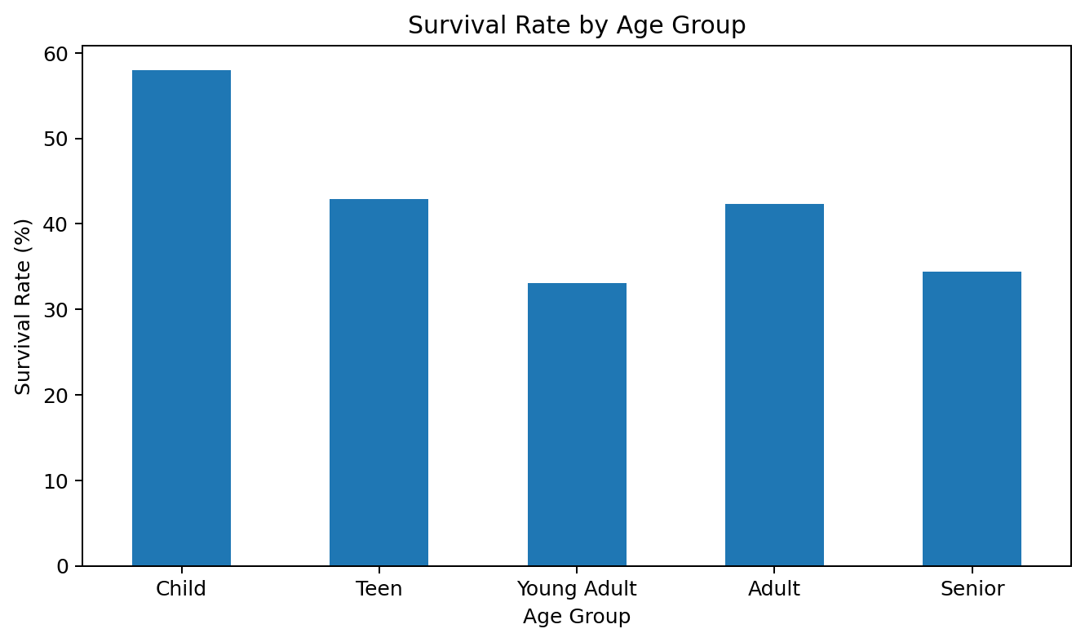

4.6 Survival Rate by Family Category
Small-family passengers had the highest survival rate (57.88%). Passengers travelling alone had 30.35%, medium-family passengers had 20.41%, and large-family passengers had 0.00%. This suggests that family size was associated with survival, although the large-family group is much smaller and should be interpreted carefully.
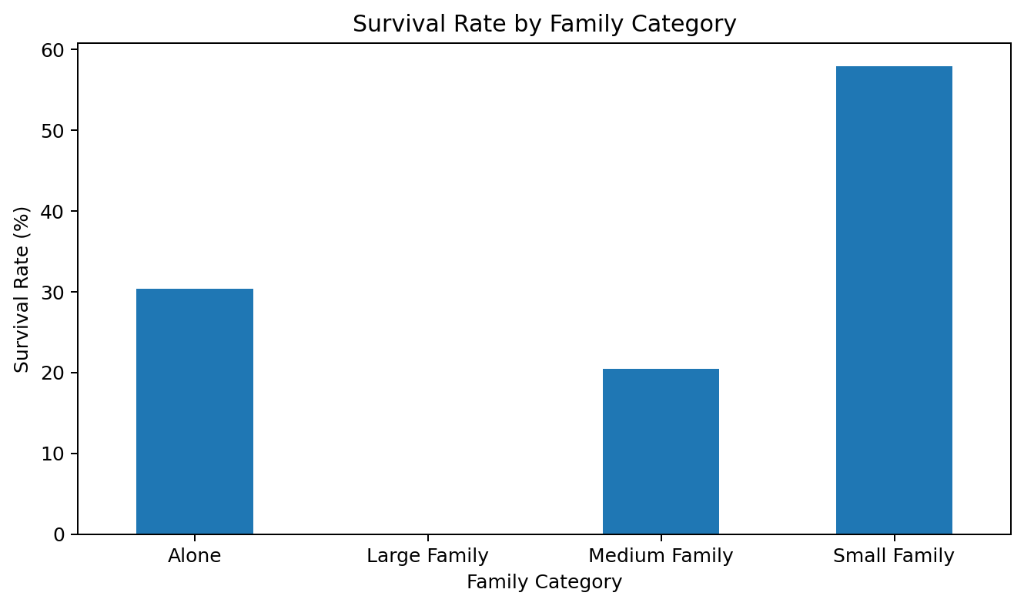

4.7 Survival by Gender and Passenger Class
The combined analysis produced an especially strong contrast. Female first-class passengers had the highest survival rate (96.81%), while male third-class passengers had the lowest (13.54%). The result shows why examining variables jointly can reveal patterns that are less visible when each variable is analyzed separately.
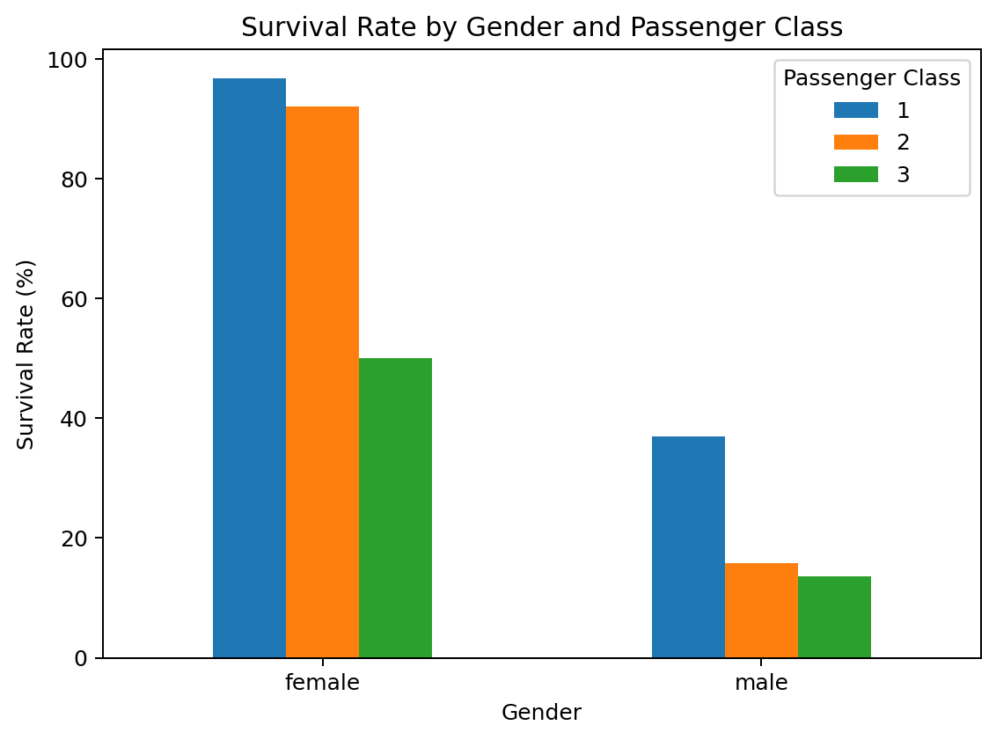

4.8 Survival Rate by Embarkation Port
Passengers who embarked at Cherbourg (C) had the highest survival rate (55.36%), followed by Queenstown (Q) at 38.96% and Southampton (S) at 33.90%. The difference may reflect the passenger mix across the ports rather than the port itself causing survival.
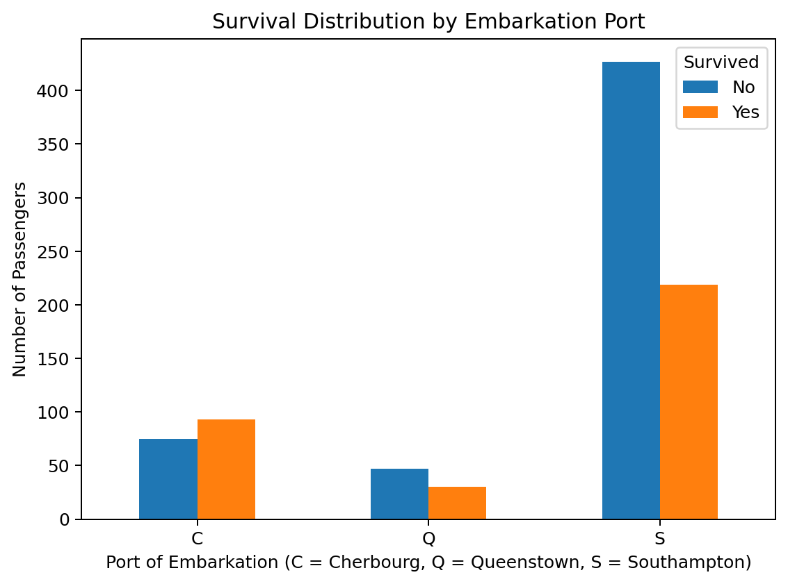

4.9 Fare Distribution by Survival Status
The boxplot shows that survivors generally had higher fare values than non-survivors. There are also several high-fare outliers. Because fare is related to passenger class, this pattern should be interpreted together with the strong class-survival relationship.
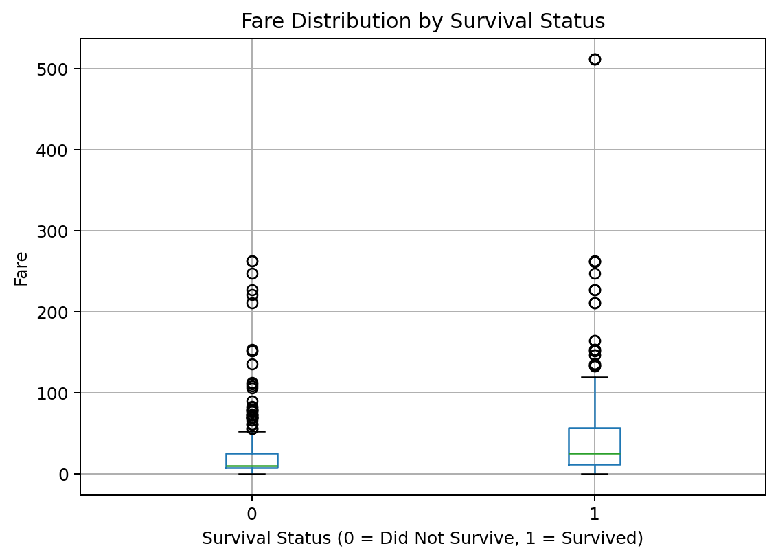

5. Correlation Analysis
Pearson correlation was calculated for the main numerical variables. Passenger class had the strongest negative correlation with survival among the variables examined, while Fare had the strongest positive correlation. Age, SibSp, and Parch had comparatively weak linear correlations with survival.
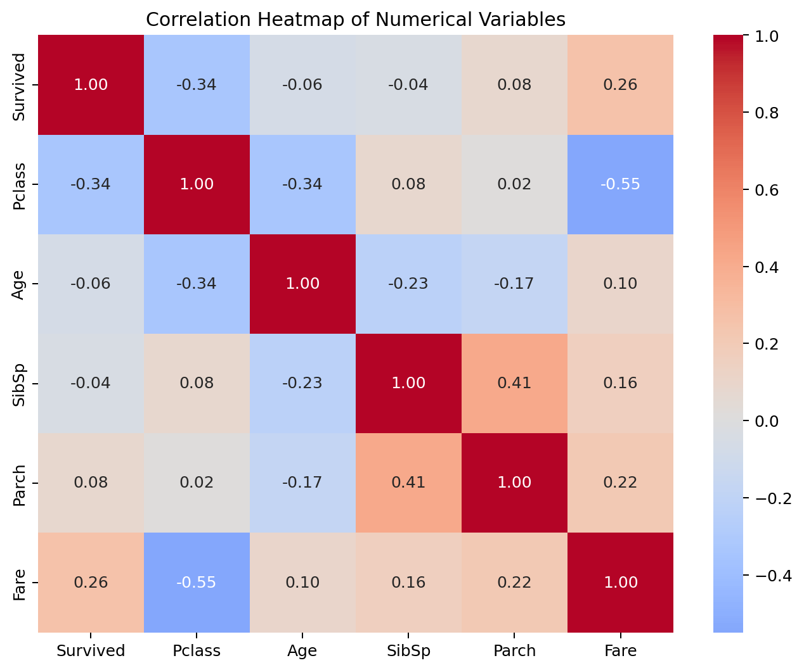
Variable vs Survived | Correlation
Pclass | -0.338
Fare | 0.257
Age | -0.065
SibSp | -0.035
Parch | 0.082
The negative Pclass correlation is consistent with the class-level survival rates: lower class number (higher passenger class) is associated with higher survival. The positive Fare correlation is also consistent with the higher survival observed among passengers paying higher fares.

6. Key Findings
- Overall survival rate was 38.38%.
- Female passengers had a much higher survival rate (74.20%) than male passengers (18.89%).
- First-class passengers had the highest survival rate (62.96%), while third-class passengers had the lowest (24.24%).
- Female first-class passengers had the highest combined survival rate (96.81%), while male third-class passengers had the lowest (13.54%).
- Small-family passengers had the highest survival rate among family categories (57.88%).
- Children had the highest survival rate among the defined age groups (57.97%).
- Passengers embarking at Cherbourg had the highest survival rate among ports (55.36%).
- Survivors generally had higher fares than non-survivors.
- Pclass had a correlation of -0.338 with survival, while Fare had a correlation of 0.257.

7. Interpretation and Limitations
The EDA identifies associations, not causal relationships. For example, the higher survival rate among first-class passengers does not prove that class alone caused the outcome; passenger class is related to other characteristics such as fare, family structure, and the composition of passengers. Similarly, the higher survival rate at a particular embarkation port may reflect differences in the types of passengers who boarded there.
The Cabin field is highly incomplete (687 missing values). Rather than inventing cabin values, the analysis retains the original field and creates CabinKnown as a binary indicator. Grouped categories with very small populations, such as large families, should also be interpreted cautiously.

8. Conclusion
The Titanic dataset was successfully explored and transformed for EDA. The analysis began with 891 rows and 12 original columns and produced an analysis dataset with 891 rows and 16 columns after adding FamilySize, AgeGroup, CabinKnown, and FamilyCategory. The overall survival rate was 38.38%. The visual and statistical analysis consistently showed that gender and passenger class were strongly associated with survival. Female passengers, higher-class passengers, and passengers with higher fares generally had better survival outcomes. Family category and age group also showed meaningful differences, while the correlation analysis confirmed a negative relationship between Pclass and survival and a positive relationship between Fare and survival. These findings provide a clear exploratory understanding of the dataset and establish a useful foundation for further statistical analysis or machine-learning work.

9. Tools and Technologies Used
- Python 3
- Pandas
- Matplotlib
- Seaborn
- Jupyter Notebook

10. Key Analysis Code
Representative code used to calculate the principal survival statistics is shown below.
# Overall survival
overall_survival = df["Survived"].mean() * 100
# Survival by gender
gender_survival = df.groupby("Sex")["Survived"].mean() * 100
# Survival by passenger class
class_survival = df.groupby("Pclass")["Survived"].mean() * 100
# Survival by age group
age_survival = df.groupby("AgeGroup", observed=True)["Survived"].mean() * 100
# Survival by family category
family_survival = df.groupby("FamilyCategory")["Survived"].mean() * 100
# Correlation
correlation = df[
["Survived", "Pclass", "Age", "SibSp", "Parch", "Fare"]
].corr()

11. Final Submission Checklist
- Word report contains the EDA methodology, visualizations, interpretations, and conclusion.
- Jupyter Notebook: YUVA_Week2_Titanic_EDA.ipynb
- Dataset used: train.csv
- Notebook and dataset should be placed in the GitHub project for the technical-task submission.
- Portal requires a .doc or .docx report file; the notebook itself should not be uploaded as the report file.

12. Appendix A — Descriptive Statistics
Descriptive statistics were reviewed as part of the initial EDA to understand the scale, central tendency, spread, and range of the numerical variables. The table below reports the main statistics for the analysis-ready numerical fields.
Variable | Count | Mean | Std | Min | 25% | Median | 75% | Max
Survived | 891.00 | 0.38 | 0.49 | 0.00 | 0.00 | 0.00 | 1.00 | 1.00
Pclass | 891.00 | 2.31 | 0.84 | 1.00 | 2.00 | 3.00 | 3.00 | 3.00
Age | 891.00 | 29.36 | 13.02 | 0.42 | 22.00 | 28.00 | 35.00 | 80.00
SibSp | 891.00 | 0.52 | 1.10 | 0.00 | 0.00 | 0.00 | 1.00 | 8.00
Parch | 891.00 | 0.38 | 0.81 | 0.00 | 0.00 | 0.00 | 0.00 | 6.00
Fare | 891.00 | 32.20 | 49.69 | 0.00 | 7.91 | 14.45 | 31.00 | 512.33
FamilySize | 891.00 | 1.90 | 1.61 | 1.00 | 1.00 | 1.00 | 2.00 | 11.00
CabinKnown | 891.00 | 0.23 | 0.42 | 0.00 | 0.00 | 0.00 | 0.00 | 1.00

12.1 Original Data Quality Snapshot
The raw dataset contains 891 records. Age has 714 non-null observations (177 missing), Cabin has 204 non-null observations (687 missing), and Embarked has 889 non-null observations (2 missing). The remaining original fields are complete. No duplicate rows were found.

12.2 Data Dictionary — Original Columns
Column | Meaning
PassengerId | Unique passenger identifier
Survived | Target: 0 = did not survive, 1 = survived
Pclass | Passenger class: 1, 2, or 3
Name | Passenger name
Sex | Passenger gender
Age | Passenger age in years
SibSp | Number of siblings/spouses aboard
Parch | Number of parents/children aboard
Ticket | Ticket identifier
Fare | Passenger fare
Cabin | Cabin information; highly incomplete
Embarked | Port of embarkation: C, Q, or S

12.3 Analytical Features Created
Feature | Definition | Analytical purpose
FamilySize | SibSp + Parch + 1 | Measures the total travelling family group represented by the passenger.
CabinKnown | 1 if Cabin is present, otherwise 0 | Preserves cabin availability information without inventing missing cabin values.
AgeGroup | Child / Teen / Young Adult / Adult / Senior | Groups continuous age into interpretable categories.
FamilyCategory | Alone / Small Family / Medium Family / Large Family | Groups FamilySize into categories for comparative survival analysis.

13. Appendix B — Visualization Code
The following representative code snippets document the main visualizations used in the EDA. They correspond to the figures included in this report and make the analysis reproducible.

Overall Survival
plt.figure(figsize=(7, 4.5))
df["Survived"].value_counts().sort_index().plot(kind="bar")
plt.title("Survival Distribution")
plt.xlabel("Survival Status (0 = Did Not Survive, 1 = Survived)")
plt.ylabel("Number of Passengers")
plt.xticks(rotation=0)
plt.show()

Gender and Class Comparisons
gender_survival = df.groupby("Sex")["Survived"].mean() * 100
class_survival = df.groupby("Pclass")["Survived"].mean() * 100
gender_class = df.groupby(["Sex", "Pclass"])["Survived"].mean() * 100
gender_survival.plot(kind="bar", title="Survival Rate by Gender")
plt.ylabel("Survival Rate (%)")
plt.show()
class_survival.plot(kind="bar", title="Survival Rate by Passenger Class")
plt.ylabel("Survival Rate (%)")
plt.show()

Age and Age Groups
plt.figure(figsize=(7, 4.5))
plt.hist(df["Age"], bins=30, edgecolor="black")
plt.title("Age Distribution of Passengers")
plt.xlabel("Age")
plt.ylabel("Number of Passengers")
plt.show()
age_survival = df.groupby("AgeGroup", observed=True)["Survived"].mean() * 100
age_survival.plot(kind="bar", title="Survival Rate by Age Group")
plt.ylabel("Survival Rate (%)")
plt.xticks(rotation=0)
plt.show()

Family and Embarkation
family_survival = df.groupby("FamilyCategory")["Survived"].mean() * 100
port_survival = df.groupby("Embarked")["Survived"].mean() * 100
family_survival.plot(kind="bar", title="Survival Rate by Family Category")
plt.ylabel("Survival Rate (%)")
plt.xticks(rotation=0)
plt.show()
port_survival.plot(kind="bar", title="Survival Rate by Embarkation Port")
plt.ylabel("Survival Rate (%)")
plt.xticks(rotation=0)
plt.show()

Fare and Correlation
plt.figure(figsize=(7.5, 4.5))
df.boxplot(column="Fare", by="Survived")
plt.suptitle("")
plt.title("Fare Distribution by Survival Status")
plt.xlabel("Survival Status (0 = Did Not Survive, 1 = Survived)")
plt.ylabel("Fare")
plt.show()
corr = df[["Survived", "Pclass", "Age", "SibSp", "Parch", "Fare"]].corr()
sns.heatmap(corr, annot=True, fmt=".2f", cmap="coolwarm", center=0)
plt.title("Correlation Heatmap of Numerical Variables")
plt.show()

13.1 Reproducibility Note
All reported percentages are calculated from the same cleaned 891-row analysis dataset used for the figures. The preprocessing choices are explicitly documented so that the results can be reproduced from train.csv in the accompanying Jupyter Notebook.

