**Text Report for the Emotion Detection Project**

**1. Related Work Related to the Topic**

Emotion detection from textual data is a rapidly evolving field of Natural Language Processing (NLP). It leverages techniques like sentiment analysis, emotion classification, and deep learning to understand human emotions embedded in text. Traditional approaches, such as lexicon-based methods (e.g., AFINN, SentiWordNet), focus on predefined emotional dictionaries. In contrast, modern methods utilize machine learning and deep learning models, such as Random Forest, Support Vector Machines (SVMs), and Transformer-based architectures like BERT or DistilBERT, for more nuanced emotion prediction.

This project incorporates both traditional machine learning approaches (Random Forest Classifier) and pre-trained Transformer models (e.g., j-hartmann/emotion-english-distilroberta-base) to classify emotions. By combining feature extraction (TF-IDF vectorization) with advanced NLP pipelines, the project ensures robust and accurate emotion detection.

**2. Data Pre-processing**

Textual data requires substantial preprocessing to prepare it for machine learning models. In this project, the following preprocessing steps were implemented:

1. **Normalization**:
   * Conversion of text to lowercase to ensure case-insensitive analysis.
   * Removal of punctuation and numerical characters using Python's string and re libraries.
2. **Tokenization**:
   * Text was split into individual words (tokens) using word_tokenize from NLTK.
3. **Stopword Removal**:
   * Commonly used words (e.g., "the", "is", "and") that do not contribute to the meaning of the text were removed using NLTK's English stopword list.
4. **Lemmatization**:
   * Words were reduced to their base or dictionary form (e.g., "running" → "run") using NLTK's WordNetLemmatizer.
5. **Rare Word Removal**:
   * Words that appear only once in the dataset were excluded to reduce noise.

This process ensured that the text data was clean, standardized, and suitable for feature extraction.

**3. Data Visualization / Exploratory Data Analysis (EDA)**

Visualizations provided insights into the dataset, helping to understand word frequency and emotion distribution:

1. **Word Frequency Analysis**:
   * A frequency distribution of words was computed and visualized using bar plots.
   * Words with high frequency (e.g., those occurring more than 300 times) were identified, providing insight into the dominant terms in the dataset.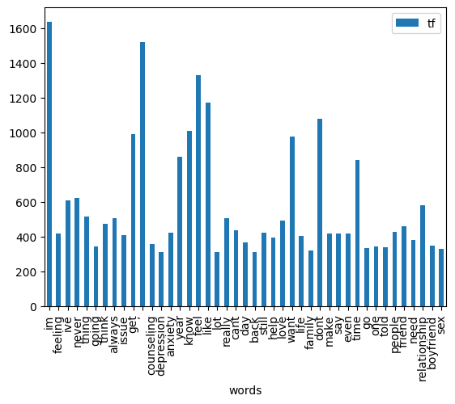
2. **Emotion Distribution**:
   * Using Hugging Face’s pipeline, the emotions in the dataset were classified and their distribution was plotted.
   * This provided an understanding of the balance or imbalance of classes in the dataset, which is crucial for model performance.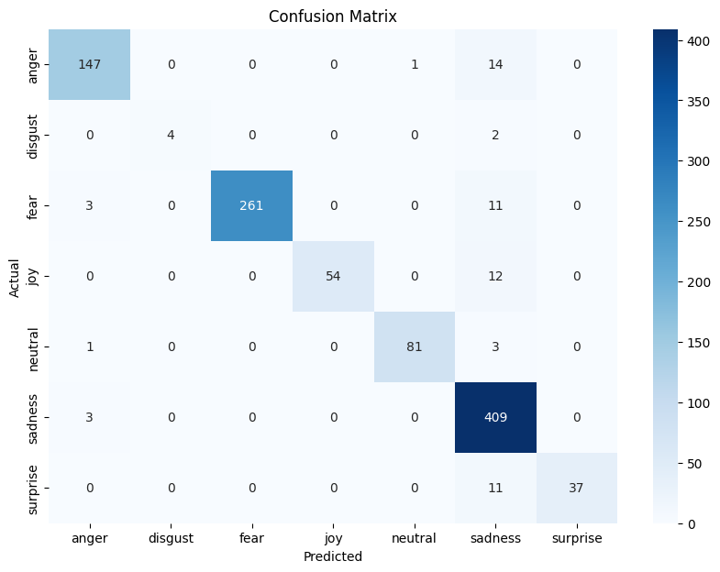

**4. Model Creation and Testing**

**4.1. Random Forest Classifier**

* **Feature Extraction**: TF-IDF vectorization was applied to transform the preprocessed text data into numerical representations.
* **Training**: A Random Forest model was trained on the TF-IDF features and emotion labels.
* **Hyperparameter Tuning**: Grid Search was performed to optimize hyperparameters such as:
  + Number of estimators (n_estimators): [100, 200, 300]
  + Maximum depth (max_depth): [None, 10, 20, 30]
* **Evaluation**: The model was evaluated using a test set, achieving high accuracy, as measured by metrics like:
  + Accuracy
  + Precision, Recall, and F1-score
  + Confusion Matrix (visualized using seaborn)

**4.2. Pre-trained Transformer Model**

* A Hugging Face pre-trained emotion detection model (j-hartmann/emotion-english-distilroberta-base) was used for comparison.
* **Inference**: This model classified emotions directly from the raw text, demonstrating the power of transfer learning.

**4.3. Model Comparison**

* Both the custom Random Forest classifier and the pre-trained model were tested on unseen text samples.
* Results showed that the Random Forest model performed well with structured data, while the Transformer model excelled at handling varied and complex text inputs.

**Summary**

This project successfully implements and compares traditional and modern NLP techniques for emotion detection. Data preprocessing and EDA ensured the dataset was clean and well-understood. A Random Forest classifier was built, optimized, and evaluated, while a pre-trained Transformer model served as a benchmark. The insights gained from this project can guide future work in emotion detection and related fields.