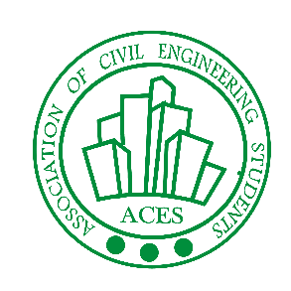

**Association of Civil Engineering Students**

**Rules**

**(Event)**

**Instruction for Poem recitation**

***:- Theme: Shri Guru Nanak Dev Ji and his teachings***

***(Make sure to join our whatsapp group given in registration form)***

* Make a video of yourself on reciting a poem.
* Maximum time limit for video is 3 minutes.
* You have to introduce yourself, college, Branch and semester.
* You are allowed to use English, Hindi and Punjabi.
* The video has to be uploaded on your google drive then it's link should be submitted through our submission form which will be provided through what's app group
* Submission deadline are 27/11/2020 to 30/11/2020 till 11.59 pm.
* Judgement of jury will be final.

**Instruction for Poetry writing *:-***

* Line limit for the poetry should be 10 to 30 lines
* Poem should be original and not copied.
* Make pdf of your poetry and upload it on your google drive then it's link should be submitted through our submission form which will be provided through what's app group.
* The language in which you can submit is English, Hindi and Punjabi.
* Submission deadline are 27/11/2020 to 30/11/2020 till 11.59 pm.
* Judgement of jury will be final.

**Instruction for Art *:-***

* Any type of art work including painting, Sketching and other forms should be hand made.
* Click pics of your artwork and upload it to your google drive then it's link should be submitted through our submission form which will be provided through what's app group.
* Submission deadline are 27/11/2020 to 30/11/2020 till 11.59 pm.
* Judgement of jury will be final.