**Hashing**: - Transformation of a string of characters into a usually shorter fixed length value or key that represents the original string using some function called Hash function is called Hashing.

Why is Hashing used?

It is used to index and retrieve values in O (1) space because it is faster to find using key.

Hash Code is generated by using a key(unique).

How it works?

We store the data in the form of table called Hash Table. In Hash Tables, you store data in forms of key

and value pairs. The key, which is used to identify the data, is given as an input to the hashing

function. The hash code, which is an integer, is then mapped to the fixed size we have.

There may be a condition where two string can have same hash code, this condition is called collision.

This condition can be handled by following ways: -

1. Chaining (Open Hashing)

2. Open Addressing (Closed Hashing)

**Chaining (Open Hashing)**: - Slot where collision occurs, we create a Linked List at that place. Here we

add a new key in the beginning of the Linked List.

Example: - key= {42,19,10,12} hash function(k)=k mod 5

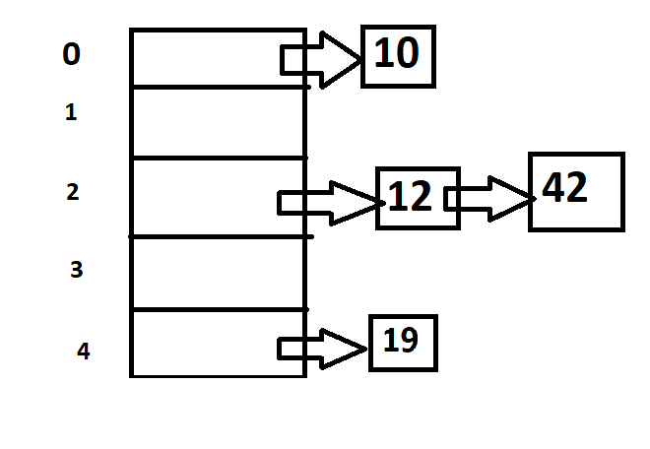

This is the hash table representation for Open hashing.

**Advantages**: -

* Deletion is easy O (N).
* Insertion is easy O (1).

**Disadvantages**: -

* Searching take long time O (N).
* Space Wastage.

**Open Addressing (Closed Hashing)**: - It is also divided into 3 sub-types.

**Linear Probing**: - In case of collision, we fill the element with the empty position.

Example: - h(k)= k mod 10, R(k,i)=(h(k)+i)%10, keys={43,135,72,23,99,19,82}

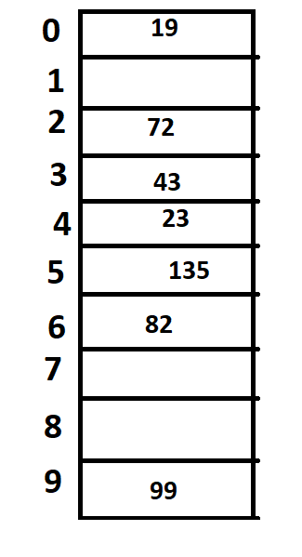

Hash Table diagram. Key allotment according to linear probing.

**Advantage**: - No extra space

**Disadvantage**: -

* Search Time O(N).
* Deletion difficult
* Primary Clustering
* Secondary Clustering

**Quadratic Probing**: - Quadratic probing operates by taking the original hash index and adding successive values of an arbitrary [quadratic polynomial](https://en.wikipedia.org/wiki/Quadratic_polynomial) until an open slot is found.

Example: - h(k)= k mod 10, R(k,i)=(h(k)+i2) mod 10, keys={42,16,91,33,18,27,36,62}

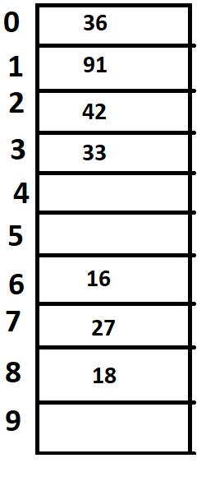Note: - the key ‘62’ is not allotted

**Advantage**: -

* No Extra Space
* Primary Clustering Resolved

**Disadvantage**: -

* Search O(N)
* Secondary Clustering
* No guarantee of finding the slots.

**Double Hashing**: - Double hashing is a computer programming technique used in conjunction with open addressing in hash tables to resolve hash collisions, by using a secondary hash of the key as an offset when a collision occurs.

Example: - h1(k)= k mod 11, h2(k)=8-(k mod 8), R(k)=(h1(k)+I*h2(k)) mod 11

Keys={20,34,45,70,56}

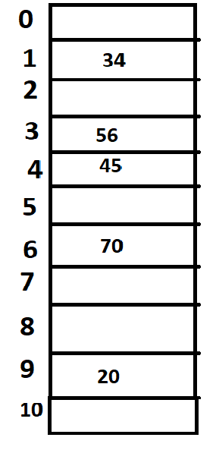

Hash table after implementing double hashing.

**Advantages**: -

* No extra space.
* No primary clustering
* No secondary clustering

**Disadvantages**: - searching is still O(N).