Use Case Diagram: University identifies if a student exists. But university and student both wants to request grade reports. Instructor enters and update grades for the class taught by himself, and admin change course. Theses three use case have one use in common that they all need to enter the course code.

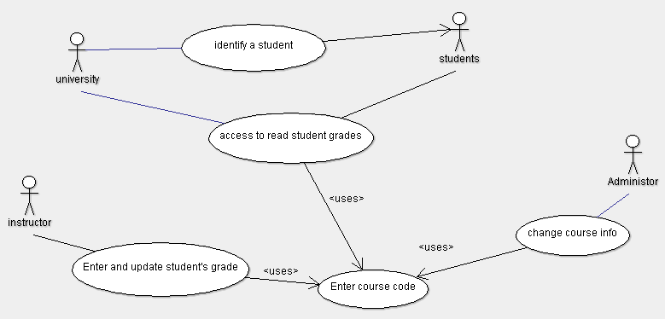

Class diagram: Student pick courses from department first. University can access student’s personal information.

Student can acquire grade reports, and grade reports can also access “student” class as well to get each course grades.

Section class belongs to course class. Instructor can modify the student grades. Also, admin can modify course info.

Attention, there are some operations in department class. “GetAllDepartmentTaken” is for gradeReport class to access all grades of courses taken.

