Part1:

for GUI component:

Purchase Component cost = Developer cost + End user cost + maintenance cost for components =(30*300+40*50)*2=22000$;

Build Component cost = cost to build + cost to maintain components you build=(50*300+40*50)*2=34000$;

**Improvement in productivity factor for GUI components = 0.4**

**Your application reuse savings = (0.4 x cost to build) x (number of applications - 1)**

In-house development reuse saving=0.4*34000*49=666400$;

Farming out reuse savings=0.4*22000*49=431200$;

**Component cost / sum of users across all applications**

In-house development cost per user=34000/10000=3.4$;

Farming out cost per user=22000/10000=2.2$;

The cost of farming out to a developer is much lower than in-house development. Also, In terms of quality consideration for GUI component, there is not much worry to let other developer to build it. So I would farm out this GUI component 100% to a developer.

For service component:

Component cost=cost to build+ cost to maintain;

In-house development cost=50*500*2=50000$;

Farming out cost =30*500*2=30000$;

**Impovement in productivity factor for service components = 1.5**

**Your application reuse savings = ((1.5 x cost to build) x (number of applications - 1))**

**- Complexity cost**

In-house development reuse savings=1.5*50000*49=3675000$;

Farming out reuse savings=1.5*30000*49=2205000$;

**cost per user = (Component cost + Complexity cost)/ sum of users across applications**

**(ignoring overlap in users)**

In-house development cost per user=(50000+20000)/10000=7$;

Farming out cost per user=(30000+20000)/10000=5$;

For security and quality reason, I cannot let developer to do it for me even though it is cheap. Thus, I would like to 50% to 50% for in-house and farm out development.

Then my development cost =40000$;

Reuse saving=1.5*40000*49=2940000$;

Cost per user=(40000+20000)/10000=6$;

Domain component:

**Domain build cost = sum of costs for the domain components and supporting**

**components + application framework costs**

I would like to take 50% to 50% for in-house and farm out development.

Then build cost=(50+30)/2*800*2=64000$;

Reuse savings=10*64000*49=31360000$;

Cost per user=(64000+20000)/10000=8.4$;

Part2:

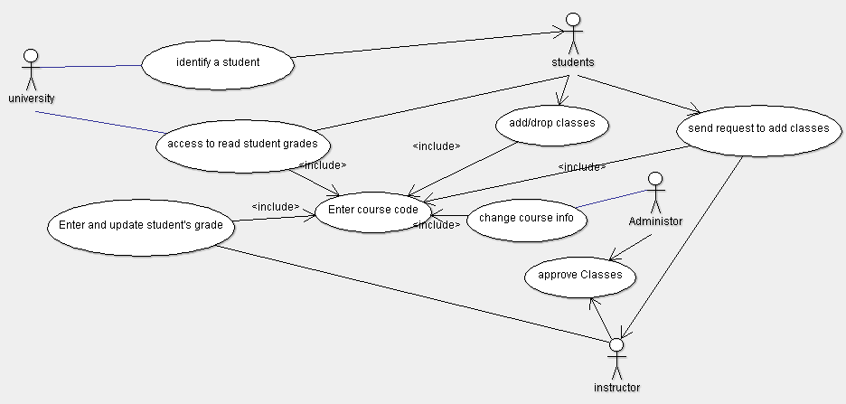

My actor weight is “complex”, which is worth 3 points for each actor.

So my actor weight in total=4 actors*3=12;

My use case weight is “average”, which is worth 13 points for each. So my use case=7 use cases*13 =91;

So my UUCP=12+91=103;

For TCF=1 end user efficiency+0.5 easy to use+ 1 include special security features=2.5;

EF=1.5 familiar+0.5 experience=2;

So my UCP=UUCP*TCF*EF=103*2.5*2=515;

Suppose effort is 20 hours.

Effort=UCP*PHperUCP=515*20=10300;

Cost=100$/hr*20=2000$;