You can use Amazon Kinesis Data Streams to collect and process large [streams](https://aws.amazon.com/streaming-data/) of data records in real time. You can create data-processing applications, known as *Kinesis Data Streams applications*.

Amazon Kinesis Data Firehose is a fully managed service for delivering real-time [streaming data](http://aws.amazon.com/streaming-data/) to destinations such as Amazon Simple Storage Service (Amazon S3), Amazon Redshift, Amazon Elasticsearch Service (Amazon ES), and Splunk.

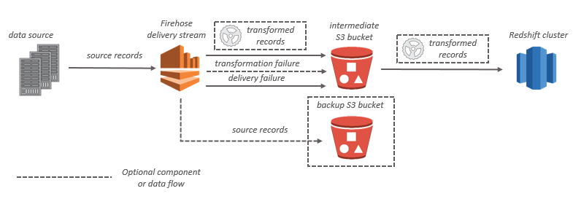

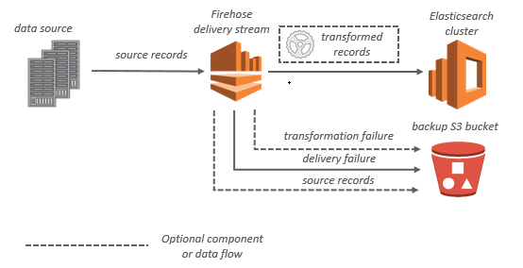

With Amazon Kinesis Data Analytics, you can process and analyze streaming data using standard SQL. The service enables you to quickly author and run powerful SQL code against streaming sources to perform time series analytics, feed real-time dashboards, and create real-time metrics.

To get started with Kinesis Data Analytics, you create a Kinesis data analytics application that continuously reads and processes streaming data. The service supports ingesting data from Amazon Kinesis Data Streams and Amazon Kinesis Data Firehose streaming sources. Then, you author your SQL code using the interactive editor and test it with live streaming data. You can also configure destinations where you want Kinesis Data Analytics to send the results.

Kinesis Data Analytics supports Amazon Kinesis Data Firehose (Amazon S3, Amazon Redshift, and Amazon Elasticsearch Service), AWS Lambda, and Amazon Kinesis Data Streams as destinations.

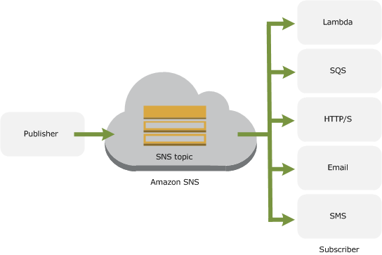

**Amazon SQS Visibility Timeout**

When a consumer receives and processes a message from a queue, the message remains in the queue. Amazon SQS doesn't automatically delete the message. Because Amazon SQS is a distributed system, there's no guarantee that the consumer actually receives the message (for example, due to a connectivity issue, or due to an issue in the consumer application). Thus, the consumer must delete the message from the queue after receiving and processing it.

Immediately after a message is received, it remains in the queue. To prevent other consumers from processing the message again, Amazon SQS sets a *visibility timeout*, a period of time during which Amazon SQS prevents other consumers from receiving and processing the message. The default (minimum) visibility timeout for a message is 30 seconds. The maximum is 12 hours.

# Amazon SQS Delay Queues

Delay queues let you postpone the delivery of new messages to a queue for a number of seconds. If you create a delay queue, any messages that you send to the queue remain invisible to consumers for the duration of the delay period. The default (minimum) delay for a queue is 0 seconds. The maximum is 15 minutes.