Project Report for Project 1
Member: 陳昱瑋, 林家伶

There are 5 java class:
- Company (name, address, contact) -> describe the company info
- Distributor -> it inherits company class.
- NeedSupply -> it contains supply class and the needed amount
- SellSupply -> it contains supply class and the sold amount
- Supply (name, price) -> describe the supply item
- UserData -> store all the data here

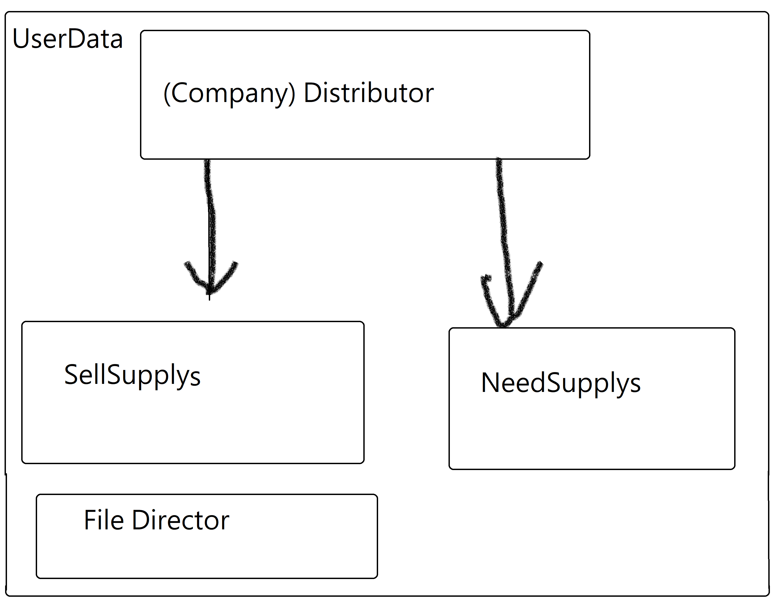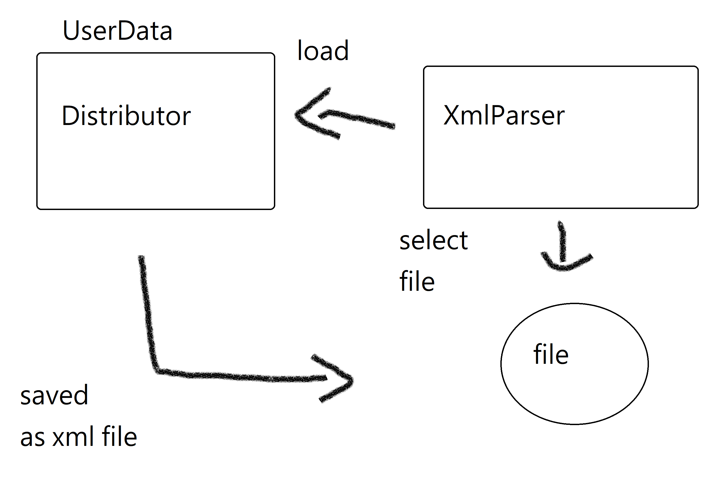
Design
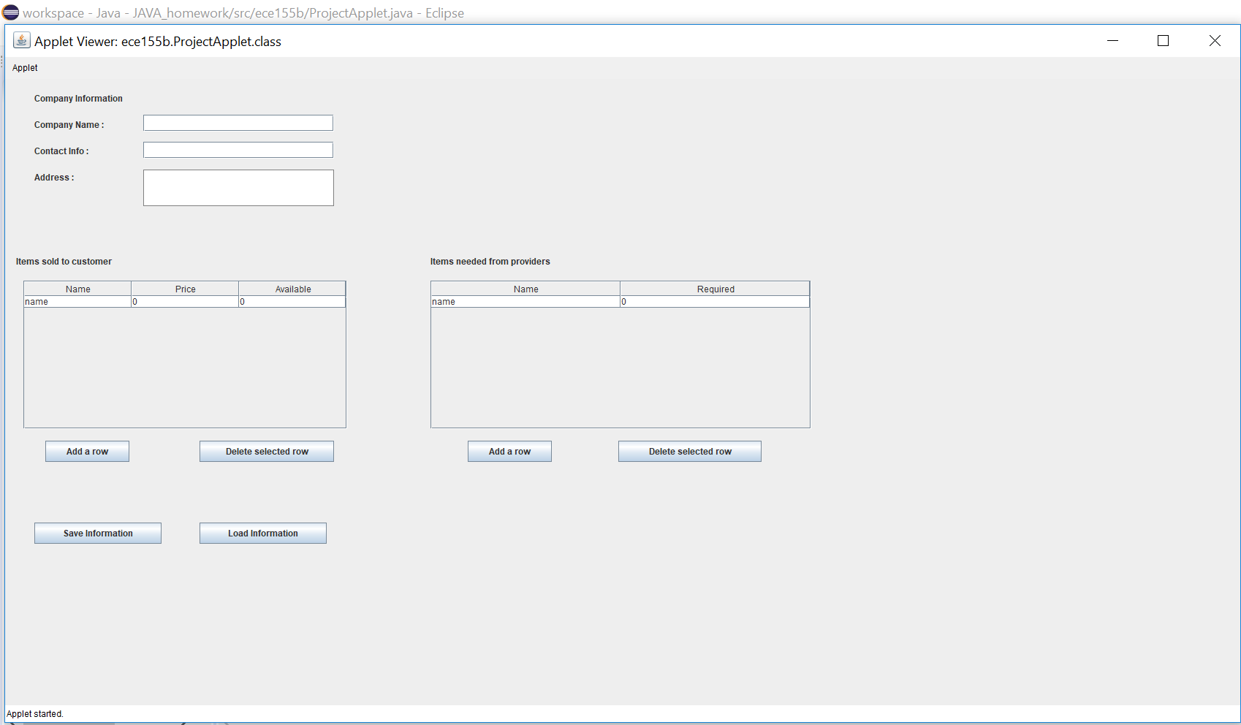
Sample input and output
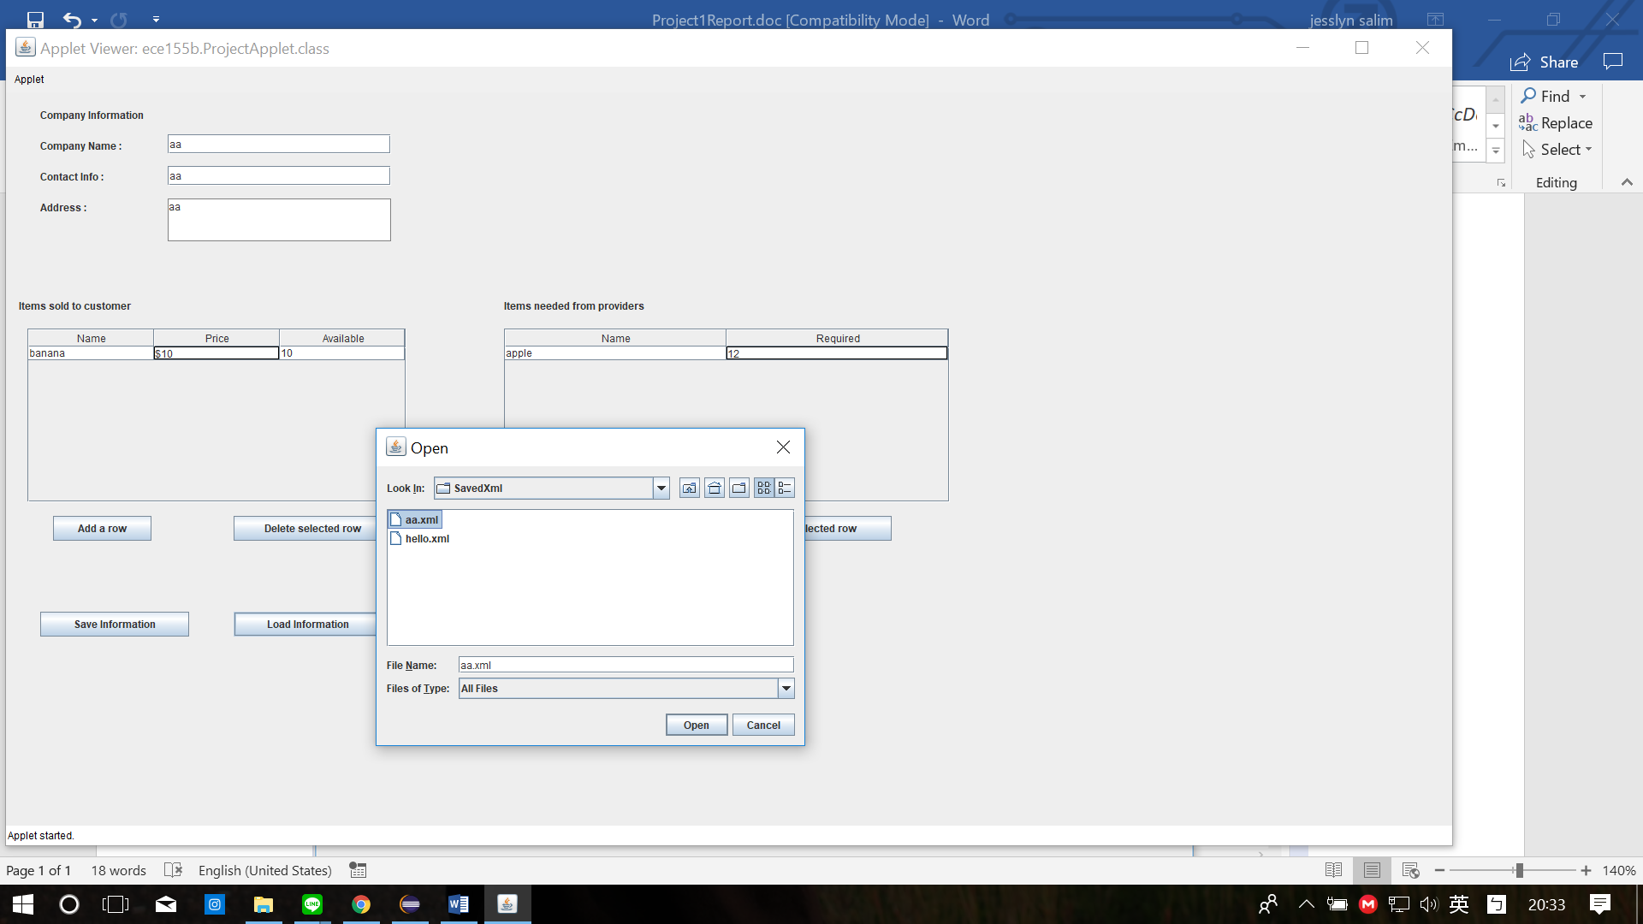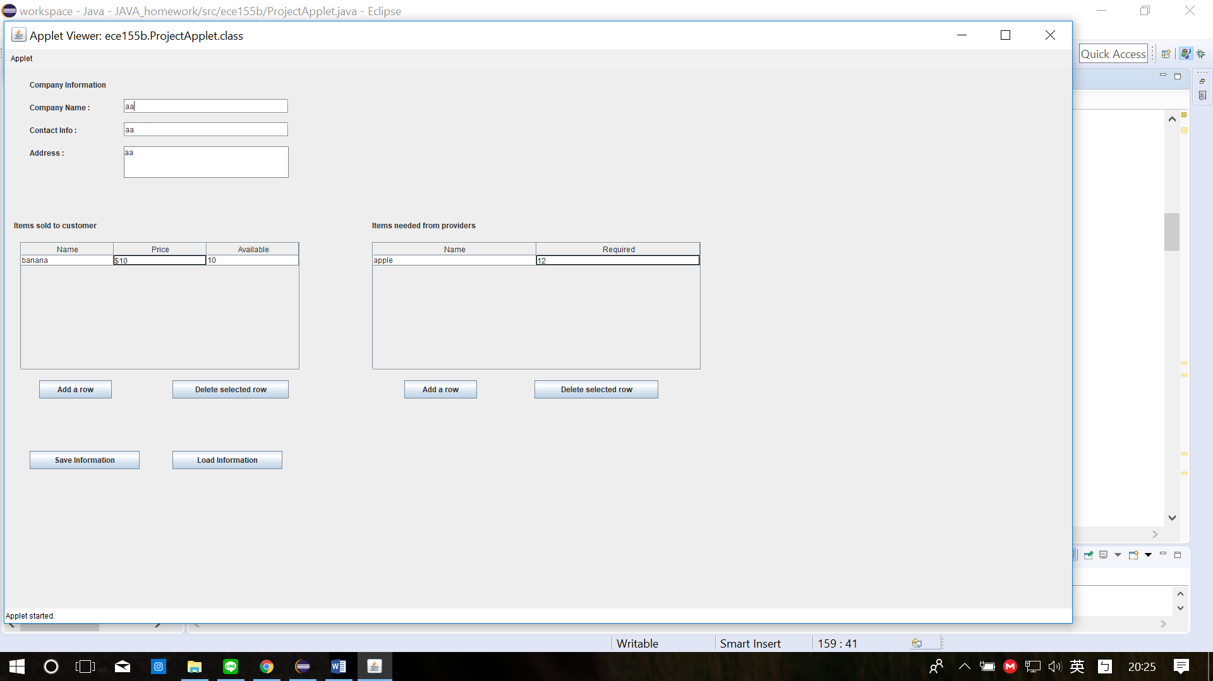

We design the design like this because we think it is simple for user to use (insert, update, and delete). We create the design using the absolutelayout. It is simpler to design whether you use flowlayout.

