Report for Homework4

File structure:

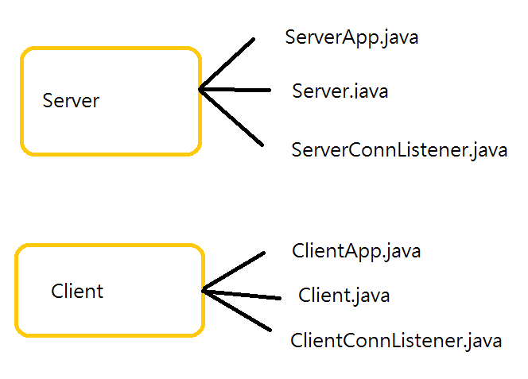

ServerApp: the GUI for server

Server: the core of server

ServerConnListener: handles the socket service

ClientApp: the GUI for client

Client: the core of client

ClientConnListener: handles the socket service

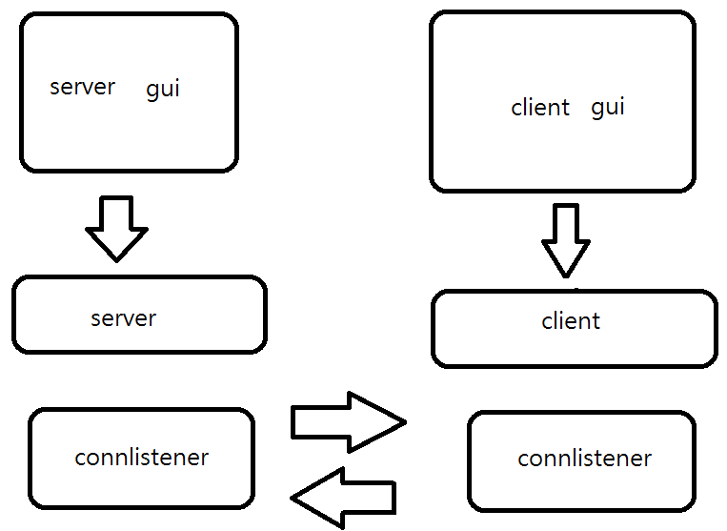

Server:

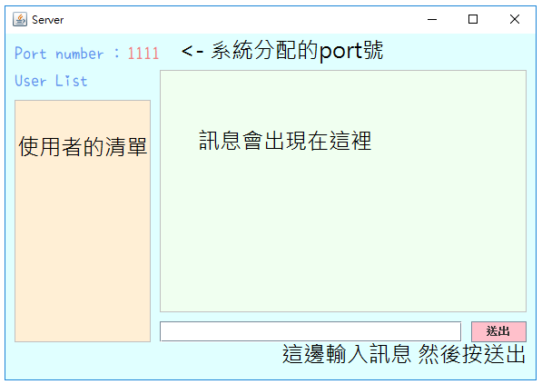

Client:

先取個名字

