Computer Organization Lab 1
0113110 Po-han Chen, 0316213 Yu-wen Pwu
Architecture Diagram
We’ve modified the ALU slightly.
alu_single (1 bit) | alu (32 bit)
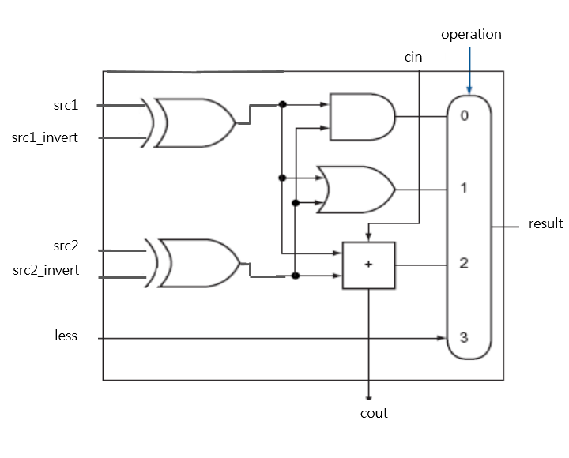 | 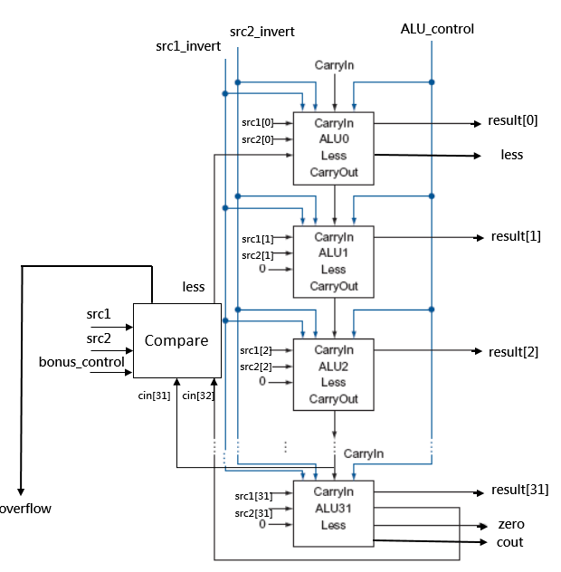

Detailed Description of the Implementation
We have designed a 32-bit ALU that supports common arithmetic operations including: And, Or, Add, Subtraction, Nor, Nand and Comparisons (Set less than, Set greater than, Set less equal, Set greater equal, Set equal, Set not equal).
The design is composed of 32 1-bit ALUs interconnected sequentially. Let’s denote the ALU for the LSB (least significant bit) by ALU0, the ALU for the second LSB by ALU1 and all the way to the ALU for the MSB (most significant bit) by ALU31.
- For ALUi, where 1 ≤ i ≤ 31:
  - (Input) src1 and src2, the 2 single-bit input numbers, are connected to src1[i] and src2[i] respectively.
  - (Input) less, the input for the comparison signals, is connected to 0 (constant).
  - (Input) src1_invert and src2_invert, indicating whether the input bit should be flipped, are connected to src1_invert and src2_invert respectively.
  - (Input) cin, the carry-in for this ALUi, is connected to cin[i].
  - (Input) operation, indicating the type of arithmetic operation to be carried out, is connected to operation.
  - (Output) result is the calculated result of ALUi.
  - (Output) cout, the carry-out for bit i, connects with the carry-in for the next bit (ie. cin[i + 1]).
- For ALU0, everything is the same except that:
  - (Input) less, the input for the comparison signals, is connected to less.
- Regarding the wire connections outside the 1-bit ALUs, we considered them reversely during implementation:
  - cin[0], the carry-in for the LSB, is:
1, if ALU_control is 4’b0110 (Subtract) or 4’b0111 (Compare)
0, otherwise
  - src1_invert, indicating whether src1 should be inverted, is:
1, if ALU_control is 4’b1100 (Nor) or 4’b1101 (Nand)
0, otherwise
  - src2_invert, indicating whether src2 should be inverted, is:
1, if ALU_control is 4’b1100 (Nor), 4’b1101 (Nand), 4’b0110 (Subtract) or 4’b0111 (Compare)
0, otherwise
  - operation, indicating the type of calculation for the 1-bit ALUs is:
2’b00, if ALU_control is 4’b0000 (And) or 4’b1100 (Nor)
2’b01, if ALU_control is 4’b0001 (Or) or 4’b1101 (Nand)
2’b10, if ALU_control is 4’b0010 (Add) or 4’b0110 (Subtract)
2’b11, otherwise
- On the higher-level considerations, or mathematical foundations, we have:
  - src1 ⊽ src2 = ¬src1 ∧ ¬src2
  - src1 ⊼ src2 = ¬src1 ∨ ¬src2
  - real_less (whether src1 < src2)
= (src1 – src2 < 0)
= bit 31 of result is 1 or negative integer overflow
= (src1_31 ⊕ src2_31 ⊕ cin[31]) ∨ (src1_31 ∧ src2_31 ∧ ¬cin[31])
  - equal = (src1 == src2)
  - less
case (bonus_control)
3'b000 (Set less than): less = (src1 < src2) = real_less
3'b001 (Set greater than): less = ¬ (src1 < src2 ∨ src1 == src2) = ¬ (real_less ∨ equal)
3'b010 (Set less equal): less = (src1 < src2 ∨ src1 == src2) = (real_less ∨ equal)
3'b011 (Set greater equal): less = ¬ (src1 < src2) = ¬real_less
3'b110 (Set equal): less = (src1 == src2) = equal
3'b100 (Set not equal): less = (src1 ≠ src2) = ¬equal
default: less = real_less
  - zero = (result == 32’b0)
  - cout
= cin[32], if operation is 4’b0010 (Add) or 4’b0110 (Subtract)
= 0, otherwise.
  - overflow
= (cout[31] ⊕ cout[30]) = (cin[32] ⊕ cin[31]), if operation is 4’b0010 (Add) or 4’b0110 (Subtract)
= 0, otherwise
Problems Encountered and Solutions
We haven’t encountered any problems during the implementation.
We have detailed our solutions or approaches above and within the comments of our code.
Lesson Learned (If Any)
- 肝毋好，人生係黑白的；
肝若好，作業係空白的。
- Verilog 2001 added the generate block, which is very handy to instantiate an abundance of modules.
- Xilinx Vivado Design Suite is much more powerful than its legacy EDA tool – Xilinx ISE Design Suite.

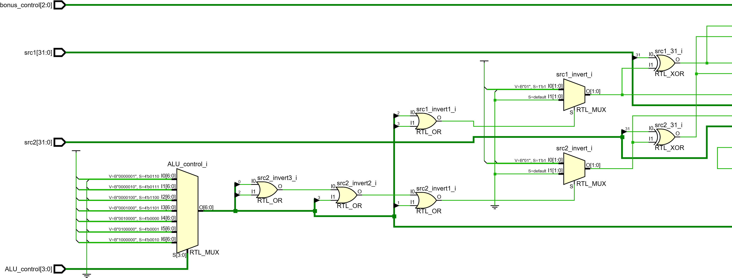
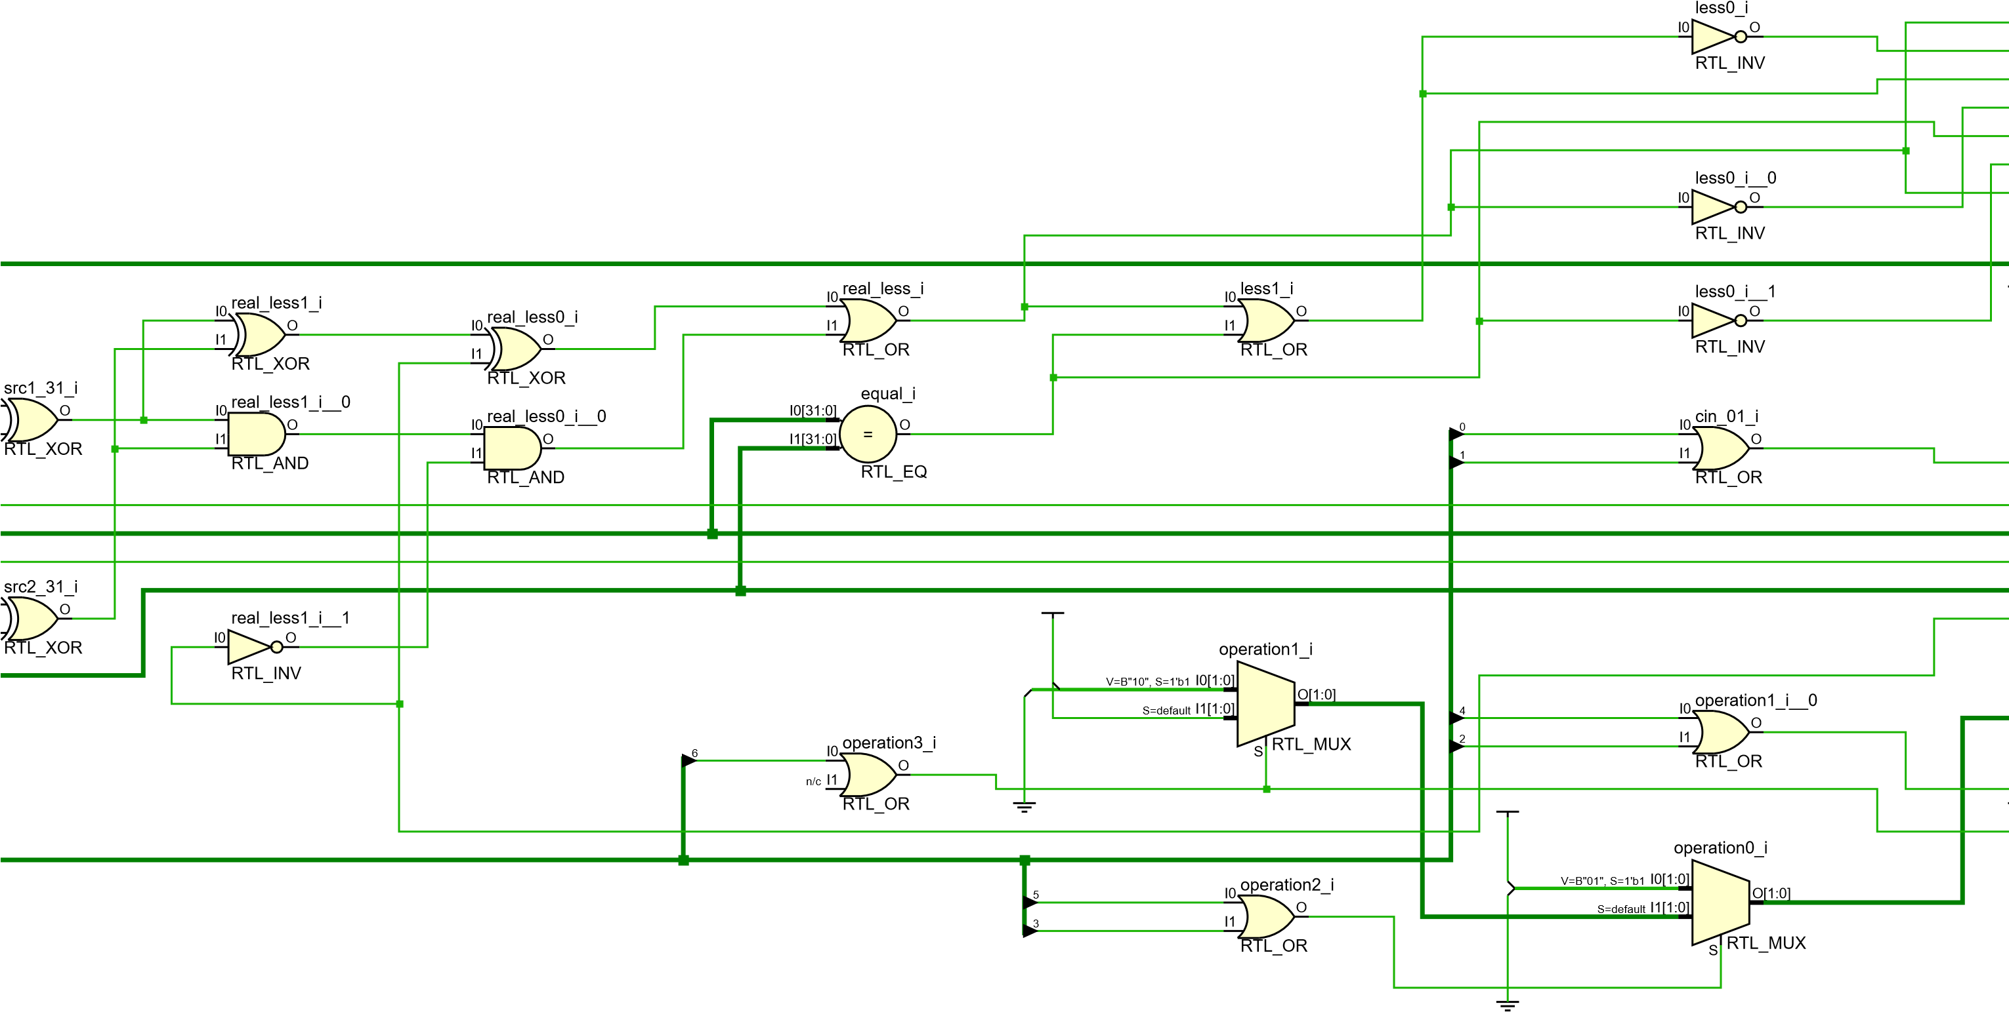
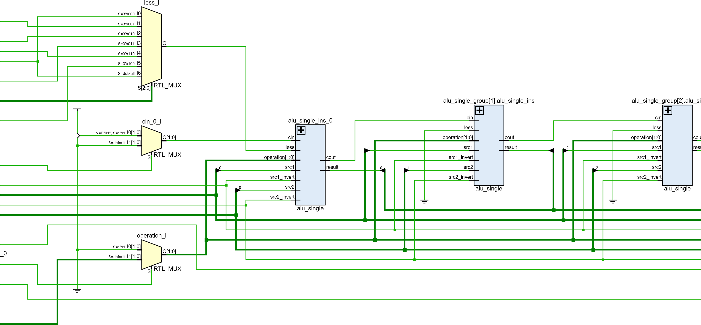
X
