Computer Organization Lab 3
0113110 Po-han Chen (Lab1 Basic, Lab2, Lab3), 0316213 Yu-wen Pwu (Lab1 Adv.)
Architecture Diagram
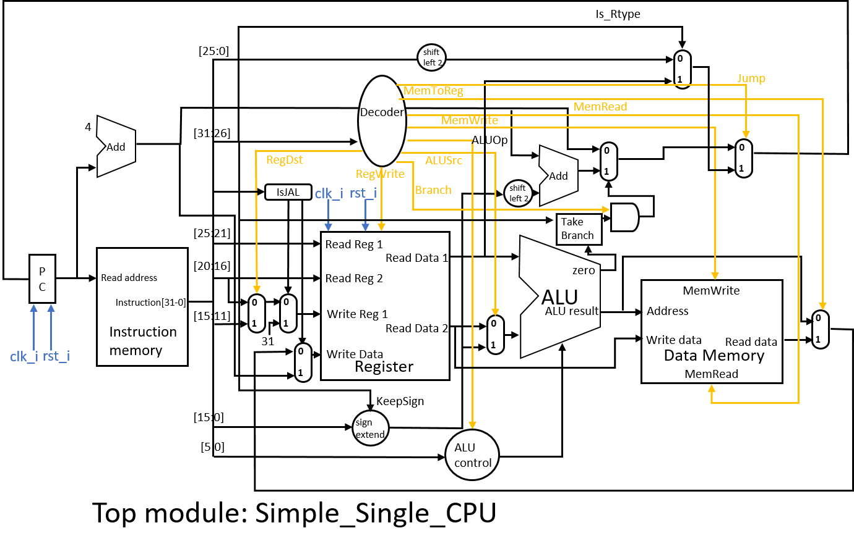
Detailed Description of the Implementation
Here are the major changes since Lab2:
- A Data_Memory module was added, along with new signals MemRead, MemWrite and MemToReg.
MemRead = 1, if instruction is LW.
MemWrite = 1, if instruction is SW.
MemToReg = 1, if instruction is LW.
- Support for JAL and JR.
JumpAddress = instruction[25:0] << 2, if instruction is R-type (JR).
= Read Data 1, otherwise.
Write the next instruction address to the 31st register if instruction is JAL.
- Support for more Branch instructions.
TakeBranch = inst[31:26] == 1 ? Less :
(inst[31:26] == 4 ? Zero : // BEQ
(inst[31:26] == 5 ? !Zero : // BNE
(inst[31:26] == 6 ? (Less || Zero) : // BLE
0)));
- Added new ALU signal for MUL.
Problems Encountered and Solutions
- I didn’t fully understand how JAL and JR work until reviewing Chapter 2. The architecture illustrated in the handout of Chapter 4 is incomplete.
Going over the second test case also helped me fully understand the instructions.
- It took me quite some time to implement the Bubble Sort machine code. It was also difficult to debug since I wasn’t sure whose fault was it (machine code or CPU).
Lesson Learned (If Any)
- Lab4 looks scary …

