Computer Organization Lab 5
0113110 Po-han Chen (#1, 2, 3), 0316213 Yu-wen Pwu (#1, 4, 5)

Basic Problem

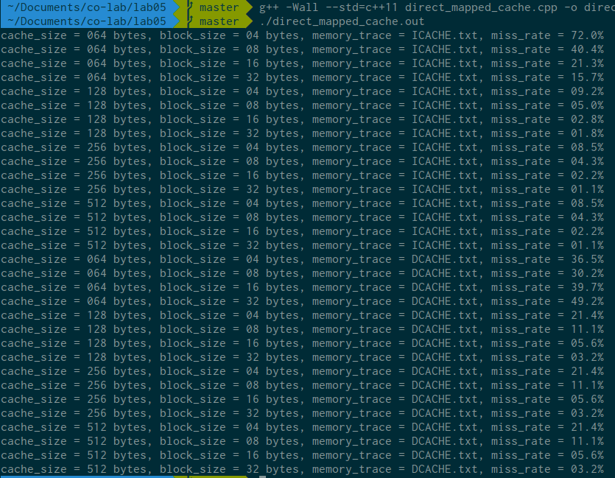

Lowering cache size and block size will increase the possibility to miss.

If cache size and block size are too close, the possibility to miss also increases.

Advanced Problem

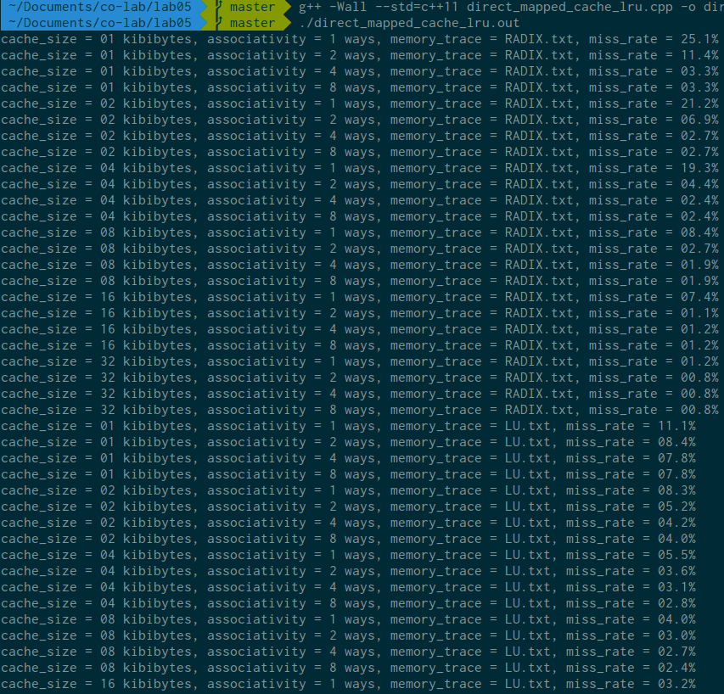

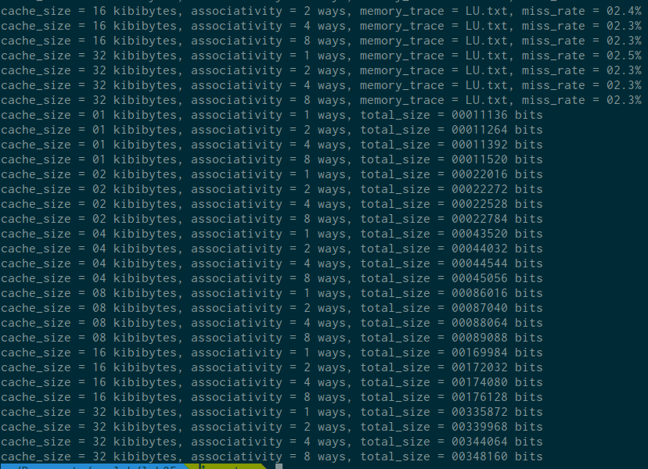

Lowering cache size and associativity will increase the possibility to miss.

Same as above.

Total Size in Bits
associativity cache size | 1-way | 2-way | 4-way | 8-way
1K | 011,136 | 011,264 | 011,392 | 011,520
2K | 022,016 | 022,272 | 022,528 | 022,784
4K | 043,520 | 044,032 | 044,544 | 045,056
8K | 086,016 | 087,040 | 088,064 | 089,088
16K | 169,984 | 172,032 | 174,080 | 176,128
32K | 335,872 | 339,968 | 344,064 | 348,160

