1.1. Use Cain to crack passwords on “your” Windows system with the following three different methods supported by Cain: Brute-force cracking
1.2. Use Cain to crack passwords on “your” Windows system with the following three different methods supported by Cain: Dictionary cracking
1.3. Use Cain to crack passwords on “your” Windows system with the following three different methods supported by Cain: Rainbow cracking

2. Use John the Ripper (JTR) to crack passwords on “your” Linux system.
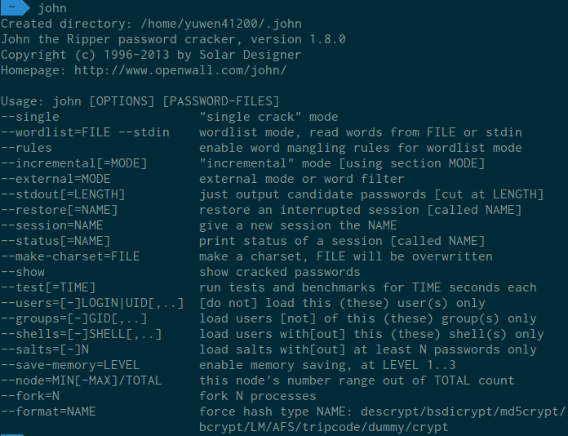
→ Because my real password is really complex, I created a pseudo passwd file and a pseudo shadow file. The username is “root” and the password is “1234.” In fact, this password is used by Quanta LTE routers! (See https://pierrekim.github.io/blog/2016-04-04-quanta-lte-routers-vulnerabili ties.html)

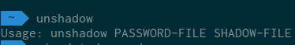

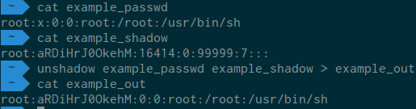

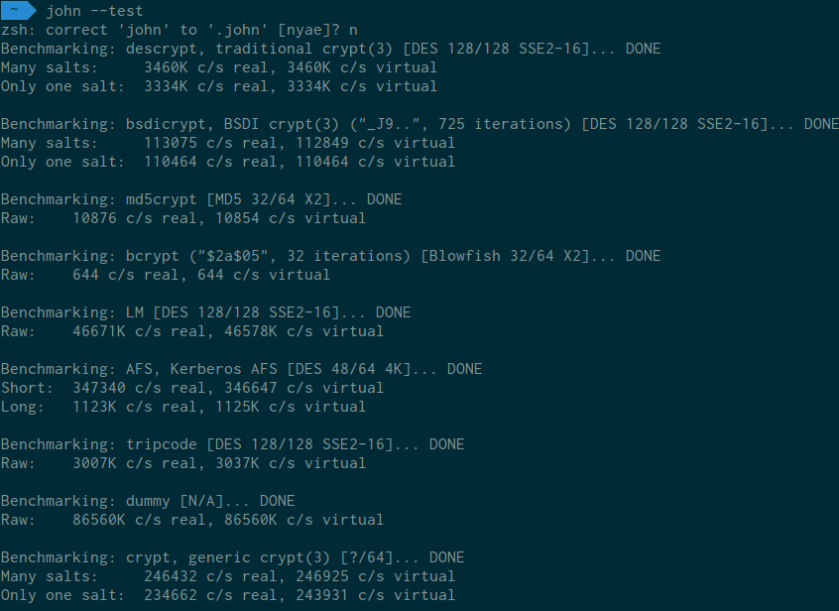

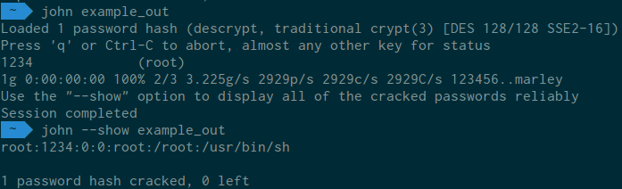

3. Use Metaexploit to exploit a known vulnerability on a server of your choice and on a browser of your choice, respectively.
4. After you gain the access of a target host, show how you could install a back-door program and make it accessible with netcat. You can listen on your host to wait for the back-door to connect over.
5. Compare the vulnerability information that you can collect from three sources: Bugtraq, Open Source Vulnerability Database, Common Vulnerability and Exposures Database. Draw a table to compare them in several features.
6. Use find to search the SUID, SGID, and world-writable files on your Linux system.
7. Use Logclean-ng to clean the logs created during one login session on your Linux system.

